Module 17
HTTP request: to control over the total project. Normal api call e barbar same code likhte hobe.

Module 18
Class: 01
SharedPreference: lightweight database. Token save kore rakhar jonno use korbo. As we have to save the token from someone signed up in the app, and use it for later log in and save his acc’s data in backend server.
Steps to save user data:
- Create new folder named controller in UI
- inside we make auth_controller.dart file
- there we declare class authcontroller
- Inside it, we need a user model to define controller, then save it in a string. So parse both of them.
- Inside data, we make models folder and user model. dart file. Here, we declare the value we got from command line in logger. Basically response boy/ body. Lol.
- Then make user model class and declare the datas, also constructor or late can be used.
- We use a factory constructor to get the response data by json.

Factory Constructor:
A factory constructor gives more flexibility to create an object. Generative constructors only create an instance of the class. But, the factory constructor can return an instance of the class or even subclass. It is also used to return the cached instance of the class.
Nije nije use korte pare. Nijer method nijei use kore factory dile.
Blog: https://dart-tutorial.com/
Syntax:
class ClassName {
factory ClassName() {
// TODO: return ClassName instance}

factory ClassName.namedConstructor() {
// TODO: return ClassName instance }}
example:
with normal constructor:
class Area {
final int length;
final int breadth;
final int area;

// Initializer list
const Area(this.length, this.breadth) : area = length * breadth;
}

void main() {
Area area = Area(10, 20);
print("Area is: ${area.area}");

// notice that here is a negative value
Area area2 = Area(-10, 20);
print("Area is: ${area2.area}");
}
with factory constructor:
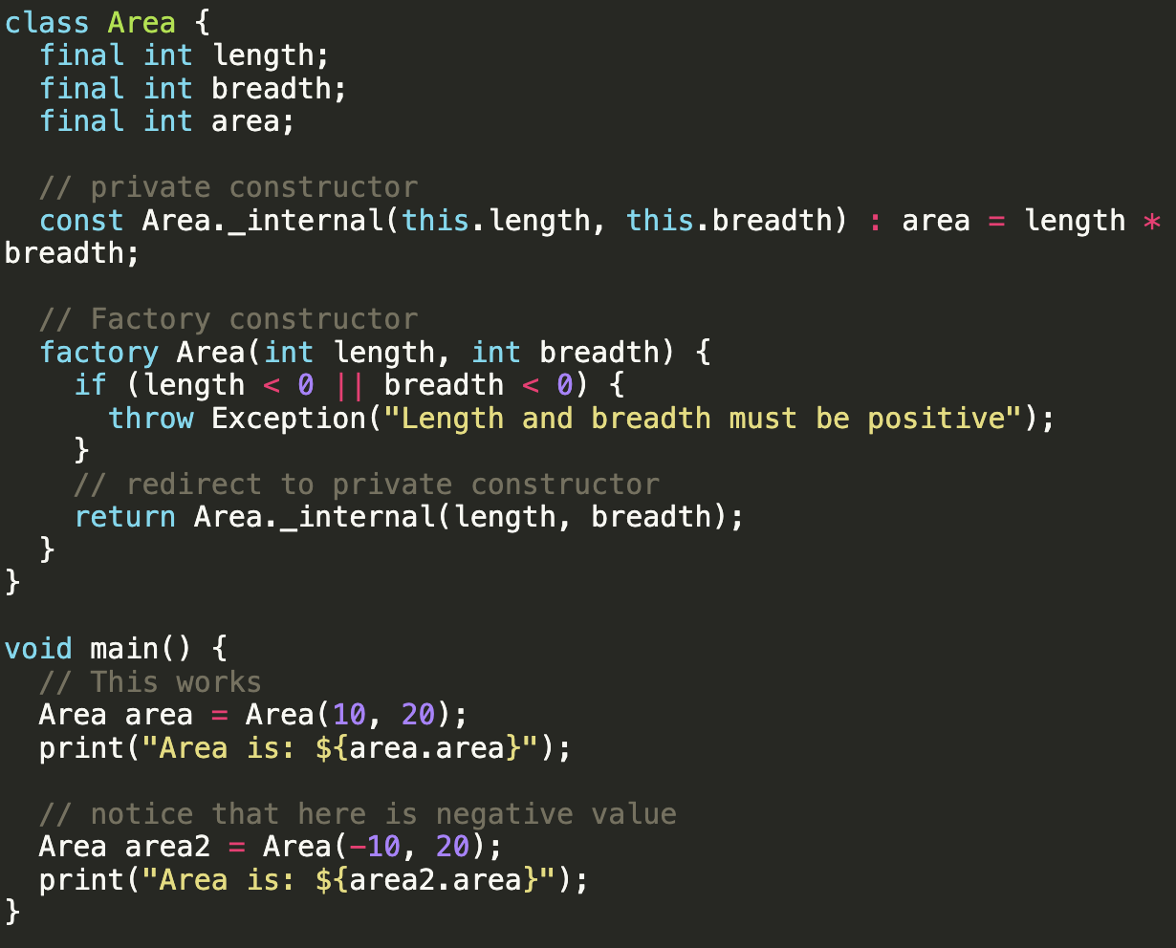

another example with factory constructor:
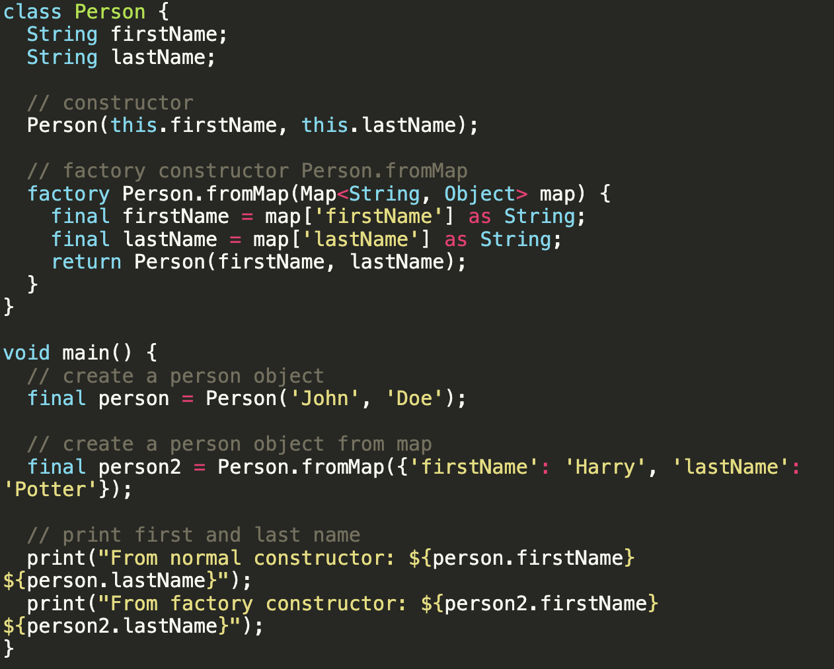
Output:

Asynchronous Function:
An asynchronous function in Dart is a function marked with the async keyword that performs operations without blocking the main execution thread. It allows your program to initiate time-consuming tasks—like fetching network data, reading files, or database queries—and continue working on other tasks while waiting for those operations to finish.
Next Steps:
- Another function declare inside class user model. ToJson. In this class we pass the commented response. But in map. As the response came in map format.
- Now inside the auth_controller.dart file, we will save the user data from model by using shared preferences. SharedPreference by itself a future function. So we use await and async. As it will work in a different thread at the same time with main function without hampering it. Also will wait for the response first before execution of next codes.
- By set string, we set the data/ save it inside the shared preferences.
- Another function we make get User data, from where we do get string and get user data from set string method. All inside auth_controller.dart file.
- First get string the token, if the token is not null / exists, then take user data by get string. And user model theke json decode → user data.

Class: 02
Check if the user is logged in or not (Auth controller)
If a user is logged and wants to log out, we have to clear data. So first we have to check if he is logged in or not. If the database has the token, then he is logged in, if not then not. So return a boolean future function and check if he is logged in or not. If yes then remove data.
Clear SharedPreference (Auth controller)
write a function and clear simply
LogOut Function (Auth controller)
To do log out, we go to app bar icon and call the clear function. Then navigate into log in and remove previous all routes.

What does (predicate) => false mean?
It means:
“For every old route, return false.”
So Flutter removes ALL previous routes.
Predicate is a simple function that returns true or false. If true, it keeps previous routes, it false, I removes all.
AddNewTask validation:
Normally using form key and validate function.
Post AddNewTask in database:
- Create New function where progress make it true(before declare progress as false in boolean). Then set state.
- Then make a request body from response of postman.
- Send the request body in Api response as post request.
- make task progress false again and set state.
- If response is successful, then clear text field’s data. Calling a function and clearing controllers.
- Now we will se a 401 error→ unauthorized. So we need to authorize the access token. Lets go to api caller and inside get and post request, add token in headers: token: access token(previously we didn’t need it, now we are needing it!).
- But as its a 401 error, he does not have token or lost it. So we have to check him and make him leave. He is risky to be inside the app. So in else if condition, we will put him into log in screen. (API caller)
- So we declare a function where we first clear the user data by calling auth_controller.clear user data. Then navigate to log in page. But as api caller does not have any context, we have to build a global key (Like Form key) for using context. And it will take the context of app, as app is the main root of the project.
- Then just add the function in if the response is 401 and return an api response telling false.

Class: 03

{BaseURL}/listTaskByStatus/New
- this is a database. Here all of the added tasks are saved.
- First we are creating task count model from postman request. And adding new future function to track how many tasks are added. Inside is success, we keep them in a list<TaskCountModel>
- Then comes the task model. We create task model so that we access it from database and show it in UI.
- After task model, inside is success, we first count task count. For this, use for loop inside Map of response from postman url. And it will be inside response.response [data]. This data is coming from task count postman response, where sum = my added tasks. That data we are calling and running loop. Then get the json data from that and adding it inside the List.
- To update the ui, call it inside init state function.

New Task dynamic:
- Same way just copy paste get All count function and change url.
- Changed task card widget into task model and accessed it.
- Now we need to change the status. We need to make it dynamic. So we make a function called change status or smth. Then, we make a show dialogue and alert dialogue box and put some ui and call it from the edit icon.
- To change status we take the backend response of update task by status and declare it in urls.
- Take the future function from new task, copy and create a new function named “change Status”, call it inside every list tile. And change the status.
- Similarly do for the rest. Progress, cancel, others. Do for delete using backend response called /delete
- But there is a loader needed, like, if it updates, it should show that its taking time. We can use if else condition and put list separated into condition by circular progress indicator. Other way, we can simply wrap the separated into “Visibility” widget and make it visible when count is false. Also put circular progress indicator for better visual smoothness.

