Anemone_Data_R_Script.R

gilliandee

2019-05-29

#Plot Anemone Data  
library(ggplot2)  
library(tidyverse)

## ── Attaching packages ───────────────────────────────────────── tidyverse 1.2.1 ──

## ✔ tibble 2.1.1 ✔ purrr 0.3.2  
## ✔ tidyr 0.8.3 ✔ dplyr 0.8.1  
## ✔ readr 1.3.1 ✔ stringr 1.4.0  
## ✔ tibble 2.1.1 ✔ forcats 0.4.0

## ── Conflicts ──────────────────────────────────────────── tidyverse_conflicts() ──  
## ✖ dplyr::filter() masks stats::filter()  
## ✖ dplyr::lag() masks stats::lag()

library("gridExtra")

##   
## Attaching package: 'gridExtra'

## The following object is masked from 'package:dplyr':  
##   
## combine

library(dplyr)  
load(url("https://stat.duke.edu/~mc301/R/fun/inference.RData"))  
### Input your data ###  
setwd("/Users/gilliandee/Documents/BIOHOPK47")  
  
  
###getdata  
cbq <- read.csv("/Users/gilliandee/Documents/BIOHOPK47/Anemone and Shell Cover Data.csv")  
Quadrat <-as.factor(cbq$Quadrat..)  
head(Quadrat)

## [1] 1 1 1 1 1 1  
## Levels: 1 2 3 4 5 6 7 8 9 10 11 12 13 14 15

## Get data in long format  
cbq_long <- cbq %>%   
 gather(key = timing, value = percent_shell, Percent.Before:Percent.After)  
## Plot data, with separate regression lines by 'timing' (before/after experiment)  
cbq_long %>%  
 ggplot(aes(UV.Light.Value, percent_shell, color = timing)) +   
 geom_point() +   
 geom_smooth(method = "lm")

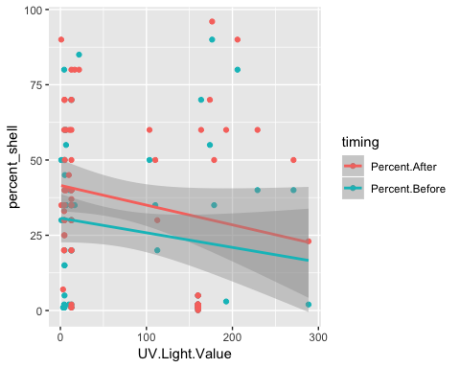

cbq_long %>%  
 ggplot(aes(UV.Light.Value, percent_shell, color = timing)) +   
 geom_point() +   
 geom_smooth(method = "lm") +   
 facet_wrap(~ Treatment)

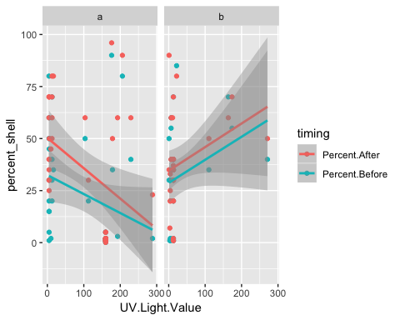

cbq_long %>%  
 filter(timing == "Percent.Before") %>%   
 ggplot(aes(UV.Light.Value, percent_shell, color = timing)) +   
 geom_point() +   
 geom_smooth(method = "lm")

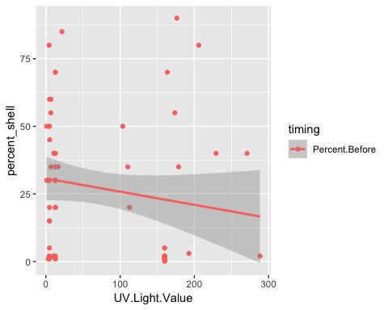

cbq_long %>%  
 filter(timing == "Percent.Before") %>%   
 ggplot(aes(UV.Light.Value, percent_shell, color = timing)) +   
 geom_point() +   
 geom_smooth(method = "lm") +   
 facet_wrap(~ Treatment)

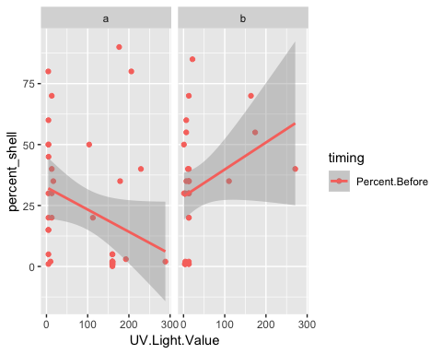

## Regression between uv and percent shell cover BEFORE experiment  
cbq_long_before <- cbq_long %>%   
 filter(timing == "Percent.After")  
lm0 <- lm(percent_shell ~ UV.Light.Value, data = cbq_long_before)  
summary(lm0)

##   
## Call:  
## lm(formula = percent_shell ~ UV.Light.Value, data = cbq_long_before)  
##   
## Residuals:  
## Min 1Q Median 3Q Max   
## -39.735 -26.081 -2.498 21.415 65.994   
##   
## Coefficients:  
## Estimate Std. Error t value Pr(>|t|)   
## (Intercept) 41.57489 4.31770 9.629 3.37e-14 ***  
## UV.Light.Value -0.06559 0.03964 -1.655 0.103   
## ---  
## Signif. codes: 0 '***' 0.001 '**' 0.01 '*' 0.05 '.' 0.1 ' ' 1  
##   
## Residual standard error: 27.05 on 66 degrees of freedom  
## Multiple R-squared: 0.03984, Adjusted R-squared: 0.02529   
## F-statistic: 2.738 on 1 and 66 DF, p-value: 0.1027

anova(lm0)

## Analysis of Variance Table  
##   
## Response: percent_shell  
## Df Sum Sq Mean Sq F value Pr(>F)  
## UV.Light.Value 1 2003 2003.04 2.7384 0.1027  
## Residuals 66 48277 731.47

## Analysis of covariance  
lm1 <- lm(percent_shell ~ UV.Light.Value * timing * Treatment, data = cbq_long)  
summary(lm1)

##   
## Call:  
## lm(formula = percent_shell ~ UV.Light.Value * timing * Treatment,   
## data = cbq_long)  
##   
## Residuals:  
## Min 1Q Median 3Q Max   
## -35.009 -17.102 -2.117 14.990 73.616   
##   
## Coefficients:  
## Estimate Std. Error  
## (Intercept) 50.32371 6.18522  
## UV.Light.Value -0.14581 0.04749  
## timingPercent.Before -17.87620 8.74722  
## Treatmentb -15.76526 8.13007  
## UV.Light.Value:timingPercent.Before 0.05474 0.06717  
## UV.Light.Value:Treatmentb 0.25917 0.08834  
## timingPercent.Before:Treatmentb 12.03336 11.49765  
## UV.Light.Value:timingPercent.Before:Treatmentb -0.05740 0.12493  
## t value Pr(>|t|)   
## (Intercept) 8.136 3.08e-13 ***  
## UV.Light.Value -3.070 0.00261 **   
## timingPercent.Before -2.044 0.04304 *   
## Treatmentb -1.939 0.05469 .   
## UV.Light.Value:timingPercent.Before 0.815 0.41663   
## UV.Light.Value:Treatmentb 2.934 0.00397 **   
## timingPercent.Before:Treatmentb 1.047 0.29726   
## UV.Light.Value:timingPercent.Before:Treatmentb -0.459 0.64668   
## ---  
## Signif. codes: 0 '***' 0.001 '**' 0.01 '*' 0.05 '.' 0.1 ' ' 1  
##   
## Residual standard error: 25.12 on 128 degrees of freedom  
## Multiple R-squared: 0.163, Adjusted R-squared: 0.1172   
## F-statistic: 3.561 on 7 and 128 DF, p-value: 0.001564

anova(lm1)

## Analysis of Variance Table  
##   
## Response: percent_shell  
## Df Sum Sq Mean Sq F value Pr(>F)   
## UV.Light.Value 1 3041 3041.1 4.8184 0.029960 *   
## timing 1 3184 3183.6 5.0441 0.026424 *   
## Treatment 1 144 144.2 0.2284 0.633506   
## UV.Light.Value:timing 1 66 66.4 0.1052 0.746242   
## UV.Light.Value:Treatment 1 8592 8591.6 13.6128 0.000331 ***  
## timing:Treatment 1 575 574.6 0.9104 0.341806   
## UV.Light.Value:timing:Treatment 1 133 133.2 0.2111 0.646678   
## Residuals 128 80786 631.1   
## ---  
## Signif. codes: 0 '***' 0.001 '**' 0.01 '*' 0.05 '.' 0.1 ' ' 1

## Two-way ANOVA, for experiment  
lm2 <- lm(percent_shell ~ timing * Treatment, data = cbq_long)  
summary(lm2)

##   
## Call:  
## lm(formula = percent_shell ~ timing * Treatment, data = cbq_long)  
##   
## Residuals:  
## Min 1Q Median 3Q Max   
## -37.310 -21.438 -2.379 21.594 66.562   
##   
## Coefficients:  
## Estimate Std. Error t value Pr(>|t|)   
## (Intercept) 35.900 4.225 8.496 3.61e-14 ***  
## timingPercent.Before -12.462 5.976 -2.085 0.039 *   
## Treatmentb 2.410 6.470 0.373 0.710   
## timingPercent.Before:Treatmentb 6.531 9.150 0.714 0.477   
## ---  
## Signif. codes: 0 '***' 0.001 '**' 0.01 '*' 0.05 '.' 0.1 ' ' 1  
##   
## Residual standard error: 26.39 on 132 degrees of freedom  
## Multiple R-squared: 0.04776, Adjusted R-squared: 0.02612   
## F-statistic: 2.207 on 3 and 132 DF, p-value: 0.0903

anova(lm2)

## Analysis of Variance Table  
##   
## Response: percent_shell  
## Df Sum Sq Mean Sq F value Pr(>F)   
## timing 1 3184 3183.6 4.5721 0.03434 *  
## Treatment 1 1072 1071.5 1.5389 0.21698   
## timing:Treatment 1 355 354.7 0.5094 0.47668   
## Residuals 132 91911 696.3   
## ---  
## Signif. codes: 0 '***' 0.001 '**' 0.01 '*' 0.05 '.' 0.1 ' ' 1

cbq_summary <- cbq_long %>%   
 group_by(Treatment, timing) %>%   
 summarise(mean = mean(percent_shell),   
 sd = sd(percent_shell),   
 n = n(),   
 se = sd / sqrt(n)) %>%   
 ungroup()  
  
theme_set(theme_bw())  
cbq_summary %>%   
 ggplot(aes(Treatment, mean,   
 shape = timing, group = timing, color = timing)) +   
 geom_point() + geom_path() +   
 geom_errorbar(aes(ymin = mean - se, ymax = mean + se),   
 width = 0.1) +   
 labs(x = "Treatment", y = "Shell cover (%)")

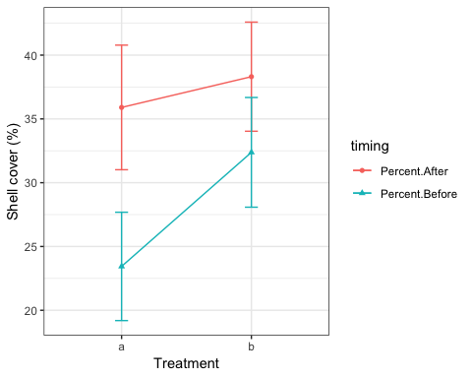

ggsave(filename = "experiment_2way_fig.png",   
 height = 3.5, width = 4)  
  
getwd()

## [1] "/Users/gilliandee/Documents/BIOHOPK47"

###stats  
  
(regression.before <- lm(cbq$Percent.Before~cbq$UV.Light.Value, data = cbq))

##   
## Call:  
## lm(formula = cbq$Percent.Before ~ cbq$UV.Light.Value, data = cbq)  
##   
## Coefficients:  
## (Intercept) cbq$UV.Light.Value   
## 30.7021 -0.0487

(regression.after <- lm(cbq$Percent.After~cbq$UV.Light.Value, data = cbq))

##   
## Call:  
## lm(formula = cbq$Percent.After ~ cbq$UV.Light.Value, data = cbq)  
##   
## Coefficients:  
## (Intercept) cbq$UV.Light.Value   
## 41.57489 -0.06559

beforeregression <- ggplot(cbq, aes(x = UV.Light.Value, y = Percent.Before)) +   
 geom_point() +  
 stat_smooth(method = "lm", col = "red")  
beforeregression + labs(title="Shell Cover Before Treatment as Function of UV Light",x="UV Light (J)", y = "Shell Cover (%)")

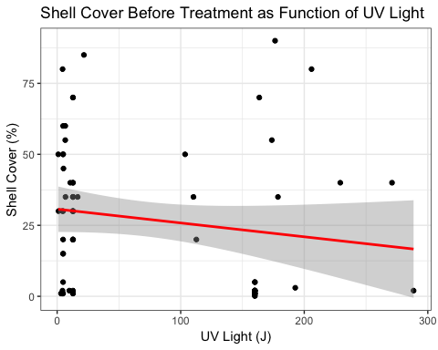

afterregression <- ggplot(cbq, aes(x = UV.Light.Value, y = Percent.After)) +   
 geom_point() +  
 stat_smooth(method = "lm", col = "blue")  
afterregression + labs(title="Shell Cover After Treatment as Function of UV Light",x="UV Light (J)", y = "Shell Cover (%)")

