**The Effects of Temperature Change on Katharina tunicata and Intertidal Population Dynamics**

**INTRODUCTION**

The effects of anthropogenic climate change are very important in ecological studies. Rising temperatures are resulting in worldwide changes in many marine and terrestrial environments. Since 1979, average global sea surface temperatures have increased by around 0.08 degrees C per decade (EPA 2016). An increase of this magnitude can have serious effects on populations; intertidal organisms are already exposed to abiotic stressors such as increased sun and air exposure that can kill an organism or reduce its biomass or body size (Dethier 1984). Given rising temperatures in the intertidal, the effects on these organisms will only be exacerbated. Rocky intertidal shores, such as those found on the San Juan Islands in Washington State, serve as the boundary line between marine, atmospheric, and terrestrial environments. Organisms in these ecosystems are especially susceptible to the effects of climate change since they are affected by both changes in marine and aerial climates (Helmuth et al. 2006).

Studies have shown that a decline in body size of organisms is the third universal effect of global climate change (Gardner et al. 2011). Populations are experiencing large structural changes including reductions in size-at-age, overall body sizes, and larger ratios of juveniles to adults (Daufresne et al. 2009). Temperature rises have also been suggested to affect the metabolic demands of species; were a rise in temperature to favor a smaller body size, the metabolic demand of an organism would resultinly decrease due to less need for nutrients (Kordas et al. 2011). We explored whether populations of the leathery chiton, *Katharina tunicata,* in this ecosystem are indeed experiencing changes in body size and density coincident with patterns of increased temperatures. We also asked how a reduction in body size of *Katharina* would affect the populations of macroalgae as well as limpets, who rely on *Katharina* as an “ecosystem engineer” (Sorte et al. 2017). Due to the increased temperatures as well as the stress of living within the intertidal, I predict the populations of these dominant herbivores will experience the same body size reduction and a decline in density. Further, I believe the cascading effect of decrease in density of herbivores will result in a larger algal canopy in the intertidal zone.

Some intertidal organisms are considered “ecosystem engineers”, or those whose populations are abundant and are capable of largely affecting other species in the environment (Jenkins et al. 1999). Important herbivores and carnivores can be capable of keeping populations of organisms within lower trophic levels in check. Organisms may experience population booms or declines with changes in the amount of available food, such as many algae or plankton. An example of these species within the intertidal zone is the leathery chiton, *Katharina tunicata,* of the Pacific Northwest United States*.* They are generalist herbivores capable of consuming both microalgae and macroalgae. This diet helps keep canopy sizes of large macroalga such as *Saccharina sessilis* in check. *Saccharina* serves as a large food source for *Katharina*;and is also an important provider of a shady habitat (Burnaford, 2004). This relationship is also beneficial to limpets, who are limited in their distribution by the cover of these large algal canopies; and are capable only of consuming microalgae such as diatoms (Duggins and Dethier 1985). The removal of *Katharina* in the intertidal resulted in a large increase in the abundance of canopy kelps, as well as a reduction in the abundance of limpets, who experience a decrease in fitness with reduced sunlight. (Duggins and Dethier 1985).

Our study was performed at Pile Point, Washington. By comparing our collected data with historical records from 1979, we will examine the effects of rising temperatures on the intertidal ecosystem, specifically to determine whether these rising temperatures will favor smaller densities of *Katharina tunicata*, and as a result favor larger densities of macroalgae canopies, and a reduced density of limpets.

**METHODS**

**Previous Historical Surveys**

The main purpose of this study was to answer whether rising temperatures have resulted in a change in the diversity of intertidal organisms along Pile Point. In the Duggins and Dethier (1985) study, population censuses were reported before studying the effects of the removal of *Katharina tunicata* on limpet and algal populations within Pile Point. This data serves as an important record of historical populations that we are able to use to compare our findings with.

**Zone Information.**

Pile Point is a private area of rocky intertidal shore on the South side of San Juan Island. It is surrounded by mostly private residential land which according to property owners has been relatively preserved since the property was sold.As a result, this location serves as an important site to study the effects of more indirect anthropogenic effects, in this case the rise of ocean temperatures. To determine populations of *Katharina,* limpets, and algae, four experimental zones of 25 square meters each were determined (Table 1). Previous experimental zones from the 1985 study were identified with the help of the original experimenters (Duggins & Dethier 1985). GPS coordinates for each location are listed in Table 1. In this previous study, two zones, known as Removal Zones A and B, were the site of removal of *Katharina;* two zones, known as Control Zones A and B, served as controls for abundance surveying (Fig. 6). Since the purpose of this paper was to determine the overall populations of each organism at Pile Point, no removal of any organisms took place.

Within each zone, two 5-m transects were placed along the contours of the shoreline. 4 quadrats of 0.1 square meter size were randomly placed along each transect. Locations along the transect were randomly chosen via random number generation (between 0 and 500 centimeters); the direction of deviation from the transect (left or right) was determined by whether or not the random number was odd or even; even numbers resulted in us deviating to the right, and odd numbers to the left. A second randomly generated number (Between 0 and 166 centimeters) determined the distance from the transect that the quadrat would lie. In the case of Removal Zone A, an additional quadrat was placed along each transect for a total of ten. Tidal heights of each quadrat were also determined, and were segregated into two categories: those that fell below 0’ MLLW were placed in the ‘low’ category, while quadrats above 0’ MLLW were placed in the ‘high’ category.

Populations and densities of limpets were measured and compared with the same data for *Katharina.* In addition to this data, body sizes of *Katharina* were measured and recorded. These were measured across a 5 square meter transect with a 1 square meter quadrat, using scientific calipers without removing organisms from the substrate.. Due to the difficulties in identifying the numerous species of limpets found on Pile Point, these organisms were counted as one single group. Percent coverage of algae and other plants, such as *Saccharina sessilis, Phyllospadix scouleri,* encrusting corraline algae, and non-corraline crusts were also determined and recorded;

**Analytical processing**

Our data was collected by hand within the field. It was then digitally inscribed into multiple CSV (Comma separated values) files that were further processed using R studio. Statistical means, medians, and deviations were calculated and used to create multiple plots using ggplot, a versatile library within R Studio.

**RESULTS**

Our collected data shows small changes in body size and density of *Katharina.* To determine average body size distribution, 375 individuals were measured in 1979, and 575 individuals were measured in 2018. In both years, a maximum body size of 9 centimeters was observed (Figure 1). Since 1979, we observed a small decrease in range of body size from 1-9 centimeters, to 2-9 centimeters. The proportional frequency of smaller body sizes (below 6 centimeters) has overall decreased since 1979, whereas we saw an increased frequency of larger body sizes (above 5 centimeters) in 2018. Frequency of *Katharina* with larger body sizes (6-9 cm) increased slightly (Figure 1).

Historic and current density of grazers (*Katharina* and limpets), in terms of individuals per square-meter, in all treatment areas were also analyzed. We observed that the density of limpets seems to have increased in all treatments except Removal B since 1979, while the density of *Katharina* seems to have slightly decreased in all treatments except Control A (Figure 3). Variation in chiton density has remained similar, but the majority of quadrats in all treatments except Control A have decreased (Figure 3). Overall, maximum population size of limpets compared to *Katharina* differs by a factor of about 10. While the highest observed number of limpets was 133 individuals, the highest number of *Katharina* was only 10 individuals (Figure 3).

The ratios of *Katharina* to limpets within each treatment area were further analyzed. Our results showed the ratios of chitons to limpets in Removal B showed no change over time, with a general increase in the ratio of chitons to limpets in the three other treatments (Figure 2). Treatments Control B and Removal B both shared a higher abundance of *Katharina* than limpets, whereas treatments Control A and Removal A showed a higher ratio of limpets to *Katharina* (Figure 2). Treatment Control B showed the highest decrease in both overall ratios and range. Here, more than 50 percent of the sampled quadrats in Control B contained a higher ratio of *Katharina* to limpets in 1979, and in 2018 we observed only one quadrat with a higher ratio of chitons (Figure 2). These decreases were less significant in treatments Control A and Removal A.

There seems to be a direct correlation between the population of *Katharina*/limpets and overall canopy coverage of *Saccharina sessilis* in all treatments*.* The highest number of limpets were observed in areas with near-zero percent *Saccharina* coverage in both years, with a maximum observed abundance of 80 individuals in 1979, and 133 individuals in 2018 (Figure 4). In 1979, the highest observed level of *Saccharina* coverage was 60 percent, and a minimum of 2 limpets were recorded (Figure 4). The highest coverage of *Saccharina* in 2018 was 95 percent coverage, with zero limpets recorded in this quadrat (Figure 4).

Changes in populations of *Katharina* experienced an inverse correlation to limpets. In areas of near-zero *Saccharina* coverage, an average population density of around 10 individuals per square meter was observed in both years (Figure 4). In 1979, one quadrat was observed with zero *Katharina* at zero percent coverage, and a minimum population of 5 individuals was observed in 2018 at the same coverage level (Figure 4). The highest number of observed *Katharina* with canopy coverage greater than zero was 9 individuals at 40 percent coverage in 1979, and 8 individuals at 60 percent coverage in 2018 (Figure 4). Since 1979, these trends in population vs. canopy coverage have seem to remain unchanged.

Algal canopies within the upper- and lower- intertidal at Pile Point have experienced some changes. Percent coverage of *Saccharina sessilis* has remained nearly constant; no change in coverage was seen in the upper zone, while the lower zone experienced negligible changes far smaller than our standard deviation of change (Figure 5). Crustose algae abundances have experienced little to no change since 1979, as well. Non-corraline crustose algae abundances both slightly increased and decreased in the lower- and upper- intertidal zones respectively, by equal levels, implying no population change (Figure 5). Corraline crustose algae on the other hand has overall slightly decreased by 4.08-percent in the upper zone, and by 1.5-percent in the lower zone (Figure 5).

The most noticeable change in algal coverage is the increase in abundance of the surfgrass *Phyllospadix scouleri.* Abundance of the surfgrass increased from a maximum coverage of only 0.37-percent coverage in 1979 to 8.13-percent, observed in 2018 (Figure 5). In both years of study, there was little to no *Phyllospadix* found in the upper intertidal zone. {*Phyllospadix* coverage has remained quite low in the upper-intertidal zone, likely due to the organism’s decreased fitness in higher zones. }--Move somewhere in discussion

**DISCUSSION**

Observed changes in ecological diversity within our study site have been surprisingly small relative to our previous predictions. Our results have thus far been unable to present any significant changes in *Katharina* body size on the San Juan Islands. Though we observed a slight decrease in frequency of smaller body sizes and an increase of larger sizes, our data still follows the same 1979 trend in which body sizes of 6-7 cm are the most frequent, with larger and smaller body sizes being 0-50 percent as frequent (Figure 1).

Our most supportive evidence to our hypothesis was from our observations of *Katharina* and limpet density over time. This plot does show a reduction in *Katharina* density within 3 of 4 plots (Fig. 2). This could very well be a result of smaller body sizes becoming more favorable within a population (Daufresne, 2009). The plot also shows that *Katharina* populations have decreased over time, which could be an alternative explanation for the reduced density. It is difficult to attribute these changes in population to rising temperatures, however, as there are many possibilities for a drop in population size. Limpet densities have also varied; they increased in two areas and decreased in two areas. These variations make attributing a trend to these effects very difficult. It also remains difficult to determine whether the *Katharina*, and in a greater sense this ecosystem, has as of yet been significantly affected by rising ocean temperatures.

Our most relevant temperature data was collected at Race Rocks Marine Protected Area, an ecological preserve directly west of San Juan Island; this data spans from 1921 to 2011, with average ocean temperatures for each month. Given our close proximity to this location, we expect that Pile Point would be similarly affected by any changes in temperature. From 1970-1979, the average ocean temperature at this location was 8.82 degrees C, and had increased by 0.26 degrees C per decade, to 9.86 degrees C from 2002-2011 (Race Rocks). This is a much larger increase compared to the global average increase of 0.08 degrees C/decade. Although these temperatures show an increasing trend over time, there still remain similar variations in temperature over smaller temporal scales. For instance, the average ocean temperature in both May 1979 and 2010 was 9.5 degrees C (Race Rocks). These similarities lead me to infer that a similar variation would be seen from 2011-2018, even though we unfortunately are unable to obtain such data at this time. If average 2018 temperatures were similar to those seen during the 1985 study, this could potentially help explain the similarity of trends in body size we size currently.

Our observations of grazer density vs. *Saccharina* coverage did not show evidence of a smaller favorable body size here, we did in fact see a strong correlation between *Katharina/*limpet density and *Saccharina coverage.* There was a strong correlation between *Katharina* populations and kelp coverage; quadrats with the largest abundance of *Saccharina* also had the highest numbers of *Katharina* observed. Many quadrats did not contain any *Saccharina,* and in these quadrats we also saw virtually no *Katharina* present (Fig. 4). An entirely inverse correlation was seen with limpet populations and kelp coverage; those quadrats with no *Saccharina,* limpets were very abundant and were also missing in quadrats dominated by kelp canopies (Fig. 4). This correlation was very similar in both years which is expected due to no observed changes in *Saccharina* abundance. If in future years the body sizes of *Katharina* and limpets are affected by rising temperatures, we would expect to see their distributions still correlate with *Saccharina* coverage.

*Saccharina* coverage has remained overall unchanged since 1979, supporting a lack of change in *Katharina* population structure. If body sizes of the chitons were to decrease over time then we would expect less of a nutritional demand on individuals; in turn they would graze less *Saccharina* and canopy coverage would increase. If body size were to increase, then nutritional demands would increase and canopy coverage would decrease. We would not expect the *Saccharina* to change if the chiton population has remained unchanged as well.

What is interesting about algal canopy change is the substantial increase in the surfgrass *Phyllospadix.* This grass was previously entirely absent in Pile Point, with very few sparse patches here and there, according to David Duggins and Megan Dethier. We first asked ourselves whether or not the increase in *Phyllospadix* is causing increased spatial competition in the intertidal since it has taken up so much bare space. Our observations suggest however that there has likely been no decrease in competition, since we see hardly any change in canopy coverage from any other species (Fig. 5). What we believe instead is that the *Phyllospadix* has filled in an ecological niche, and has grown substantially within areas that have otherwise stayed relatively bare. The presence of *Phyllospadix* in the intertidal can also potentially benefit other organisms, by substantially lowering the ambient water temperature within tide pools (Shelton 2010). While there is a large presence of tide pools in Pile Point, a large portion of the *Phyllospadix* present lies instead on bare rock and is exposed to air during low tides. Since the surf grass also seems to be filling a niche where other algae are not present, this benefit would also seem to be less important.

We also observed a very small number of both limpets and *Katharina,* as well as other chitons, in areas where *Phyllospadix* was dominant. Other studies have suggested that there is a positive correlation between *Phyllospadix* abundance vs. other gastropods, such as *Chlorostoma sp.* It was suggested that this was the result of an increased amount of allochthonous nutrients available to gastropods (Hori 2006); it is very interesting that *Katharina* and limpets do not seem to be following this correlation. Further study on the resource consumption of *Katharina* and limpets is recommended to further explain this pattern.

The general geology of Pile Point may also play a large role in the lack of change we have observed. This point is located in a relatively high-energy, wave-exposed area of San Juan Island, on the west side towards the Strait of Juan de Fuca. Previous studies have suggested that it is difficult to differentiate the effects of anthropogenic change from physical processes such as wave action or predation, which can have a much larger effect on population dynamics (Murray et al. 2016). If this is the case, then it may be more difficult to determine the effects of anthropogenic change vs. physical processes, until perhaps temperatures have risen further.

Given our collected evidence, it remains difficult to attest any observed changes in the Pile Point ecosystem to a rise in temperature. What we have observed is a remarkably interactive ecosystem that is delicately balanced. Algal populations directly influence the abundance of grazers within the intertidal, both by providing food and shade, as well as driving other incompatible grazers out to other areas. Even when very little change was observed in canopy coverage here, we observed a population explosion of surfgrass, something that survives here apparently without harming the other organisms that call this rocky outcropping home. Although this ecosystem may have not yet experienced the effects of rising temperatures to a large degree, the delicacy of the ecosystem should not be expected to hold out forever. Organisms here are exposed to many stressors that will only be exacerbated as time goes by and the effects of climate change are experienced on an even greater level. Even though we do not yet see this third universal response to rising temperatures (reduction in body size) affecting *Katharina tunicata* at Pile Point, we believe that future observation efforts are imperative to understand how temperatures are rising here. We also believe that any future reductions in body size could be a bioindicator for rising temperatures or other climatic effects; patterns of these changes may prove to be a valuable proxy for determining how temperature change is trending in future years.

Tables and Figures

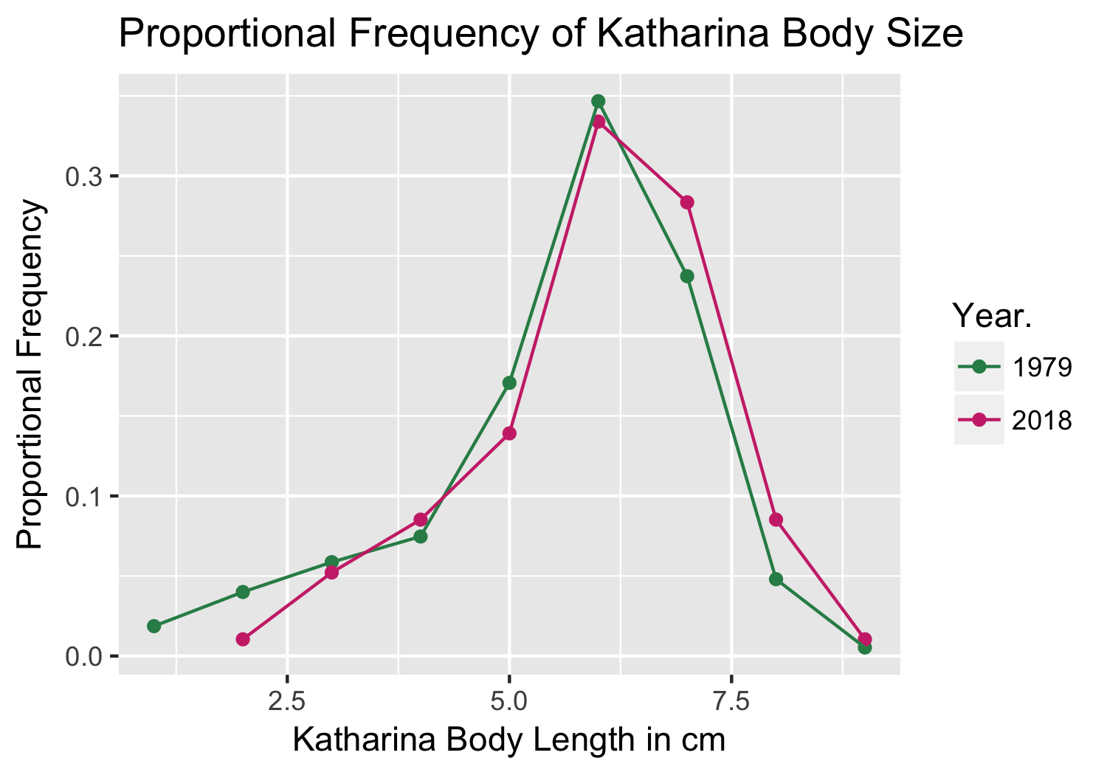

Figure 1. Historic and current proportional frequencies of *Katharina* body size across all treatments. Body sizes were measured to the nearest centimeter, and include a range of 1-9 centimeters. In 1979, a total of 375 *Katharina* were measured; 575 individuals were measured in 2018.

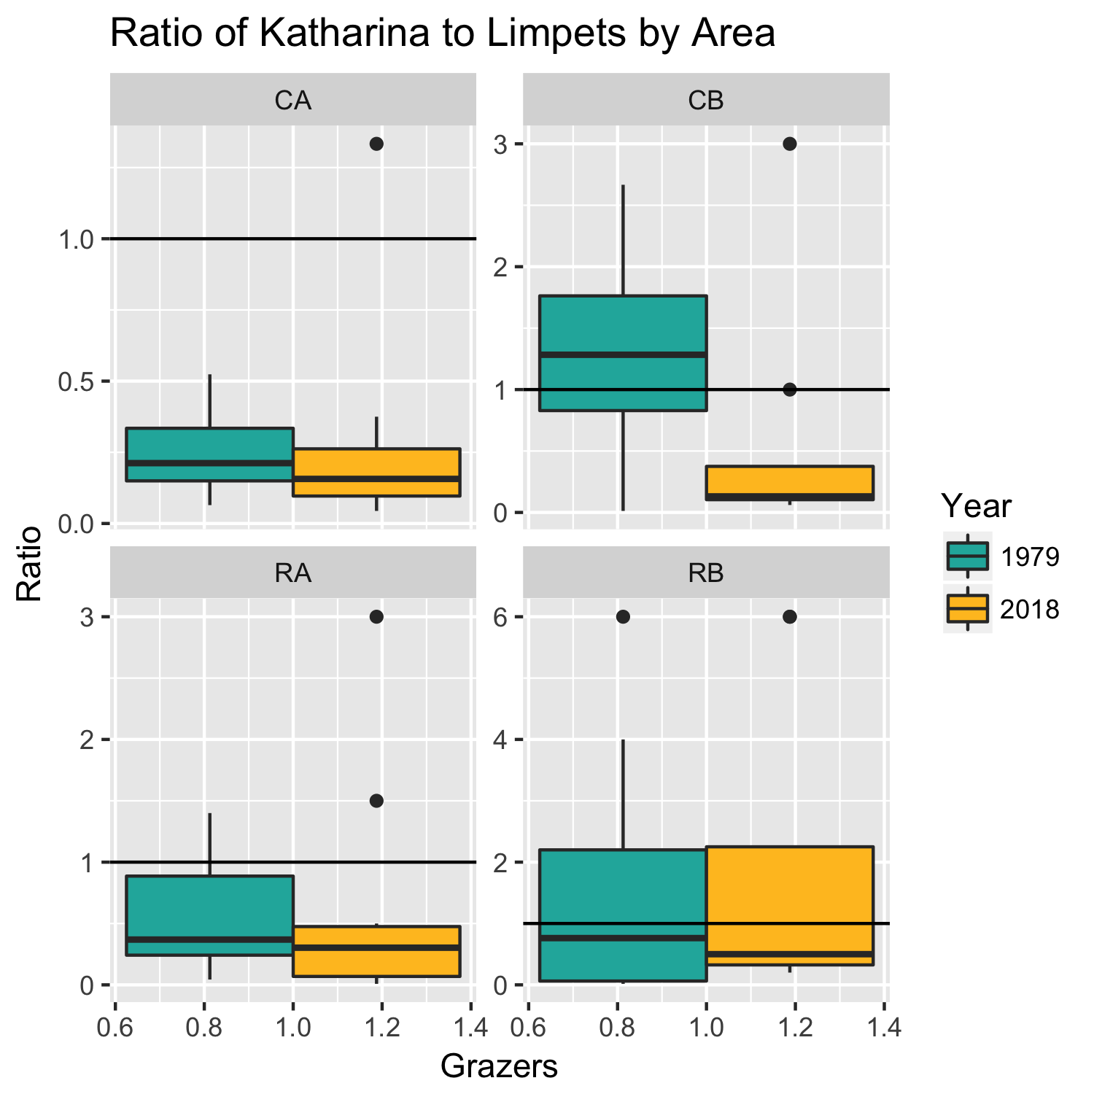

Figure 2. A box plot showing historic and current ratios of Katharina to limpets within each treatment area. Boxes in blue represent data from 1979, and yellow boxes represent 2018 data. Differences in ratios are represented on the y-axis, and the x-axis serves as a dimensionless visualization. Data points that fall above the horizontal line at y = 1.0 represents higher ratios of *Katharina* to limpets. The solid boxes represent the 50% quartile of data points, while the whiskers above and below represent variation in the upper and lower 25% quartiles, respectively. Solid black dots are single outlying data points.

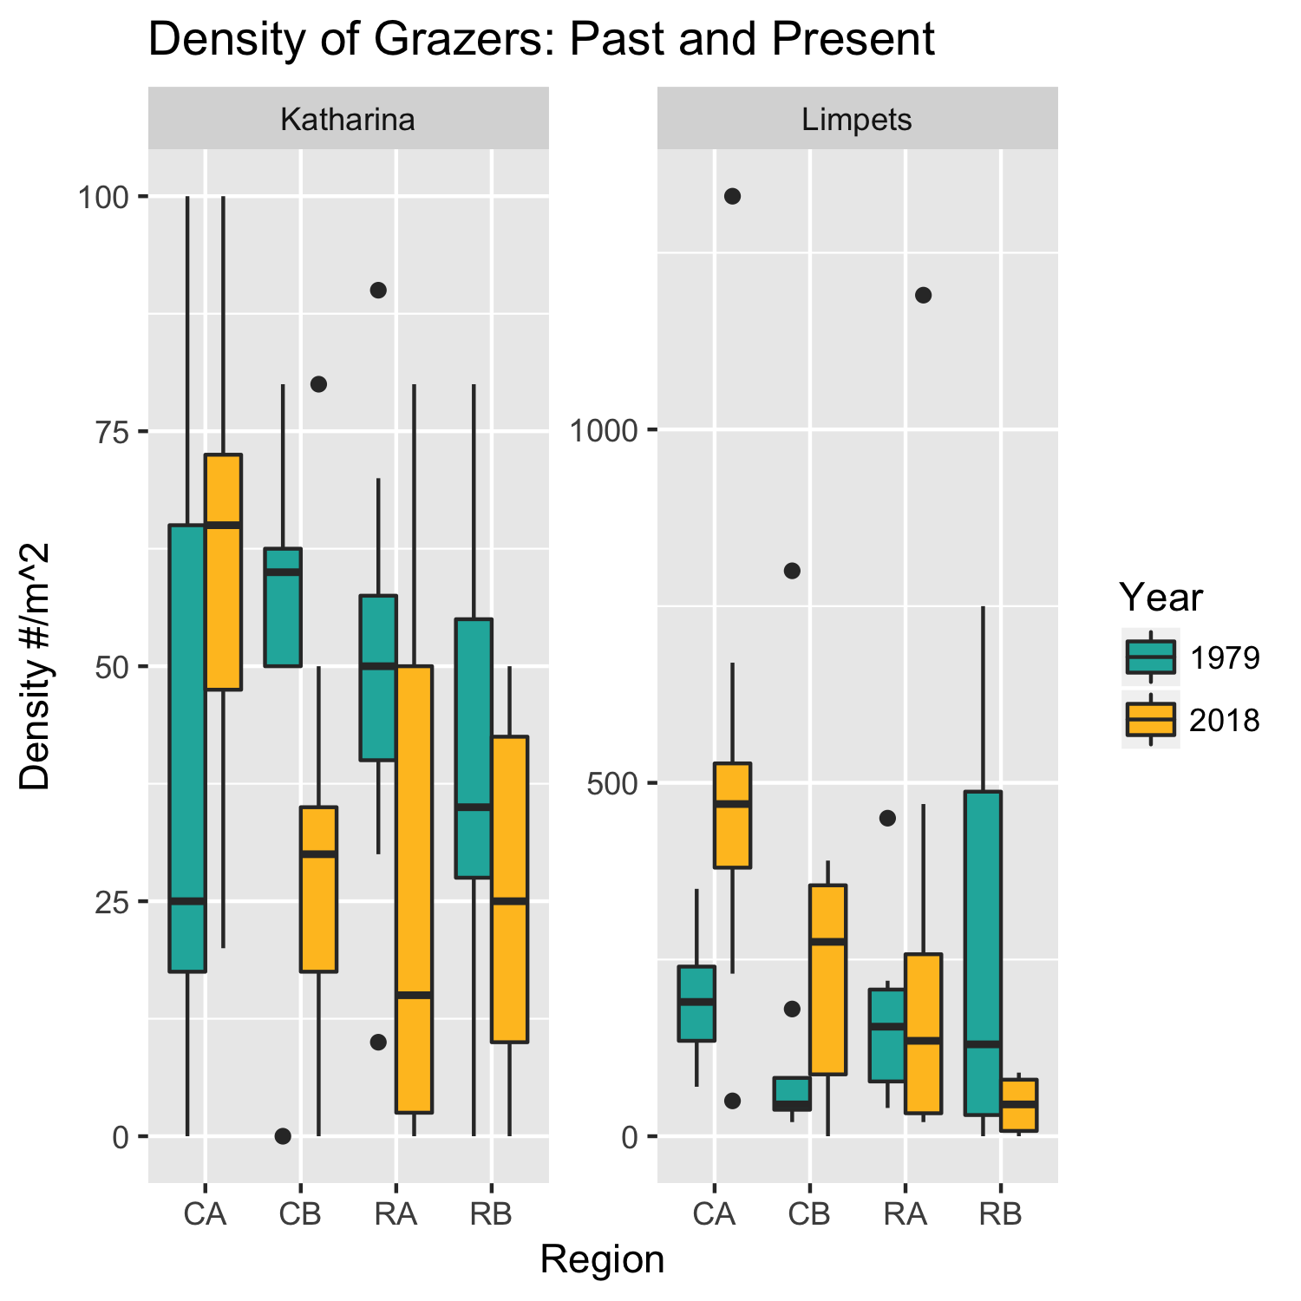

Figure 3. Historic and current data of *Katharina* and limpet densities, separated by treatment areas. The left panel represents historic and current densities of *Katharina tunicata,* and the right panel represents densities of limpets. Data in blue represents our historic 1979 data, and data in yellow represents current 2018 data. Our 4 treatment areas are found on the x-axis and are represented by their initials (i.e. CA = Control A). The y-axis represents variations in densities of both organisms, determined by number of individuals per square meter.

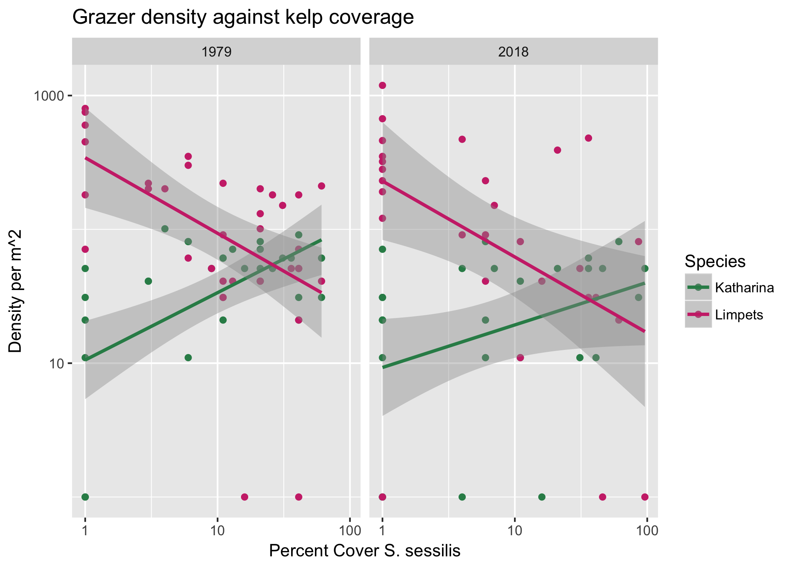

Figure 4. Here the density of all intertidal grazers (*Katharina* and limpets) is displayed each year, calculated in terms of number of individuals per square meter, vs. percent coverage of *Saccharina sessilis* per quadrat. The left panel displays densities vs. *Saccharina* coverage in 1979, and the right panel displays the same 2010 data. The green line represents the trend of *Katharina* density/kelp coverage, with the shaded area representing variation in the data. The individual green dots represent the values of individual quadrats within all observation areas. For limpets, the same data is displayed as pink lines and dots.

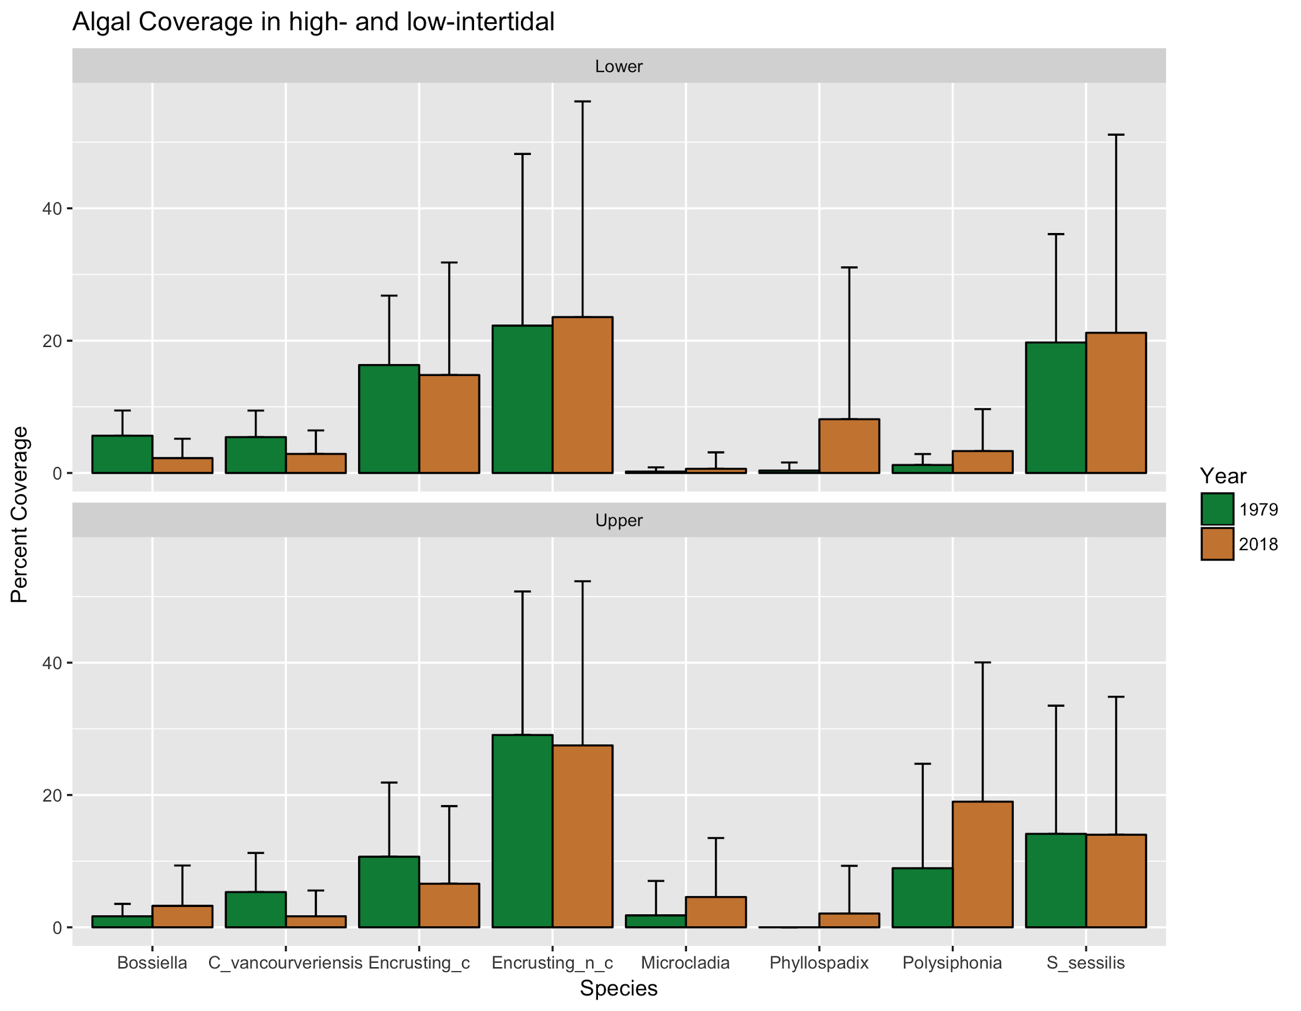

Figure 5. Percent coverage of algae within the upper and lower intertidal across all experimental sites. The green bar represents historical data collected from 1979, and our collected data from 2018 is presented in brown. Error bars are represented by the standard deviation of each alga, calculated by the mean coverage.

|  |  |  |
| --- | --- | --- |
| **Location name/Color** | **Latitude** | **Longitude** |
| Removal Zone A (Red) | 48.48169 | -123.09373 |
| Control Zone A (Yellow) | 48.48163 | -123.09358 |
| Removal Zone B (Red) | 48.48200 | -123.09222 |
| Control Zone B (Yellow) | 48.48217 | -123.09220 |
| Addition Zone (Blue) | 48.48268 | -123.09186 |

Table 1. These coordinates signify the locations of all zones used in this study. Removal and Control Zones A are found on the Southeast side of the point, while Removal and Control Zones B are found on the Southwest side. The addition area is located just north of Control Zone B.

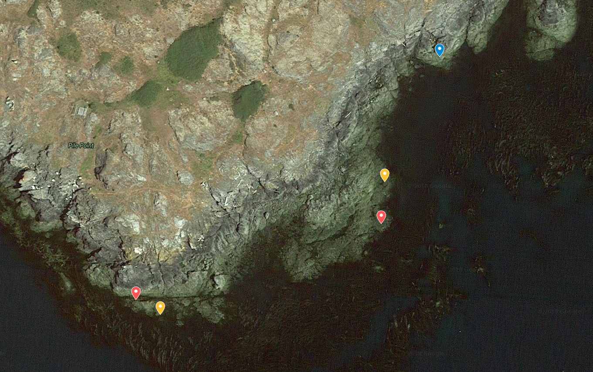

Figure 6. Locations of all experimental zones. Southwest locations are Removal and Control areas A (Red and Yellow, respectively). East-Southeast locations are Removal and Control Zones B (Red and Yellow). The northernmost location (Blue) is the site of the addition area.

Works Cited

Burnaford, J. L. (2004). Habitat modification and refuge from sublethal stress drive a marine plant–herbivore association. *Ecology*, *85*(10), 2837-2849.

Daufresne, M., Lengfellner, K., & Sommer, U. (2009). Global warming benefits the small in aquatic ecosystems. *Proceedings of the National Academy of Sciences*, *106*(31), 12788-12793.

Dethier, M. N. (1984). Disturbance and recovery in intertidal pools: maintenance of mosaic patterns. *Ecological Monographs*, *54*(1), 99-118.

Duggins, D., & Dethier, M. (1985). Experimental Studies of Herbivory and Algal Competition in a Low Intertidal Habitat. *Oecologia,* *67*(2), 183-191. Retrieved from <http://www.jstor.org/stable/4217711>

EPA. 2016. "Climate Change Indicators: Ocean Heat." Accessed August 16. https://www.epa.gov/climate-indicators/climate-change-indicators-ocean-heat

Gardner, J. L., Peters, A., Kearney, M. R., Joseph, L., & Heinsohn, R. (2011). Declining body size: a third universal response to warming?. Trends in ecology & evolution, 26(6), 285-291.

Helmuth, B., Mieszkowska, N., Moore, P., & Hawkins, S. J. (2006). Living on the edge of two changing worlds: forecasting the responses of rocky intertidal ecosystems to climate change. *Annu. Rev. Ecol. Evol. Syst.*, *37*, 373-404.

Kordas, R. L., Harley, C. D., & O'Connor, M. I. (2011). Community ecology in a warming world: the influence of temperature on interspecific interactions in marine systems. Journal of Experimental Marine Biology and Ecology, 400(1-2), 218-226.

Masakazu Hori, Intertidal surfgrass as an allochthonous resource trap from the subtidal habitat,

Marine Ecology Progress Series Vol. 314: 89-96, 2006

Murray, S. N., Weisberg, S. B., Raimondi, P. T., Ambrose, R. F., Bell, C. A., Blanchette, C. A., ... & Miner, C. M. (2016). Evaluating ecological states of rocky intertidal communities: A Best Professional Judgment exercise. *Ecological indicators*, *60*, 802-814.

Race Rocks. (2011). Sea Temperature as an Abiotic Factor at Race Rocks. Race Rocks lighthouse keepers’ assistants.

Reusch, T. B., Ehlers, A., Hämmerli, A., & Worm, B. (2005). Ecosystem recovery after climatic extremes enhanced by genotypic diversity. *Proceedings of the National Academy of Sciences of the United States of America*, *102*(8), 2826-2831.

Shelton, A. O. (2010). Temperature and community consequences of the loss of foundation species: Surfgrass (Phyllospadix spp., Hooker) in tidepools. *Journal of experimental marine biology and ecology*, *391*(1-2), 35-42.