Determining Population Change in *Pisaster ochraceus* and *Henricia­*

Jessica Stutz

FHL 470

Hilary Hayford and Robin Elahi

Key words: *Pisaster ochraceus*, *Henricia*, *Leptasterias*, Sea Star Wasting Disease, Population

Abstract

This paper seeks to identify and count sea star populations, particularly *Pisaster ochraceus* and *Henricia* spp.. In doing so, it will be compared to 1997 data of these stars population to see if there is a change. Using three 45 m transects at Lime Kiln and Land Bank, a survey was done to count any stars found. Also, the size of each star was measured from the center of the star to the end of the longest arm. There appeared to be a decreased in *Pisaster* *ochraceus* populations compared to 1997 data, however *Henricia* spp. had a decline at Lime Kiln but not at Land Bank. There were also a few other species of stars, none found in great abundance except for *Leptasterias* spp.. This information can be used to compare to other data using star counts in hope to see if there is an increase or decrease of star populations after the Sea Star Wasting Disease which greatly decreased many star populations.

Introduction:

An important role in ecological systems are keystone species, defined by Power et. al. (1996) as “… one whose effect is large, and disproportionally large relative to its abundance.” Each keystone species is unique to its specific environment and that uniqueness is dependent on factors and interactions with the variety of surrounding organisms. These essential species range from the three-toed woodpecker, all the way down to the freshwater fish, Tambaqui (Tregidgo, 2017, Pakkala, 2018). The sea star *Pisaster ochraceus* has been acknowledged as being such a species (Paine. 1966).

The relationship between *P. ochraceus* and other species is important to maintaining ecological balance and a loss of them can dramatically affect the ecosystem. *P. ochraceus* feed on an abundant population of mussels, *Mytilus* spp. and barnacles, *Balanus* spp. (Feder, 1959). When these sea stars are removed from the ecosystem, *Balanus* spp. takes over encroaching on 60-80% of the available space. Within one year, *Mytilus* spp. blooms and pushes out the *Balanus* spp. This soon leads to the disappearance of most benthic algae, and also drives out invertebrate animal species such as chitons and limpets due to the lack of space and food availability (Paine, 1966).

In recent years, sea stars have been hit with a syndrome known as Sea Star Wasting Disease. This disease has been observed in sea stars at different levels of severity, some with “… twisted arms, lesions and/or being deflated, having recently lost arms, losing their grip on the substratum or dissolving or disintegrating or melting.” (Menge et al. 2016). Originally the source of this disease was thought to be bacterial, or possibly due to a fungus (Dungan, 1982, Bates, 2009). Now this disease is believed to be caused by a single-stranded DNA virus known as Sea Star-associated Densovirus (SSaDV), nevertheless the exact origin of the disease remains a mystery (Hewson et. al, 2014). This disease will inevitably lead to death, which can negatively impact the environments that depend on species such as *P. ochraceus*. Notably, however, this is not the first case of sea star wasting. Studies have been linked back to 1978 showing a similar disease in other star species (Dungan, 1982). Nevertheless, the first case of sea star wasting was not seen in Washington State until the year 2013 (Eisenlord, 2016). With the decrease in the number of *P. ochraceus* there may be “…significant changes in population density, species composition, and overt appearance…” of surrounding ecosystems where these carnivores previously inhabited (Paine, 1969). Even mankind will soon feel the pressure of unbalanced intertidal zones, as we rely on such spaces for a variety of things such as raw materials, food, erosion control, and even tourism and recreation (Barbier et. al. 2011). Protecting these ecosystems and inhabitants are in our best interests as well.

This paper analyzes population changes of *Pisaster ochraceus* in the San Juan islands at two different locations, Lime Kiln and Land Bank. These two locations were resampled using three 45 m transects at each location and compared to populations sizes from 1997. Due to the unfortunate proliferation of Sea Star Wasting Disease, populations sizes are expected to be smaller than the originally study, presumably following the pattern of other sea star populations such as *Heliaster kubiniji* (Dungan, 1982). In addition to observing populations of these two species, other sea stars were recorded along with all the stars size measurements from the center to the end of the longest arm in cm. Analysis of Friday Harbor populations is so vital due to the ecological significance of the area. The island provides several protected areas for marine wildlife including national parks and biological preserves. In addition, information can be compared to Eisenlord et. al. (2016) data, where *P. ochraceus* populations were obtained all throughout the San Juan Islands, including a single location, Pile Point, on the west side of Friday Harbor. This will give more data on an estimated population size for *P. ochraceus* and indicate changes.

Methods:

Site Information:

This study takes place at two separate locations. Both are provided by Gopaul 1997 on the west side of Friday Harbor Island. The first is Lime Kiln located N48.30o:W123.09o and Land Bank located at N48.30o:W123.08o. Lime Kiln is more easily accessible with dirt paths and low sloping intertidal which is made up of bedrock. Land bank is just south of Lime Kiln and is less easily accessible due to large cliffs and steep bedrock intertidal zones. Due to the ambiguity of the GPS coordinates, three transects were done at each location with specific GPS coordinates at the start of each transect.

Historical Surveying Methods:

For Lime Kiln and Land Bank, the *Pisaster* survey methods are the same. Due to the fact these invertebrates tend to hide themselves in crevices and their large size, using quadrats or doing a simple visual estimation would not be a sufficient count of the population. Therefore, a time count was used. Surveying for the stars were done within an hour during which the tidal height was between 1.7 feet and 1.4 feet above the MLLW (Gopaul, 1997). Algal covering was also analyzed based on percent covered at different parts of the intertidal (Gopaul, 1997).

Contemporary Surveying Methods:

To maintain the integrity of this research assignment, methods used at the sites were replicated the same as the original paper. The author went out and did a timed survey of the stars within an hour during the tidal height between as close as possible to the original height of 1.7 feet to 1.4 feet above the MLLW. Marine flora and fauna in the different intertidal zones were not taken into account as they were in the original Gopaul study. However, specifics on how surveys were conducted is unknown. To best replicate the analysis, three 45 m transects were taken at both locations. A thorough search of two researchers were taken down the transect, at Lime Kiln, the three took approximately 45 minutes each. At Land Bank, two of the three transects took around an hour, however, due to the excess amount of seaweed covering the substrate, the third transect took roughly an hour and a half.

In addition to looking for star count abundance at the two locations, measurements of each star were also taken. For larger stars such as *P. ochraceus*, the longest arm was measured from the center of the star to the tip, rounding to the nearest cm. The same measuring procedure was followed for smaller stars such as *Henricia* spp. However, in order to obtain a more accurate measurement, the length was measured to the nearest half cm.

Results:

Abundances of Stars:

During the historical study, there were six *P. ochraceus* recorded at Lime Kiln and 13 recorded at Land Bank. The numbers found during this most recent study, shows a noticeable decrease in the number of *P. ochraceus*. This can be seen where only one was found at Lime Kiln over the three 45 m transects. Land Bank had a total of 12 *P. ochraceus* in the three 45 m transects (Figure 1).

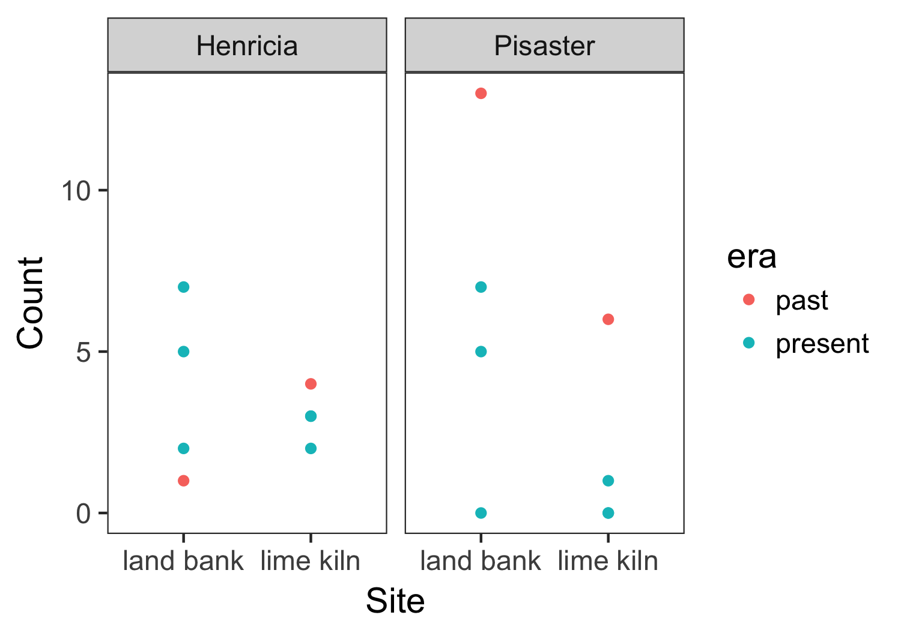

Figure 1: A graph comparing the past and present populations of *Pisaster ochraceus* and *Henricia* spp. at Lime Kiln and Land Bank

*Henricia* spp. followed a similar pattern of decreased population size like *P. ochraceus* at Lime Kiln (Figure 1). However, when it came to Land Bank, a different trend was observed in *Henricia* spp. In the historical study there was only a single *Henricia* spp. counted, yet there were seven, two, and five found in each transect respectively (Figure 1). Showing an increase in number. All together there were 22 *Henricia* spp. found at both locations.

Due to the fact there was no available information on the area covered in the historical study, densities were not calculated. Nevertheless, densities for the 2018 survey were analyzed after estimating the area covered using google earth (Table 1). This information gives us a good idea how of how infrequent each species of star was found. There was a mean density of about 0.015 per m2 for *Henricia* spp. and 0.01 for *P. ochraceus.*

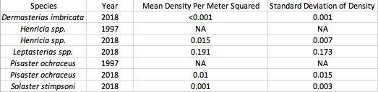

Table 1: An analysis of the mean density per meter squared and standard deviation of density for the different species of stars found at Lime Kiln and Land Bank

Size of Key Species:

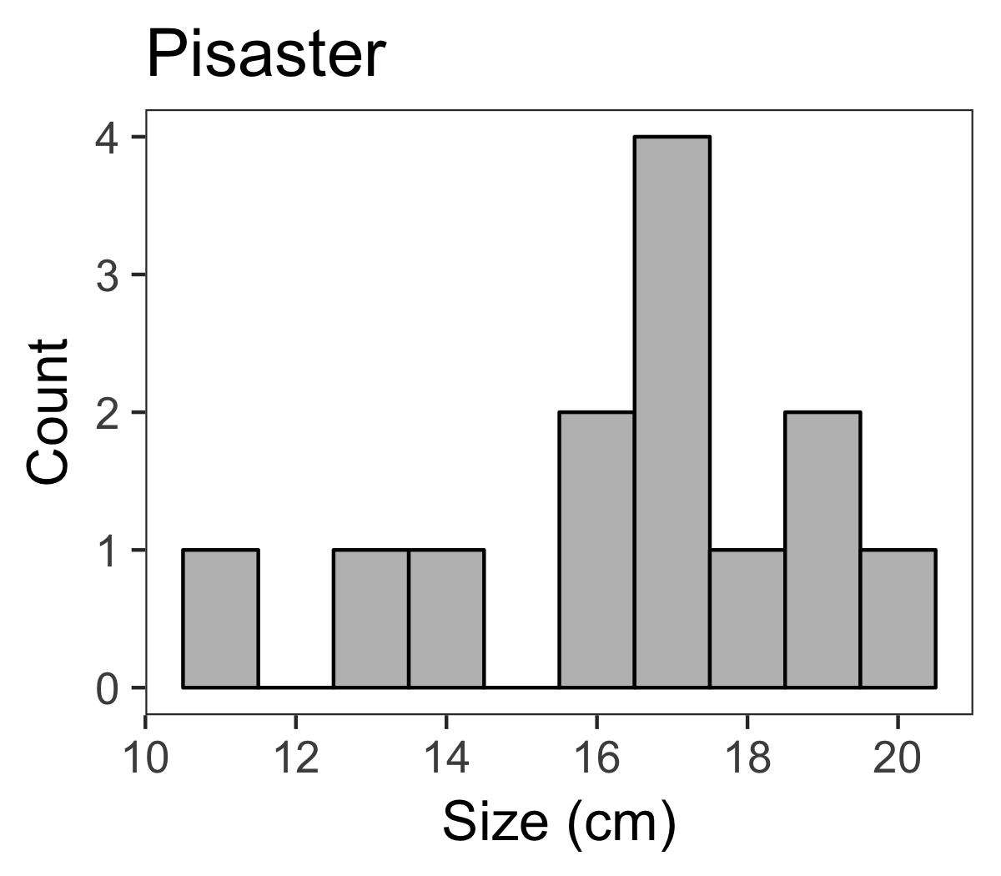In addition to doing a population count for the key species, measurements were taken from the center of the star to the tip of the longest arm. For *P. ochraceus*, the length was measured to the nearest cm. Sizes ranged from 10 cm to 20 cm, with the mode being at 17 (Figure 2). Taking into consideration the smaller size of *Henricia* spp., they were measured to the nearest half cm. They ranged in size form 1 cm to 7 cm (Figure 3). The mode for *Henricia* spp. is between one and two cm and four and five cm (Figure 3).

Figure 2: The measurements of *P. ochraceus* found at both sites in all transects with the size to the nearest cm on the x-axis and the count for each size on the y-axis.

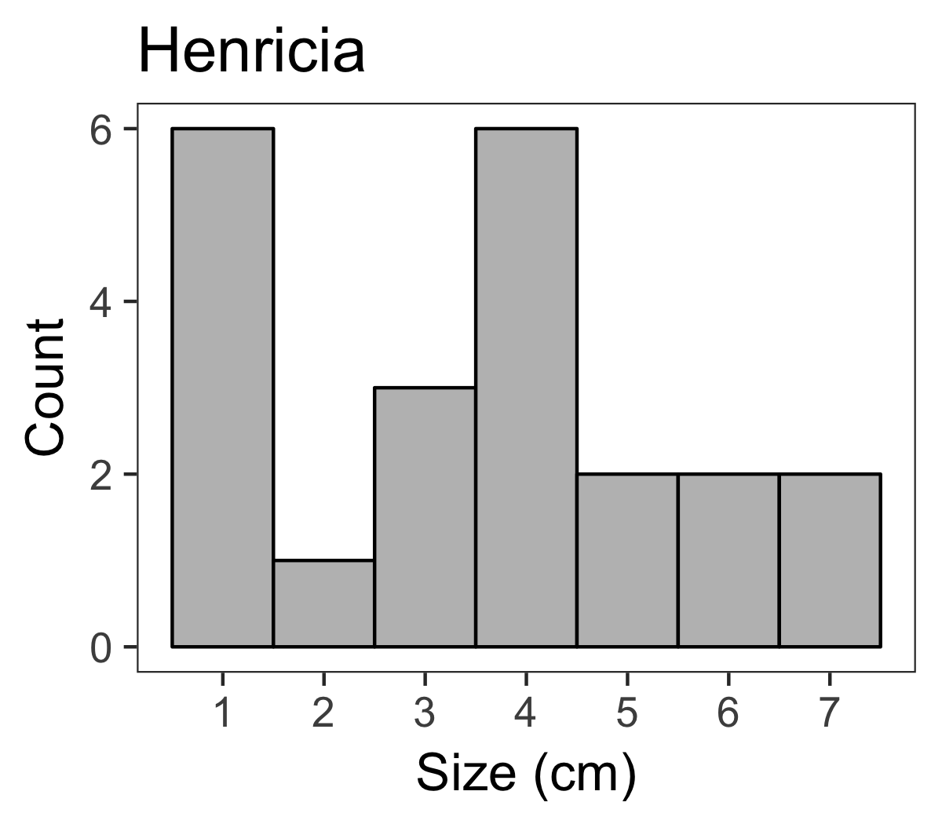

Figure 3: The measurements of *Henricia* spp. found at both sites in all transects with the size to the nearest half cm on the x-axis and the count for each size on the y-axis. Any star measured between one and two cm are found in the “1” column.

Observations of Other Star Species:

Within the two sites *Dermasterias imbricata*, *Leptasterias* spp., and *Solaster stimpsoni* were also found. Only one *D. imbricata* and one *S. stimpsoni* were found, however there were 238 *Leptasterias* spp. located within the six transects at the two locations. *Leptasterias* spp. ranged in size from 0.5 to five cm, which can be seen in Figure 4. And the mode was between two and three cm. Densities of these three species of stars were also calculated. It is worth noting that *D. imbricata* had a mean density per m2 of <0.001 which is the lowest density, comparable to the mean density per m2 of *S. stimpsoni* at 0.001. *Leptasterias* spp. had the highest density of approximately 0.191 per m2 (Table 1).

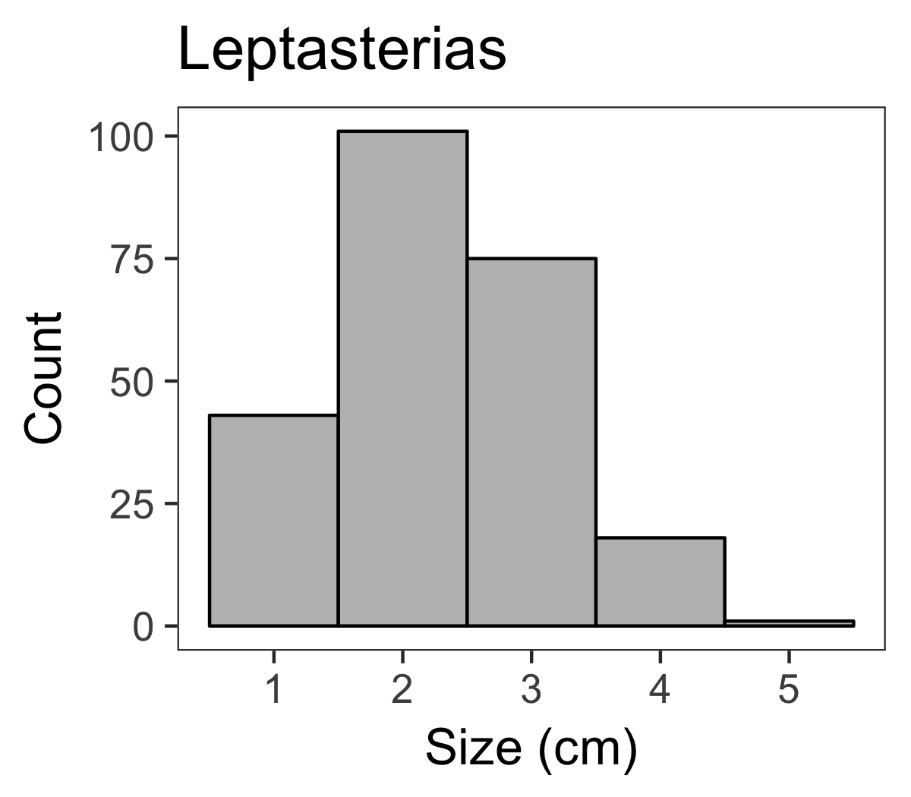

Figure 4: The measurements of *Leptasterias* spp. found at both sites in all transects with the size to the nearest half cm on the x-axis and the count for each size on the y-axis. Any star measured between one and two cm are found in the “1” column.

Discussion:

Through the course of this experiment I have found fewer *P. ochraceus* compared to the 1997 study, despite a greater sampling effort. Sea Star Wasting Disease, presumably caused by a densovirus, may have taken its toll on this specific species (Eisenlord, 2016). Yet when it comes to the sea star, *Henricia* spp., there is evidence that their populations could be increasing (Figure 1). Though it is believed that this densovirus may have more extreme effects on differing species (Bates, 2009).

It is also interesting to note the effect that *P. ochraceus* may have on surrounding organisms. During the survey of the transects, the population of mussels were opportunistically observed. There were few seen in each transect, and if there was an amount over 10, they typically were less than seven cm. Knowing the relationship between *P. ochraceus*, barnacles, and mussels, it begs the question as to how the ecosystem would further change if there continued to be a decreased size in the sea stars. Analyzing the small number of mussels, yet high populations of barnacles it may be soon enough that the mussels begin to grow in number and crowd out the barnacles which could lead to a decrease in other invertebrates (Paine, 1966).

Eisenlord et. al. (2016) observed the population of *P. ochraceus* at a large range of location including a variety throughout the San Juan Islands. In general, they also noticed a decrease in the star numbers. It is interesting to note that they compared data from 2014 to 2015, just a simple year difference, yet there was obviously a considerably decrease in the stars. The study repeated in this paper is based off a 1997 study, and the analysis of the two studies for their populations follow a similar trend (Eisenlord 2016).

Summary:

As current analysis shows, there has been a noticeable decrease in the population size of multiple sea stars, including the keystone species, *Pisaster ochraceus*. This is possible attributed to Sea Star Wasting Disease, yet there are still many unknowns. Such things as what could make a species of sea star more susceptible or resistant to this disease is an interesting aspect to look into. Also, more work on how much, if any, does temperature, pH, and salinity affect the development of the disease. Studies have shown a change in the rate of the disease based on salinity and temperature, but more analysis is needed (Bates, 2009). Also, looking into how the disease affects juveniles versus adults could have an impact on the future population of stars as well (Eisenlord, 2016). *Pisaster ochraceus*, and many other stars in surround communities are key to the healthy survival of an ecosystem and an effort needs to be made to ensure their existence.

Acknowledgements:

I wish to thank the Mary Gates Endowment Scholarship for providing support in funding this research project, my professors for all their wealth of knowledge and my classmates for helping me through all the long nights of studying.

References

Barbier E. et. al. (2011). The Value of Estuarine and Coastal Ecosystem Services. *Ecological Monographs.*, 81(2), 169-193

Bates, A. (2009). Effects of Temperature, Season and Locality on Wasting Disease in the Keystone Predatory Sea Star *Pisaster ochraceus*. *Diseases of Aquatic Organisms*., 86(3), 245-251.

Dungan, M. (1982). Catastrophic Decline of a Top Carnivore in the Gulf of California Rocky Intertidal Zone. *Science*., 216(4549), 989-991

Eisenlord, M. (2016). Ochre Star Mortality During the 2014 Wasting Disease Epizootic: Role of Population Size Structure and Temperature. *Philosophical Transactions of the Royal Society of London*., 371(1689)

Feder, H. (1959). The Food of the Starfish, *Pisaster ochraceus*, Along the California Coast. *Ecology*., 40(4), 720-724.

Gopaul, P., (1997) An Ecological Study of the Effects of Human Disturbance in the Intertidal at Three Sites on San Juan Island. Unpublished.

Hewson, I. (2014). Densovirus Associated with Sea-Star Wasting Disease and Mass Mortality. *Proceedings of the National Academy of Sciences of the United States of America*., 111(48, 17278-17283.

Menge, B. (2016). Sea Star Wasting Disease in the Keystone Predator *Pisaster ochraceus* in Oregon: Insights into Differential Population Impacts, Recovery, Predation Rate, and Temperature Effects from Long-Term Research. *PloS One.,* *11*(5), PloS one., 2016, Vol.11(5).

Paine, R. (1966). Food Web Complexity and Species Diversity. *The American Naturalist*., 100(910), 65.

Paine, R. (1969). A Note on Trophic Complexity and Community Stability. *The American Naturalist.*, 103(929), 91-93

Pakkala, T. (2018). Three-toed Woodpecker Cavities in Trees: A Keystone Structural Feature in Forests Shows Decadal Persistence but Only Short-Term Benefit for Secondary Cavity- Breeders. *Forest Ecology and Management*, 413, 70-75.

Power, M. E. et. al. (1969) Challenges in the Quest for Keystones. *Bioscience*. 46(8), 609-620.

Tregidgo, D. (2017). Rainforest Metropolis Casts 1,000-km Defaunation Shadow. *Proceedings of the National Academy of Sciences of the United States of America*., 114(32), 8655- 8659