**Ecological Survey of Intertidal Mollusks, Algae and their Community Interactions**

Kia Sutter

FHL 470

Spring 2018

Contact information: Kia Sutter

University of Washington Department of Biology

kias@uw.edu

Keywords: *Katharina tunicata*, chiton, limpet, *Saccharina sessilis*, algae, rocky intertidal, ecology, historical survey, community interactions

**Abstract**

The purpose of this study was to examine how the intertidal community dynamics and abundance has changed over time at Pile Point on San Juan Island, WA, and to ask if anthropogenic effects could explain the changes seen. Specifically we were looking at the leathery chiton, *Katharina tunicata,* and limpets. We wanted to know if rising temperatures have caused a shift towards smaller *Katharina* body sizes, and if the grazer ratio between *Katharina* and limpets has become skewed to favor the smaller animals (limpets). We performed an ecological resurvey using quadrats to estimate percent cover of algal species and *Phyllospadix*, count limpets, and *Katharina* and measure *Katharina* body lengths. Data was analyzed using R. We found that chiton body lengths have stayed consistent over the years surveyed. Algal coverage has also stayed consistent, but there has been an increase in *Phyllospadix*. *Katharina* to limpet density ratios have stayed pretty constant across all areas except one. *Katharina* abundance has decreased in all areas except one and limpet abundances varied in their changes across areas. While we did not have conclusive evidence of population shifts due to hotter temperatures, the intertidal is a key place to monitor for changes related to global warming.

**Introduction**

With the continued rise of global warming and climate change, ecosystems around the world are facing unprecedented challenges (Sagarin *et al*., 1999). As these trends of increased temperature, sea level rise, and ocean acidification show no sign of stopping (IPCC 2001), understanding how these changes will affect ecosystems is at the forefront of ecological conservation (Parmesan & Galbraith 2004). Comparing historical data with modern ecological studies can give insight into the changes that have occurred in these ecosystems over time, and potentially give insight into how these communities may change as the climate continues to shift (Hawkins *et al*., 2015). Increased temperature is one of the most dire of these changes, as elevated temperatures directly affect a myriad of physiological processes (Hochachka & Somero 2002).

As temperatures rise, studies show that the third universal response to global warming is decreased body size (Gardner *et al*., 2011). Species are not only shifting towards overall smaller body sizes but their size at age is decreasing, and populations are experiencing population age structure changes, shifting towards higher proportions of juveniles to adults (Daufresne *et al*., 2009). Community assemblages are also changing as populations of smaller individuals are favored over populations of larger organisms (Daufresne *et al*., 2009). As ocean temperatures and levels rise and the oceans become more acidic, anthropogenic changes are likely to be felt by ecologically important intertidal zones (Sorte *et al*., 2017).

Intertidal ecosystems are some of the most studied biological zones (Paine 1994), and are valuable models for climate change as they span both terrestrial and marine environments (Helmuth *et al*., 2006). With the daily ebb and flood of tides, intertidal organisms must contend with stressors such as desiccation, temperature fluctuations, and predators, along with the inevitable dangers of being in wave exposed habitats (Connell 1972). As a result of these stressors, a distinct zonation arises (Hochachka & Somero 2002) as the ability of the organisms to handle stress changes up the intertidal. These zones are shaped further by complex interactions between the species within these zones (Menge & Sutherland 1976).

Within intertidal ecosystems, there are ecosystem engineers that have profound effects on the community composition (Jenkins *et al*., 1999; Sorte *et al.,* 2017). In the rocky intertidal of San Juan Island, the chiton *Katharina tunicata* acts as this engineer, directly shaping the algal assemblage and indirectly allowing limpet populations to thrive through habitat maintenance (Duggins & Dethier 1985). *Katharina* are generalist herbivores, eating both macroalgae and their sporelings (Duggins & Dethier 1985). The chitons depend on the brown alga *Saccharina sessilis* for shade protection (Burnaford 2004) and keep the populations of these large browns in check through their unique radulae that allow them to be such broad generalists (Steneck & Watling 1984). Limpets are generally much smaller than *Katharina* and have diets that are constricted to microalgae (Nicotri 1977). The limpets depend on the chitons to keep the macroalgal populations in check so that there continues to be available rocky habitat (Duggins and Dethier 1985). *Katharina* is a hardy species that shows high resistance to decreased ocean pH (Sigwart *et al*., 2015) but so far their response to increasing ocean temperatures has not been studied.

This ecological survey of the rocky intertidal occurs in an area that has been relatively untouched by direct human activities. This area was studied in 1985 by David Duggins and Megan Dethier; they performed an experimental study but censused the area before any manipulations were made. This census provides us with ample historical data on the abundance of *Katharina*, limpets and macroalgae, and *Katharina* sizes. The relative seclusion of Pile Point along with the available historical data allows for a unique opportunity to study the more indirect anthropogenic effects as described earlier. We will be comparing our data to the historical data to see if *Katharina* body sizes have decreased, and if the proportion of small organisms (limpets) has increased in relation to large bodied organisms (chitons), and how algae, chiton and limpet abundances have changed over time.

**Methods**

**Study site**

This study was performed at the highly wave exposed location of Pile Point On San Juan Island in Washington State (48.482828, -123.088682). The algal community is composed of the macroalgae *Saccharina sessilis*, *Corallina vancouvereinsis, Bossiella plumosa, Polysiphonia* spp., *Microcladia borealis* and other assorted erect algae (Duggins and Dethier 1985). There are also encrusting corallines and non-coralline crusts. The most abundant animals are *Katharina tunicata* and the limpets, *Acmaea mitra*, *Notacmea scutum*, *Lottia pelta*, and *Lottia strigatella*, hereafter referred to collectively as limpets.

**Historical procedure**

We will be comparing our contemporary data with census data from an experimental study. As our study is solely an ecological survey and is not experimental, the methods described here from the 1984 study will be of the censusing aspects and will not describe the manipulations performed.

The pre-study census was performed in 1979. Five areas of about 25 m2 were established, labeled Removal A and B, Control A and B, and Addition. Dethier and Duggins set up 8-10 permanent quadrats within each area, ranging from +0.5m MLLW to -0.5 MLLW. There were 4-5 quadrats from 0 to +0.5 MLLW and 4-5 quadrats from 0 to -0.5 MLLW. Quadrats were laid haphazardly but features such as tide pools and cracks were generally avoided.

The abundance survey included primary space cover which consists of crusts and holdfasts of erect species, and canopy cover which consists of all erect algae. The herbivores (chitons and limpets) were counted within the quadrats and chiton lengths were measured.

**Contemporary procedure**

In this ecological survey, the same areas were used as those censused in the previous study, with the exception of the addition area which was not re-censused. The gps coordinates of the areas are as follows: Removal A (RA): 48.48169, -123.09373, Removal B (RB): 48.48217, -123.09220, Control A (CA): 48.48163, -123.09358, Control B (CB): 48.48200, -123.09222, Addition: 48.48268, -123.09186. The exact locations of the previous quadrats were unknown so quadrats were randomly placed to avoid bias. Two transects were laid in each area, roughly dividing the areas into thirds. Using random number generation, quadrats were placed between -0.5 to +0.5 relative to MLLW. To place the quadrats, numbers were generated to determine how far along the quadrat to go. A second set of randomly generated numbers dictated how far from the transect the quadrat would be placed. A coin toss determined the direction (right or left) deviated from the transect. Quadrats used were 0.1 m2. We estimated the abundances of algae, chitons and limpets. Percent cover was estimated for crustose algae and erect, canopy forming algae. Four types of limpets were counted, *Acmaea mitra*, *Notacmea scutum*, *Lottia pelta*, and *Lottia strigatella*. *Katharina tunicata* were counted and measured to the nearest mm.

*Katharina* body sizes were also resurveyed in RA and CB, with measurements taken to the nearest cm.

The data was analyzed using Rstudio. Summary statistics were calculated using Rstudio with the packages “tidyverse” and “ggplot2” and the libraries “dplyr”, “tidyr” and “tidyverse”. We created visual representations of the data to show how proportional frequencies of size, densities, and algal abundance have changed over time. Boxplots show the median, the interquartile range (IQR) and the whiskers represent 1.5 times the IQR. Potential outliers lay beyond the whiskers.

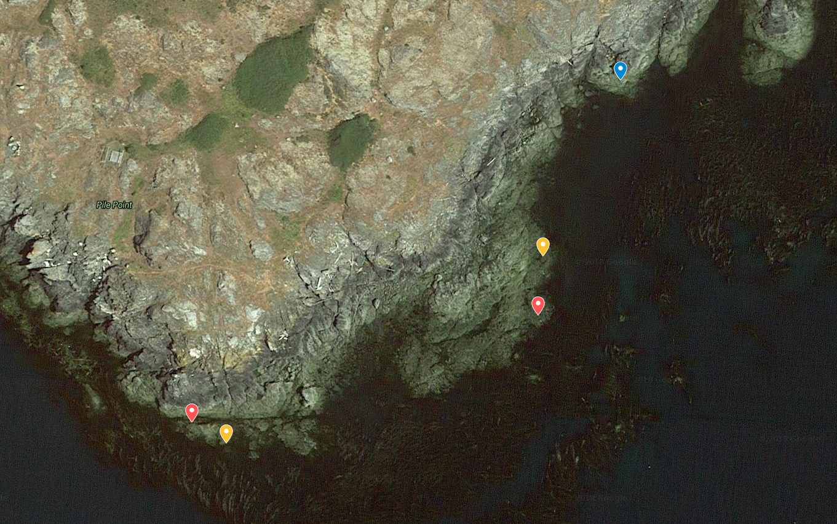

Map 1. Locations of all experimental zones. Southwest locations are Removal and

Control areas A (Red and Yellow, respectively). East-Southeast locations are Removal and

Control Zones B (Red and Yellow). The northernmost location (Blue) is the site of the addition

Area. Coordinates can be found in Methods section.

**Results**

Figure 1

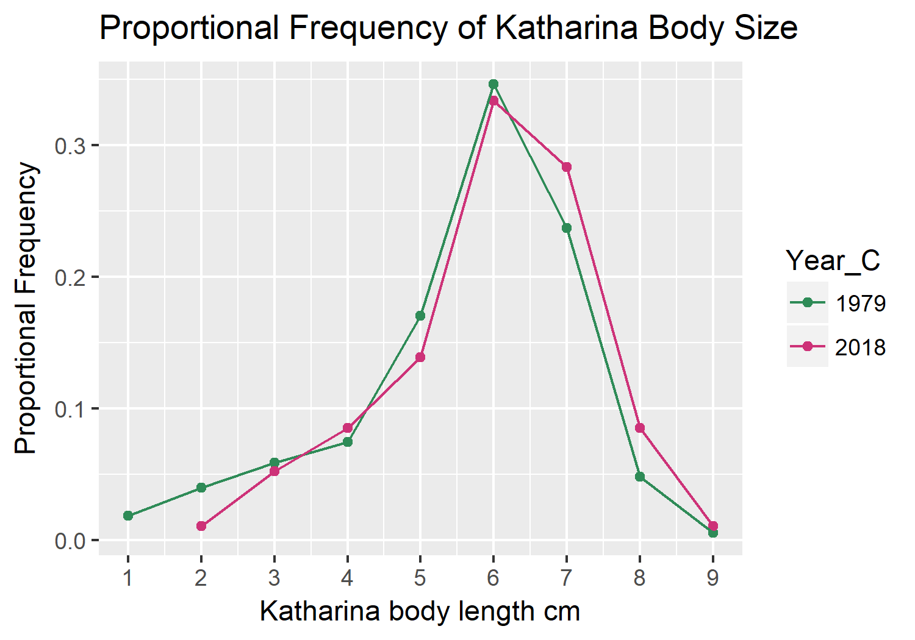

Figure 1. Proportional frequency of *Katharina* body size. 375 and 575 *Katharina* were sampled in 1979 and 2018 respectively. Each year surveyed is plotted in different colors. X-axis represents the length in centimeters of the *Katharina* sampled. Y-axis represents the proportional frequency of the sizes of *Katharina* across all areas surveyed.

*Katharina* Body size

We plotted the proportional frequency of *Katharina* body sizes, by finding the frequency of each body size across all areas and then dividing it by the total number of *Katharina* sampled (Fig. 1). We plotted this relationship for both 1979 and 2018 and found that the size trend is generally the same. There are very few *Katharina* smaller than 2.5 cm and the highest frequency lies around 6 cm, with the frequency tapering off again with body sizes larger than 7 cm. The largest *Katharina* measured was 9 cm in both years, occuring at a very low frequency.

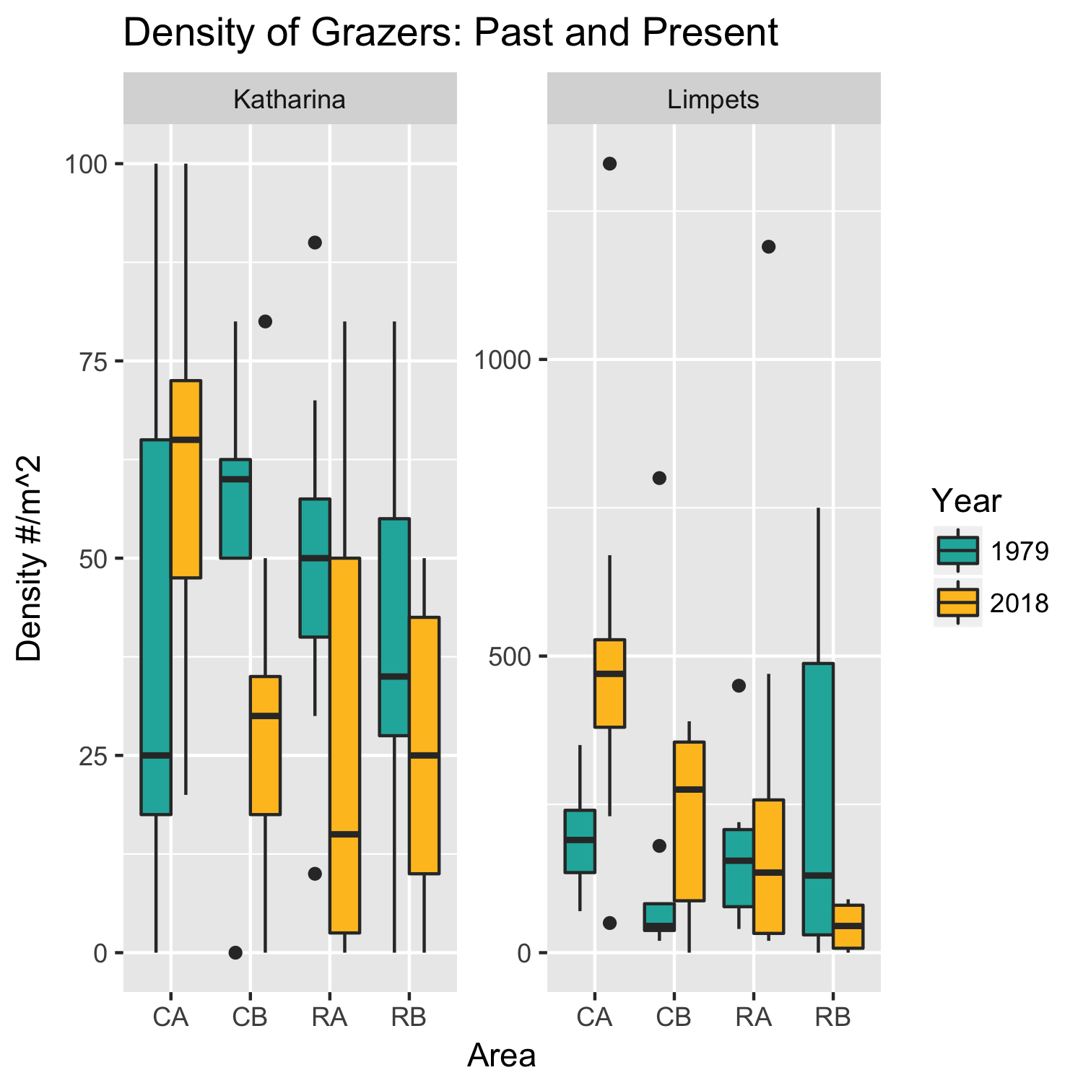

Figure 2

Boxplot of grazer density per meter squared per area. X-axis shows the area, y-axis shows density per meter squared. Years are shown in separate colors and grazer populations depicted on separate graphs.

Grazer Density

We found the density per meter squared for both *Katharina* and Limpets in each of the areas, CA, CB, RA, and RB. We plotted these values for the two years surveyed and found that for *Katharina*, the median density decreased in areas CB, RA, and RB, and increased in area CA, although the variation in density across the quadrats sampled decreased in area CA (Fig 2). The variation increased in RA although the median decreased. In CB, the variation is similar but the overall density has decreased greatly. For limpets, in CA and CB, the median and the variation increased. In RA, the median decreased slightly and the variation increased slightly. In RB, the variation decreased greatly and the median decreased slightly as well.

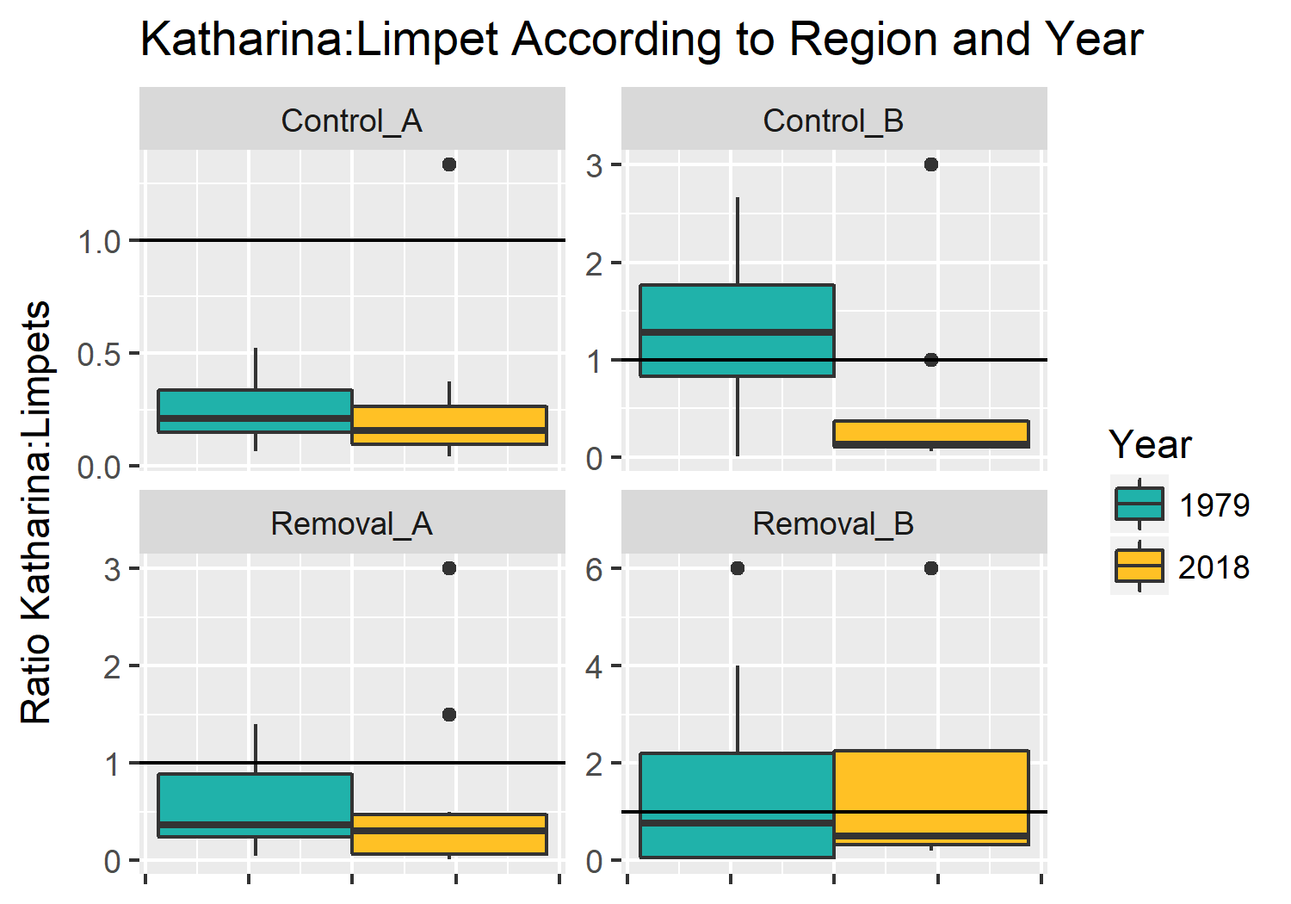

Figure 3

Boxplot ratio of *Katharina* to limpets by area. Years are separated by color. Y-axis is the ratio of *Katharina* to limpets. X-axis is scaled to 1.5 for visualization of the data.

In approaching our question of whether the ratio of small bodied grazers has increased in relation to larger bodied grazers, we found the density ratio of *Katharina* to limpets in each area and compared between years (Figure 3). In CA, for both years, there are fewer *Katharina* than limpets, the variation in density across quadrats is similar and the median density ratio has decreased. In CB in 1979, there were more *Katharina* than limpets, in 2018 there were more limpets than *Katharina*. In RA, both years had a higher density ratio of limpets than *Katharina* and in RB there were more *Katharina* than limpets.

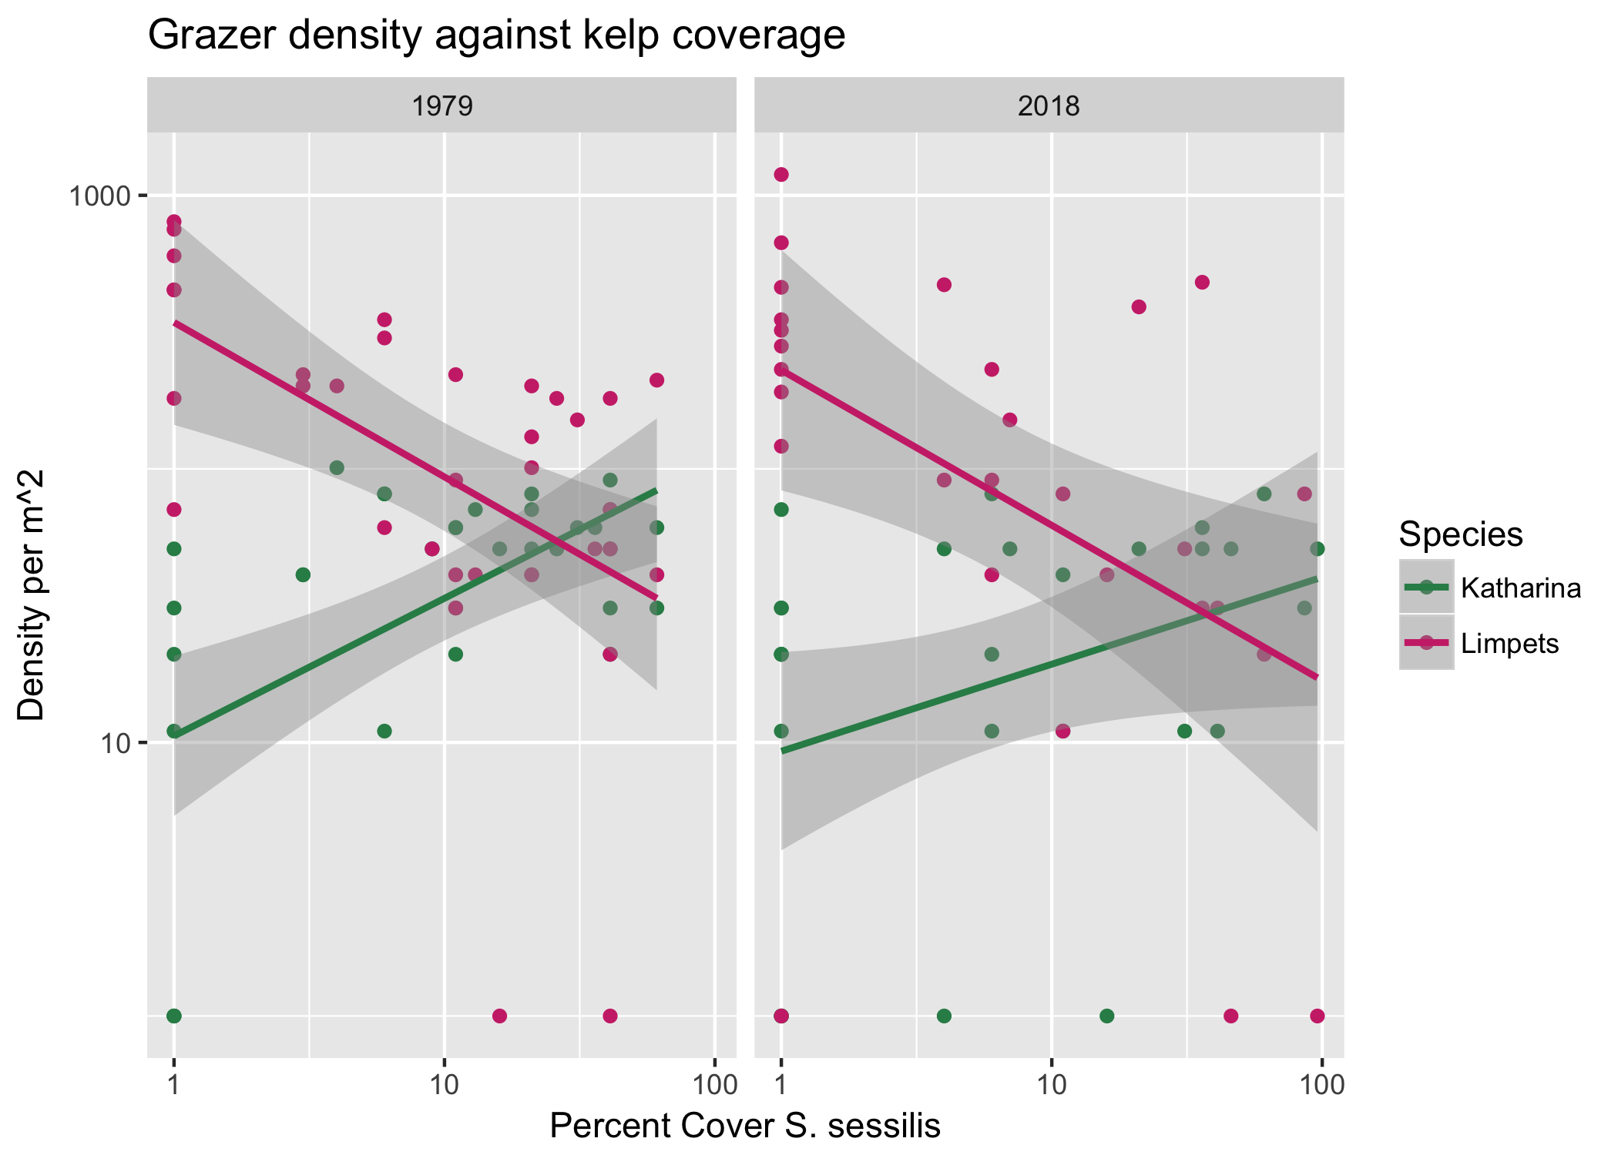

Figure 4. Grazer density vs kelp coverage. Species are colored separately. X-axis represents percent cover of *Saccharina* *sessilis*. Y-axis represents grazer density per meter squared.

Kelp coverage and grazer density

We wanted to know how *Saccharina* coverage affected the density of *Katharina* and limpets, so we plotted the density per meter squared *Saccharina* percent cover and found that as *Saccharina* coverage increased, *Katharina* density increased and limpet density decreased. These findings were consistant across both years.

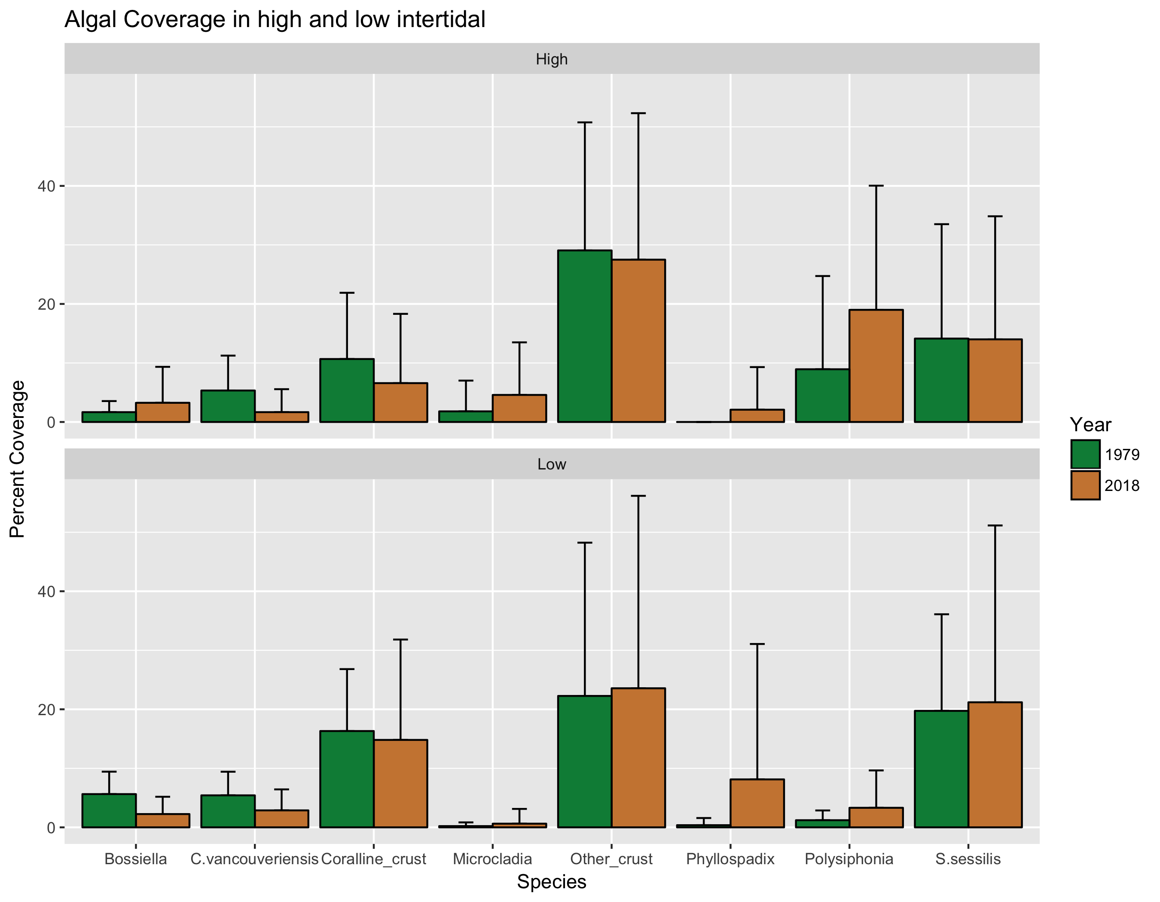

Figure 5. Algal abundance at Pile Point separated by upper and lower quadrats. Upper is defined by above 0 MLLW and lower by below 0 MLLW. Columns are separated by species and color coded by year. Y-axis shows percent cover of each algal species.

Algal abundance

Across the algal species surveyed, the abundances have stayed relatively constant from 1979 to 2018, with the exception of *Phyllospadix* *scouleri* and *Polysiphonia spp*. When Dethier and Duggins surveyed the area in 1979, there was almost no *Phyllospadix*, in the modern survey we found that the lower reaches (below 0 MLLW) were covered in the seagrass. In both the upper and lower zones, *Saccharina* have the same percent coverage across the years surveyed.

**Discussion**

As global warming causes changes in ecosystems around the world, we expected to see some of these changes in the ecosystem of Pile Point. As the general trend is towards a warming climate and sea, we expected to see decreased body sizes, an increased ratio of limpets to *Katharina* and increased algal coverage. Instead, we found that Pile Point seems to be a unique intertidal oasis.

When comparing the body sizes of *Katharina* between 1979 and 2018, we found that the proportional frequency of sizes has stayed constant across the areas sampled. When looking at the air and temperature data from the San Juan Island area across the timescale of these two surveys, there has not been a significant temperature increase (NOAA). This suggests that although declining body size is a universal trend in the face of global warming (Gardner *et al.* 2011), this particular area is not yet experiencing this phenomenon.

The most abundant grazers in the intertidal zone of Pile Point, *Katharina* and limpets, are involved in an indirect commensalism with the limpets relying on the *Katharina* to keep areas of the rocky substrate clear from macroalgae (Duggins and Dethier 1985). We looked at the median ratio of *Katharina* to limpets across the areas, and found that the median ratios have decreased only slightly in all areas except for CB. In CB in 1979, there was a higher ratio of *Katharina* to limpets and now that relationship has flipped where there are more limpets than *Katharina* and the median ratio has decreased greatly. Although this is the trend we expected to see across all sites, it would appear that in general the overall ratio of grazers has stayed relatively consistant. We hypothesized that the ratio would become skewed in favor of the limpets, but again the lack of significant temperature changes and the relative seclusion of the site seem to be allowing the communities to maintain the status quo. We also looked at the densities of these grazer populations. In all areas but one, the median density of *Katharina* has decreased. This is surprising since *Saccharina* abundance has stayed constant, and the chiton depends on the kelp for protection from desiccation (Burnaford 2004). Limpet densities increased in two areas and slightly decreased in the other two.

While analyzing our data and pondering the complex interactions between species populations in the communities, we thought an interesting relationship to examine would be that between the grazers and *Saccharina*. We found that as the percent cover of the kelp increases, the density of limpets decreases and the density of *Katharina* increases. This trend was the same for both 1979 and 2018. As stated earlier, this relationship may be explained by the fact that the chitons rely heavily on *Saccharina* for shade protection whereas limpets cannot navigate areas heavily populated by kelp and also rely on microalgae as a food source (Burnaford 2004, Nicotri 1977) which may get outcompeted by the macroalgae.

Algal abundances have stayed relatively constant, with the few differences not being statistically significant, other than *Phyllospadix*. *Phyllospadix* was virtually nonexistant when the area was censused in 1979 (Dethier field data notebook 1979). *Phyllospadix* was very abundant in the contemporary survey. This may help explain how some of the other areas have not changed either, as *Phyllospadix* has been shown to buffer water temperature changes in intertidal zones (Shelton 2010).

At the time of this resurvey, the ecosystem at Pile Point seems to be a stable intertidal community. The area is protected from direct anthropogenic effects because it is located on private property and is not easily accessible. Indirect effects such as temperature (both air and water), ocean acidification and sea level rise have either not progressed to the point where significant changes are visible, or are being buffered by the community assemblage and interspecific interactions. It has been shown that intertidal communities with healthy herbivore populations are more resilient and capable of resisting the effects of warming (Kordas, Donehue and Harley 2017). Although we did not observe a high level of change, *Katharina* densities have decreased slightly which may signal the start of the cascade of changes. With decreased *Katharina* densities, *Saccharina* could grow more prolifically which could lead to altered states in the algal and limpet communities (Barner *et al.* 2015). *Katharina* feeding behavior may also shift as temperatures increase, as it has been shown that herbivores modify their feeding habits to reduce their heat exposure and stress during low tides (Hayford 2015).

For greater understanding on how this community may transform as the effects of global warming become more pronounced, a long term study at the site is necessary. The available temperature data are yearly averages, so more consistant air and water temperature measurements are necessary, along with pH measurements. A longer study period will also allow a better understanding of the effects of stressors as they develop and how they contribute to community interactions across the reproductive and developmental stages of these intertidal organisms.

**Acknowledgments**

I would like to thank the many people whose generous contributions, both intellectually and financially made this research project possible. A huge thank you to Megan Dethier and David Duggins for providing such an interesting study to resurvey, for their help sleuthing out the exact study areas, and for providing us with the raw data from their census. Thanks to Robin Elahi for guiding us to answers to our endless questions of “but how?”, imparting valuable knowledge on the rocky intertidal, how to conduct research and of course, for turning us into RockstaRs. Thank you to Hilary Hayford for all the valuable knowledge, feedback, and guidance. Thanks to Tom Mumford for algae ID and field pictures. Thanks to the Ragens, who so generously allowed us to access their beautiful property. Thanks to the Mary Gates Endowment for providing the means for me to take part in this program. And last but not least, thanks to my wonderful team Chloe May and Henry Steinhebel. Without you guys I probably would have been washed out to sea. Or Vancouver Island.

**References**

Barner, A. K., Hacker, S. D., Menge, B. A. & Nielsen, K. J. The complex net effect of reciprocal interactions and recruitment facilitation maintains an intertidal kelp community. *Journal of Ecology***104,**33–43 (2015).

Burnaford, J. L. Habitat Modification And Refuge From Sublethal Stress Drive A Marine Plant–Herbivore Association. *Ecology* 85, 2837–2849 (2004).

Connell, J. H. Community Interactions on Marine Rocky Intertidal Shores. *Annual Review of Ecology and Systematics* **3,** 169–192 (1972).

Daufresne, M., Langfellner, K. & Sommer, U. Global warming benefits the small in aquatic ecosystems. Proceedings of the National Academy of Sciences of the United States of America 106, 12788–12793 (2009).

Duggins, D. O. & Dethier, M. N. Experimental studies of herbivory and algal competition in a low intertidal habitat. *Oecologia* 67, 183–191 (1985).

Gardner, J. L., Peters, A., Kearney, M. R., Joseph, L. & Heinsohn, R. Declining body size: a third universal response to warming? *Trends in Ecology & Evolution* 26, 285–291 (2011).

Hawkins, S. J. *et al.* Looking backwards to look forwards: the role of natural history in temperate reef ecology. *Marine and Freshwater Research* 67, 1 (2016).

Hayford, H., Gilman, S. & Carrington, E. Foraging behavior minimizes heat exposure in a complex thermal landscape. *Marine Ecology Progress Series* **518,**165–175 (2015).

Helmuth, B., Mieszkowska, N., Moore, P. & Hawkins, S. J. Living on the Edge of Two Changing Worlds: Forecasting the Responses of Rocky Intertidal Ecosystems to Climate Change. *Annual Review of Ecology, Evolution, and Systematics* **37,** 373–404 (2006).

Hochachka, P. W. & Somero, G. N. Biochemical Adaptation: Mechanism and Process in Physiological Evolution. *Oxford Univ. Press* (2002)

IPCC, 2001: Climate Change 2001: The Scientific Basis. Contribution of Working Group I to the Third Assessment Report of the Intergovernmental Panel on Climate Change [Houghton, J.T., Y. Ding, D.J. Griggs, M. Noguer, P.J. van der Linden, X. Dai, K. Maskell, and C.A. Johnson (eds.)]. Cambridge University Press, Cambridge, United Kingdom and New York, NY, USA, 881pp

Jenkins, S. R., Hawkins, S. J. & Norton, T. A. Interaction between a fucoid canopy and limpet grazing in structuring a low shore intertidal community. *Journal of Experimental Marine Biology and Ecology* 233, 41–63 (1999).

Kordas, R. L., Donohue, I. & Harley, C. D. G. Herbivory enables marine communities to resist warming. *Science Advances***3,**(2017).

Menge, B. A. & Sutherland, J. P. Species Diversity Gradients: Synthesis of the Roles of Predation, Competition, and Temporal Heterogeneity. *The American Naturalist* **110,** 351–369 (1976).

Nicotri, M. E. Grazing Effects of Four Marine Intertidal Herbivores on the Microflora. *Ecology* 58,1020–1032 (1977).

Paine RT. Marine Rocky Shores and Community Ecology: An Experimentalist's Perspective. *Oldendorf/Luhe, Germany: Ecology (*1994)

Parmesan, C. & Galbraith, H. Observed Impacts of global climate change in the U.S. *Pew Center on Global Climate Change* (2004).

Sagarin, R. D., Barry, J. P., Gilman, S. E. & Baxter, C. H. Climate-Related Change in an Intertidal Community over Short and Long Time Scales. *Ecological Monographs* **69,** 465 (1999)

Shelton, A. O. Temperature and community consequences of the loss of foundation species: Surfgrass (Phyllospadix spp., Hooker) in tidepools. *Journal of Experimental Marine Biology and Ecology***391,**35–42 (2010).

Sigwart, J. D., Green, P. A. & Crofts, S. B. Functional morphology in chitons (Mollusca, Polyplacophora): influences of environment and ocean acidification. *Marine Biology* 162, 2257–2264 (2015).

Sorte, C. J. B. *et al.* Long-term declines in an intertidal foundation species parallel shifts in community composition. *Global Change Biology* 23, 341–352 (2016).

Steneck, R. S. & Watling, L. Feeding capabilities and limitation of herbivorous molluscs: A functional group approach. *Marine Biology* 68, 299–319 (1982).