**A Comparison of the Historical and Contemporary Population Densities of Barnacle and Crab Populations Within the Intertidal of Deadman’s Bay, San Juan Island**

Cormac Toler-Scott

Research in Marine Biology

Spring 2018

Contact Information:

Cormac Toler-Scott

University of Washington

9015 24th Ave SW

Seattle, WA 98106

[Cts26@uw.edu](mailto:Cts26@uw.edu)

*Keywords: Balanus glandula, Semibalanus cariosus, Hemigrapsus nudus, Pugettia gracilis*

Abstract:

The intertidal is a diverse and tightly knit ecosystem that challenges its marine inhabitants with fluctuations in water level, temperature, and species interaction. Intertidal crustaceans are able to withstand this variability with the use of morphological and behavioral adaptations e.g. a calcified chitinous exoskeleton which can withstand great chemical and mechanical stress. Globally aerial temperatures have increased since the industrial revolution of the 1700s. It is unclear how many intertidal crustaceans will respond to this shift in climate. Here we compare the population densities of five crustaceans at Deadman Bay in 1973 to 2018, by repeating a species composition survey performed by Dwinell et al. We found that there was an increase in the population densities of *Balanus glandula*, *Semibalanus cariosus*, and *Pagarus spp*, and a decrease in the densities of *Hemigrapsus nudus* and *Pugettia gracilis* over the 45-year span between surveys. This data suggests that the morphological adaptations of both barnacle and hermit crab may allow them to withstand temperature shifts to a greater extent than both *Hemigrapsus* and *Pugettia*. Our results demonstrate the variety of responses that can occur within the crustacea subphylum when aerial temperatures increase over time. We anticipate our study will provide a baseline for further ecological surveys within the intertidal of Deadman Bay, which will continue to provide insight into the effects of climate change on such a unique ecosystem.

Introduction:

Increased greenhouse gases, mainly carbon dioxide (CO2) and methane trapped within Earth’s atmosphere, are responsible for an average increase of 0.9 degrees Celsiusin the earth’s surface temperature (Manabe & Wetherald, 1967, https://climate.nasa.gov/vital-signs/global-temperature/). Recently, CO2 in the atmosphere reached a level originally described as the tipping point for climate change, 400 ppm (Betts et al., 2016**)**. There are serious ecological implications for such a shift in the atmosphere’s chemical makeup. Both direct and indirect effects can be seen in many terrestrial and marine ecosystems, and the complex communities within them. While individuals may respond negatively to temperature on a physiological level, community dynamics can also become altered. For instance, many foundation species have been shown to negatively respond to increased air temperatures, putting strain on other species within this community who interact with or feed upon them (Dayton, 1972, Sorte et. al, 2016). The decrease or increase of a single species within a community can have unforeseen effects on the balance of an ecosystem (Paine, 1966). While it may seem that air temperature would only effect terrestrial ecosystems, the ocean responds equally, if not even more so, to such a shift. Ocean acidification, the dissolving of atmospheric CO2 in the ocean’s waters, not only acidifies waters by releasing hydrogen ions into the ocean, but also inhibits the calcification process used by many marine invertebrates to form shells by removing bicarbonate ions from the seawater. Further, coastal ecosystems represent an even more vulnerable collection of organisms, those that are caught between land and ocean feel the brunt of this shift in the temperature equilibrium.

The ocean is home to a great deal of diverse ecosystems, each housing their own unique biotic communities and abiotic features. The intertidal, an extremely harsh ocean ecosystem, consists of abrasive and unyielding waves, variable temperature and water levels, and highly dense communities of organisms rich with competitive and predatory interaction (Tomanek, 2002). Temperature is a determinate factor in the location of fauna within the intertidal (Wethey, 1986). Invertebrates able to withstand higher temperatures and therefore greater levels of desiccation are able to colonize areas higher on shore, which are exposed to air temperatures for a longer period of time. Those that cannot withstand such temperatures are present near the low tide level, where the length of exposure is greatly decreased. This phenomenon is known as zonation, and it allows marine organisms to function in an ever-shifting habitat by specializing biological functions to a small threshold of temperature change (Connell, 1961a & 1961b). Because of this intertidal specialization, the thermal niche width of a particular species can be incredibly small in range. Stillman & Somero (1996) found that intertidal porcelain crabs, *Petrolisthes sp.*, were within 1-2° C of maximum ambient temperatures, suggesting that this crustacean’s physiological limits were very close to the temperatures that it experienced in natural conditions. In order to maintain such a small thermal niche, vertical movement within and between these zones is needed throughout the tidal cycle (Tomanek & Helmuth, 2002*)*.

Crustaceans are a large and diverse subphylum within Arthropoda. They are prevalent in nearly every marine ecosystem in the world, adept in many extreme environments. A significant part of the intertidal food chain, crustaceans act as herbivores, carnivores, and primary nutrients for many organisms. While crustaceans are remarkably resistant to short term chemical and mechanical pressures because of their chitinous exoskeleton, evidence shows that their responses to long-term shifts in temperature can vary, but are often negative (Stillman & Somero, 1996, Paganini et al., 2014). However, temperature alone is not the only factor in play. Location within the intertidal, morphology, and overall exposure to the elements must be taken into account to understand these reactions to temperature variation (Tomanek & Helmuth, 2002).

In both barnacles and crabs, temperature increases have been shown to interfere with behavioral patterns of their larvae, decreasing the survival rates of these larvae into adulthood (Nasrolahi et al., 2011, Zisserson & Cook, 2017). While both groups have an exoskeleton made of layered chitin fibrils with a calcified agent, barnacles are housed in an additional suit of armor, a calcium carbonate test that serves as protection from predators and allows them to withstand longer exposure to air temperatures which would otherwise desiccate a crab (Nasrolahi et al., 2011, Swift, 2012, Nagasawa, 2012). Crabs make up for this difference by adjusting their location according to the preferred conditions e.g. actively avoiding desiccation with the use of shelter beneath rocks or within tidepools. In contrast, barnacles are sessile and unable to avoid increases in temperature unless they settle during their larval stage in an area with said attributes (Dungan, 1985). While crustacean exoskeletons are hardened by the calcification of chitin, barnacle tests depend on an abundance of bicarbonate ions in order to build this two-layered matrixed crystalline structure; a structure that allows for their sessile nature, and which can be interrupted by a decrease of these ions due to ocean acidification (Kroeker et al. 2010, Swift, 2012). Because of these unique differences in morphology, barnacles and crabs often inhabit different zones within the intertidal. But whereas crabs are able to adjust their position to suit their thermal preferences, when a barnacle settles in the cyprid stage of its life, it must withstand the fluctuation of temperatures that come with this location, which isn’t always feasible.

Here we compared the current population densities of three common intertidal crabs and two species of barnacle from Dead Man’s Bay to the historical data of this site gathered in 1973, and air temperature as a mechanism for a shift in population size was investigated. We hypothesized that there would be a general decrease in the crustacean population sizes of Dead Man’s Bay, furthermore, the barnacle populations would decrease to a greater extent because of their sessile nature and greater exposure to increased air temperatures.

Methods:

This study was based on a previous ecological survey, *Survey of the intertidal fauna and flora of Dead man’s Bay* by Leonard Dwinell et al., 1973 performed by students of the Friday Harbor Labs Marine Station as a class project. The data that were collected over the course of this survey were compared to those collected in the previous study. Dead Man’s Bay is located on the west side of San Juan Island; WA and experiences a modest amount of foot traffic. It was preserved as publicly accessible land in 1997 and is in close proximity of Lime Kiln State Park. There is a large portion of rocky intertidal, approximately 6,000 square meters**,** that is completely exposed during low tide (semi-exposed at high tide), located on the northern edge of the beach. The substrate of this intertidal area is a combination of sand, small boulders, and large rock outcroppings, with tide pools up to three meters in diameter scattered throughout. This area is abundant in both invertebrates and algae and is where the following surveys took place over the months of April and May. The procedure of this study was meant to incorporate as much of the previous study as possible in order to make the data sets comparable, including the time of year the study was implemented, the sampling method utilized, and the species recorded.

Using Google Earth®, six transects were placed perpendicularly along a central axis parallel to the coast. Dwinell et al. (1973) did not specify the exact locations of the transects used, but their randomness was noted. Therefore, the transects were randomly placed using a Google® random number generator moving south to north along the coast (see *figure* 2). Once these transects were mapped, points were placed randomly along them by using the same random number generator to provide numbers between 1 and 55, the approximate length from the splash zone to the low tide line. Numbers generated that were either below the low tide mark, above the splash mark, or were focused on an area other than rock bench were omitted and the subsequent randomly generated number was used. This differs from Dwinell et al., 1973, where every randomly generated quadrat number was counted, whether it was outside of the splash zone, or had been previously counted. These points are where the 50 by 50 cm quadrat surveying took place (Table 1). 10 points along each transect were surveyed, 40 for the entirety of the site. It should be noted that the original study surveyed 20 quadrats for the first transect but adjusted this number to 10 for the 5 subsequent transects. For the purpose of time all the transects in this study were surveyed at 10 points. Plotted survey sites were located in the field using a Garmin etrex 10 GPS and the transect tape measuring from the coast to the water (see appendix I for coordinates). In contrast, Dwinell et al. measured the transect from the low tide line to the splash zone, however, this was adjusted for the sake of practicality because of the variability of the low tide level. The quadrat, made of PVC piping, was organized into a grid using 8 pieces of evenly spaced, intersecting cordage. Placing the quadrat on the surface of the plotted area, the organisms within its limits were collected, identified using specially made keys (See appendix 1), and counted using a mechanical counter/tally system and a premeditated surveying paper based from the observed species in the original scouting of the site. Sessile organisms such as barnacles were counted where they stood. For each individual counted, a tally was written beneath their species name, for larger populations such as those seen with *Balanus* the counter was implemented. All algae and invertebrates were counted and identified within each quadrat excluding sponge, however, for the sake of this paper only the abundances of *Pugettia gracilis, Pagarus sp., Hemigrapsus nudus, Balanus glandula, and Semibalanus cariosus* were included in the analysis. These mean abundances were compared to those found by Dwinell et al. in 1973.

Algae percent cover was recorded by dividing the quadrats into 25 sub-quadrats measuring 10 by 10 cm each. Scores from 0% to 4% were assigned to each algae species within each sub-quadrat after visual inspection. In adding the percentages of each sub-quadrat, the final percentage was obtained. This is an effective method of surveying algae (Dethier, 1993). Canopy was accounted for and then moved aside in order to access understory alga. Because of this, algae percent coverage may exceed 100%. Maximum air temperature records included in this present study were taken from Olga, Orcas Island; WA. Analysis was performed using R® and Rstudio®. The packages “tidyr”, “dplyr”, and “ggplot” were installed and the mean observed densities of the species present were calculated and plotted with the use of these packages.

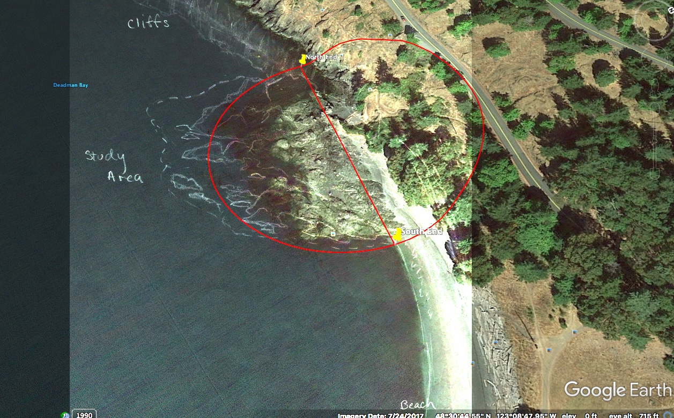

Figure 1: a sketch of the original site from Dwinell et al., 1973 overlaid on a google earth image of Dead Man’s Bay, survey site within left red semicircle (approximately 6000 square meters).

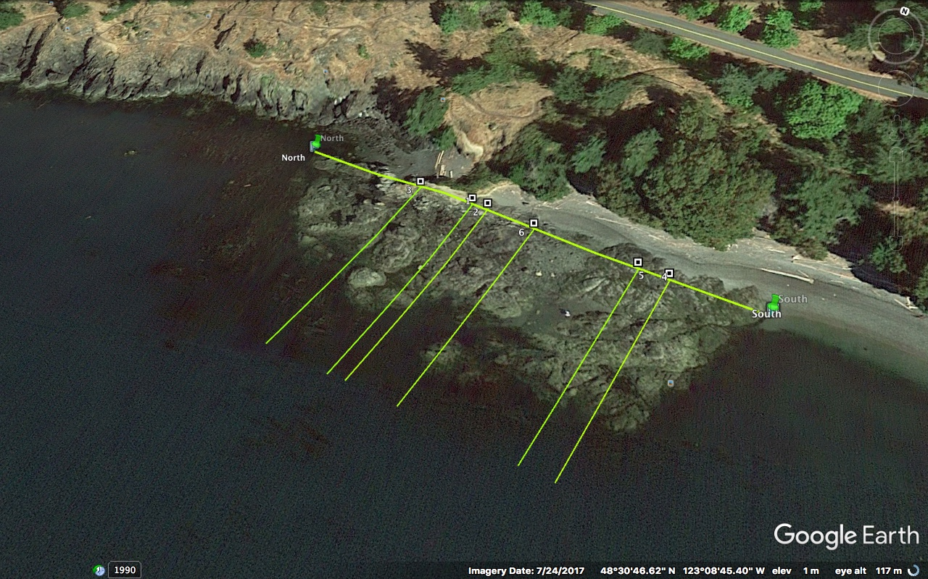

Figure 2: the plotted transects along the coast of the survey site, generated using a random number generator. See table 1 for transect coordinates.

|  |  |  |  |
| --- | --- | --- | --- |
| latitude | longitude | name | description |
| 48 30 48.04 | -123 08 49.82 | 1 | 46m |
| 48 30 48.02 | -123 08 49.63 | 2 | 50m |
| 48 30 48.13 | -123 08 50.49 | 3 | 32m |
| 48 30 47.75 | -123 08 47.56 | 4 | 94m |
| 48 30 47.79 | -123 08 47.89 | 5 | 87m |
| 48 30 47.95 | -123 08 49.07 | 6 | 62m |
| 48 30 48.32 | -123 08 52.00 | North |  |
| 48 30 47.62 | -123 08 46.54 | South |  |

Table 1: The randomly generated transects surveyed at Dead Man’s Bay: coordinates, name, and placement along the 120-meter length of the survey site.

Results:

The density of both *Balanus glandul*a and *Semibalanus cariosus*, increased when comparing 1973 to 2018. The mean density of *Balanus* was 1598.30 +/- 4485.25 individual barnacles per square meter, a large difference from the density of 174.23 +/- 361.42 found in 1973 (Fig. 3). *Semibalanus* increased to a lesser extent. The mean density was found to be 304.20 +/- 727.25 barnacles per square meter, whereas in 1973 the mean density was 157.37 +/- 263.99 (Fig. 3).

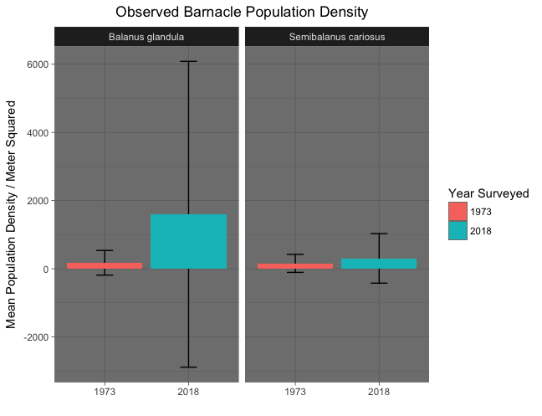

Figure 3: A comparison of the mean population densities of Balanus and Semibalanus in 1973 (pink) and 2018 (blue) with whiskers representing standard deviation.

There was also a shift in the crab population of Deadman’s Bay. We observed a decrease in the population density of *Hemigrapsus nudus*, with an observed mean density of 1.90 +/- 5.43 individual crabs per square meter, compared to the previous mean density of 10.4 +/- 50.96 seen by Dwinell et al., 1973 (Fig. 4*)*. *Pugettia gracili*s decreased in population density from 2.51 +/- 6.64, observed in 1973, to 1.90 +/- 5.28 (Fig. 4). In contrast, *Pagarus spp*. increased nearly threefold, with an observed population density of 62.20 +/- 164.55, compared to 22.17 +/- 108.46 observed in 1973 (Fig. 4).

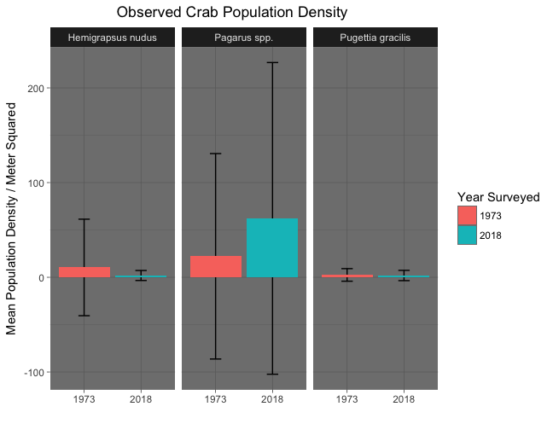

Figure 4: A comparison of the mean population densities of Hemigrapsus, Pagarus, and Pugettia in 1973 (pink) and 2018 (blue), with whiskers representing standard deviation

Maximum annual air temperatures measured on Orcas Island; WA (an island within the San Juan archipelago) increased by approximately 2° F between 1965 and 2016 (NOAA, <https://www.ncdc.noaa.gov>, Fig. 5).

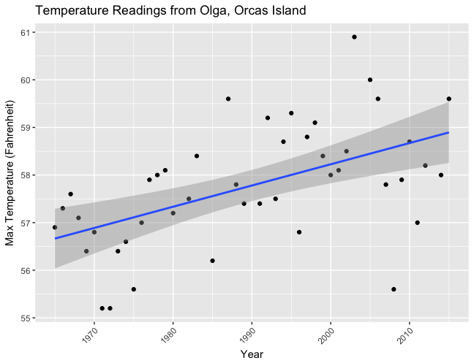

Figure 5: Maximum air temperature data collected on Olga, Orcas Island; WA plotted against year: 1965 to 2016. Note the positive trend towards 59° F.

Discussion:

Between the past and present surveys of Deadman Bay maximum regional air temperatures increased by approximately 2° F. While there are large seasonal fluctuations in temperature as can be expected, this overall increase can be attributed to the increased levels of CO2 within the earth’s atmosphere, which insulate the planet, allowing less UV radiation to escape through the ozone than otherwise would. One of the more apparent stressors experienced by intertidal invertebrates is desiccation, a process incited by temperature changes and air exposure (Fyhn et al., 1972). As air temperature increases, so does the amount of water that is lost through the cuticle of crustaceans, water that is needed for respiration, circulation, etc. With this regional increase in air temperature by nearly 2° F, intertidal invertebrates become more vulnerable to desiccation when exposed during low tide.

Barnacle populations, although inconsistent along a transect due to zonation, overall increased immensely following the 1973 surveys performed by Dwinell et al.. To understand why this may be, the phenomenon of recruitment must be considered. Recruitment is defined by Keough & Downes, 1982 as any recently settled juveniles who have survived for a period of time after settlement. In the case of surveying a population of barnacles that has recently recruited new juveniles, the density of this population can be inflated dramatically for a short period of time before mortality rates eventually bring this population down to a density that is sustainable within the ecosystem, in turn, distorting this concentration to an inaccurate level for a short period of time (Connell, 1985, Keough & Downes, 1982). This mass settlement of juvenile barnacles occurs seasonally and is influenced by many features of the intertidal including air and water temperature, hydrodynamics, and species interactions. Although we were unable to test for this influx of juvenile barnacles due to a lack of historical data on the subject, it is possible that an increase in air temperature could have effects on the seasonality of barnacle recruitment, shifting this phenomenon temporally and therefore presenting itself in our data, while being absent during the surveys of 1973.

Barnacles are surrounded in a calcareous test during their adult life stage, which allows them to not only trap oxygen within their shell for respiration when the tide recedes, but also provides protection from UV rays (Barnes, 1957). Crabs on the other hand, while still surrounded by a calcified exoskeleton must resort to translocation within the intertidal to allow respiration e.g. water trapped beneath rocks. Increased temperature is directly related to the amount of water that is lost due to evaporation, however this is inhibited to a great extent by a barnacle’s outer layer of calcareous shell (Wolcott, 1973, Barnes, 1957). What may seem like a drawback, the sessile nature of the barnacle is in fact a characteristic that allows them to sustain themselves in an environment of increasing temperature. Once settled, a barnacle must make do with the conditions of its permanent habitat, whether there be changes in temperature or water level, its test being a major contributor to this resilience. Therefore, it has adapted to withstand a great amount of fluctuation throughout the tidal cycle (Wethey, 1983). In addition, the settling larval stage of a barnacle, known as the cyprid life stage, is remarkably capable at choosing a sufficient permanent residence (Crisp, 1976). Complex behavior including the investigation of surfaces by means of a temporary attachment mechanism and antennules allows these larvae to choose with great accuracy as to whether a substrate is worthy of their permanent attachment (Alsaab et al., 2017). The combination of these characteristics could allow *Balanus glandula* and *Semibalanus cariosus* to proliferate in an increasingly warm climate.

Interspecific interactions within a community can also shift dramatically with a change in climate. *Nucella ostrina*, a common marine snail found within Deadman Bay’s intertidal ecosystem, feeds on *Balanus* glandula by drilling through the calcareous test that surrounds them to consume their softer inner body. A study performed by Yamane & Gilman, 2009, found that when exposed to increased aerial temperatures, N. ostrina’s rate of predation decreased significantly. This has clear implications for *Balanus glandula*. If N. ostrina were to feed on *Balanus* less as aerial temperatures increased, by order of the top down effect, it would follow that Balanus populations will increase in density as they are no longer kept in check by this predator. This type of interaction was not considered in our analysis but should be noted as a possible mechanism for population shifts.

The population densities of both *Hemigrapsus nudus* and *Pugettia gracilis* decreased to an average of 1.90 individuals per square meter from the previous 10.4 (*Hemigrapsus*) and 2.5 (*Pugettia*). This was unexpected when considering their mobility compared to barnacles, but it is possible that this characteristic could become a drawback in relation to temperature. The ability to move within the intertidal does have clear benefits, including shelter selection, greater flexibility in habitat choice, and active predation and predator avoidance (Robles & Desharnais, 2002). However, the possibility of being caught in an inhospitable area of the intertidal when seawaters recede may increase when an organism is mobile (Lohrer et al., 2000, Robles & Desharnais, 2002). The temperature of tide pools can increase significantly within the time it takes to be overtaken by the next high tide (Hernández, 2002). Unlike barnacles, where specific adaptations such as a calcareous shell allow them to withstand desiccation to a large degree, mobile crabs can only be exposed for a short period of time, otherwise bodily functions as significant as respiration and metabolism can be inhibited (Stillman & Somero 1996).

In contrast*, Pagarus spp,* increased in population density by nearly threefold compared to the previously observed density. While *Pagarus* is grouped within the class Malacostraca, anatomically there are large differences that should be considered when comparing this genus to its counterparts. Housed in a calcareous shell adopted in the adult stage of their life history, hermit crabs are without carapace, forcing them to take shelter in a foreign snail shell (Reese, 1969). The implications of this added protection are significant, it provides an immense amount of protection, a transportable shelter, and it inhibits desiccation to a great extent. Brodie, 2005 experimentally tested the desiccation rates of terrestrial hermit crabs and found that shell-less *Coenobita compressus* couldn’t withstand a relative humidity of less than 99%, whereas housed hermits were able to survive a 52% RH. Within the intertidal, the benefits of having a home that retains water are apparent, being the difference between surviving a low tide or dying of desiccation.

In order to repeat *Survey of the intertidal fauna and flora of Dead man’s Bay* by Leonard Dwinell et al., 1973, we were forced to fill in the gaps of their methodology with what seemed to be the most logical and unbiased of procedures. In the field, *Cthamalus* was found to be abundant, but there was no evidence of their presence being acknowledged in the data from Dwinell et al.. It seems highly unlikely that these populations of *Cthamalus* weren’t present during the 1973 survey, and instead that the surveyors grouped this genus within *Balanus* because of their physical similarities. Further, it was assumed that recently settled barnacles were omitted from the data because of the challenge involved in distinguishing different genera at this stage in their life history. It should also be noted that standard deviations from the calculated mean density were great, particularly for the surveyed barnacles. This was due to the incredible variability of the intertidal, and should of course be considered in evaluating the conclusions made.

We were determined to collect as much data as possible to provide a baseline for future surveys of Deadman’s Bay. As an extension, the zonation of the species considered in this survey should be recorded and compared to previous data, for zonation could be greatly influenced by temperature shifts in the long term. Still, because of the additional data collection that was performed during this survey, there is now a wealth of information that can be used in future studies of this area in order to better understand the flora and fauna of this diverse and dense ecosystem and their response to a changing climate.

Acknowledgements:

I wish to acknowledge my fellow surveyors, Sean Dougherty and Jamie Andersen Fields Maron, who put in the time and effort to make this ecological survey possible and were a pleasure to work with in the field. I would also like to thank my two professors Robin Elahi and Hilary Hayford for their untiring support throughout this process and the immense amount of time that they devoted to us, in and out of the classroom.

Scholarship support received from the Mary Gates Endowment

Appendix I:

|  |  |  |  |
| --- | --- | --- | --- |
| Transect number | Quadrat distance | latitude | longitude |
| 5 | 30 | 48˚ 30' 47.00" N | 123˚ 8' 48.35" W |
| 5 | 21 | 48˚ 30' 47.28" N | 123˚ 8' 48.24" W |
| 5 | 13 | 48˚ 30' 47.45" N | 123˚ 8' 48.14" W |
| 5 | 8 | 48˚ 30' 47.66" N | 123˚ 8' 47.99" W |
| 5 | 32 | 48˚ 30' 46.93" N | 123˚ 8' 48.46" W |
| 5 | 24 | 48˚ 30' 47.10" N | 123˚ 8' 48.31" W |
| 5 | 35 | 48˚ 30' 46.85" N | 123˚ 8' 48.50" W |
| 5 | 38 | 48˚ 30' 46.74" N | 123˚ 8' 48.58" W |
| 5 | 42 | 48˚ 30' 46.66" N | 123˚ 8' 48.70" W |
| 5 | 34 | 48˚ 30' 46.84" N | 123˚ 8' 48.48" W |
| 3 | 5 | 48˚ 30' 47.89" N | 123˚ 8' 50.54" W |
| 3 | 18 | 48˚ 30' 47.53" N | 123˚ 8' 50.79" W |
| 3 | 21 | 48˚ 30' 47.47" N | 123˚ 8' 50.76" W |
| 3 | 19 | 48˚ 30' 47.48" N | 123˚ 8' 50.78" W |
| 3 | 16 | 48˚ 30' 47.54" N | 123˚ 8' 50.74" W |
| 3 | 10 | 48˚ 30' 47.84" N | 123˚ 8' 50.63" W |
| 3 | 7 | 48˚ 30' 47.83" N | 123˚ 8' 50.58" W |
| 3 | 8 | 48˚ 30' 47.91" N | 123˚ 8' 50.56" W |
| 3 | 15 | 48˚ 30' 47.60" N | 123˚ 8' 50.71" W |
| 3 | 3 | 48˚ 30' 47.86" N | 123˚ 8' 50.61" W |
| 2 | 17 | 48˚ 30' 47.39" N | 123˚ 8' 49.94" W |
| 2 | 12 | 48˚ 30' 47.56" N | 123˚ 8' 49.95" W |
| 2 | 10 | 48˚ 30' 47.63" N | 123˚ 8' 49.95" W |
| 2 | 31 | 48˚ 30' 46.96" N | 123˚ 8' 50.17" W |
| 2 | 27 | 48˚ 30' 47.11" N | 123˚ 8' 50.16" W |
| 2 | 20 | 48˚ 30' 47.26" N | 123˚ 8' 50.02" W |
| 2 | 21 | 48˚ 30' 47.24" N | 123˚ 8' 50.03" W |
| 2 | 24 | 48˚ 30' 47.13" N | 123˚ 8' 50.09" W |
| 2 | 5 | 48˚ 30' 47.71" N | 123˚ 8' 49.94" W |
| 2 | 25 | 48˚ 30' 47.10" N | 123˚ 8' 50.02" W |
| 6 | 21 | 48˚ 30' 47.60" N | 123˚ 8' 49.68" W |
| 6 | 12 | 48˚ 30' 47.37" N | 123˚ 8' 49.78" W |
| 6 | 18 | 48˚ 30' 47.55" N | 123˚ 8' 49.67" W |
| 6 | 20 | 48˚ 30' 47.63" N | 123˚ 8' 49.73" W |
| 6 | 16 | 48˚ 30' 47.39" N | 123˚ 8' 49.92" W |
| 6 | 16 | 48˚ 30' 47.46" N | 123˚ 8' 49.73" W |
| 6 | 25 | 48˚ 30' 47.65" N | 123˚ 8' 49.70" W |
| 6 | 7 | 48˚ 30' 47.13" N | 123˚ 8' 50.01" W |
| 6 | 2 | 48˚ 30' 46.99" N | 123˚ 8' 50.04" W |
| 6 | 9 | 48˚ 30' 47.20" N | 123˚ 8' 49.96" W |

References:

Alsaab A, Aldred N, Clare AS. (2017) Automated tracking and classification  
of the settlement behaviour of barnacle cyprids. J. R. *Soc. Interface* 14: 20160957. http://dx.doi.org/10.1098/rsif.2016.0957

Barnes, H., & Barnes, M. (1957). Resistance to Desiccation in Intertidal Barnacles. *Science,126*(3269), 358-358. doi:10.1126/science.126.3269.358

Betts, R. A., Jones, C. D., Knight, J. R., Keeling, R. F., & Kennedy, J. J. (2016). El Niño and a record CO2 rise. *Nature Climate Change,6*(9), 806-810. doi:10.1038/nclimate3063

Brodie, J. R. (2005). Desiccation resistance in megalopae of the terrestrial hermit crab *Coenobita compressus*: Water loss and the role of the shell. *Invertebrate Biology,124*(3), 265-272. doi:10.1111/j.1744-7410.2005.00024.x

Connell, J.H., (1985). The consequences of variation in initial settlement vs. post settlement mortality in rocky intertidal communities. *Journal of Experimental Marine Biology and Ecology* 93, 11–45.

Crisp DJ. (1976) Settlement responses in marine organisms. In Adaptation to environment. *Essays on the physiology of marine animals* (ed. RC Newell), pp. 83–124. London, UK: Butterworths.

Darnell, M. Z., Nicholson, H. S., & Munguia, P. (2015). Thermal ecology of the fiddler crab *Uca panacea* : Thermal constraints and organismal responses. *Journal of Thermal Biology,52*, 157-165. doi:10.1016/j.jtherbio.2015.06.004

Dungan, M. L. (1985). Competition and the morphology, ecology, and evolution of acorn barnacles: An experimental test. *Paleobiology,11*(02), 165-173. doi:10.1017/s0094837300011489

Fyhn, H. J., Petersen, J. A., Johansen, K.: Ecophysiological studies on an intertidal crustacean, Pollicipes polymerus (Cirripedia, Lepadomorpha) 1. Tolerance to body temperature change, desiccation and osmotic stress. J. *exp*. *Biol*. **57**, 83–102 (1972)

Henderson, P., Seaby, R., & Somes, J. (2011). Community level response to climate change: The long-term study of the fish and crustacean community of the Bristol Channel. *Journal of Experimental Marine Biology and Ecology,400*(1-2), 78-89. doi:10.1016/j.jembe.2011.02.028

Hernández, C. (2002). Water temperature fluctuations and territoriality in the intertidal zone: Two possible explanations for the elevational distribution of body size in Graus nigra. *Journal of Fish Biology,61*(2), 472-488. doi:10.1006/jfbi.2002.2054

Keough, M. J. & B. J. Downes, (1982). Recruitment of marine invertebrates: the role of active larval choices and early mortality. *Oecologia* (Berlin), Vol. 54, pp. 348-352.

Kroeker, Kristy J., et al. (2010). Meta‐analysis reveals negative yet variable effects of ocean acidification on marine organisms. Ecology letters 13.11, 1419-1434\

Lohrer, A.M., Whitlatch, R.B., Wada, K. et al. Biological Invasions (2000) 2: 41. https://doi.org/10.1023/A:1010069327402

Manabe, S., & Wetherald, R. T. (1967). Thermal Equilibrium of the Atmosphere with a Given Distribution of Relative Humidity. *Journal of the Atmospheric Sciences,24*(3), 241-259. doi:10.1175/1520-0469(1967)0242.0.co;2

Nagasawa, H. (2012). The crustacean cuticle structure composition and mineralization. *Frontiers in Bioscience,E4*(2), 711-720. doi:10.2741/e412

Nasrolahi, A., Pansch, C., Lenz, M., & Wahl, M. (2011). Being young in a changing world: How temperature and salinity changes interactively modify the performance of larval stages of the barnacle Amphibalanus improvisus. *Marine Biology,159*(2), 331-340. doi:10.1007/s00227-011-1811-7

Paine, R. (1966). Food Web Complexity and Species Diversity. *The American Naturalist*., 100(910), 65.

Paganini, A. W., Miller, N. A., & Stillman, J. H. (2014). Temperature and acidification variability reduce physiological performance in the intertidal zone porcelain crab Petrolisthes cinctipes. *Journal of Experimental Biology,217*(22), 3974-3980. doi:10.1242/jeb.109801

Reese, E. S. (1969). Behavioral Adaptations of Intertidal Hermit Grabs. *American Zoologist,9*(2), 343-355. doi:10.1093/icb/9.2.343

Robles, C. and Desharnais, R. (2002). History and Current Development of a Paradigm of Predation jn Rocky Intertidal Communities. *Ecology*, 83(6), p.1521.

Sorte, C. J., Davidson, V. E., Franklin, M. C., Benes, K. M., Doellman, M. M., Etter, R. J., . . . Menge, B. A. (2016). Long-term declines in an intertidal foundation species parallel shifts in community composition. *Global Change Biology,23*(1), 341-352. doi:10.1111/gcb.13425

Stephens, P. J. (1985). The Effects Of Temperature And Acclimation On Crustacean Nerve-Muscle Physiology. *The Biological Bulletin,169*(1), 92-105. doi:10.2307/1541390

Stillman, J. H., & Somero, G. N. (1996). Adaptation to temperature stress and aerial exposure in congeneric species of intertidal porcelain crabs (genus *Petrolisthes):* correlation of physiology, biochemistry, and morphology with vertical distribution. *The Journal of Experimental Biology,199*, 1845-1855. doi:10.7717/peerj.1805/supp-1

Swift, Nathan B. (2012) "Biomineral Structure and Strength of Barnacle Exoskeletons," *Colgate Academic Review*: Vol. 8, Article 10.

Tomanek, L. (2002). Physiological Ecology of Rocky Intertidal Organisms: A Synergy of Concepts. *Integrative and Comparative Biology,42*(4), 771-775. doi:10.1093/icb/42.4.771

Wethey, D. S. (1983). Geographic limits and local zonation: the barnacles *Semibalanus (Balanus)* and *Chthamalus* in New England. *Biology Bulletin, 165, 330-341*

Wolcott, T. G. (1973). Physiological Ecology And Intertidal Zonation In Limpets (Acmaea): A Critical Look At "limiting Factors". *The Biological Bulletin,145*(2), 389-422. doi:10.2307/1540048

World of Change: Global Temperatures : Feature Articles. (n.d.). Retrieved May 02, 2018, from https://earthobservatory.nasa.gov/Features/WorldOfChange/decadaltemp.php

Yamane L., & Gilman S.E. (2009) Opposite responses by an intertidal predator to increasing aquatic and aerial temperatures. *Mar Ecol Prog Ser* 393:27-36. [https://doi.org/10.3354/meps08276](https://doi.org/10.3354/meps08276%0a)

Zisserson, B., & Cook, A. (2017). Impact of bottom water temperature change on the southernmost snow crab fishery in the Atlantic Ocean. *Fisheries Research,195*, 12-18. doi:10.1016/j.fishres.2017.06.009