FHL 470

Robin Elahi

# Metrics + Data Visualization I - SVA-DSI

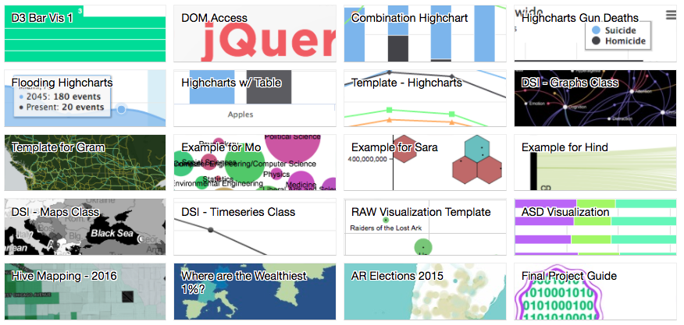

gallery

# SYLLABUS

Find this resource here: <https://mzl.la/sva-viz>

### COURSE LOGISTICS:

SVA  
Sept. 7th - Dec 14th  
Thursdays 6-9:00PM

Here is the [course listing](http://dsi.sva.edu/course/metrics-and-data-visualization-i/).

### INSTRUCTOR:

Aurelia Moser  
@auremoser

### OFFICE HOURS:

Fridays 5-6PM, by appointment via gcal - send to aurelia@mozillafoundation.org

### DESCRIPTION

Data visualizations increasingly shape the way we process the success of initiatives, and the expectations for activism and innovation globally. How might you evaluate the success or impact of a program? What skills should you hone to communicate your projects and progress to a new audience? How can technology hone critical thinking and problem framing for a particular area of social need and interest?

This course will introduce web development for data visualization, including an introduction to web scripting languages, version control for collaborative coding, and the authorship of interactive visualization on/off the web.

The goal of the course is to compliment student's existing coursework and interests with some basic visualization skills, by course completion, helping them design, build, and deploy a data-driven interactive on a topic related to their work. Students will workshop an interactive of their own design throughout the course, punctuated by smaller exercises and lecture pairings on the topics of HTML5/CSS3, Javascript and contemporary development in open source and non-profit tech.

### OBJECTIVE + LEARNING OUTCOMES

Being successful in programming or social change initiatives involves producing under deadline. Funders, employers, collaborators, and patrons of your products will expect that you work efficiently. This course is modeled for your future success, and so deadlines will be applied to keep time with a professional pace. The final project for the course, and primary graded assignment, will depend on an agglutinative series of tasks designed to help you learn and think critically throughout the semester.

#### LEARNING OUTCOMES:

1. how to assess, manipulate, and analyze data
2. how to bulletproof your data
3. the merits of certain visualization types
4. the mechanics of collaboration and github
5. the basics of building interactive graphics: html/css/js
6. the value of publishing and self-publishing

#### GRADE CALCULATION:

Here is a basic breakdown of graded tasks along that trajectory:

* 10% Attendance/Participation
* 30% Assignments
* 20% Project Proposal
* 40% Final Project, completed on conclusion of the course

TOTAL: 100%

It is understood that coding is tough and you may be new to this, you will be graded on your progress throughout the class, your ability to complete assignments on time, your interaction with peer reviewers, and your ability to justify your decisions thoughtfully.

### MATERIALS

Coding is an art; you will have a series of art supplies for this course that will all be free unless otherwise noted, but will require some non-trivial investment on your part to set-up. I'm available to help if you need it.

**SET-UP ACCOUNT**

* Hosting Service - [Github](https://github.com/) Account, [signup here](https://help.github.com/articles/signing-up-for-a-new-github-account/)
* Join our classroom here: https://classroom.github.com/classrooms/20387575-sva-dsi-data-vis

**DOWNLOAD AND INSTALL**

* Text Editor - [Sublime Text](http://www.sublimetext.com/) or [Atom.io](https://atom.io/)
* Processing - [Processing sketch editor](https://processing.org/download/?processing)
* A Markdown Editor - [Mou](http://25.io/mou/)

**LEARN**

* Setting up a Server - [Python Simple Server](http://www.pythonforbeginners.com/modules-in-python/how-to-use-simplehttpserver/)

### COURSE POLICIES

**PARTNER POLICY**

You will find a parter, or a triplet in this course and have some time afforded to workshop your ideas, your narratives and your code with them during peer review. They will give me feedback that contributes to your grade; so pair well with your peers.

**ATTENDANCE/PARTICIPATION**

Attendance accounts for 10% of your final grade.

**ASSIGNMENTS**

Each week you will have readings assigned, accompanied by often (but not always) an Assignment and a Practice activity. See the calendar below to confirm the expectations from week to week. I will grade your assignments and aggregate them as contributions to your final grade. Most assignments are working toward your Final Project, counting as 40% of your final grade.

* All assignments will be submitted via [gist](https://gist.github.com/) on your [Github](https://github.com/) account.
* Aurelia will repost assignments in Canvas, where possible
* You can view a template of what your assignment should look like here in this [gist](https://gist.github.com/auremoser/9dcfac8163e7737e7b5f).
* We have a [Github classroom](https://classroom.github.com/classrooms/20387575-sva-dsi-data-vis) for our course, to which you will likely add your final projects, more on that later.
* Assignments are due on the course date following the class in which they are assigned unless otherwise indicated - there are short assignments every week - Week 2 for example, "Critique an interactive" is due on 9/13

|  |  |  |  |  |
| --- | --- | --- | --- | --- |
| WEEK | DATE | ASSIGNMENT DUE | PRACTICE | NOTE |
| 1 | 09/07 | Read the syllabus | X |  |
| 2 | 09/14 | Critique an interactive | X | GUEST: Daniel Goddemeyer |
| 3 | 09/21 | Comparing interactives | X | GUEST: Caroline Sinders |
| 4 | 09/28 | Evaluating platforms + Versioning | X | NO CLASS |
| 5 | 10/05 | Dataset selection | X | GUEST: Alejandro Figueroa |
| 6 | 10/12 | Practice HTML/CSS | X | GUEST: Francis Tseng |
| 7 | 10/19 | **Prototype 1**: Time-Series/Stats | X | GUEST: Andy Eschbacher |
| 8 | 10/26 | **Prototype 2**: Mapping | X | GUEST: Robby Kraft |
| 9 | 11/02 | **Prototype 3**: Graphs | X |  |
| 10 | 11/09 | Style guide for Final Project |  |  |
| 11 | 11/16 | **Proposal** for Final Project | X |  |
| 12 | 11/23 | Template your project |  | NO CLASS - THANKSGIVING |
| 13 | 11/30 | Peer review: groom projects with feedback |  |  |
| 14 | 12/07 | **Final Presentations** |  |  |
| 15 | 12/14 | **Final Projects Due** - Appts w/ Aurelia |  | NO CLASS - FINALS DUE |

**READINGS**

Readings are assigned to correspond with that week's assignment and class lesson. I'll be lecturing outside the readings with some references to them, and your assignments will allude to them too. Feel free to read ahead to make certain weeks easier.

**There is no textbook for this course** as most of the resources can be found for free online.

You can find the [FULL BIBLIOGRAPHY](https://github.com/sva-dsi/2017-fall-course/blob/master/bibliography.md) in the repository for this course.