Introduction to R, RStudio, and Rmarkdown

### Present day birth records in the U.S.

In the previous few pages, you recreated some of the displays and preliminary analysis of Arbuthnot’s baptism data. Your assignment involves repeating these steps, but for present day birth records in the United States. Load up the present day data with the following command.

source("http://www.openintro.org/stat/data/present.R")

The data are stored in a data frame called present.

What years are included in this data set? What are the dimensions of the data frame and what are the variable or column names?

summary(present)

## year boys girls   
## Min. :1940 Min. :1211684 Min. :1148715   
## 1st Qu.:1956 1st Qu.:1799857 1st Qu.:1711404   
## Median :1971 Median :1924868 Median :1831679   
## Mean :1971 Mean :1885600 Mean :1793915   
## 3rd Qu.:1986 3rd Qu.:2058524 3rd Qu.:1965538   
## Max. :2002 Max. :2186274 Max. :2082052

dim(present)

## [1] 63 3

The years range from 1940 to 2002.  
The dimensions are 63 rows and 3 columns.  
The column names are year, boys, girls.

How do these counts compare to Arbuthnot’s? Are they on a similar scale?

These counts are 3 orders of magnitude higher than Arbuthnot’s.

Make a plot that displays the boy-to-girl ratio for every year in the data set. What do you see? Does Arbuthnot’s observation about boys being born in greater proportion than girls hold up in the U.S.? Include the plot in your response.

bg_ratio <- with(present, boys / girls)  
plot(present$year, bg_ratio, type = "l", xlab = "Year", ylab = "Boy:girl ratio")

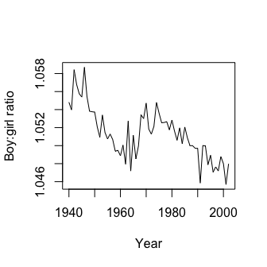

The ratio is above 1, meaning that more boys than girls are being born in the US - similar to Arbuthnot. In addition, there is a decreasing trend.

In what year did we see the most total number of births in the U.S.? You can refer to the help files or the R reference card <http://cran.r-project.org/doc/contrib/Short-refcard.pdf> to find helpful commands.

births <- with(present, boys + girls)  
present$year[which.max(births)]

## [1] 1961

The highest number of births occurred in 1961