Tips for formatting Rmd output

Robin Elahi

2019-04-14

Render your output as a word document - see above in yaml header.

Include an author field in the yaml header - with your name.

In general, be concise with your answers and the R code necessary to demonstrate that you know how to get the answers. Do not include pages of output - e.g., an dataframe with 100’s of lines.

Use > to highlight your answers in text. E.g.:

My answer to this question is correct. Make sure there is a space between this line and the previous one.  
Make sure that you use 2 spaces at the end of the previous sentence to get this on the next line.  
This is important for me (Robin), as it helps me identify your answers (vs the questions).

If you are doing some preliminary inspection of the data, or testing out some things - but you don’t want this in the rendered file that you submit - then use eval = FALSE in the code chunk. But if you need the code to be evaluated, but you don’t want to show the code - then use echo = FALSE. If you don’t want to show the results of the code, then use results = "hide".

## Examples

I want to evaluate this code (b/c I need the data in downstream chunks), but I don’t want to show it in the rendered file:

Echo (show) the code, but don’t show the results:

summary(present)  
dim(present)

Don’t echo the code, but show the results: 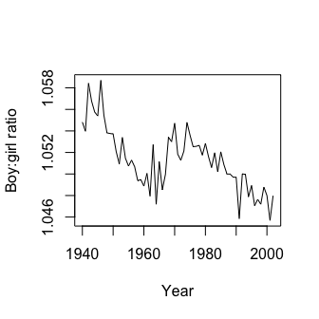

For more information on how to change the chunk options see <https://yihui.name/knitr/options/>

If you don’t love the default Word rendering, you can change it here: <https://rmarkdown.rstudio.com/articles_docx.html>