Project Name : Technical Challenge

Client Name : Uyi

Team : Abdul

Document Create By : Abdul

Task: **Address Book**

Pages : **Login, Add contacts, List Contacts and Search**

Models Created: **User and Contact**

Controller Created: **LoginController and ContactsController**

View Created : **Contacts ,Layout and Login**

**Page Login**

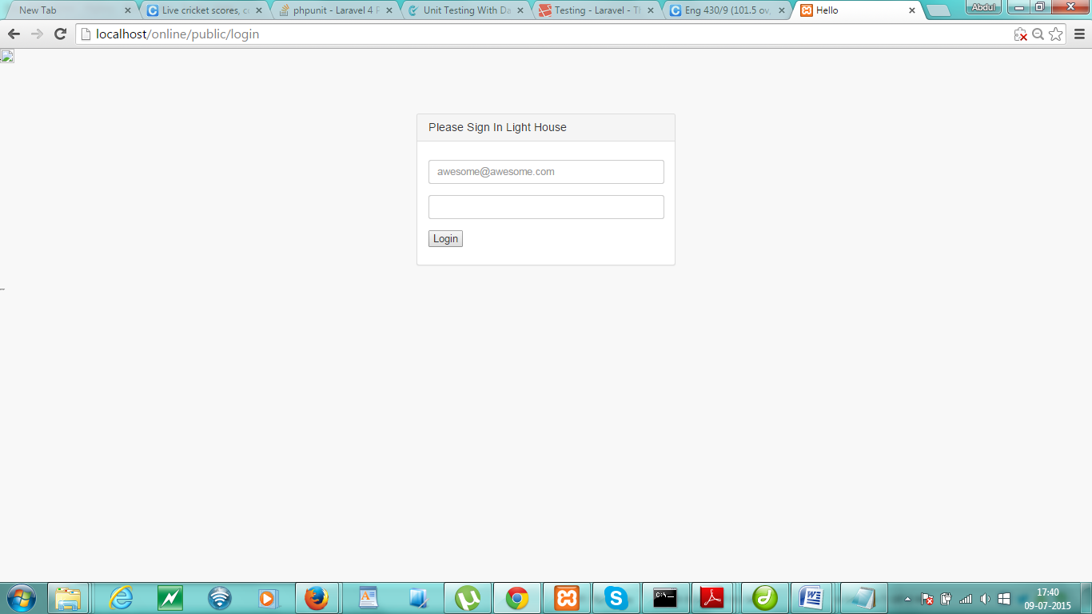

Username :elahiabdul007@gmail.com

Password :demo

Validation implemented for Email and password .

Page 2 : Add contacts

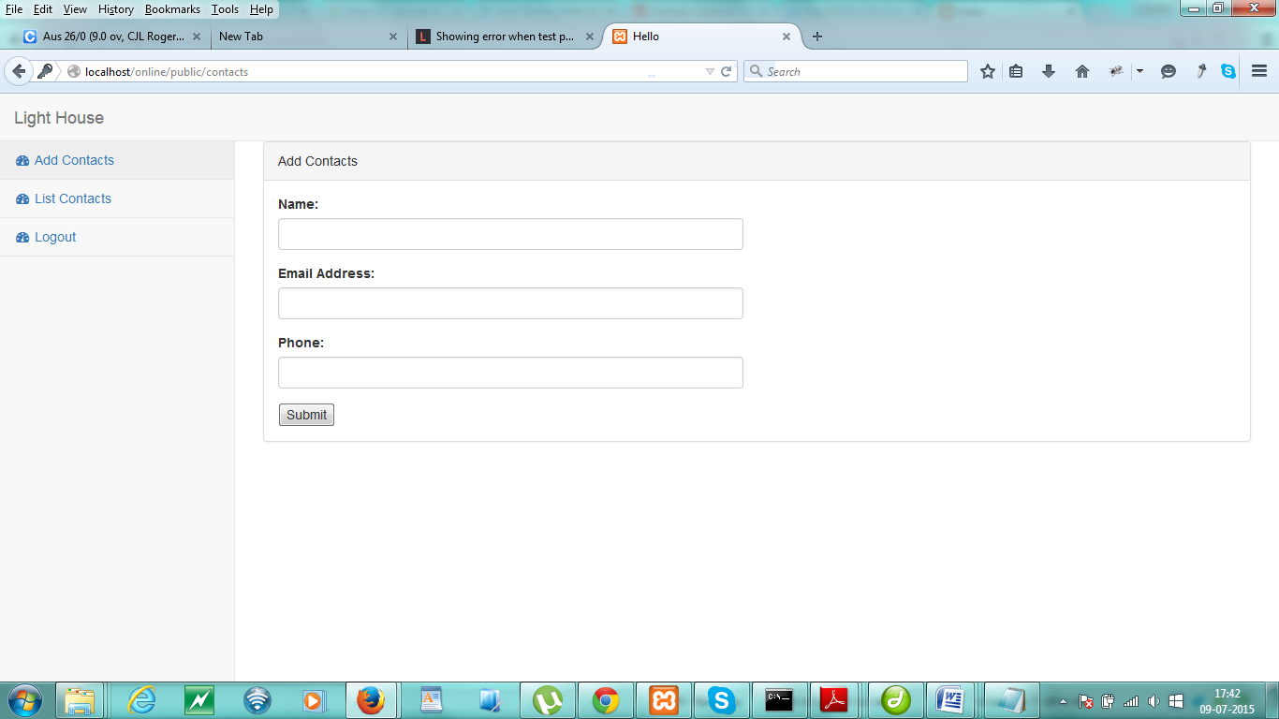

User can able to add contacts

Validation implemented for Name, Email and Phone

**Page 3 : Search & List**

