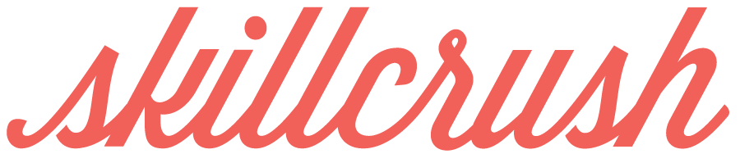

WEBSITE QUESTIONNAIRE

**GENERAL INFORMATION**

**What will the purpose of this site be?**

I want to promote my skills while clearly showing my personality, who I am, and how that relates to my work. I want my audience to clearly know what I do, how to find samples of my work, and to understand who I am as a person.

**AUDIENCE**

**Who are the people I really want to reach with my site?** *Describe your target user for the site (ie. new clients, other design professionals to network with, companies).*

I want to connect with future clients and employers for companies and small businesses that I find most appealing.

**What are the 3 main actions I want my users to take?** *List the most important first.*

1. I want them to learn about my skills and areas of expertise.
2. I want to them to view samples of my work.
3. I want them to contact me.

**WEBSITE DETAILS**

**What will I call my website?**

I want to use my own name, Sadie Sharp, to make sure that my users connect with *me* and not an impersonal business name.

**What will the URL be? Is it available?**

My URL will be [www.sadiesharp.com](http://www.sadiesharp.com) and it’s available!