**COMP421 Section B**

**Elaiha Ahmed**

**Assignment 1**

**Screenshot:**

**Link 1:**

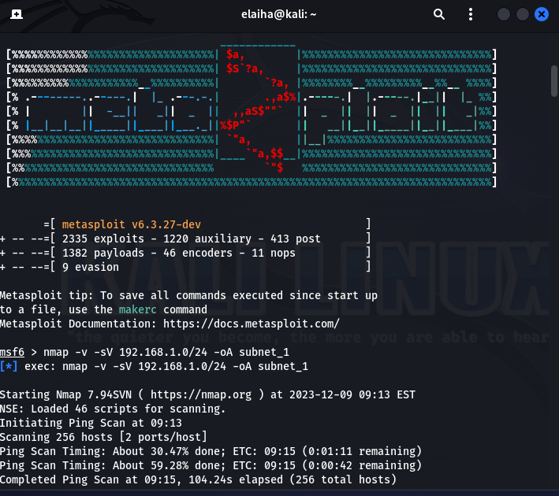

**Link 2:**

