Project X 2020

**Estimating SARS-COV-2 Virus Transmissions in Singapore using the SIR model**

**Nanyang Girls’ High School**

**Ma Jinghong, Wang Xinyue, Zhu Wenxin**

Teacher mentor: Tan Chik Leng

# Table of contents

**Table of contents** **2**

**1. Abstract** **3**

**2. The SIR Model Prediction** **4**

2.1 Prediction 4

Fig 1 5

2.2 Analysis of results 5

Fig 2 6

2.3 Limitations 7

**3. Key Junctures** **8**

3.1 Juncture 1 (Start to 26 April) 8

3.2 Juncture 2 (26 April to 7 June) 8

3.3 Juncture 3 (7 June to 23 June) 9

**4. Conclusion** **9**

**5. References** **10**

**6. Annexes** **12**

6.1 Annex A: Data collected of cases of COVID-19 in Singapore from 23 Jan to 1 April 12

6.2 Annex B: Python code used for the prediction model 14

6.3 Annex C: Output of the Python model 16

# 1. Abstract

In 2019, a new coronavirus was found in Wuhan, China. This virus was later named SARS-COV-2 and causes the disease COVID-19, and has become a global pandemic crisis.

This report aims to use the SIR model (Susceptible-Infected-Recovered) to estimate the spread of the virus in Singapore, specifically the Kermack-McKendrick model. The result is then compared against the actual data collected from 23rd January to 31st March 2020. Based on the results, we discussed the different key junctures in the stages of the viral epidemic and precautions recommended for each juncture.

# 2. The SIR Model Prediction

## 2.1 Prediction

The Kermack-McKendrick model was used to predict the virus as it is simpler and easier to predict. The model consists of 3 systems of differential equations,



$\frac{dS}{dt}= -βSI$

$\frac{dI}{dt} = βSI - γI$

$\frac{dR}{dt} = γI$

Where $t$ is the time (in days), $S(t)$ is the total number of individuals susceptible to infection, $I(t)$ is the number of infected individuals, $R(t)$ is the number of recovered individuals, $β$ is the infection rate and $γ$ is the recovery rate.

$t$ is set to be 183 days (from 23 Jan, the first confirmed case in Singapore, to 27 Sept.)

$β$ is set be 0.157, and was calculated by us using data collected from Singapore from 23 Jan to 1 April.[1]

is set to be 0.05. (1/20 days per infected person. Estimated recovery time based on different sources.)

The total population is set at 5.5 million, with no changes.

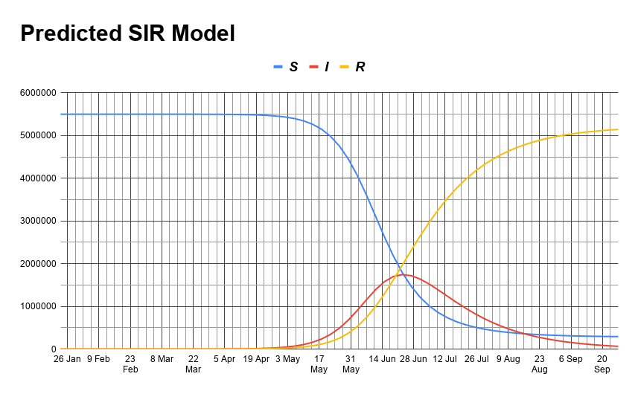

#### Fig 1

The data points are plotted once every 4 days on the graph as to reduce non-whole number data points.

## 2.2 Analysis of results

To analyse the accuracy of our prediction, the data collected of actual COVID-19 cases was used to check against it.

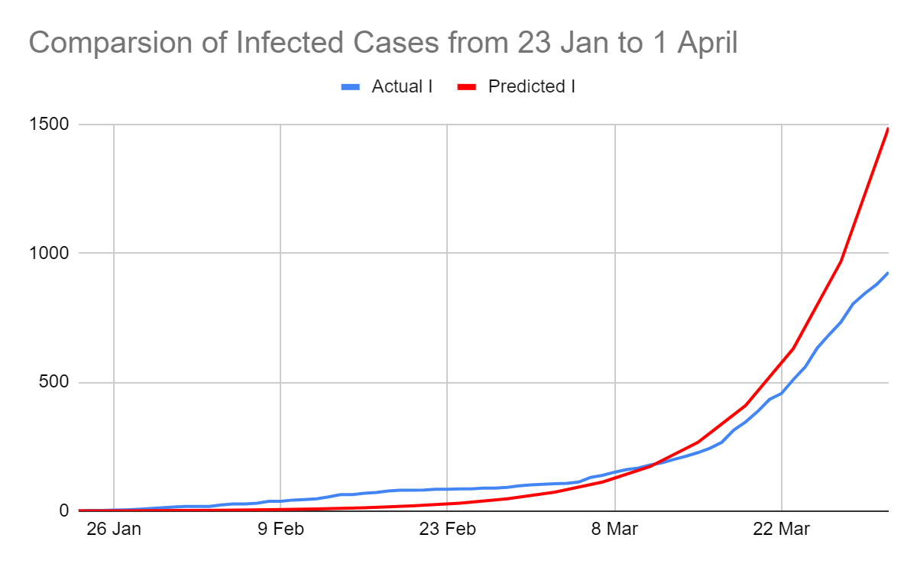

#### Fig 2

The 2 graphs are largely similar, however, after 22 March, the predicted model seems to deviate from the actual data. This could be due to some assumptions made.[2]

We also identified 3 key junctures[3] of viral transmission based on Fig 1,

**Juncture 1: 26 April**

The curve is relatively flat before, but starts to rise fast after this.

**Juncture 2: 26 April to 7 June**

The curve is the steepest at this period, the number of infections at this point increases exponentially.

**Juncture 3: 7 June to 23 June**

The curve is reaching the turning point at this period, and the number of cases will peak around 23 June, action is needed to flatten the curve.

## 2.3 Limitations

This prediction model is based on several assumptions:

1. There is no change in total population, and it is a closed population.
2. The virus does not have a incubation period
3. There are no imported cases
4. There were no efforts made to contain the virus
5. Everyone has equal chance of getting the virus
6. All recovered individuals are immune to the virus.
7. There are no deaths caused by the virus.
8. And other assumptions.

471 words so far. (not including acknowledgements)

# 3. Key Junctures

## 3.1 Juncture 1 (Start to 26 April)

During this juncture, the curve is relatively flat compared to the rest of the curve. During this period, the number of infected cases is small and relatively easy to contain. However, the graph started to escalate dramatically after this period. To prevent a massive outbreak, measures must be taken to stop the virus from spreading in the community effectively during this period. All symptomatic patients should be quarantined and people with close contact with them be given stay-at-home notices, and active contact tracing measures to take place. Awareness on the importance of wearing masks and social distancing should be spread, thus avoiding the spread of the virus by presymptomatic and asymptomatic cases, and proper hygiene practices taught. This may be a challenge as many people may not be aware or understand the gravity of the situation and may not comply with certain measures, thus complicating the process of containment. (149 words for this part)

## 3.2 Juncture 2 (26 April to 7 June)

This juncture is when the number of infected people starts to increase sharply, and the gradient of the curve is the steepest. Governments notice that the virus is a big problem in the society, and put in place measures to make sure that the number of infected cases do not increase exponentially. Big shifts in society are made and people’s lives are affected to prevent further spread of the virus. During this juncture, the whole society accepts the seriousness of the virus and takes major steps into containing it. The main goal is to flatten the curve and slow down the spread of the virus. Although the number of cases are increasing drastically, people understand the gravity of the situation, and understand the measures taken. If the government and the people both play their role well, it will hopefully result in the successful management and containment of the virus. (149 words)

## 3.3 Juncture 3 (7 June to 23 June)

This juncture is when the number of infections begin to peak. The number of infected people increases at a slower rate than before, and after this juncture, the number of cases start to decrease and that is when herd immunity kicks in. At this point in time, healthcare systems are being put under high levels of pressure and are reaching their maximum capacity and capability. The hospital beds would be quickly filled and more hospital beds are needed, and the country can make use of community facilities to help lighten the hospital’s loads. Another challenge is that more professionals are needed to take care of the coronavirus patients, and Singapore needs to consider how to distribute the limited manpower over areas of need, such as further training to take up additional roles. The public needs to continue observe previous healthcare measures such as social distancing as there is now a higher risk of being affected by the coronavirus. (158 words)

# 4. Conclusion

Using the SIR model, we had projected the trajectory for the growth in the number of cases, and this could help in the government's efforts to contain the virus. We have identified critical junctures and preventive measures needed to be taken. This pandemic is projected to be disastrous if no precautions and preventive measures were taken. We should do our part to curb the spread as much as possible.

(90 words)

# 5. References

1. Chen, Y., Liu, Q., Guo, D. (2020) Emerging coronaviruses: Genome structure, replication, and pathogenesis. Journal of Medical Virology, 92(4). <https://doi.org/10.1002/jmv.25681>
2. Goodwin, M. (2020, May 7) Everything You Should Know About the 2019 Coronavirus and COVID-19. Healthline. Retrieved from <https://www.healthline.com/health/coronavirus-covid-19#complications> date of access: 15 May 2020
3. Liu, Y., Gayle, A.A., Wilder-Smith A., Rocklöv, J. (2020) The reproductive number of COVID-19 is higher compared to SARS coronavirus. Journal of Travel Medicine, 27(2). <https://doi.org/10.1093/jtm/taaa021>
4. Lumen. (n.d.) The Viral Life Cycle. Retrieved from <https://courses.lumenlearning.com/microbiology/chapter/the-viral-life-cycle/> date of access: 15 May 2020
5. Ministry of Health Singapore. (2020) PAST UPDATES ON COVID-19 LOCAL SITUATION. Retrieved from<https://www.moh.gov.sg/covid-19/past-updates> date of access: 18 June 2020
6. Ministry of Health Singapore. (2020) UPDATES ON COVID-19 (CORONAVIRUS DISEASE 2019) LOCAL SITUATION. Retrieved from <https://www.moh.gov.sg/covid-19> date of access: 18 June 2020
7. Mousavizadeh, L and Ghasemi S. (March 2020) Genotype and phenotype of COVID-19: Their roles in pathogenesis. Journal of Microbiology, Immunology and Infection Retrieved from <https://www.sciencedirect.com/science/article/pii/S1684118220300827#>!
8. Radcliffe S. (2020, May 15) Here’s Exactly Where We Are with Vaccines and Treatments for COVID-19.Healthline. Retrieved from <https://www.healthline.com/health-news/heres-exactly-where-were-at-with-vaccines-and-treatments-for-covid-19> date of access: 15 May 2020
9. Sanche S. et al (July 2020) High Contagiousness and Rapid Spread of Severe Acute Respiratory Syndrome Coronavirus 2. Emerging Infectious Diseases, 26(7). Retrieved from <https://wwwnc.cdc.gov/eid/article/26/7/20-0282_article>
10. Sandoiu, A. (2020, May 15) COVID-19: New drug candidates, treatments offer reasons for hope. *Medical News Today.* Retrieved from <https://www.medicalnewstoday.com/articles/covid-19-new-drug-candidates-treatments-offer-reasons-for-hope> date of access: 15 May 2020
11. SciPython. (n.d.) The SIR epidemic model. Retrieved from <https://scipython.com/book/chapter-8-scipy/additional-examples/the-sir-epidemic-model/> date of access: 18 June 2020
12. Shereen, M.A. et al (2020) COVID-19 infection: Origin, transmission, and characteristics of human coronaviruses. Journal of Advanced Research, 24, 91-98. Retrieved from <https://www.sciencedirect.com/science/article/pii/S2090123220300540#>! date of access: 18 June 2020
13. Strain, S. (2011, March 7) SIR Epidemic Dynamics. *Wolfram Demonstrations Project.* Retrieved from <https://demonstrations.wolfram.com/SIREpidemicDynamics/> date of access: 18 June 2020
14. Raffles Medical Group. (last update 2020, May 13) COVID-19. Retrieved from <https://www.rafflesmedicalgroup.com/covid-19-advisory/about-covid-19> date of access: 15 May 2020
15. Wolfram MathWorld. (n.d.) Kermack-McKendrick Model. Retrieved from <https://mathworld.wolfram.com/Kermack-McKendrickModel.html>. date of access: 18 June 2020
16. Wolfram MathWorld. (n.d.)SIR Model. Retrieved from <https://mathworld.wolfram.com/SIRModel.html>. date of access: 18 June 2020
17. World Health Organisation. (2020, March 29) Modes of transmission of virus causing COVID-19. Retrieved from <https://www.who.int/news-room/commentaries/detail/modes-of-transmission-of-virus-causing-covid-19-implications-for-ipc-precaution-recommendations> date of access: 15 May 2020

# 6. Annexes

Annex A, Annex C: <https://docs.google.com/spreadsheets/d/1P_4dyOxjGTBG2m38KdLjJdXDVXnjGJZ2sAcn-1gtxeQ/edit?usp=sharing>

Annex B: <https://drive.google.com/file/d/1gijdFfa9YSl7uuHVz06HOZOOQja1OJcE/view?usp=sharing>

OR

<https://colab.research.google.com/drive/1WTpibnqfUtl4yj8PpMrp9GpkE33KGOlC?usp=sharing>

OR

<https://github.com/7114180021/SIR-Model-Project-X-2020->

## 6.1 Annex A: Data collected of cases of COVID-19 in Singapore from 23 Jan to 1 April

| Date | New Cases | Recovered | total recovered (B) | total cases | total active cases | beta (infection rate per day, calculated as new case on a given day divided by total cases) |
| --- | --- | --- | --- | --- | --- | --- |
| 23 Jan | 1 | 0 | 0 | 1 | 1 | 1 |
| 24 Jan | 2 | 0 | 0 | 3 | 1 | 2 |
| 25 Jan | 0 | 0 | 0 | 3 | 3 | 0 |
| 26 Jan | 1 | 0 | 0 | 4 | 4 | 0.25 |
| 27 Jan | 1 | 0 | 0 | 5 | 5 | 0.2 |
| 28 Jan | 2 | 0 | 0 | 7 | 7 | 0.2857142857 |
| 29 Jan | 3 | 0 | 0 | 10 | 10 | 0.3 |
| 30 Jan | 3 | 0 | 0 | 13 | 13 | 0.2307692308 |
| 31 Jan | 3 | 0 | 0 | 16 | 16 | 0.1875 |
| 1 Feb | 2 | 0 | 0 | 18 | 18 | 0.1111111111 |
| 2 Feb | 0 | 0 | 0 | 18 | 18 | 0 |
| 3 Feb | 0 | 0 | 0 | 18 | 18 | 0 |
| 4 Feb | 6 | 1 | 1 | 24 | 23 | 0.2608695652 |
| 5 Feb | 4 | 0 | 1 | 28 | 27 | 0.1481481481 |
| 6 Feb | 0 | 0 | 1 | 28 | 27 | 0 |
| 7 Feb | 3 | 1 | 2 | 31 | 29 | 0.1034482759 |
| 8 Feb | 7 | 0 | 2 | 38 | 36 | 0.1944444444 |
| 9 Feb | 0 | 4 | 6 | 38 | 32 | 0 |
| 10 Feb | 5 | 1 | 7 | 43 | 36 | 0.1388888889 |
| 11 Feb | 2 | 2 | 9 | 45 | 36 | 0.05555555556 |
| 12 Feb | 3 | 6 | 15 | 48 | 33 | 0.09090909091 |
| 13 Feb | 7 | 0 | 15 | 55 | 40 | 0.175 |
| 14 Feb | 9 | 2 | 17 | 64 | 47 | 0.1914893617 |
| 15 Feb | 0 | 1 | 18 | 64 | 46 | 0 |
| 16 Feb | 5 | 1 | 19 | 69 | 50 | 0.1 |
| 17 Feb | 3 | 5 | 24 | 72 | 48 | 0.0625 |
| 18 Feb | 6 | 5 | 29 | 78 | 49 | 0.1224489796 |
| 19 Feb | 3 | 5 | 34 | 81 | 47 | 0.06382978723 |
| 20 Feb | 0 | 3 | 37 | 81 | 44 | 0 |
| 21 Feb | 1 | 10 | 47 | 82 | 35 | 0.02857142857 |
| 22 Feb | 3 | 2 | 49 | 85 | 36 | 0.08333333333 |
| 23 Feb | 0 | 2 | 51 | 85 | 34 | 0 |
| 24 Feb | 1 | 2 | 53 | 86 | 33 | 0.0303030303 |
| 25 Feb | 0 | 5 | 58 | 86 | 28 | 0 |
| 26 Feb | 3 | 4 | 62 | 89 | 27 | 0.1111111111 |
| 27 Feb | 0 | 4 | 66 | 89 | 23 | 0 |
| 28 Feb | 3 | 3 | 69 | 92 | 23 | 0.1304347826 |
| 29 Feb | 6 | 3 | 72 | 98 | 26 | 0.2307692308 |
| 1 Mar | 4 | 2 | 74 | 102 | 28 | 0.1428571429 |
| 2 Mar | 2 | 4 | 78 | 104 | 26 | 0.07692307692 |
| 3 Mar | 2 | 0 | 78 | 106 | 28 | 0.07142857143 |
| 4 Mar | 2 | 1 | 79 | 108 | 29 | 0.06896551724 |
| 5 Mar | 5 | 2 | 81 | 113 | 32 | 0.15625 |
| 6 Mar | 18 | 1 | 82 | 131 | 49 | 0.3673469388 |
| 7 Mar | 8 | 8 | 90 | 139 | 49 | 0.1632653061 |
| 8 Mar | 12 | 0 | 90 | 151 | 61 | 0.1967213115 |
| 9 Mar | 10 | 3 | 93 | 161 | 68 | 0.1470588235 |
| 10 Mar | 6 | 0 | 93 | 167 | 74 | 0.08108108108 |
| 11 Mar | 12 | 3 | 96 | 179 | 83 | 0.1445783133 |
| 12 Mar | 9 | 0 | 96 | 188 | 92 | 0.09782608696 |
| 13 Mar | 13 | 1 | 97 | 201 | 104 | 0.125 |
| 14 Mar | 12 | 8 | 105 | 213 | 108 | 0.1111111111 |
| 15 Mar | 14 | 0 | 105 | 227 | 122 | 0.1147540984 |
| 16 Mar | 17 | 4 | 109 | 244 | 135 | 0.1259259259 |
| 17 Mar | 23 | 5 | 114 | 267 | 153 | 0.1503267974 |
| 18 Mar | 47 | 0 | 114 | 314 | 200 | 0.235 |
| 19 Mar | 32 | 7 | 121 | 346 | 225 | 0.1422222222 |
| 20 Mar | 40 | 7 | 128 | 386 | 258 | 0.1550387597 |
| 21 Mar | 47 | 9 | 137 | 433 | 296 | 0.1587837838 |
| 22 Mar | 23 | 4 | 141 | 456 | 315 | 0.07301587302 |
| 23 Mar | 54 | 8 | 149 | 510 | 361 | 0.1495844875 |
| 24 Mar | 49 | 3 | 152 | 559 | 407 | 0.1203931204 |
| 25 Mar | 73 | 5 | 157 | 632 | 475 | 0.1536842105 |
| 26 Mar | 52 | 12 | 169 | 684 | 515 | 0.1009708738 |
| 27 Mar | 49 | 11 | 180 | 733 | 553 | 0.08860759494 |
| 28 Mar | 70 | 15 | 195 | 803 | 608 | 0.1151315789 |
| 29 Mar | 41 | 14 | 209 | 844 | 635 | 0.06456692913 |
| 30 Mar | 35 | 16 | 225 | 879 | 654 | 0.05351681957 |
| 31 Mar | 47 | 12 | 237 | 926 | 689 | 0.06821480406 |
| 1 Apr | 74 | 5 | 242 | 1000 | 758 | 0.09762532982 |
|  |  |  |  |  |  |  |
|  |  |  |  |  |  | average beta |
|  |  |  |  |  |  | 0.1572132305 |

## 6.2 Annex B: Python code used for the prediction model

#NumPy, matplot, etc needs to be installed first

import numpy as np

from scipy.integrate import odeint

import matplotlib.pyplot as plt

# Total population, N.

N = 5500000

# Initial number of infected and recovered individuals, I0 and R0.

I0, R0 = 47, 12

# S0, number of individuals susceptible to infection initially.

S0 = N - I0 - R0

# Infection rate, beta, and mean recovery rate, gamma, (in 1/days).

beta, gamma= 0.157, 1./20

# A grid of time points (in days)

t = np.linspace(0, 183, 183)

# The SIR model differential equations.

def deriv(y, t, N, beta, gamma):

S, I, R = y

dSdt = -beta * S * I / N

dIdt = beta * S * I / N - gamma * I

dRdt = gamma * I

return dSdt, dIdt, dRdt

# Initial conditions vector

y0 = S0, I0, R0

# Integrate the SIR equations over the time grid, t.

ret = odeint(deriv, y0, t, args=(N, beta, gamma))

S, I, R = ret.T

# Plot the data on three separate curves for S(t), I(t) and R(t)

fig = plt.figure(facecolor='w')

ax = fig.add_subplot(111, facecolor='#dddddd', axisbelow=True)

ax.plot(t, S/5000000, 'b', alpha=0.5, lw=2, label='Susceptible')

print(S, "=S")

ax.plot(t, I/5000000, 'r', alpha=0.5, lw=2, label='Infected')

print(I, "=I")

ax.plot(t, R/5000000, 'g', alpha=0.5, lw=2, label='Recovered with immunity')

print(R, "=R")

ax.set_xlabel('Time /days')

ax.set_ylabel('Number (5000000s)')

ax.set_ylim(0,1.2)

ax.yaxis.set_tick_params(length=0)

ax.xaxis.set_tick_params(length=0)

ax.grid(b=True, which='major', c='w', lw=2, ls='-')

legend = ax.legend()

legend.get_frame().set_alpha(0.5)

for spine in ('top', 'right', 'bottom', 'left'):

ax.spines[spine].set_visible(False)

plt.show()

## 6.3 Annex C: Output of the Python model

| Date | S | I | R |
| --- | --- | --- | --- |
| 23 Jan | 5,499,999 | 1.0 | 0.0 |
| 27 Jan | 5,499,998 | 1.5 | 0.3 |
| 31 Jan | 5,499,997 | 2.4 | 0.6 |
| 4 Feb | 5,499,995 | 3.6 | 1.2 |
| 8 Feb | 5,499,992 | 5.6 | 2.1 |
| 12 Feb | 5,499,988 | 8.6 | 3.5 |
| 16 Feb | 5,499,981 | 13.2 | 5.7 |
| 20 Feb | 5,499,971 | 20.2 | 9.0 |
| 24 Feb | 5,499,955 | 31.1 | 14.1 |
| 28 Feb | 5,499,930 | 47.8 | 21.9 |
| 3 Mar | 5,499,893 | 73.5 | 33.9 |
| 7 Mar | 5,499,835 | 112.9 | 52.3 |
| 11 Mar | 5,499,746 | 173.6 | 80.6 |
| 15 Mar | 5,499,609 | 266.8 | 124.2 |
| 19 Mar | 5,499,399 | 409.9 | 191.1 |
| 23 Mar | 5,499,076 | 630.0 | 293.9 |
| 27 Mar | 5,498,580 | 968.0 | 452.0 |
| 31 Mar | 5,497,818 | 1,487.4 | 694.8 |
| 4 Apr | 5,496,647 | 2,285.1 | 1,067.8 |
| 8 Apr | 5,494,849 | 3,510.2 | 1,640.9 |
| 12 Apr | 5,492,088 | 5,390.6 | 2,521.1 |
| 16 Apr | 5,487,852 | 8,275.0 | 3,872.6 |
| 20 Apr | 5,481,358 | 12,695.3 | 5,946.7 |
| 24 Apr | 5,471,414 | 19,458.6 | 9,127.2 |
| 28 Apr | 5,456,219 | 29,782.7 | 13,998.6 |
| 2 May | 5,433,068 | 45,485.8 | 21,446.4 |
| 6 May | 5,397,957 | 69,240.0 | 32,802.6 |
| 10 May | 5,345,078 | 104,876.0 | 50,046.2 |
| 14 May | 5,266,260 | 157,672.7 | 76,067.2 |
| 18 May | 5,150,580 | 234,447.7 | 114,971.9 |
| 22 May | 4,984,573 | 343,070.1 | 172,357.0 |
| 26 May | 4,753,825 | 490,795.4 | 255,379.1 |
| 30 May | 4,446,807 | 680,871.9 | 372,321.4 |
| 3 Jun | 4,060,935 | 907,746.4 | 531,318.7 |
| 7 Jun | 3,608,628 | 1,153,215.5 | 738,156.5 |
| 11 Jun | 3,118,709 | 1,387,562.3 | 993,728.8 |
| 15 Jun | 2,629,719 | 1,577,832.0 | 1,292,449.1 |
| 19 Jun | 2,177,747 | 1,699,478.0 | 1,622,775.2 |
| 23 Jun | 1,786,371 | 1,743,855.3 | 1,969,773.6 |
| 27 Jun | 1,463,984 | 1,717,632.2 | 2,318,383.7 |
| 1 Jul | 1,207,381 | 1,636,689.5 | 2,655,929.3 |
| 5 Jul | 1,007,306 | 1,519,421.2 | 2,973,272.8 |
| 9 Jul | 852,849 | 1,382,321.5 | 3,264,829.8 |
| 13 Jul | 733,887 | 1,238,146.7 | 3,527,966.2 |
| 17 Jul | 642,021 | 1,095,765.7 | 3,762,212.9 |
| 21 Jul | 570,679 | 960,780.3 | 3,968,540.4 |
| 25 Jul | 514,875 | 836,340.5 | 4,148,784.3 |
| 29 Jul | 470,882 | 723,887.4 | 4,305,230.3 |
| 2 Aug | 435,928 | 623,739.9 | 4,440,332.1 |
| 6 Aug | 407,947 | 535,521.1 | 4,556,531.6 |
| 10 Aug | 385,393 | 458,455.6 | 4,656,151.2 |
| 14 Aug | 367,099 | 391,566.2 | 4,741,334.6 |
| 18 Aug | 352,178 | 333,802.4 | 4,814,020.1 |
| 22 Aug | 339,946 | 284,119.0 | 4,875,934.7 |
| 26 Aug | 329,877 | 241,522.6 | 4,928,600.1 |
| 30 Aug | 321,557 | 205,096.9 | 4,973,346.1 |
| 3 Sep | 314,659 | 174,013.5 | 5,011,327.1 |
| 7 Sep | 308,926 | 147,534.3 | 5,043,540.2 |
| 11 Sep | 304,147 | 125,009.3 | 5,070,843.2 |
| 15 Sep | 300,158 | 105,870.2 | 5,093,972.0 |
| 19 Sep | 296,821 | 89,623.9 | 5,113,555.6 |
| 23 Sep | 294,025 | 75,844.0 | 5,130,131.0 |
| 27 Sep | 291,680 | 64,163.9 | 5,144,155.9 |

Raw output:

[5499941. 5499933.16671934 5499924.44369511 5499914.72987159

5499903.91271324 5499891.86690543 5499878.45290046 5499863.51530932

5499846.8810873 5499828.3575457 5499807.73011325 5499784.7598545

5499759.18070392 5499730.6963853 5499698.97698923 5499663.65514815

5499624.32179079 5499580.52140951 5499531.74679654 5499477.43317654

5499416.95168015 5499349.60207779 5499274.60469159 5499191.09139106

5499098.09557355 5498994.54101348 5498879.22945005 5498750.8267731

5498607.84765975 5498448.63847776 5498271.35825641 5498073.95753371

5497854.15482582 5497609.41044564 5497336.89741048 5497033.46909678

5496695.62326976 5496319.46213405 5495900.64795012 5495434.35371221

5494915.20840998 5494337.23627414 5493693.78933297 5492977.47263782

5492180.06138169 5491292.40902888 5490304.34560469 5489204.5651659

5487980.50132047 5486618.18970199 5485102.11626785 5483415.04976534

5481537.85749105 5479449.30247697 5477125.82082703 5474541.27747997

5471666.69905069 5468469.98200981 5464915.57488206 5460964.13309019

5456572.14512585 5451691.52961756 5446269.20232261 5440246.61360947

5433559.25727567 5426136.15193937 5417899.29940216 5408763.12279694

5398633.89259301 5387409.14852629 5374977.12976637 5361216.22575594

5345994.4708822 5329169.10239937 5310586.21143004 5290080.52096653

5267475.3305937 5242582.67437407 5215203.74370129 5185129.63433974

5152142.48022812 5116017.04103346 5076522.80923739 5033426.70211424

4986496.39475818 4935504.33390667 4880232.45578427 4820477.60013569

4756057.57060906 4686817.74692828 4612638.10732621 4533440.44631324

4449195.5195083 4359929.79949685 4265731.46350657 4166755.21652092

4063225.56632969 3955438.1546936 3843758.86397481 3728620.50674759

3610516.98234843 3489995.03837666 3367643.86873776 3244082.9151902

3119948.46891545 2995879.63999038 2872504.3926785 2750426.3175501

2630212.65871504 2512384.17302273 2397407.10872115 2285687.46233402

2177567.62686478 2073325.25732746 1973174.15810703 1877266.9167813

1785698.89206009 1698513.24194623 1615706.62535308 1537235.23081617

1463020.90512077 1392957.12818816 1326914.65582342 1264746.73641786

1206293.80100755 1151387.59400187 1099854.76655051 1051519.86575452

1006207.88298788 963746.23860688 923966.44358182 886705.28127815

851805.76497203 819117.74528506 788498.34029895 759812.14653096

732931.31472818 707735.49988918 684111.71683381 661954.12805763

641163.77894011 621648.29700778 603321.56949918 586103.40105273

569919.18481275 554699.54865671 540380.0355199 526900.76885052

514206.14985952 502244.55691914 490968.0641727 480332.17828056

470295.58399094 460819.91640589 451869.53594901 443411.33064409

435414.52205973 427850.49367298 420692.62563524 413916.14584304

407497.99013148 401416.67405839 395652.1746168 390185.82045139

385000.19161588 380079.0261346 375407.13485759 370970.32223408

366755.31390968 362749.68936261 358941.82024426 355320.81403262

351876.46097571 348599.18587892 345480.0035028 342510.47743698

339682.68195399 336989.16695013 334422.92570868 331977.36456003

329646.27537037 327423.81003247 325304.45633849] =S

[4.70000000e+01 5.23385768e+01 5.82835318e+01 6.49037358e+01

7.22758824e+01 8.04853745e+01 8.96273141e+01 9.98075991e+01

1.11144159e+02 1.23768309e+02 1.37826278e+02 1.53480897e+02

1.70913483e+02 1.90325942e+02 2.11943096e+02 2.36015291e+02

2.62821291e+02 2.92671498e+02 3.25911541e+02 3.62926271e+02

4.04144208e+02 4.50042488e+02 5.01152368e+02 5.58065366e+02

6.21440074e+02 6.92009755e+02 7.70590791e+02 8.58092084e+02

9.55525511e+02 1.06401756e+03 1.18482227e+03 1.31933563e+03

1.46911155e+03 1.63587970e+03 1.82156526e+03 2.02831087e+03

2.25850111e+03 2.51478959e+03 2.80012906e+03 3.11780488e+03

3.47147210e+03 3.86519666e+03 4.30350098e+03 4.79141458e+03

5.33453008e+03 5.93906522e+03 6.61193143e+03 7.36080964e+03

8.19423402e+03 9.12168424e+03 1.01536872e+04 1.13019293e+04

1.25793788e+04 1.40004214e+04 1.55810080e+04 1.73388158e+04

1.92934245e+04 2.14665081e+04 2.38820415e+04 2.65665252e+04

2.95492258e+04 3.28624334e+04 3.65417359e+04 4.06263085e+04

4.51592170e+04 5.01877328e+04 5.57636551e+04 6.19436370e+04

6.87895072e+04 7.63685801e+04 8.47539426e+04 9.40247063e+04

1.04266205e+05 1.15570119e+05 1.28034508e+05 1.41763709e+05

1.56868084e+05 1.73463570e+05 1.91670993e+05 2.11615095e+05

2.33423238e+05 2.57223721e+05 2.83143684e+05 3.11306528e+05

3.41828851e+05 3.74816864e+05 4.10362292e+05 4.48537806e+05

4.89392040e+05 5.32944324e+05 5.79179265e+05 6.28041414e+05

6.79430262e+05 7.33195861e+05 7.89135414e+05 8.46991168e+05

9.06449921e+05 9.67144451e+05 1.02865705e+06 1.09052522e+06

1.15224961e+06 1.21330385e+06 1.27314600e+06 1.33123129e+06

1.38702524e+06 1.44001692e+06 1.48973136e+06 1.53574070e+06

1.57767356e+06 1.61522214e+06 1.64814693e+06 1.67627894e+06

1.69951949e+06 1.71783791e+06 1.73126727e+06 1.73989871e+06

1.74387471e+06 1.74338165e+06 1.73864209e+06 1.72990713e+06

1.71744901e+06 1.70155427e+06 1.68251757e+06 1.66063612e+06

1.63620509e+06 1.60951362e+06 1.58084161e+06 1.55045729e+06

1.51861529e+06 1.48555538e+06 1.45150159e+06 1.41666181e+06

1.38122766e+06 1.34537468e+06 1.30926273e+06 1.27303653e+06

1.23682635e+06 1.20074874e+06 1.16490736e+06 1.12939381e+06

1.09428852e+06 1.05966151e+06 1.02557331e+06 9.92075673e+05

9.59212393e+05 9.27019999e+05 8.95528442e+05 8.64761735e+05

8.34738547e+05 8.05472750e+05 7.76973935e+05 7.49247874e+05

7.22296961e+05 6.96120592e+05 6.70715539e+05 6.46076265e+05

6.22195232e+05 5.99063161e+05 5.76669285e+05 5.55001560e+05

5.34046869e+05 5.13791198e+05 4.94219795e+05 4.75317313e+05

4.57067938e+05 4.39455503e+05 4.22463586e+05 4.06075604e+05

3.90274887e+05 3.75044750e+05 3.60368555e+05 3.46229760e+05

3.32611971e+05 3.19498978e+05 3.06874791e+05 2.94723668e+05

2.83030141e+05 2.71779039e+05 2.60955500e+05 2.50544988e+05

2.40533306e+05 2.30906600e+05 2.21651368e+05] =I

[1.20000000e+01 1.44947039e+01 1.72727731e+01 2.03663927e+01

2.38114044e+01 2.76477201e+01 3.19197854e+01 3.66770916e+01

4.19747540e+01 4.78741453e+01 5.44436086e+01 6.17592487e+01

6.99058127e+01 7.89776725e+01 8.90799148e+01 1.00329561e+02

1.12856918e+02 1.26807093e+02 1.42341663e+02 1.59640552e+02

1.78904111e+02 2.00355435e+02 2.24242940e+02 2.50843243e+02

2.80464352e+02 3.13449231e+02 3.50179759e+02 3.91081143e+02

4.36626829e+02 4.87343962e+02 5.43819471e+02 6.06706837e+02

6.76733622e+02 7.54709849e+02 8.41537331e+02 9.38220033e+02

1.04587562e+03 1.16574828e+03 1.29922299e+03 1.44784141e+03

1.61331949e+03 1.79756707e+03 2.00270969e+03 2.23111278e+03

2.48540854e+03 2.76852576e+03 3.08372297e+03 3.43462519e+03

3.82526466e+03 4.26012606e+03 4.74419648e+03 5.28302097e+03

5.88276375e+03 6.55027608e+03 7.29317114e+03 8.11990673e+03

9.03987642e+03 1.00635099e+04 1.12023836e+04 1.24693417e+04

1.38786290e+04 1.54460370e+04 1.71890618e+04 1.91270779e+04

2.12815257e+04 2.36761153e+04 2.63370455e+04 2.92932402e+04

3.25766002e+04 3.62222713e+04 4.02689276e+04 4.47590679e+04

4.97393244e+04 5.52607782e+04 6.13792803e+04 6.81557702e+04

7.56565857e+04 8.39537555e+04 9.31252633e+04 1.03255271e+05

1.14434282e+05 1.26759238e+05 1.40333507e+05 1.55266770e+05

1.71674754e+05 1.89678802e+05 2.09405252e+05 2.30984594e+05

2.54550389e+05 2.80237929e+05 3.08182628e+05 3.38518139e+05

3.71374218e+05 4.06874339e+05 4.45133122e+05 4.86253616e+05

5.30324513e+05 5.77417395e+05 6.27584090e+05 6.80854274e+05

7.37233405e+05 7.96701115e+05 8.59210127e+05 9.24685795e+05

9.93026287e+05 1.06410344e+06 1.13776425e+06 1.21383299e+06

1.29211378e+06 1.37239369e+06 1.45444596e+06 1.53803360e+06

1.62291288e+06 1.70883683e+06 1.79555857e+06 1.88283437e+06

1.97042639e+06 2.05810510e+06 2.14565128e+06 2.23285764e+06

2.31953009e+06 2.40548860e+06 2.49056778e+06 2.57461714e+06

2.65750110e+06 2.73909878e+06 2.81930363e+06 2.89802285e+06

2.97517683e+06 3.05069838e+06 3.12453196e+06 3.19663291e+06

3.26696658e+06 3.33550758e+06 3.40223893e+06 3.46715132e+06

3.53024233e+06 3.59151576e+06 3.65098093e+06 3.70865206e+06

3.76454770e+06 3.81869019e+06 3.87110512e+06 3.92182093e+06

3.97086842e+06 4.01828045e+06 4.06409152e+06 4.10833750e+06

4.15105530e+06 4.19228269e+06 4.23205800e+06 4.27041995e+06

4.30740745e+06 4.34305949e+06 4.37741493e+06 4.41051240e+06

4.44239025e+06 4.47308634e+06 4.50263809e+06 4.53108229e+06

4.55845514e+06 4.58479213e+06 4.61012803e+06 4.63449687e+06

4.65793187e+06 4.68046547e+06 4.70212928e+06 4.72295407e+06

4.74296980e+06 4.76220556e+06 4.78068963e+06 4.79844943e+06

4.81551157e+06 4.83190184e+06 4.84764521e+06 4.86276585e+06

4.87728718e+06 4.89123179e+06 4.90462157e+06 4.91747765e+06

4.92982042e+06 4.94166959e+06 4.95304418e+06] =R

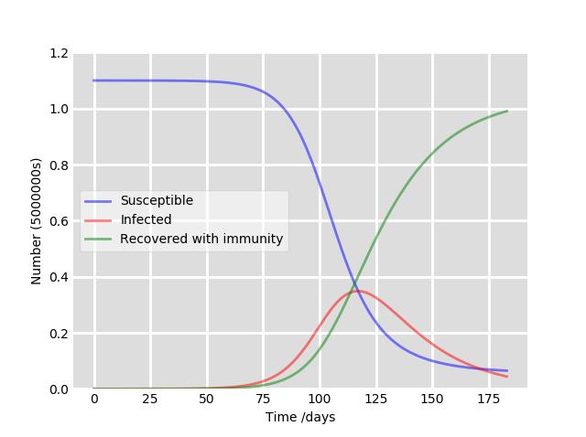

1. Annex A
2. See *2.3 Limitations*
3. See *3. Key Junctures*