Isabel Dinan

9/26/2022

Unix Programming

2. /Users/isabeldinan/unixprogramming/dinan

3. 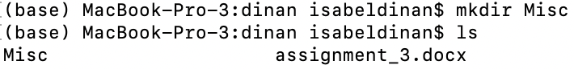

4. 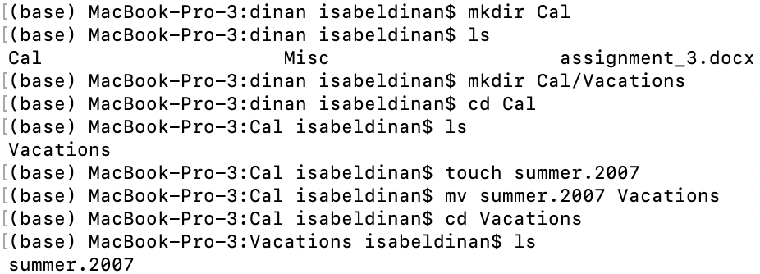

5.

fun

summer.2007

Vacations

Misc

assignment_3.docx

Cal

dinan