Name: Anaelle Jolivet

Date: 16 sept 2022

Course: Unix 255U

2. /home/centos/anaelle

3. 

4. 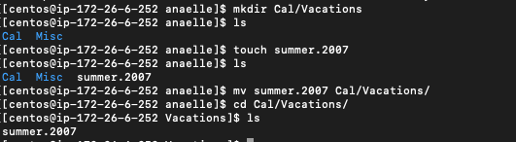

5.