Name: Quynh Nguyen

Date: Oct 31, 2022

Course: Unix 255U

**Assignment 7**

Chapter 33

5.

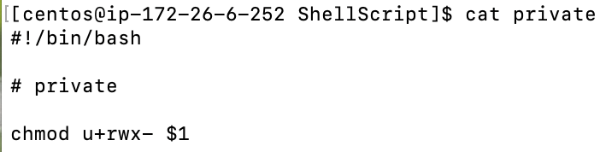

6.

7.

10.

