# Unix assignment 3

## Chapter 8:

2) the absolute pathname of the home directory is /

3) 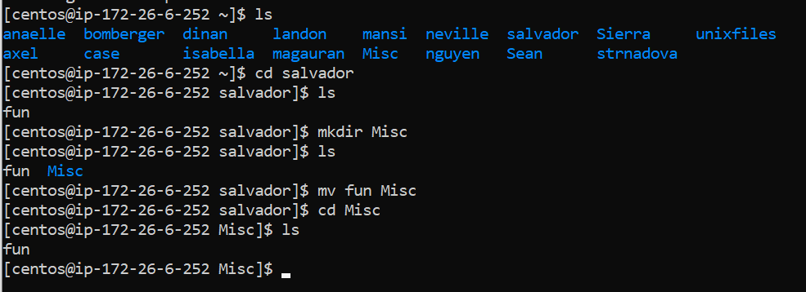

4) 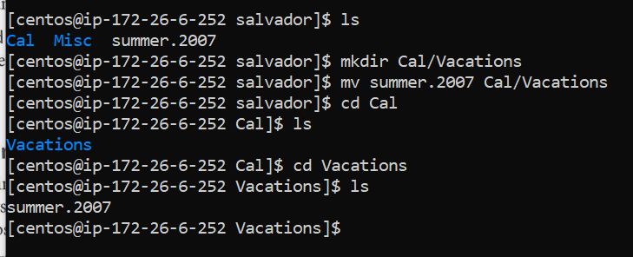

5)