11 April, 2016

**Documentation for**

**Best Cities Series, Graduation Edition**

**The Top 25 List**

Cities are selected based on a hierarchy of per capita real GDP, housing affordability, low unemployment among those who hold a degree, and a young median age. This is a selection of cities based entirely on demographic and economic factors, which address the most basic economic and social needs of a recent graduate. There is a lot of room to interpret and explain the results.

1. San Jose, CA
2. San Francisco, CA
3. Seattle, WA
4. Boston, MA
5. Durham-Chapel Hill area, NC
6. Washington DC, Arlington, and Alexandria area, DC-VA-MD-WV
7. New York area, NY-NJ-PA
8. Houston, TX
9. Boulder, CO
10. Dallas-Fort Worth area, TX
11. Anchorage, AK
12. Portland, OR
13. Hartford, CT
14. Madison, WI
15. Cedar Rapids, IA
16. Minneapolis-St. Paul area, MN-WI
17. Denver, CO
18. Los Angeles, CA
19. Salt Lake City, UT
20. Philadelphia, PA
21. Chicago, IL
22. Omaha, NE
23. Indianapolis, IN
24. Baltimore, MD
25. Milwaukee, WI

|  |
| --- |
| **The Top 100 Pool**  This sample contains only Metropolitan Statistical Areas (MSAs) with populations of above 250,000 and per capita GDP levels of above $40,000. |
| 1. San Jose-Sunnyvale-Santa Clara, CA |
| 1. San Francisco-Oakland-Hayward, CA |
| 1. Seattle-Tacoma-Bellevue, WA |
| 1. Boston-Cambridge-Newton, MA-NH |
| 1. Durham-Chapel Hill, NC |
| 1. Washington-Arlington-Alexandria, DC-VA-MD-WV |
| 1. New York-Newark-Jersey City, NY-NJ-PA |
| 1. Houston-The Woodlands-Sugar Land, TX |
| 1. Boulder, CO |
| 1. Dallas-Fort Worth-Arlington, TX |
| 1. Anchorage, AK |
| 1. Portland-Vancouver-Hillsboro, OR-WA |
| 1. Hartford-West Hartford-East Hartford, CT |
| 1. Madison, WI |
| 1. Cedar Rapids, IA |
| 1. Minneapolis-St. Paul-Bloomington, MN-WI |
| 1. Denver-Aurora-Lakewood, CO |
| 1. Los Angeles-Long Beach-Anaheim, CA |
| 1. Salt Lake City, UT |
| 1. Philadelphia-Camden-Wilmington, PA-NJ-DE-MD |
| 1. Chicago-Naperville-Elgin, IL-IN-WI |
| 1. Omaha-Council Bluffs, NE-IA |
| 1. Indianapolis-Carmel-Anderson, IN |
| 1. Baltimore-Columbia-Towson, MD |
| 1. Milwaukee-Waukesha-West Allis, WI |
| 1. Cleveland-Elyria, OH |
| 1. Charlotte-Concord-Gastonia, NC-SC |
| 1. Nashville-Davidson--Murfreesboro--Franklin, TN |
| 1. Austin-Round Rock, TX |
| 1. Columbus, OH |
| 1. Kansas City, MO-KS |
| 1. Baton Rouge, LA |
| 1. Ann Arbor, MI |
| 1. Atlanta-Sandy Springs-Roswell, GA |
| 1. Harrisburg-Carlisle, PA |
| 1. Pittsburgh, PA |
| 1. Raleigh, NC |
| 1. Norwich-New London, CT |
| 1. Cincinnati, OH-KY-IN |
| 1. Green Bay, WI |
| 1. Albany-Schenectady-Troy, NY |
| 1. Detroit-Warren-Dearborn, MI |
| 1. Richmond, VA |
| 1. Tulsa, OK |
| 1. Lafayette, LA |
| 1. Lincoln, NE |
| 1. Huntsville, AL |
| 1. Birmingham-Hoover, AL |
| 1. Peoria, IL |
| 1. Santa Maria-Santa Barbara, CA |
| 1. St. Louis, MO-IL |
| 1. Little Rock-North Little Rock-Conway, AR |
| 1. Louisville/Jefferson County, KY-IN |
| 1. Virginia Beach-Norfolk-Newport News, VA-NC |
| 1. Toledo, OH |
| 1. Beaumont-Port Arthur, TX |
| 1. Oklahoma City, OK |
| 1. Corpus Christi, TX |
| 1. Greensboro-High Point, NC |
| 1. Davenport-Moline-Rock Island, IA-IL |
| 1. Evansville, IN-KY |
| 1. Shreveport-Bossier City, LA |
| 1. Grand Rapids-Wyoming, MI |
| 1. Fayetteville-Springdale-Rogers, AR-MO |
| 1. Miami-Fort Lauderdale-West Palm Beach, FL |
| 1. Sacramento--Roseville--Arden-Arcade, CA |
| 1. Orlando-Kissimmee-Sanford, FL |
| 1. Jackson, MS |
| 1. Rochester, NY |
| 1. Atlantic City-Hammonton, NJ |
| 1. Buffalo-Cheektowaga-Niagara Falls, NY |
| 1. Phoenix-Mesa-Scottsdale, AZ |
| 1. Dayton, OH |
| 1. Fort Wayne, IN |
| 1. Syracuse, NY |
| 1. Providence-Warwick, RI-MA |
| 1. Charleston-North Charleston, SC |
| 1. Wilmington, NC |
| 1. Albuquerque, NM |
| 1. Crestview-Fort Walton Beach-Destin, FL |
| 1. Wichita, KS |
| 1. Reno, NV |
| 1. San Luis Obispo-Paso Robles-Arroyo Grande, CA |
| 1. Salinas, CA |
| 1. Fayetteville, NC |
| 1. Jacksonville, FL |
| 1. Amarillo, TX |
| 1. Las Vegas-Henderson-Paradise, NV |
| 1. Roanoke, VA |
| 1. Columbia, SC |
| 1. Naples-Immokalee-Marco Island, FL |
| 1. Lancaster, PA |
| 1. Lansing-East Lansing, MI |
| 1. San Antonio-New Braunfels, TX |
| 1. Fort Collins, CO |
| 1. Montgomery, AL |
| 1. Boise City, ID |
| 1. Tampa-St. Petersburg-Clearwater, FL |
| 1. Knoxville, TN |
| 1. Mobile, AL |

**Methodology**

The top 100 pool of cities was selected based on the following factors.

1. Population size

2. Percentage of population aged 20-29

3. Median age

4. Employment rate in the 20-24 age group

5. Percentage of working-age population who hold a bachelor’s degree

6. Employment rate of working-age degree holders  
7. Per capita personal income  
8. Per capita real GDP  
9. Median income  
10. Employment levels in management, business, science, and arts occupations

11. Median income in management, business, science, and arts occupations

12. Employment levels in service occupations

13. Median income in service occupations

14. Employment levels in sales and office occupations

15. Median income in sales and office occupations  
16. Housing affordability index  
17. Quality-of-life index  
18. Amenities index

**Assumptions**

In choosing the top 100 based on population and median earnings, I made the following assumptions:

1. Holding all other factors constant, a higher population offers a higher likelihood of making friends and finding jobs.

2. People prefer higher earnings to lower earnings

In choosing the top 25 by four variables (per capita real GDP, housing affordability, low unemployment among those who hold a degree, and a young median age), I made the following assumptions:

1. Economic strength and employment are the highest priorities for college graduates entering the job market.

2. Housing affordability is the second highest priority for entry-level workers. They want to have the option to start saving or consume more by not having to spend disproportionate amounts on housing.

3. People tend to prefer to socialize with people in the same age group, and that’s the third highest priority for entry-level workers.

Data come from the Census Bureau, the Bureau of Economic Analysis, and the Bureau of Labor Statistics.

The indices on housing affordability, quality of life, and amenities are based on Professor David Albouy’s 2015 [paper](http://davidalbouy.net/cityvalue.pdf), What Are Cities Worth? Land Rents, Local Productivity, and the Total Value of Amenities.

The amenities index includes factors of weather, average slope of land (presence of mountains), coastal proximity, crime rate, air quality, availability of bars and restaurants, and availability of arts and culture services. I transformed the original index values to eliminate negative values.

The quality-of life index is based on the results from a model developed by Albouy, based on a series of scaled economic factors that express the cost of living, the price of capital, wages, tax rate, quality of life, and productivity.

**Additional Comments**

A hierarchical clustering analysis shows a descriptive view (Fig. 1) on clusters of cities that have the most similarity among cluster members, based on the selection factors. The higher level a city is at in the tree diagram, the less similar it is to other cities. New York, towards the bottom of Fig.2, is almost unique among all cities in the pool, based on the selection factors.

In the hand-drawn diagram (Fig. 2), the cluster on the top that includes Naples, Denver, and Seattle is a refreshing collection. Looking deeper into these can be a novel approach to selecting a relocation destination.

The large cluster on the far right contains mostly middle-of-the-road cities, and you can cherry-pick the ones that you think might be a good market to target with the promotional campaign. Naturally, it seems that focusing on the top cluster of surprise cities and the bottom clusters of cliché megacities would capture good chunks of market share.

Sometimes the location destination does depend heavily on the choice of career. This dependency could be higher than ever for a generation that grew up during the Great Recession.

For students pursuing a career in institutional finance, New York is the first choice. For students choosing a career in computer science, the Bay Area and Silicon Valley are no-brainers. Laid-back artsy types might tend towards cities like Madison, Minneapolis and Omaha, where they can stretch their money and hang out for a little before starting to work. For graduates pursuing a professional services career, the most favorable jobs are often located in megacities.

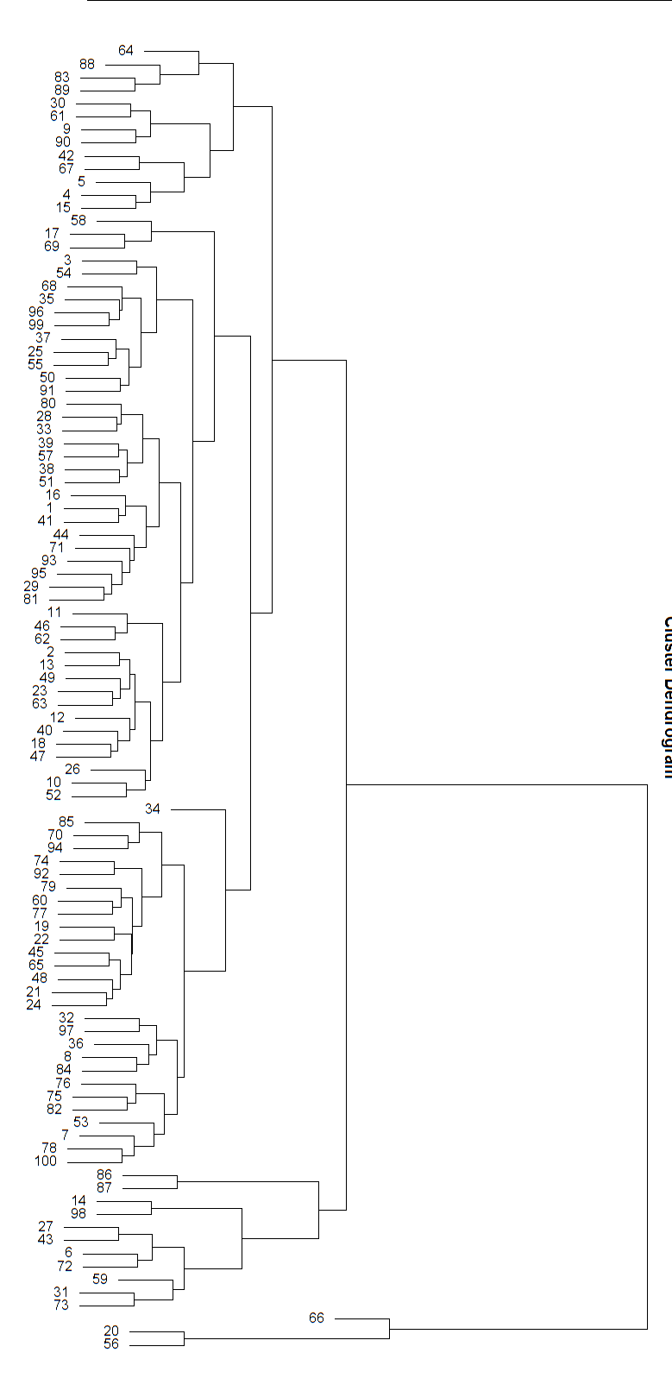

Figure 1. Tree diagram that clusters cities according to similarity.

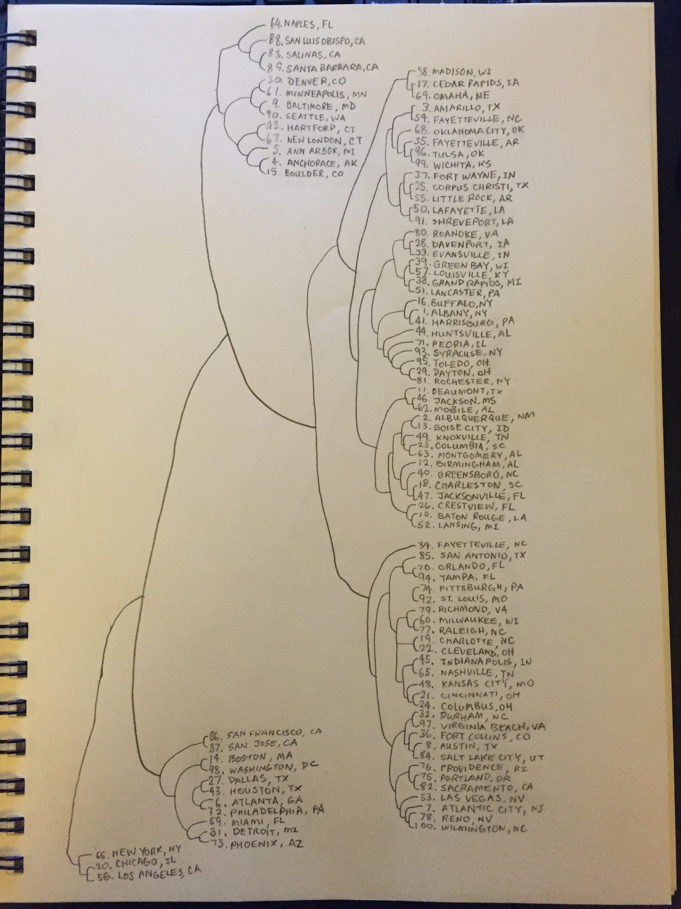

Figure 2. Tree diagram showing names of cities clustered with similar members in the pool.