**DEFECTS – SAVE BANK DETAILS**

1. **Defect #1: Error message ‘Length of account_number should be between 7 and 11 when bank_country_code is US’ is shown instead of 'Length of account_number should be between 1 and 17 when bank_country_code is US'**

Requirement

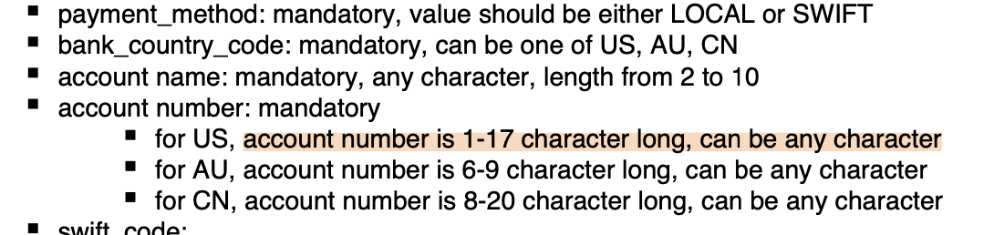

Steps to recreate:

1. Send the request payload below:

{

"payment_method": "LOCAL",

"bank_country_code": "US",

"account_name": "ab",

"account_number": "1234567890-87650A!",

"swift_code": "",

"bsb": "123898",

"aba": ""

}

1. Validate if request return an error with the error message 'Length of account_number should be between 1 and 17 when bank_country_code is US' is shown

Expected results:

'Length of account_number should be between 1 and 17 when bank_country_code is US' is returned

Actual results:

‘Length of account_number should be between 7 and 11 when bank_country_code is US’

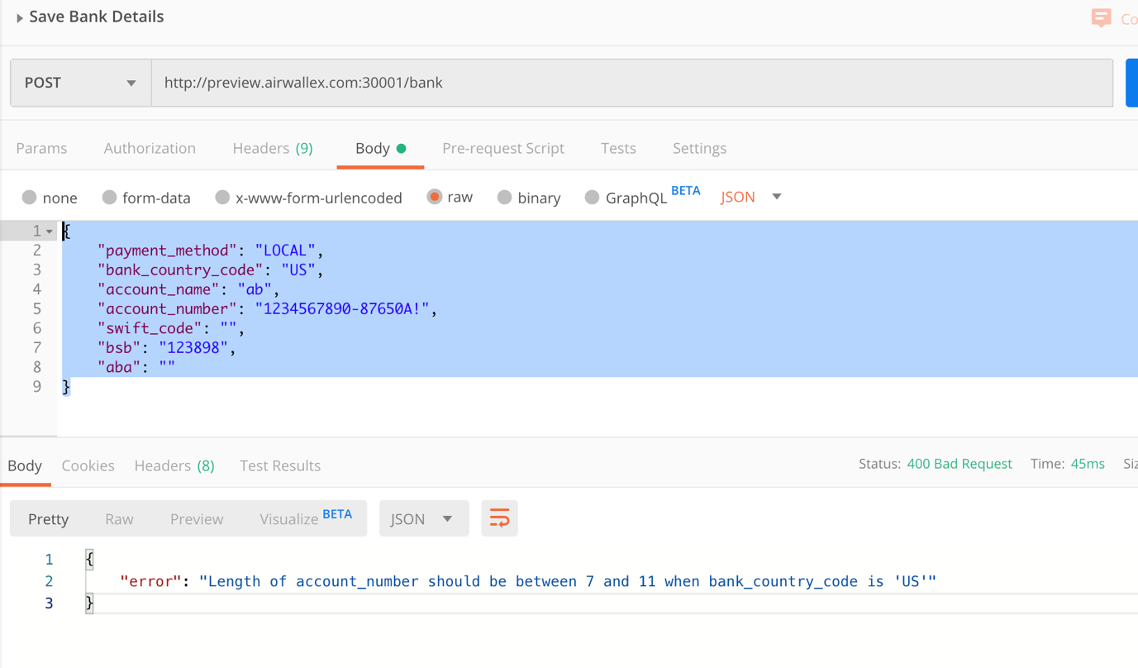

1. **Defect #2: Error message ‘Length of account_number should be between 7 and 11 when bank_country_code is US’ is shown for invalid account number for AU and CN banks**

**Requirement**



Steps to recreate:

1. Send the request payload below:

{

"payment_method": "LOCAL",

"bank_country_code": "US",

"account_name": "ab",

"account_number": "1234567890-87650A!",

"swift_code": "",

"bsb": "123898",

"aba": ""

}

1. Validate if request return an error with the error message 'Length of account_number should be between 1 and 17 when bank_country_code is US' is shown

Expected results:

'Length of account_number should be between 1 and 17 when bank_country_code is US' is returned

**Actual results:**

‘Length of account_number should be between 7 and 11 when bank_country_code is US’



1. **Defect #3: Account Number error message is displayed when account number is 20 characters for country code 'CN' bank details**

Requirement



Steps to recreate:

1. Send the request payload below:

{

"payment_method": "LOCAL",

"bank_country_code": "CN",

"account_name": "JohnCo",

"account_number": "8898-4321-0981-1111!",

"swift_code": "",

"bsb": "",

"aba": ""

}

1. Validate if bank details is saved

Expected results:

Bank details is saved

Actual results:

‘Length of account_number should be between 7 and 11 when bank_country_code is US’ is returned (refer to defect 1 as it is not the appropriate error message)



1. **Defect #4: Bank details is saved when account number is less than 8 characters for CN country code**

Requirement



Steps to recreate:

1. Send the request payload below:

{

"payment_method": "LOCAL",

"bank_country_code": "CN",

"account_name": "JohnCo",

"account_number": "1234567",

"swift_code": "",

"bsb": "",

"aba": ""

}

1. Validate if bank details is saved

Expected results:

‘Length of account_number should be between 8 and 20 when bank_country_code is 'CN'’ is returned

Actual results:

Bank details is saved



1. **Defect #5: 9-10 character swift code is accepted / bank details is saved**

Requirement



Steps to recreate:

1. Send the request payload below:

9 character swift code

{

"payment_method": "SWIFT",

"bank_country_code": "AU",

"account_name": "Savings",

"account_number": "8834219",

"swift_code": "12-4AUCD#",

"bsb": "088123",

"aba": ""

}

10 character swift code

{

"payment_method": "SWIFT",

"bank_country_code": "AU",

"account_name": "Savings",

"account_number": "8834219",

"swift_code": "12-4AUCD 0",

"bsb": "088123",

"aba": ""

}

1. Validate if error message 'Length of 'swift_code' should be either 8 or 11' is returned

Expected results:

Error message 'Length of 'swift_code' should be either 8 or 11' is returned

Actual results:

Bank details is saved

9 character swift code

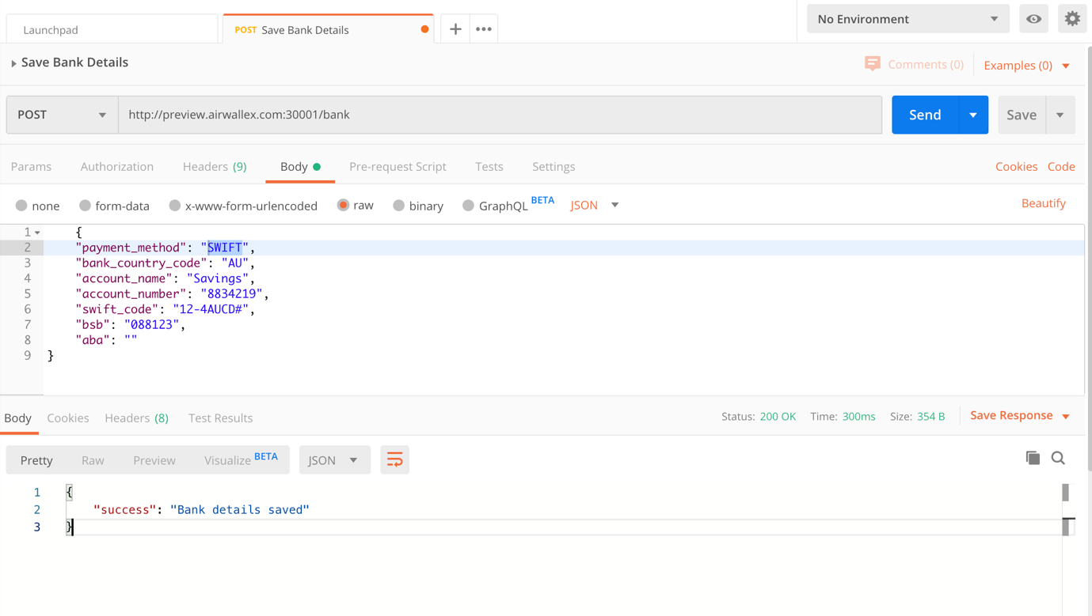

10 characters

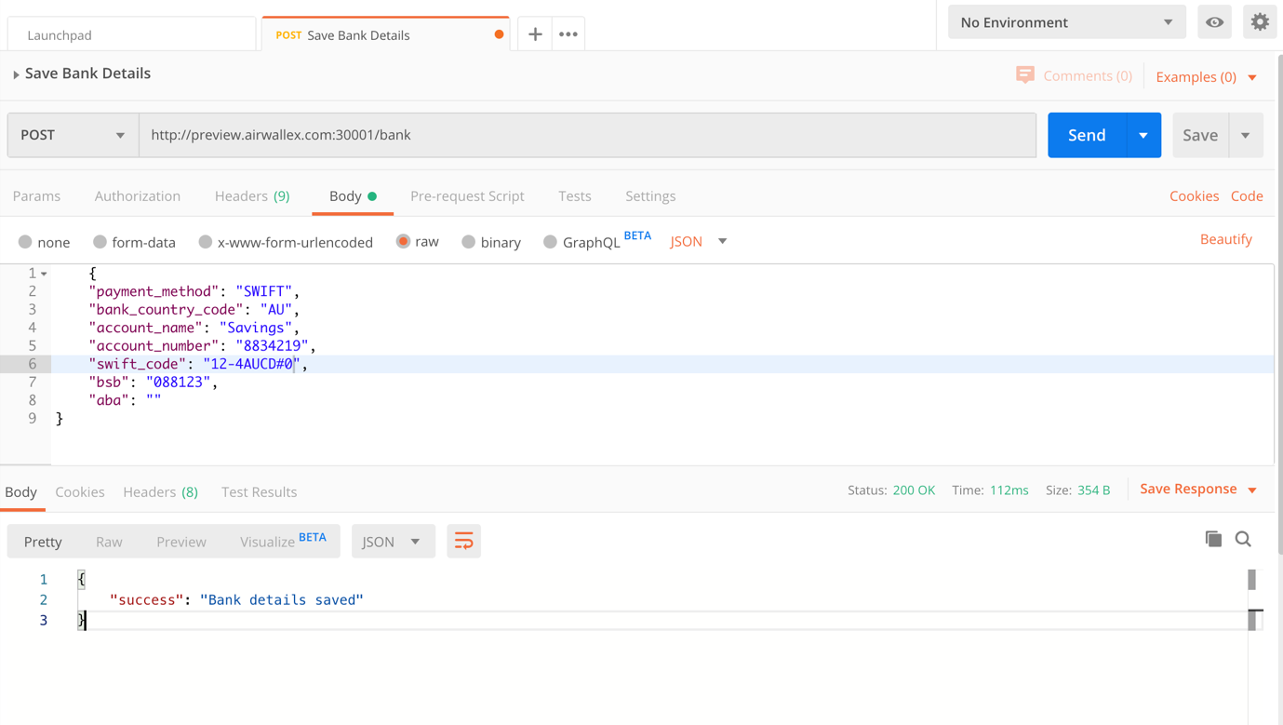

1. **Defect #6 Bank Details is saved when ABA is blank for Country code US**

Requirement

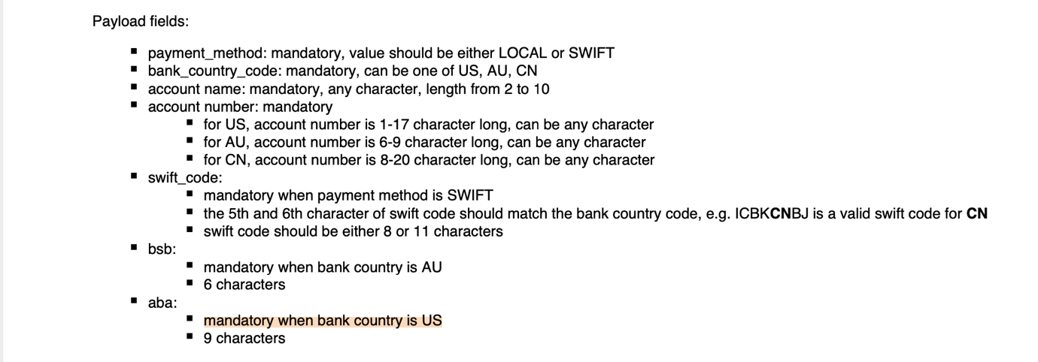

Steps to recreate:

1. Send the request payload below:

{

"payment_method": "SWIFT",

"bank_country_code": "US",

"account_name": "Business",

"account_number": "8834219-0123",

"swift_code": "12-4US7811",

"bsb": "",

"aba": ""

}

1. Validate if error message ''aba' is required when bank country code is 'US'' is returned

Expected results:

'aba' is required when bank country code is 'US' is returned

Actual results:

Bank details is saved

