Analyses

E.Kozma

Last modified: 2021-02-16

## Summary

The strength data set was compiled from the [KNHANES](https://knhanes.cdc.go.kr/knhanes/main.do) and the [NHANES](https://wwwn.cdc.gov/nchs/nhanes/) surveys

summary(strength)

## survey ID sex age   
## Length:5227 Length:5227 Length:5227 Min. :18.00   
## Class :character Class :character Class :character 1st Qu.:26.00   
## Mode :character Mode :character Mode :character Median :35.00   
## Mean :34.21   
## 3rd Qu.:42.00   
## Max. :50.00   
## hgt wt bmi gs.max   
## Min. :128.8 Min. : 34.50 Min. :15.58 Min. :12.00   
## 1st Qu.:160.3 1st Qu.: 58.50 1st Qu.:21.70 1st Qu.:28.50   
## Median :167.2 Median : 69.50 Median :24.60 Median :35.80   
## Mean :167.5 Mean : 73.27 Mean :25.95 Mean :37.91   
## 3rd Qu.:174.2 3rd Qu.: 83.30 3rd Qu.:28.67 3rd Qu.:46.70   
## Max. :204.5 Max. :216.10 Max. :80.60 Max. :85.80   
## gs.mean   
## Min. : 8.183   
## 1st Qu.:25.833   
## Median :32.500   
## Mean :34.498   
## 3rd Qu.:42.733   
## Max. :78.050

## PLOTS

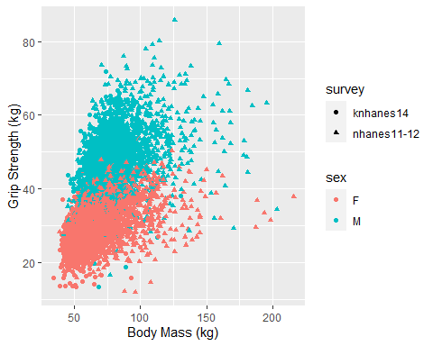

Fig. 1: Maximum grip strenght as a function on body mass in men and women