Workflow PieGraph

Here is a pie graph for one single workflow ID, and we will modify it soon.

Firstly, input a workflow ID, here is “7113f605-aca8-461e-b734-39a357c09ed7”, and the following is the pie graph.

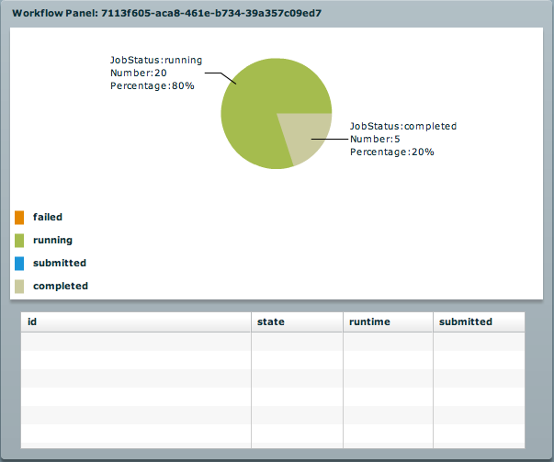

Secondly, when clicking the completed area, the table will show the corresponding information of that area, which includes five successful jobs in the table.

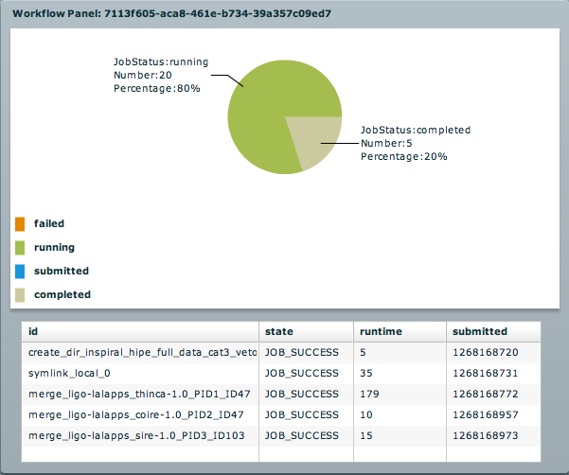

Finally, when clicking the green area, the table will show the corresponding information of that area, which includes 20 running jobs.

