**II. Data**

To study the feasibility of this project, first of all we evaluated the presence of shops in the area. To do this, we used data from the Wikipedia webpage, which was submitted to a scrapping process.

1. 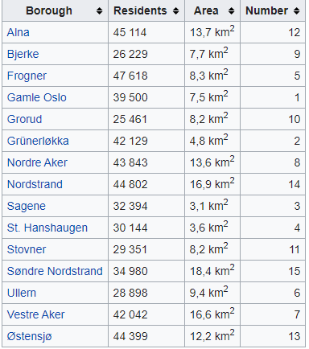**List of boroughs in Oslo**

<https://en.wikipedia.org/wiki/List_of_boroughs_of_Oslo>

1. **List of exact locations and commercial activity**

From the obtained data GEOLOCATOR is used in order to determine the precise location of each one of the neighborhood, and to extract the sort of businesses present in the vicinity with FOURSQUARE API.

<https://developer.foursquare.com/docs>

The information was compared in regard to the commercial activity of the different boroughs in Oslo by clustering analysis. From the neighborhoods, we will use Foursquare to obtain information regarding the presence of businesses which will be subjected to a clustering analysis.