Assignment 2
Name: E Renu Sree
Reg no: 192511035
Q1. code:
public class TicketBenchmark {
static final int FIELDS = 50;
static final int TICKETS = 10000;
static String[] makeFields() {
String[] a = new String[FIELDS];
for (int i = 0; i < FIELDS; i++) a[i] = "Field" + i + "=Value" + i;
return a;
}
static String usingString(String[] fields) {
String ticket = "";
for (String field : fields) ticket = ticket + field + "\n";
return ticket;
}
static String usingBuilder(String[] fields) {
StringBuilder ticket = new StringBuilder();
for (String field : fields) ticket.append(field).append('\n');
return ticket.toString();
}
static String usingBuffer(String[] fields) {
StringBuffer ticket = new StringBuffer();
for (String field : fields) ticket.append(field).append('\n');
return ticket.toString();
}
static long test(int method, String[] fields) {
long start = System.nanoTime();
long checksum = 0;
for (int i = 0; i < TICKETS; i++) {
String result;
if (method == 1) result = usingString(fields);
else if (method == 2) result = usingBuilder(fields);
else result = usingBuffer(fields);
checksum += result.length();
}
long end = System.nanoTime();
System.out.println("Checksum: " + checksum);
return end - start;
}
public static void main(String[] args) {
String[] fields = makeFields();
// Warm-up
for (int i = 0; i < 3; i++) {
test(1, fields); test(2, fields); test(3, fields);
}
long s = 0, b = 0, bf = 0;
int runs = 5;
for (int i = 0; i < runs; i++) {
s += test(1, fields);
b += test(2, fields);
bf += test(3, fields);
}
System.out.println("String average ns: " + s / runs);
System.out.println("StringBuilder average ns: " + b / runs);
System.out.println("StringBuffer average ns: " + bf / runs);
}
}
Output:
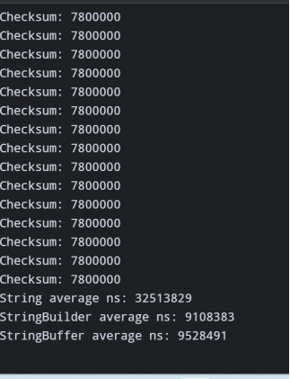
Q2:
Code:
import java.util.*;
public class PlaylistDemo {
public static void main(String[] args) {
List<String> array = new ArrayList<>();
List<String> linked = new LinkedList<>();
for (int i = 1; i <= 5; i++) {
array.add("Song" + i);
linked.add("Song" + i);
}
array.add(0, "NewSong");
linked.add(0, "NewSong");
array.remove(2);
linked.remove(2);
System.out.println("ArrayList: " + array);
System.out.println("LinkedList: " + linked);
System.out.println("Third song: " + array.get(2));
Deque<String> upNext = new ArrayDeque<>();
upNext.addLast("SongA");
upNext.addLast("SongB");
upNext.addFirst("UrgentSong");
System.out.println("Next: " + upNext.removeFirst());
System.out.println("Remaining: " + upNext);
}
}
Expected output:
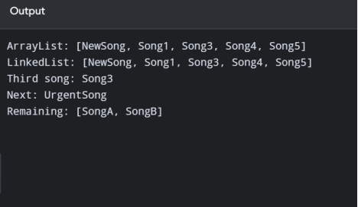
Q3:
Code:
import java.util.HashSet;
import java.util.Objects;
import java.util.Set;
class Student {
private final String regNo;
private final String name;
Student(String regNo, String name) {
this.regNo = regNo;
this.name = name;
}
@Override
public boolean equals(Object o) {
if (this == o) return true;
if (!(o instanceof Student)) return false;
Student other = (Student) o;
return Objects.equals(regNo, other.regNo);
}
@Override
public int hashCode() {
return Objects.hash(regNo);
}
@Override
public String toString() {
return regNo + " " + name;
}
}
public class Attendance {
public static void main(String[] args) {
Set<Student> present = new HashSet<>();
present.add(new Student("192311001", "Arun"));
present.add(new Student("192311002", "Divya"));
present.add(new Student("192311001", "Arun"));
System.out.println("Unique students: " + present.size());
}
}
Expected output:
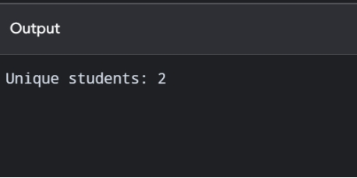
Q4:
Code:
import java.util.*;
public class PharmacyInventory {
public static void main(String[] args) {
Map<String, Integer> hash = new HashMap<>();
Map<String, Integer> sorted = new TreeMap<>();
Map<String, Integer> insertion = new LinkedHashMap<>();
String[][] data = {
{"M103", "25"}, {"M101", "40"}, {"M105", "12"}, {"M102", "30"}
};
for (String[] item : data) {
String code = item[0];
int stock = Integer.parseInt(item[1]);
hash.put(code, stock);
sorted.put(code, stock);
insertion.put(code, stock);
}
System.out.println("Stock of M103: " + hash.get("M103"));
System.out.println("Code order: " + sorted);
System.out.println("Insertion order: " + insertion);
}
}
Expected output:
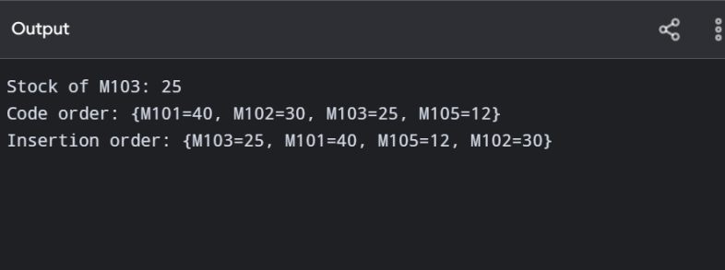

Q5:
Code:
import java.util.*;
class Team {
final String name;
final int points;
final int goalDiff;
Team(String name, int points, int goalDiff) {
this.name = name;
this.points = points;
this.goalDiff = goalDiff;
}
@Override
public String toString() {
return name + "(" + points + "," + goalDiff + ")";
}
}
class Leaderboard<T> {
private final List<T> items = new ArrayList<>();
private final Comparator<? super T> order;
Leaderboard(Comparator<? super T> order) {
this.order = order;
}
void add(T item) {
items.add(item);
}
List<T> ranking() {
List<T> copy = new ArrayList<>(items);
copy.sort(order);
return copy;
}
}
public class LeaderboardDemo {
public static void main(String[] args) {
Comparator<Team> byRank =
Comparator.comparingInt((Team t) -> t.points).reversed()
.thenComparing(
Comparator.comparingInt((Team t) -> t.goalDiff).reversed())
.thenComparing(t -> t.name);
Leaderboard<Team> board = new Leaderboard<>(byRank);
board.add(new Team("Panthers", 9, 4));
board.add(new Team("Eagles", 9, 6));
board.add(new Team("Cobras", 6, 1));
board.add(new Team("Bisons", 9, 4));
System.out.println(board.ranking());
}
}
Expected output:
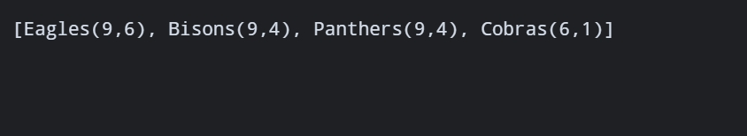

Q6:
Code:
import java.util.Comparator;
import java.util.PriorityQueue;
class Patient {
final String name;
final int severity;
final long arrival;
Patient(String name, int severity, long arrival) {
this.name = name;
this.severity = severity;
this.arrival = arrival;
}
@Override
public String toString() {
return name + "(S" + severity + ")";
}
}
public class Triage {
private long counter = 0;
private final PriorityQueue<Patient> queue =
new PriorityQueue<>(
Comparator.comparingInt((Patient p) -> p.severity)
.thenComparingLong(p -> p.arrival)
);
void admit(String name, int severity) {
if (severity < 1 || severity > 5)
throw new IllegalArgumentException("Severity must be 1 to 5");
queue.add(new Patient(name, severity, counter++));
}
Patient next() {
return queue.poll();
}
public static void main(String[] args) {
Triage er = new Triage();
er.admit("Ravi", 3);
er.admit("Meena", 1);
er.admit("John", 3);
er.admit("Asha", 5);
er.admit("Kumar", 1);
er.admit("Lata", 2);
StringBuilder order = new StringBuilder();
Patient p;
while ((p = er.next()) != null) {
order.append(p).append(' ');
}
System.out.println(order.toString().trim());
}
}
Expected output:


