CO1_AT1_ASSIGNMENT 1
PROGRAMMING IN JAVA (CSA0907)
Assignment Title: Design, Implement and Validate an Object-Oriented Model for a Campus Smart-Parking System
Name: Renu Sree E
Register Number: 192511035
Submission Date: 20/10/2026
Git hub link: https://github.com/elakatirenu/CSA0907_Renusree_192511035.git

TASK 1 – Understand the Problem and Identify the Objects

1.1 Inputs and outputs
- Inputs: vehicle registration number and category, floor/slot availability, entry and exit time, user category, pass validity, and EV charging units.
- Outputs: allocated floor and slot, unique ticket number, entry/exit record, parking fee, charging fee, occupancy status, and error messages when an operation is invalid.

1.2 Candidate classes and responsibilities
Class | Responsibility / justification
Vehicle | Stores registration number and defines common vehicle behaviour.
TwoWheeler, Car, ElectricCar | Represent vehicle categories with their own hourly rates; ElectricCar adds charging capability.
ParkingSlot | Represents one slot and ensures it contains at most one vehicle.
ParkingFacility | Owns the floors/slots and allocates or releases slots.
ParkingTicket | Stores ticket ID, vehicle, entry time and exit time; connects a parking session to its fee.
ParkingUser / Pass | Represents student, staff or visitor and whether a valid pass applies.
PricingRule | Separates fee calculation rules from the facility and vehicle storage.
ParkingService | Coordinates entry, exit, ticket lookup and payment.

1.3 Nouns, verbs and business rules
Candidate nouns become classes or fields: vehicle, floor, slot, ticket, user, pass and fee. Action verbs become methods:
registerVehicle(), allocate(), release(), issueTicket(), calculateFee(), charge(), and validatePass().
- A slot can contain no more than one vehicle.
- Every ticket ID is unique and is never reused during the application run.
- A vehicle with an active ticket cannot enter again using the same registration number.
- Only a valid occupied slot can be released; invalid floor/slot values must be rejected.
- Negative parking duration and negative charging units are invalid.
- Monthly-pass students and staff park free while their pass is valid; visitors pay unless a valid visitor pass rule applies.
- An EV charging fee is separate from its parking fee.

1.4 Assumptions
- Registration numbers are unique and compared without accidental whitespace.
- Parking duration is rounded up to each started hour.
- The facility is represented with zero-based floor and slot indexes internally.
- For the initial model, a suitable slot means the first available slot; charging-slot compatibility can be added as a slot attribute.

1.5 Alternative: objects vs parallel arrays
With objects, each Vehicle groups registration, type, rate and future attributes. Searching an unsorted collection by registration takes O(n); adding an attribute means updating the class and its constructors/accessors. With parallel arrays regNo[], type[], entryTime[], a search also takes O(n), but every attribute must be added to and kept aligned across multiple arrays. Both approaches use O(n) storage, but objects are easier to maintain and less error-prone. Object references and object headers add some memory overhead.

TASK 2 – Choose the Data Representation
Data | Suggested type | Reason
Floor index / slot index | int | Indexes are whole numbers.
Registration number | String | Contains letters and digits.
Entry / exit time | LocalDateTime | Represents date and time safely.
Duration | long or int minutes | Whole minutes; long avoids overflow for long intervals.
Fee / hourly rate | double or BigDecimal | double is simple for coursework; BigDecimal is preferable for exact currency.
Pass validity | boolean / LocalDate | Boolean status or explicit expiry date.
Charging energy | double | Energy may be fractional kWh.
Use a jagged array such as String[][] slots because each floor may have a different number of slots. A two-dimensional rectangular array assumes equal slot counts; a jagged array allows slots[floor].length to vary. Use Scanner for console input, with careful handling when mixing nextInt() and nextLine().
Casting risk: 130 / 60 using integer division equals 2, but 130 minutes means 3 billable started hours. Avoid this by using (minutes + 59) / 60 for non-negative minutes. For 130 minutes, (130 + 59) / 60 = 3.
Alternative representations: a single array with index = floor × slotsPerFloor + slot works only when all floors have the same slot count, unless prefix offsets are maintained. A jagged array uses O(total slots) storage and direct O(1) access when floor and slot are known. ArrayList<String[]> also supports variable floor sizes and can grow the list of floors, while indexing a known floor/slot remains O(1).

TASK 3 – Design the Control Logic

3.1 Pseudocode: allocate a slot
ALGORITHM Allocate(vehicleNo)
FOR each floor f from 0 to numberOfFloors - 1
FOR each slot s from 0 to slots[f].length - 1
IF slots[f][s] is null THEN slots[f][s] = vehicleNo
RETURN (f, s)
END IF
END FOR
END FOR
RETURN null // no suitable slot is available
END ALGORITHM

3.2 Pseudocode: compute fee
ALGORITHM CalculateFee(minutes, ratePerHour)
IF minutes < 0 THEN
RETURN error
END IF hours = (minutes + 59) DIV 60 fee = hours * ratePerHour IF fee > dailyMaximum THEN fee = dailyMaximum
END IF
RETURN fee
END ALGORITHM
The inner loop checks slots, and return immediately stops searching once a free slot is found. If a slot is unsuitable, continue can skip it. break exits a loop when no further search is needed. If all slots are occupied, allocate returns null.

3.3 Completed code: ParkingFacility.java
import java.util.Arrays;

public class ParkingFacility { private final String[][] slots;

public ParkingFacility(int[] slotsPerFloor) { slots = new String[slotsPerFloor.length][]; for (int f = 0; f < slotsPerFloor.length; f++) { slots[f] = new String[slotsPerFloor[f]];
}
}

public int[] allocate(String vehicleNo) { for (int f = 0; f < slots.length; f++) { for (int s = 0; s < slots[f].length; s++) { if (slots[f][s] == null) { slots[f][s] = vehicleNo; return new int[]{f, s};
}
} }
return null; }

public boolean release(int floor, int slot) { if (floor < 0 || floor >= slots.length) return false; if (slot < 0 || slot >= slots[floor].length) return false; if (slots[floor][slot] == null) return false; slots[floor][slot] = null; return true;
}
public static void main(String[] args) {
ParkingFacility p = new ParkingFacility(new int[]{2, 1});
System.out.println(Arrays.toString(p.allocate("TN01AB1111")));
System.out.println(Arrays.toString(p.allocate("TN02CD2222")));
System.out.println(Arrays.toString(p.allocate("TN03EF3333")));
System.out.println(Arrays.toString(p.allocate("TN04GH4444")));
System.out.println(p.release(0, 1) + " " + p.release(0, 1) + " "
+ p.release(5, 0));
System.out.println(Arrays.toString(p.allocate("TN04GH4444")));
} }
Expected output:
[0, 0]
[0, 1] [1, 0] null
true false false
[0, 1]
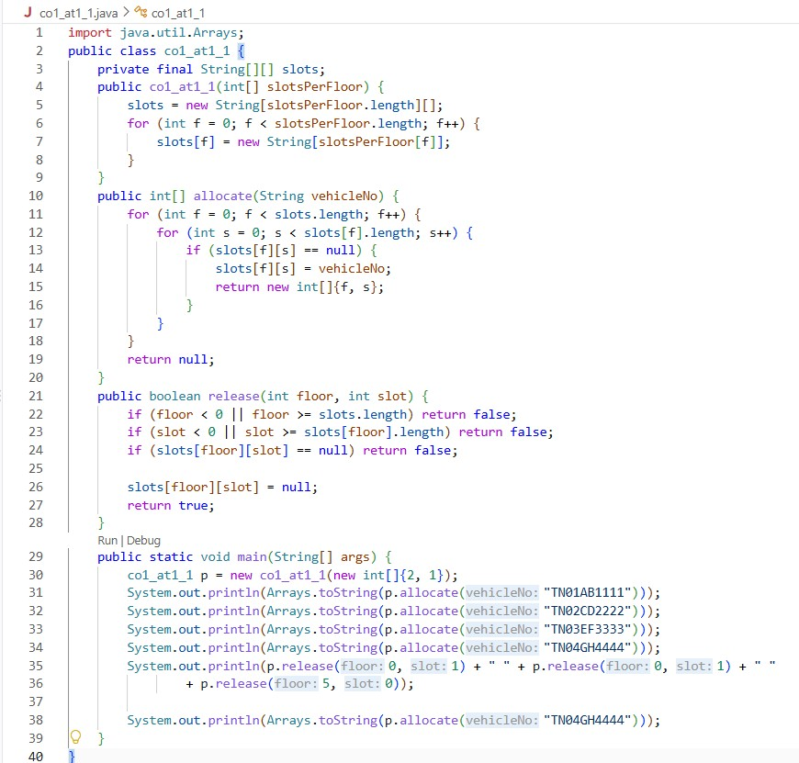

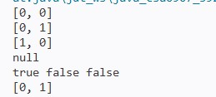

3.4 Alternative and complexity
A simple scan can take O(N) time for allocation, where N is the total number of slots; release is O(1) when the floor and slot are known. Maintaining a stack of free positions can make allocation and release O(1) amortized, but it needs O(N) extra storage for the free-position stack and care to prevent duplicate stack entries. A free-count per floor can skip full floors but does not alone identify the free slot.

TASK 4 – Design Classes, Objects and Constructors
Vehicle should have a parameterised constructor to require a registration number. ParkingTicket can offer a parameterised constructor for a valid vehicle and entry time, and an overloaded constructor that uses the current time. Constructor chaining with this(...) avoids duplicated validation. A copy constructor is not suitable for issuing a new ticket because a duplicate ticket ID would violate uniqueness; a separate ticket must receive a new ID.
class ParkingTicket { private final long ticketId; private final String regNo;
private final java.time.LocalDateTime entryTime;

ParkingTicket(long ticketId, String regNo) { this(ticketId, regNo, java.time.LocalDateTime.now());
}

ParkingTicket(long ticketId, String regNo, java.time.LocalDateTime entryTime) { if (ticketId <= 0 || regNo == null || regNo.isBlank()
|| entryTime == null) { throw new IllegalArgumentException("Invalid ticket data");
} this.ticketId = ticketId; this.regNo = regNo; this.entryTime = entryTime;
}

public long getTicketId() { return ticketId; } public String getRegNo() { return regNo; }
public java.time.LocalDateTime getEntryTime() { return entryTime; }
}
The reference variable is typically stored in a stack frame while the object is created on the heap. The reference points to the object. With a default constructor followed by setters, an object can temporarily be invalid unless every setter validates. A static factory method such as ParkingTicket.create(...) can validate and control object creation. Creating n tickets is O(n) time and O(n) total storage in all approaches; constructor chaining and factories do not change the asymptotic complexity.

TASK 5 – Apply static Members and the Object Life Cycle
A static ticket counter belongs to the class because it must be shared by all tickets: private static long nextTicketId = 1; A static method can generate the next ID. Instance fields such as regNo and entryTime must not be static because each ticket differs. A static block is appropriate only for one-time class initialization, not routine ticket creation.
class TicketIdGenerator { private static long nextId = 1; private TicketIdGenerator() {} public static synchronized long nextId() { return nextId++;
}
}
When a vehicle leaves, the ticket can be marked closed and removed from active-ticket storage. It becomes eligible for garbage collection when no reachable reference points to it. Java passes object references by value: a method can mutate the referenced object, but reassigning its local reference does not change the caller’s variable.
If the counter were an instance variable of ParkingFacility, two facilities could generate the same ticket number unless the facility ID were included. Use a shared static generator for globally unique IDs, or use a separate counter per facility with a unique facility prefix. One static counter uses O(1) counter storage for k facilities and n tickets; per-facility counters use O(k) counter storage.

TASK 6 – Design the Inheritance Hierarchy
This is hierarchical inheritance from Vehicle and multilevel inheritance from Vehicle to Car to ElectricCar. Vehicle contains common state (registration number) and common behaviour. TwoWheeler and Car supply hourly rates.
ElectricCar inherits Car behaviour and adds charging. The super(...) call invokes the parent constructor before the subclass constructor body.
Constructor trace for new ElectricCar("TN03C3"): Vehicle constructor → Car constructor → ElectricCar constructor. Java inserts super() if no explicit parent constructor call is present, but here each constructor calls super(regNo).
Composition alternative: Vehicle could contain a VehicleType/rate strategy object. A new type can then often be added by defining a new strategy rather than creating another subclass. Fee calculation is O(1) in either approach; composition adds a small strategy reference per vehicle, while inheritance avoids a separate type object if shared instances are not used.

TASK 7 – Override and Specialise Behaviour
Subclasses override ratePerHour() because their hourly rates differ. Use @Override to let the compiler verify the method signature. An override must have the same signature and a compatible return type, and cannot reduce access visibility. Use final for immutable values such as registration number, for methods that must not be overridden, or for a class that must not be subclassed.
equals() should compare stable identity such as registration number, and hashCode() must use the same identity fields. The assignment’s starter code considers any two Vehicle objects with the same registration number equal, even if their categories differ. This matches the supplied expected output, but a real system may instead reject duplicate active registrations and define equality using both registration and category.
If a single method used switch(vehicleType), fee calculation remains O(1) for a fixed number of cases, or O(k) for a sequential type check across k categories. Adding a type would require changing the central switch. With overriding, the new subtype provides its rate method and existing subclasses can remain unchanged.

TASK 8 – Apply Polymorphism
Compile-time polymorphism is method overloading: calculateFee(int minutes) and calculateFee(LocalTime in, LocalTime out). The compiler selects a method based on argument types. Runtime polymorphism occurs when a Vehicle reference refers to a Car or TwoWheeler object and the overridden method for the actual object executes.

Completed code: FeeDemo.java
interface Chargeable {
double chargingFee(int kWh);
}

abstract class Vehicle { private final String regNo;

protected Vehicle(String regNo) { this.regNo = regNo; } public String getRegNo() { return regNo; } protected abstract double ratePerHour();

public double calculateFee(int minutes) { if (minutes < 0) throw new IllegalArgumentException("Minutes cannot be negative"); int hours = (minutes + 59) / 60; return hours * ratePerHour(); }

public double calculateFee(java.time.LocalTime in,
java.time.LocalTime out) { long minutes = java.time.Duration.between(in, out).toMinutes(); if (minutes < 0) minutes += 24 * 60; return calculateFee((int) minutes);
}

@Override public boolean equals(Object o) { return o instanceof Vehicle && regNo.equals(((Vehicle) o).regNo);
}
@Override public int hashCode() { return regNo.hashCode(); }
}

class TwoWheeler extends Vehicle {
TwoWheeler(String regNo) { super(regNo); }
@Override protected double ratePerHour() { return 10; }
}

class Car extends Vehicle {
Car(String regNo) { super(regNo); }
@Override protected double ratePerHour() { return 30; }
}

class ElectricCar extends Car implements Chargeable { ElectricCar(String regNo) { super(regNo); } @Override public double chargingFee(int kWh) { if (kWh < 0) throw new IllegalArgumentException("kWh cannot be negative"); return 12.0 * kWh;
}
}

public class FeeDemo { public static void main(String[] args) { Vehicle[] parked = { new TwoWheeler("TN01A1"), new Car("TN02B2"), new ElectricCar("TN03C3") }; for (Vehicle v : parked) { double fee = v.calculateFee(130);
if (v instanceof Chargeable c) fee += c.chargingFee(10);
System.out.println(v.getClass().getSimpleName() + " " + v.getRegNo()
+ " -> Rs " + fee);
}
System.out.println(new Car("TN02B2").equals(new ElectricCar("TN02B2")));
} }
Expected output:
TwoWheeler TN01A1 -> Rs 30.0
Car TN02B2 -> Rs 90.0
ElectricCar TN03C3 -> Rs 210.0
True
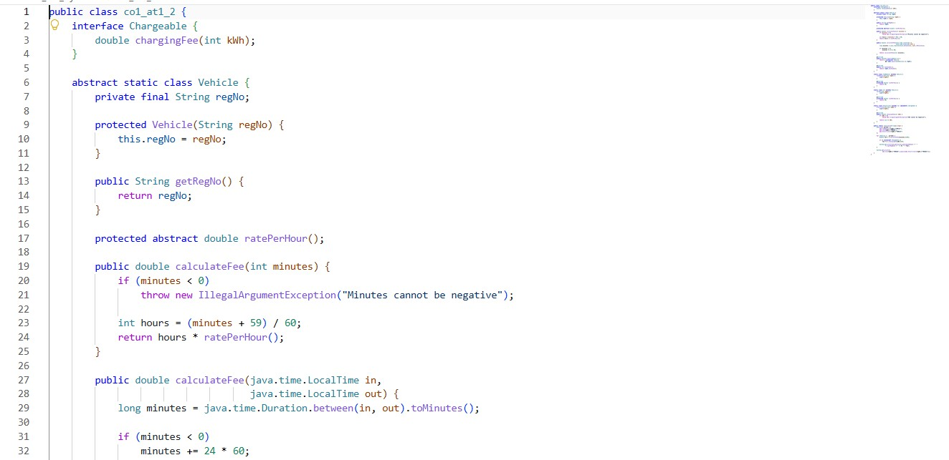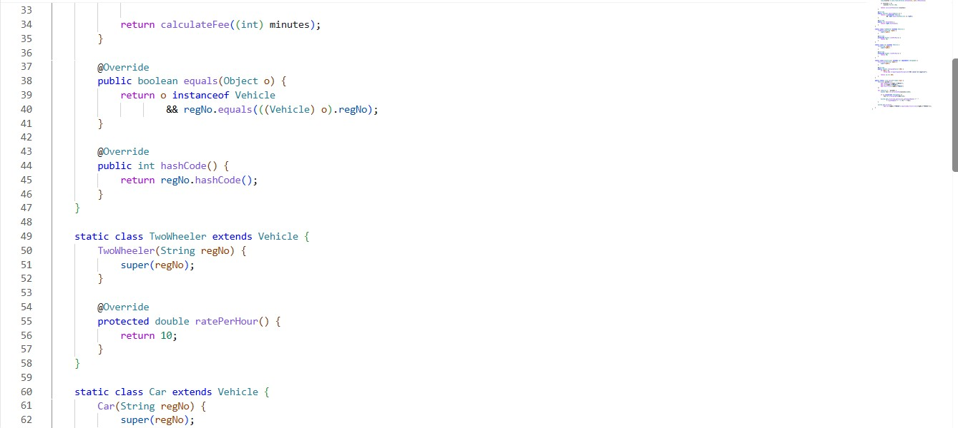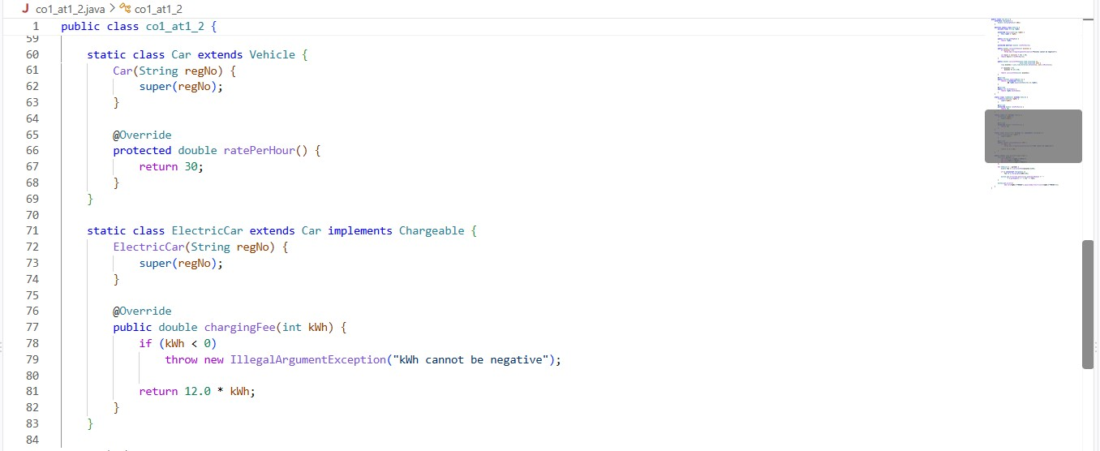
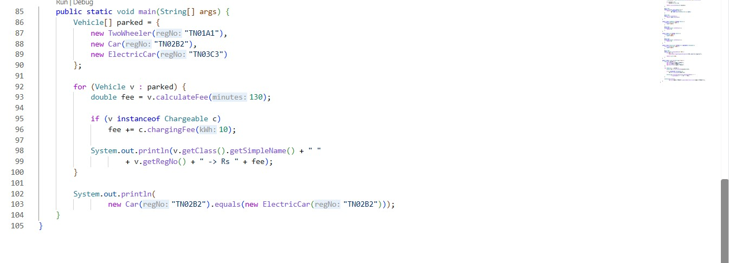

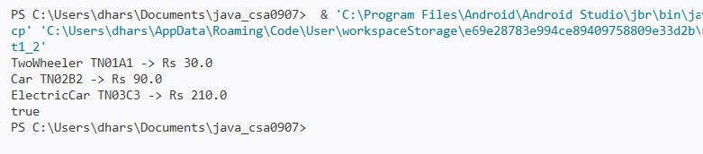

The last line is true because equals() compares only regNo, and both objects use TN02B2. Whether this is correct depends on the identity rule. For a real parking system, the safer policy is to prohibit duplicate active registrations and decide explicitly whether equality represents the physical vehicle or the parking record.
Dynamic dispatch selects the method at runtime: declared reference type = Vehicle; actual object type = Car; executed implementation = Car.ratePerHour(). With instanceof checks and casts, code may test up to k types (O(k) worst case) and grows as new types are added. Dynamic dispatch is effectively O(1) for method selection and reduces central branching.

TASK 9 – Introduce Abstraction
Vehicle is abstract because a generic vehicle has no single correct hourly rate. ratePerHour() is abstract and each concrete subclass implements it. Chargeable is an interface because charging is a capability that only some vehicles have; a class can implement multiple interfaces, such as Chargeable and another capability. An interface default method can provide a shared optional behaviour, while a static interface method can provide a utility method.
If Vehicle were an interface, it could not hold per-object instance fields in the same way or have constructors; each implementation would need to manage its own registration state. Interfaces support multiple implementation, whereas a class can extend only one class. Replacing Chargeable with an abstract class would prevent ElectricCar from extending both Car and that charging class. Method calls remain O(1) in typical use; an additional strategy/interface reference has constant per-object space overhead.

TASK 10 – Packages and Encapsulation
parking/
model/ Vehicle.java, Car.java, ParkingTicket.java, ParkingSlot.java service/ ParkingService.java, PricingRule.java app/ Main.java
Use private for fields to prevent direct modification, public for intended API methods, protected for subclass extension points, and package-private for implementation details shared only within a package. Getters expose values safely; setters or constructors validate input such as nonblank registration numbers, nonnegative duration, and valid slot indexes.
Wrapper classes such as Integer may be used in collections. Autoboxing converts int to Integer and unboxing converts back. Do not compare Integer values with == because it can compare object identity; use equals() or compare primitive values. If fields were public, any caller could set invalid values and every calling site would need duplicate validation. Validation per update is O(1), but centralizing it avoids repeated checks across many callers.

TASK 11 – Implement, Test and Defend the Design

11.1 Integrated implementation outline
The following compact example integrates the main object-oriented ideas. The two required completed programs are provided in Task 3 and Task 8. Use these classes as the core of the full project, then add the ticket/service features described below.
import java.time.Duration; import java.time.LocalDateTime;

class ParkingSession { private static long nextId = 1; private final long ticketId; private final Vehicle vehicle; private final int floor; private final int slot;
private final LocalDateTime entryTime;

ParkingSession(Vehicle vehicle, int floor, int slot) { if (vehicle == null || floor < 0 || slot < 0) throw new IllegalArgumentException("Invalid parking session"); this.ticketId = nextId++; this.vehicle = vehicle; this.floor = floor; this.slot = slot;
this.entryTime = LocalDateTime.now();
}

public long getTicketId() { return ticketId; } public Vehicle getVehicle() { return vehicle; } public int getFloor() { return floor; } public int getSlot() { return slot; } public LocalDateTime getEntryTime() { return entryTime; }

public double closeAt(LocalDateTime exitTime) { if (exitTime == null || exitTime.isBefore(entryTime)) throw new IllegalArgumentException("Invalid exit time"); long minutes = Duration.between(entryTime, exitTime).toMinutes(); return vehicle.calculateFee((int) minutes);
}
}

11.2 Test plan and results to verify
Test case | Expected result | Actual result
Allocate into first free slot | Returns first available floor/slot | Record after running
Facility full | allocate() returns null | Record after running
Release occupied slot | true | Record after running
Release same slot twice | true then false | Record after running
Invalid floor/slot | false | Record after running
Zero-minute parking | 0 billable hours and Rs 0 under this formula | Record after running
61-minute two-wheeler stay | 2 hours × Rs 10 = Rs 20 | Record after running
130-minute car stay | 3 hours × Rs 30 = Rs 90 | Record after running
Negative minutes | Throws IllegalArgumentException | Record after running
Duplicate active registration | Reject entry in ParkingService | Record after running
Illustrative hand calculation: a two-wheeler parks for 61 minutes at Rs 10/hour = 2 × 10 = Rs 20; a car parks for 130 minutes at Rs 30/hour = 3 × 30 = Rs 90; an electric car parks for 130 minutes and consumes 10 kWh = Rs 90 + (10 × Rs 12) = Rs 210. Total collection = Rs 320, excluding passes and any daily cap. Compare this hand calculation with the program output after executing it.
Evaluation: private fields support encapsulation; Vehicle subclasses support inheritance; overridden ratePerHour() demonstrates runtime polymorphism; Vehicle and Chargeable demonstrate abstraction. One limitation is that the simple array-based allocation always chooses the first free slot and does not yet optimise by distance, accessibility or charging-slot compatibility.
Alternative ticket storage: an array requires O(n) search for an active ticket and O(n) storage. ArrayList also requires O(n) search, though append is amortized O(1). HashMap<String, ParkingTicket> keyed by registration provides average O(1) lookup and O(n) storage, making it preferable for exit processing at larger scale.

TASK 12 – Re-evaluate and Adapt the Design

A. Impact analysis
- E-bikes are a new category with a flat fee; delivery vans use double the car rate between 9 AM and 5 PM.
- Visitors may buy a one-day pass, which adds a new pass rule.
- The facility expands to five floors with different slot counts. A jagged array is appropriate because each floor can have a different number of slots.
- Vehicle subclasses, pricing logic, pass validation and facility configuration are affected. The allocation algorithm can remain unchanged if it already iterates over each row length.

B. Evaluate the original design
A design with ratePerHour() overridden by each subtype can add E-Bike and DeliveryVan subclasses without changing existing vehicle subclasses. However, the delivery van rule depends on time of day, so pricing logic should be moved into a
PricingRule abstraction rather than scattered among classes. The jagged-array allocation and already-tested
TwoWheeler/Car classes can remain unchanged. The one-day visitor pass requires a pass abstraction or an extension of the existing pass model.

C. Adaptation: revised structure and working code
import java.time.LocalTime;

interface Pass { boolean isValid();
double discountOrFee(double normalFee);
}

class OneDayVisitorPass implements Pass { private final java.time.LocalDate validDate; OneDayVisitorPass(java.time.LocalDate validDate) { if (validDate == null) throw new IllegalArgumentException("Date required"); this.validDate = validDate;
} public boolean isValid() { return validDate.equals(java.time.LocalDate.now());
} public double discountOrFee(double normalFee) { return isValid() ? 0.0 : normalFee;
}
}

abstract class PricingRule { public abstract double fee(Vehicle vehicle, int minutes, LocalTime entry, LocalTime exit);
}

class StandardPricingRule extends PricingRule { public double fee(Vehicle vehicle, int minutes, LocalTime entry, LocalTime exit) { return vehicle.calculateFee(minutes);
}
}

class DeliveryVan extends Car {
DeliveryVan(String regNo) { super(regNo); }
@Override protected double ratePerHour() { return 60; }

public double feeForStay(int minutes, LocalTime entry, LocalTime exit) { double normal = calculateFee(minutes); boolean daytime = !entry.isBefore(LocalTime.of(9, 0)) && exit.isBefore(LocalTime.of(17, 0)); return daytime ? normal * 2 : normal;
}
}

class EBike extends Vehicle { private static final double FLAT_FEE = 15.0;
EBike(String regNo) { super(regNo); }
@Override protected double ratePerHour() { return 0; } public double flatParkingFee() { return FLAT_FEE; }
}
This code is designed to be placed in a separate file with the Vehicle and Car classes from Task 8 (only one public top-level class per file). For a fully integrated application, ParkingService should call EBike.flatParkingFee() for e-bikes,
DeliveryVan.feeForStay() for delivery vans, and apply the visitor pass to the computed fee. In a production version, model these as explicit PricingRule implementations to avoid special-case logic in the service.

D. Evidence-based defence
Decision: MODIFY the original design, retaining the jagged-array facility and the existing Vehicle abstraction while adding new vehicle classes, a Pass interface and a PricingRule abstraction. The array representation already supports five floors with different slot counts. Existing tested classes can remain unchanged except where pricing responsibilities are deliberately extracted. New vehicle categories can be added with new subclasses and pricing rules. The trade-off is a few more classes and interfaces, in return for clearer separation of pricing, passes and vehicle identity.
New requirement | Test / expected result
E-bike flat fee | Parking fee is Rs 15 regardless of duration, before any pass rule.
Delivery van during 9 AM–5 PM | Hourly fee is twice the car rate; e.g. 2 billable hours × Rs 60 = Rs 120 for the double-rate category.
Visitor one-day pass valid today | Parking charge becomes Rs 0 for the pass validity date.
Different floor capacities | Jagged array accepts values such as {20, 25, 30, 35, 40}.
Important boundary note: the delivery-van time rule must define how stays crossing 9 AM or 5 PM are charged. The simple example above doubles the fee only when both entry and exit are within the daytime window; a final implementation should split the duration into daytime and non-daytime minutes if the university requires precise time-based billing.

Conclusion
The Campus Smart-Parking System can be modelled effectively using classes, arrays, constructors, static members, inheritance, overriding, polymorphism, abstract classes, interfaces, packages and encapsulation. The recommended modification keeps the tested core while separating pricing rules and pass behaviour so that new vehicle categories and future policies can be introduced with limited changes.

