DAY 11

1)

Fix the bugs in below snippet

<html lang="en">

<head>

<title>Document

<body>

guvi

</title>

</head>

<div>

Lorem ipsum dolor sit amet consectetur adipisicing elit.

<div>

<div>

Guvi Geek Network

</div>

</body>

</html>

**ANSWER**

<html lang="en">

<head>

<title>Document</title>

</head>

<body>

<p>guvi</p>

<div>

Lorem ipsum dolor sit amet consectetur adipisicing elit.

</div>

<div>

Guvi Geek Network

</div>

</body>

</html>

OUTPUT

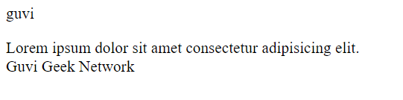

2)Try the below one

<html lang="en">

<head>

<title>Document

<body>

guvi

</head>

<div>

Lorem ipsum dolor sit amet consectetur adipisicing elit.

<div>

<div>

Guvi Geek Network

</div>

</body>

</html>

**ANSWER**

<html lang="en">

<head>

<title>Document</title>

</head>

<body>

guvi

<div>

Lorem ipsum dolor sit amet consectetur adipisicing elit.

<div>

Guvi Geek Network

</div>

</div>

</body>

</html>

**OUTPUT**

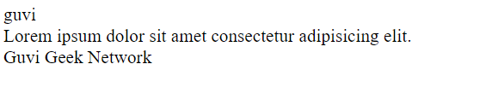

3) Design a contact us form with all fields as required.

**ANSWER**

<!DOCTYPE html>

<html>

<head><h1>Contact form</h1></head>

<body>

<form>

<label for="fname">First Name:</label><br>

<input type="text" id="fname" name="fname" required><br>

<label for="lname">Last Name:</label><br>

<input type="text" id="lname" name="lname" required><br>

<label for="country">Country:</label><br>

<select id="country" name="country">

<option value="australia">Australia</option>

<option value="canada">Canada</option>

<option value="usa">USA</option>

</select><br>

<label for="subject">Subject:</label><br>

<textarea id="subject" name="subject" placeholder="Write something.." style="height:200px" required></textarea><br>

<input type="submit" value="Submit">

</form>

</body>

</html>

**OUTPUT**

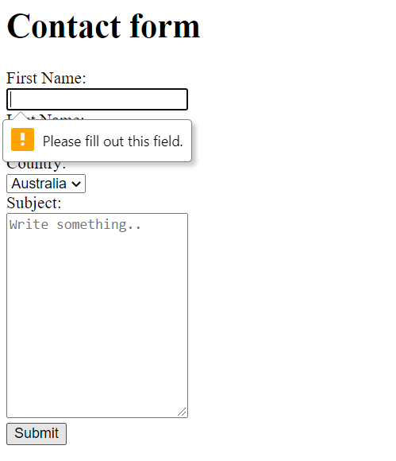

4) Use certain HTML elements to display the following in a HTML page.

**ANSWER**

<!DOCTYPE html>

<html lang="en">

<head>

<title>HTML Ordered List</title>

</head>

<body>

<ul>

<li>Programming Language</li>

<ul type="circle">

<li>Javascript</li>

<ol type="a">

<li>Angular</li>

<li>React</li>

<li>Vue</li>

</ol>

<li>Pyhton</li>

<ol type="a">

<li>Django Framework</li>

<li>Flask Framework</li>

</ol>

<li>Java</li>

<ol type="a">

<li>Spring</li>

<li>Maven</li>

<li>Hibernate</li>

</ol>

</ul>

<li>Database</li>

<ul type="circle">

<li>MYSQL</li>

<li>MongoDB</li>

<li>Cassandra</li>

</ul>

</ul>

</body>

</html>

**OUTPUT**

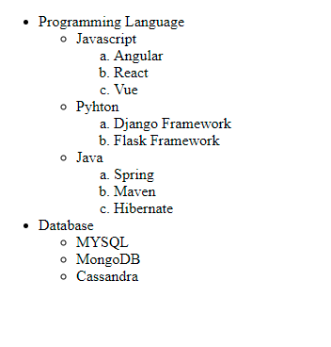

5) Create an element that helps you to open the https://google.com in separate new tab.

**ANSWER**

<!DOCTYPE html>

<html lang="en">

<head>

<title>HTML Ordered List</title>

</head>

<body>

<a href="https://www.google.com" target="_blank">Google.com</a>

</body>

</html>

**OUTPUT**



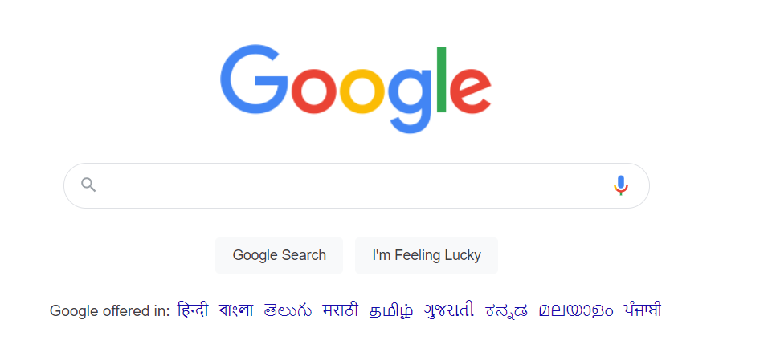

6) In the form, add two radio buttons with grouping them for employee type(Salaried and own business)

**ANSWER**

<!DOCTYPE html>

<html lang="en">

<head>

<title>HTML Ordered List</title>

</head>

<body>

<form>

<fieldset id="group1">

<input type="radio" value="value1" name="group1">Salaried

<input type="radio" value="value2" name="group1">Own Business

</fieldset>

</form>

</body>

</html>

**OUTPUT**

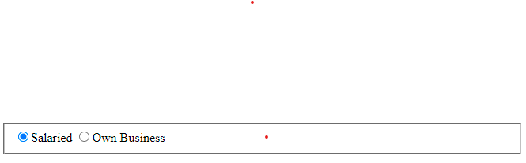

7) Design form shown in the link (<http://evccit.info/cit040/formguide/card_0.png>)

**ANSWER**

<div class="container border border-dark">

<div class="col-12">

<div class="row">&nbsp;</div>

<div class="row">

<div class="col-12 bg-danger bg-gradient text-white ">

Yes! I want to subscribe to Mag-O-Zine.

</div>

</div>

<div class="row">&nbsp;</div>

<div class="row align-left">

<div class="col-6">

<hr/>

<label for="fname" >First Name</label>

</div>

<div class="col-6">

<hr/>

<label for="lname" >Last Name</label>

</div>

</div>

<div class="row">

<div class="col-12">

<hr/>

<label for="address" >Address</label>

</div>

</div>

<div class="row">

<div class="col-4">

<hr/>

<label for="city" >City</label>

</div>

<div class="col-4">

<hr/>

<label for="state" >State</label>

</div>

<div class="col-4">

<hr/>

<label for="Zip" >Zip</label>

</div>

</div>

<div class="row form-group">

<div class="col-12">

Subscribe for:

<div class="form-check-inline">

<input class="form-check-input" type="checkbox" value="" id="flexCheckDefault" checked>

<label class="form-check-label" for="flexCheckDefault">

1 Year ($19.95)

</label>

</div>

<div class="form-check-inline">

<input class="form-check-input" type="checkbox" value="" id="flexCheckChecked" >

<label class="form-check-label" for="flexCheckChecked">

2 Years ($35.00)

</label>

</div>

</div>

</div>

<div class="row">

<div class="form-group col-8">

Send me more information about: <br/>

<div class="form-check">

<input class="form-check-input" type="checkbox" value="" id="flexCheckDefault" checked>

<label class="form-check-label" for="flexCheckDefault">

Computer-Zine

</label>

</div>

<div class="form-check">

<input class="form-check-input" type="checkbox" value="" id="flexCheckChecked" >

<label class="form-check-label" for="flexCheckChecked">

Fishing-Zine

</label>

</div>

<div class="form-check">

<input class="form-check-input" type="checkbox" value="" id="flexCheckChecked" checked>

<label class="form-check-label" for="flexCheckChecked">

Cat-O-Zine

</label>

</div>

</div>

</div>

</div>

</div>

**OUTPUT**

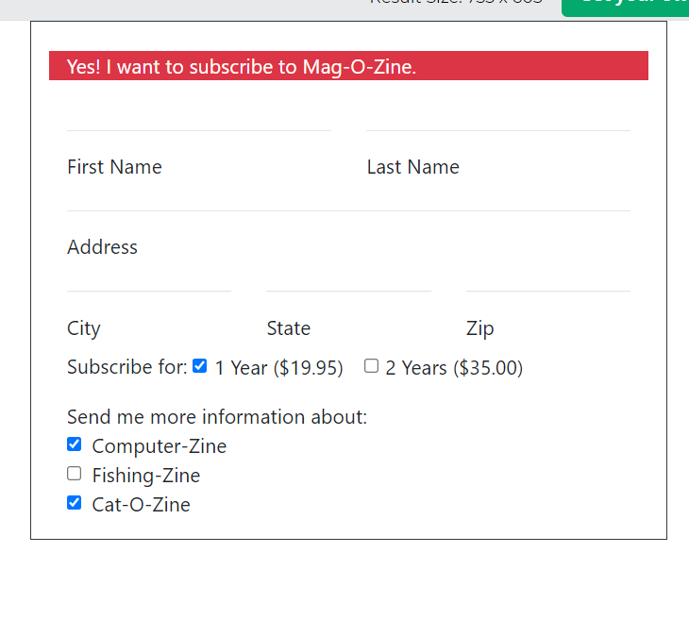

8) Use the table tag to design given image Click here.

**ANSWER**

<!DOCTYPE html>

<html lang="en">

<head>

<style>

table, th, td {

border: 1px solid black;

border-collapse: collapse;

text-align:center

}

th, td {

padding: 15px;

}

</style>

</head>

<body>

<h3><center>Health Chart</center></h3>

<table style="width:100%">

<tr>

<th rowspan="2" >State of Health</th>

<th colspan="2">Fasting</th>

<th>After Eating</th>

</tr>

<tr>

<td>Minimum</td>

<td>Maximum</td>

<td>2 hours after eating</td>

</tr>

<tr>

<td>Healthy</td>

<td>70</td>

<td>100</td>

<td>Less then 140</td>

</tr>

<tr>

<td>Pre-Diabities</td>

<td>101</td>

<td>126</td>

<td>140 to 200</td>

</tr>

<tr>

<td>Diabities</td>

<td>More than 126</td>

<td>N/A</td>

<td>More than 200</td>

</tr>

</table>

</body>

</html>

**OUTPUT**

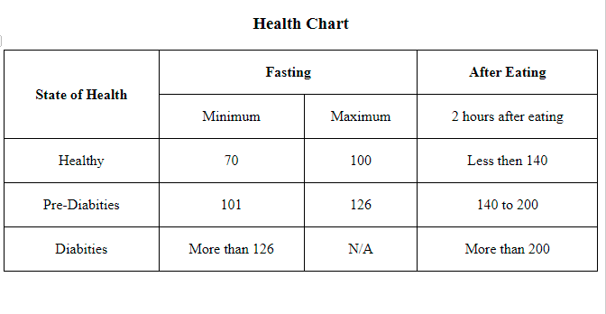

9) Write HTML input tags snippet to show default values for all Form elements.

**ANSWER**

<!DOCTYPE html>

<html lang="en">

<head>

</head>

<body>

<form>

<label for="fname">First name:</label><br>

<input type="text" id="fname" name="fname" value="Elakkiya"><br><br>

<label for="lname">Last name:</label><br>

<input type="text" id="lname" name="lname" value="Raja"><br/><br/>

<label for="email">Enter your email:</label><br>

<input type="email" id="email" name="email" value="123@gmail.com"><br><br>

Select Gender:

<label>

<input type="radio" name="gender" value="male" checked="checked" />Male

</label>

<label>

<input type="radio" name="gender" value="female">Female

</label>

<label>

<input type="radio" name="gender" value="other">Other

</label>

<br/><br />

<input type="checkbox" id="vehicle1" name="vehicle1" value="Bike" checked>

<label for="vehicle1"> I have a bike</label><br>

<input type="checkbox" id="vehicle2" name="vehicle2" value="Car">

<label for="vehicle2"> I have a car</label><br>

<input type="checkbox" id="vehicle3" name="vehicle3" value="Boat">

<label for="vehicle3"> I have a boat</label><br><br>

</form>

</body>

</html>

**OUTPUT**

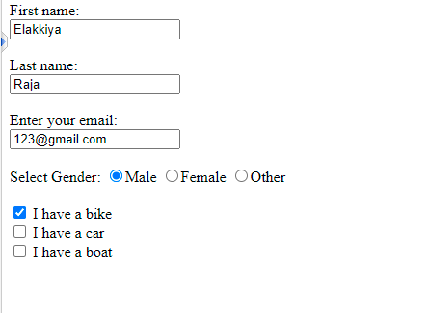

10) In your, HTML page add the below line and Highlight it without using any CSS.

"HTML & CSS is awesome"

**ANSWER**

<!DOCTYPE html>

<html lang="en">

<head>

</head>

<body>

<p>

A book is a medium for recording information in the form of writing or images, typically composed of many pages (made of papyrus, parchment, vellum, or paper) bound together and protected by a cover.[1] The technical term for this physical arrangement is codex (plural, codices). In the history of hand-held physical supports for extended written compositions or records, the codex replaces its predecessor, the scroll. A single sheet in a codex is a leaf and each side of a leaf is a page.

</p>

<p><mark>HTML and CSS is Awesome</mark></p>

</body>

</html>

**OUTPUT**

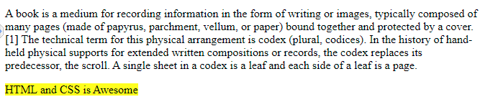

11) Create an HTML page, which should contain all types of input elements.

**ANSWER**

<p>Button : <input type="button"></p>

<p>Check Box : <input type="checkbox"></p>

<p>Color : <input type="color"></p>

<p>Date : <input type="date"></p>

<p>Datetime : <input type="datetime"></p>

<p>Datetime-local : <input type="datetime-local"></p>

<p>Email : <input type="email"></p>

<p>File : <input type="file"></p>

<p>Hidden : <input type="hidden"></p>

<p>Image : <input type="image"></p>

<p>Month : <input type="month"></p>

<p>Number : <input type="number"></p>

<p>Password : <input type="password"></p>

<p>Radio : <input type="radio"></p>

<p>Range : <input type="range"></p>

<p>Reset : <input type="reset"></p>

<p>Search : <input type="search"></p>

<p>Submit : <input type="submit"></p>

<p>Tel : <input type="tel"></p>

<p>Text : <input type="text"></p>

<p>Time : <input type="time"></p>

<p>Url : <input type="url"></p>

<p>Week : <input type="week"></p>

**OUTPUT**

