DAY – 3

1)For the given JSON iterate over all for loops (for, for in, for of, forEach)

let my_resume_data=

{

"name" : "Elakkiya E",

"age" : 21,

"email" : "elakia79@gmail.com",

"phone no" : 8610090230,

"linked in" : "https://www.linkedin.com/in/elakkiya-elangoraja-361731196/",

"address" :

{

"street_no" : 56,

"street_name": "south street",

"city" : "Madurai",

},

"studies" :

{

"SSLC" : "SBK school",

"HSC" : "Saliar school",

"UG" : "Karpagam college"

},

"courses" : ["Python","vue.js"],

"languages_known" : ["Tamil","English"],

"technical_skills" : ["C","C++","Python"],

"hobbies" : "Painting"

}

console.log("------ FOR IN LOOP ---------");

**//GETTING THE STUDIES DATA USING FOR IN LOOP**

for(let studies_data in my_resume_data["studies"])

console.log(studies_data);

console.log("------ FOR LOOP ---------");

**//GETTING COURSES DATA USING FOR LOOP**

for(courses_data=0;courses_data<my_resume_data.courses.length;coures_data++)

{

console.log(my_resume_data.courses[courses_data]);

}

console.log("------ FOR EACH ---------");

**//GETTING SKILLS DATA USING FOR EACH**

my_resume_data["technical_skills"].forEach(function(data,index){

console.log(data);

});

console.log("------ FOR OF ---------");

**//GETTING ADDRESS DATA USING FOR OF**

for (const [key, value] of Object.entries(my_resume_data["address"])) {

console.log(key,":", value);

}

OUTPUT

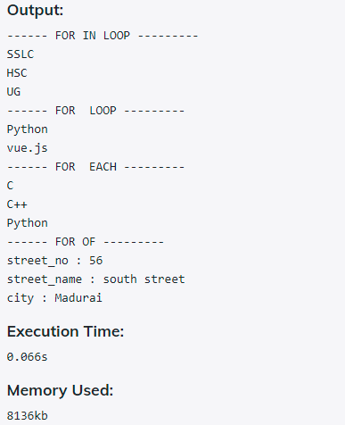

2)Create your own resume data in JSON format

let my_resume_data=

{

"name" : "Elakkiya E",

"age" : 21,

"email" : "elakia79@gmail.com",

"phone no" : 8610090230,

"linked in" : "https://www.linkedin.com/in/elakkiya-elangoraja-361731196/",

"address" :

{

"street_no" : 56,

"street_name": "south street",

"city" : "Madurai",

},

"studies" :

{

"SSLC" : "SBK school",

"HSC" : "Saliar school",

"UG" : "Karpagam college"

},

"courses" : ["Python","vue.js"],

"languages_known" : ["Tamil","English"],

"technical skills" : ["C","C++","Python"],

"hobbies" : "Painting"

}

console.log(my_resume_data); //**Print all the details**

OUTPUT

