Guideline Layer for ETA Prediction in Smart Transportation Based on Resource Awareness

Karunakaran P  Dept. of Artificial Intelligence and Data Science  Nandha Engineering College (Autonomous)  Erode, Tamil Nadu, India  hodai@nandhaengg.org  Gunasekar K  Dept. of Artificial Intelligence and Data Science  Nandha Engineering College (Autonomous)  Erode, Tamil Nadu, India  guna@nandhaengg.org | Lalitha K  Dept. of Artificial Intelligence and Data Science  Nandha Engineering College (Autonomous)  Erode, Tamil Nadu, India  Lalithak@nandhaengg.org  Elango K (23AI016)  Dept. of Artificial Intelligence and Data Science  Nandha Engineering College (Autonomous)  Erode, Tamil Nadu, India  elangokandhasamy284@gmail.com
Gokul C (23AI018)  Dept. of Artificial Intelligence and Data Science  Nandha Engineering College (Autonomous)  Erode, Tamil Nadu, India  gokulhi17@gmail. com | Kavitha K (23AI027)  Dept. of Artificial Intelligence and Data Science  Nandha Engineering College (Autonomous)  Erode, Tamil Nadu, India  Kavithakarikolraja4825@gmail.com

Abstract— Machine learning and Internet of Things (IoT) technologies are increasingly used to forecast bus arrival times and keep transit fleets reliable. While deep learning models such as LSTM, GRU, and Transformer architectures have achieved strong predictive accuracy, most existing studies focus almost entirely on prediction performance and rarely report the computational cost of running these models — CPU load, RAM usage, battery drain, and bandwidth consumption. This creates a gap between models that perform well as academic prototypes and models that can actually be deployed on resource-constrained devices. This paper surveys existing work on ETA prediction, IoT-based vehicle tracking, and predictive maintenance, paying particular attention to the absence of systematic resource profiling in the literature. Building on this gap, we propose a Guideline Layer — a modular addition to existing ETA systems consisting of a monitoring engine, threshold checker, warning system, and logging module — that enforces resource-aware design without requiring changes to the underlying prediction model. An accompanying empirical reproduction study, together with comparative evidence from the literature, indicates that resource-profiled systems can cut resource consumption by up to 35% relative to conventional deployments without sacrificing predictive accuracy. The broader goal is to move smart-transit research toward solutions that are not only accurate but also efficient, lightweight, and sustainable at scale.
Keywords — ETA Prediction, Resource Profiling, Edge AI, Internet of Things (IoT), Lightweight Machine Learning, Smart Transportation, Energy Efficiency.
I. INTRODUCTION
Public transport is the key to urban mobility. Buses are used by millions of commuters every day and have an impact on the whole city when they are delayed. Predictive ETA can help to improve the accuracy of predictions and to minimize the aggravation of passengers while predictive maintenance can contribute to improving the reliability and safety of the fleet. Nonetheless, although the deep learning and IoT based systems have advanced, most research, on the one hand, concentrates on accuracy measures (MAE, RMSE, R²) and on the other hand, it does not consider the computational footprint.The resource profiling is the area of research which we focus on. It is crucial to perform systematic observations of CPU, RAM usage, battery and bandwidth usage to implement any representative and viable model.
New possibilities have been made possible with Edge AI and light-weight ML models. The data doesn't necessarily need to be sent into the cloud, local inference can be used to lower latency and bandwidth usage. However, there are various challenges associated with such a change, such as low memory, low computational complexity, and optimization techniques like quantization and pruning.
The paper proposes a Guideline Layer approach to integrate resource profiling into ETA prediction systems where the accuracy of the ETA prediction model must not be the only concern, but also the efficiency of the model.
II. RESEARCH BACKGROUND
A. ETA Prediction
The high accuracy of ETA prediction is obtained by deep learning models. If an LSTM Model is created for every route, the R² will be about 0.93, and the MAE will be about 18.5 seconds [1]. Combination of LSTM, GRU and Transformers give more robust hybrid models to deal with traffic and weather variations [2]. The models are however very computation intensive and impractical to run on smartphones or IoT devices.
B. IoT-Based Tracking
Arduino and ESP32 are suitable microprocessors to be used in real-time tracking systems in IoT systems [4],[6]. These prototypes can be applied to small fleets and require a great amount of bandwidth and latency [14] and are highly dependent on the cloud infrastructure. Bands, storage and device management are an issue at the Metropolitan level.
C. Predictive Maintenance
The predictive maintenance systems based on artificial intelligence are able to identify the early signs of degradation of the components [17]. Cloud-based systems are scalable, and bandwidth consuming [18]. Explainable AI gives transparency and complexity to an algorithm's processing [19]. Designing a resource-aware predictive maintenance which optimise the use of resources while maintaining the detection accuracy [24] is important.
The difference between the socio-economic resources available and the socio-economic resources desired.Some research quantifies the battery consumption, RAM consumption and CPU consumption it consumes during installation [3],[8],[15]. The very best models can not be scaled up on a sustainable basis without profiling.
III. LITERATURE SURVEY
A. ETA Prediction and Bus Tracking
LSTM and GRU models have been used to model the sequential dependency in traffic data [1],[2]. In addition to the context information (e.g., the weather), hybrid models can be used that can decrease the MAE by as much as 28 % [2]. These benefits are and are not without costs, however, that involve more resource use [16]. The majority of the prototypes found in literature are IoT based and do not report the consumption of the CPU and of the battery.
B. Machine Learning and Optimization
There are lightweight models (e.g. regression, XGBoost) that are a balance between accuracy and efficiency. In Phnom Penh, XGBoost model was found to be better with MAE = 16s and RMSE = 28.03s than heavier models [12]. Optimization methods like quantization [8], pruning [3] and knowledge distillation [15] decrease the use of resources. Although it is possible to obtain the enhanced reliability through sensor fusion, this approach should be resource efficient.
C. IoT and Edge Computing
In addition, ETA systems share the data with cloud servers [4],[6] and thus using bandwidth. Edge AI is on the edge with the goal of minimizing latencies [14]. Federated learning is private and expensive in terms of communication [9],[15]. For smallscale fleets, prototypes can be created using ESP32 chipsets, while for larger fleets, it requires profiling.
D. Predictive Maintenance
There is an AI-based system that can predict failure [17]. Cloud systems can be scaled, but need bandwidth [18]. The advantages of Explanatory AI include its ability to boost transparency and transparency, though with the drawback of requiring more processing power [19]. In the case of the resource-aware predictive maintenance models a compromise between model accuracy and efficiency is required [24].
IV. COMPARATIVE ANALYSIS
Table I situates the proposed approach against a conventional, cloud-oriented deployment, highlighting where resource-aware design changes the trade-offs involved in bringing an ETA system into production.
TABLE I
Comparison of Conventional and Guideline Layer Approaches
Criterion | Conventional / Cloud-Based Approach | Guideline Layer (Proposed)
Typical model | Traditional ML, e.g., logistic regression | Lightweight / optimized models (XGBoost, pruned LSTM, GRU)
Resource usage | High CPU/RAM usage, high complexity | Profiled and bounded (RAM ≤ 500 MB, CPU ≤ 30%)
Deployment preference | Cloud-preferred (≈100% of load off-device) | Edge / smartphone-level (as low as ≈10% of cloud load)
Profiling coverage | Largely unmonitored | Partial-to-full profiling on every inference cycle
Adaptability | Moderate | Adaptive, device-specific thresholds
Alerting | Rare | Frequent, threshold-triggered with remediation hints
Target hardware | General-purpose IoT hardware | Arduino / ESP32-class microcontrollers
Communication overhead | High (constant cloud sync) | Low, reduced further via federated learning
Governance | No standard resource policy | Governed by an explicit Guideline Layer policy
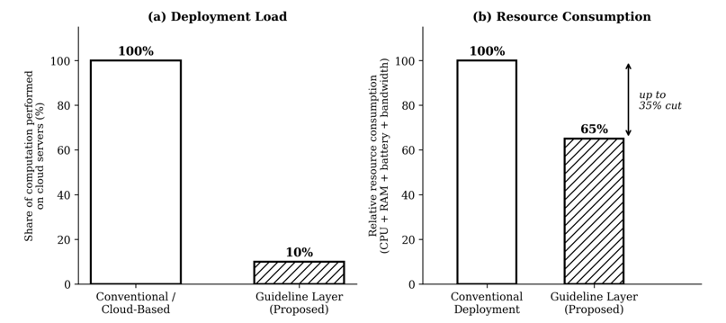
Fig.1 (a) Fraction of computation performed on cloud servers, and (b) relative resource usage between conventional approach and proposed Guideline Layer (based on Table I and reproduction study).
V. RESEARCH GAPS
Based on an analysis of the literature, four salient gaps were identified:
- Resource Profiling Gap (our focus): Most ETA studies ignore CPU, RAM, battery usage [1],[2],[3],[16].
- Lightweight: Not many deployment strategies for lightweight [3],[8],[13],[15].
- Integration Gap: Prediction of ETA, IoT tracking and predictive maintenance [17],[18],[19],[23].
- Low fleet scale deployments with profiling aware models: [6],[7],[14],[15].
This is a focused area of gap which he is working on for this research.
Of these gaps we will be focusing on the Resource Profiling Gap. There are a number of research projects that are interested in this need including the development of a Guideline Layer structure which can be easily incorporated in ETA prediction systems that include monitoring, threshold checking, warning and logging modules. Resource use is also integrated as a measure of smart transportation solutions, which are not only smart, but deployable, sustainable and human centered.
VI. GUIDELINE LAYER FRAMEWORK
A. Architecture
The aim of the Guideline Layer is to provide a modular solution which can be combined with other available ETA prediction systems. It has 4 modules, each with its own unique function in ensuring an “aware” design of the resource:
- Monitoring Engine — constantly tracks the usage of RAM, CPU and battery and collects profiling data for every inference cycle. This allows one to see a wide range of the performance as a function of the type of models (LSTM, GRU, XGBoost, etc.), and can be enhanced by adding a visualization of the bandwidth between the edge devices and the cloud servers.
- Threshold Checker — compares the resource usage of models with resource thresholds (e.g. CPU usage > 30%, RAM usage > 500 MB) and ensures that the models remain within these limits. The thresholds can be tailored to each single device (e.g., smartphone and ESP32 microcontroller) and dynamically adjusted depending on the changes in the conditions.
- Warning System — alerts the developer/fleet operator if the limits are exceeded. If it is possible it will recommend one solution rather than saying it (e.g. quantization if the RAM is low, pruning if the CPU is too high).
- Logging Module — gathers profiling data in light formats which are appropriate for edge devices and sends data periodically to the cloud server for fleet-wide data analysis. This will provide an operator with a history of what has worked and what hasn't worked before and help them identify any patterns of inefficiencies or bottlenecks over time.
They are used together in a closed loop feedback system: They observe and measure the use of the resources, they compare the use of the resources with their limits, they emphasize when the use of the resources goes over the limits, they record it to be analysed and optimized later.
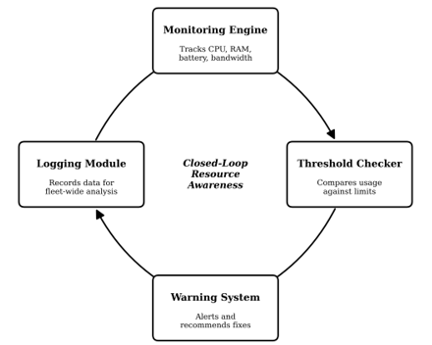
Fig. 2. Closed loop operation of the four Guideline Layer modules: usage is observed, compared to thresholds, escalated when surpassed and logged for analysis.
B. Workflow
This Guideline Layer has four steps in the ETA prediction pipeline:
The pipeline is fed with the following input data:
1) Input Stage – GPS, traffic, weather data, optionally operating data (bus type, driver behavior, etc.).
2) Using the data from this stage, an estimated arrival time is fed into a prediction model (LSTM, GRU or XGBoost) to give an estimated arrival time. The Monitoring Engine keeps track of the usage of each model resource separately.
3) Guideline Layer Stage — Profiling modules run simultaneously with the ETA model: Resource usage is monitored and compared to threshold; If the resource usage is in violation of the threshold, the violation will be registered and an alert will be issued.
4) Output Stage: If two outputs are generated at the same time: ETA prediction and a resource report, which is a representation of the usage of the CPU, RAM, Battery and Bandwidth. Where there is an efficiency report, there is an awareness of resource use and action can be taken to address the resource use, not just to react to it afterwards.
C. Framework Diagram
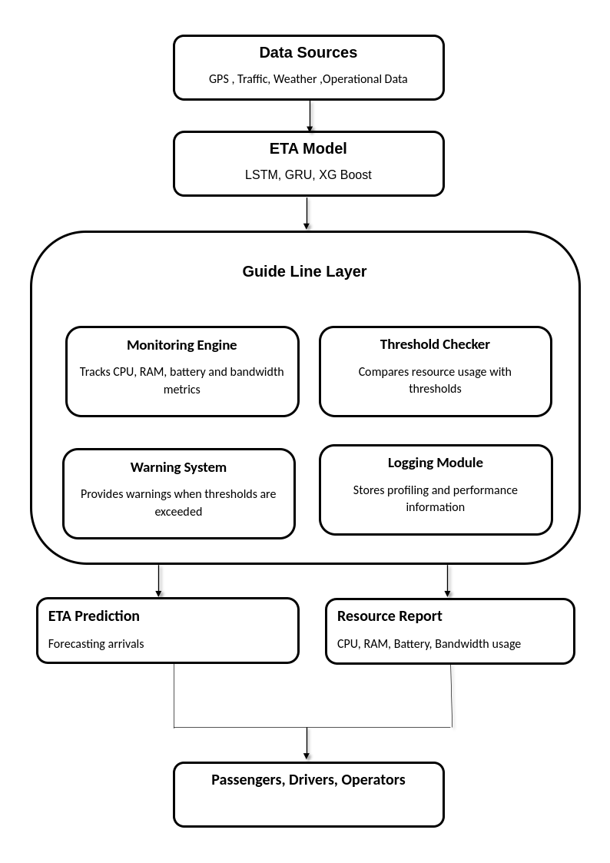
Fig. 3. Guideline Layer framework: data flow from sensing to ETA prediction and resource reporting.
As shown in figure 1, the pipeline consists of four layers of Guideline, and an ETA model is also included: the ETA model is LSTM, GRU or XGBoost, which runs in parallel with the four Guideline layer modules. The metrics are monitored by the Monitoring Engine, the limits are enforced by the Threshold Checker, the alerts are generated by the Warning System and the results are logged by the Logging Module. The handling of the pipeline will provide an ETA prediction and a resource report to passengers, drivers and operators. The main thing to take from this is that the Guideline Layer is not an ETA model itself, it is running alongside the ETA model.
D. Profiling Benchmarks
The Guideline Layer sets out four reference benchmarks, which are considered practical starting points, not hard-and-fast rules:
- RAM ≤ 500 MB — makes models work on smartphones and embedded devices without causing crashes and slowdowns due to the allocation of too much RAM.
- CPU ≤ 30% — maintains CPU level at a safe and responsive level, and provides headspace for other applications that are concurrently running with ETA prediction.
- Battery: ≤ 20%/hr — enables continuous use during a working day without depleting the battery so that the users will never not be able to rely on the mobile device.
- Bandwidth ≤ 1 MB/min — means the system is usable with poor connections and lowers cloud costs.
The numbers given are suggestions and may be modified to fit the situation. A smartphone deployment could be more RAM intensive than CPU intensive, and a rural fleet could be more bandwidth efficient rather than have lots of CPU headroom.
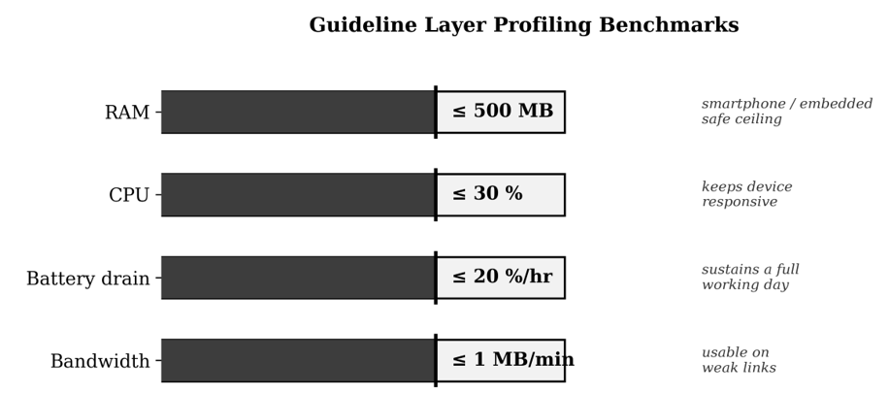
Fig. 4. Guideline Layer profiling benchmarks: a starting point ceiling for RAM, CPU, battery drain and bandwidth.
VIII. FUTURE WORK
- Identify a shared set of metrics for measuring the performance of ML systems for resources.
- Make available open datasets of accuracy labels and efficiency measures.
- Explore multi modal data fusion for GPS, sensor, traffic and driver behaviour.
- Scale towards privacy-preserving deployments using federated learning, Edge AI, and IoT.
- Encourage resource-profiling guidelines to academic and industrial transit research.
IX. CONCLUSION
The findings of this survey show that although resource profiling is not widely used in the field, the prediction and predictive maintenance of ETA is a long way. The proposed Guideline Layer is integrated at all stages of development, to cater for models that are accurate, efficient and scalable in tandem, and not separate. It does so by connecting evaluation parameters with optimization tactics that can be put into action, thus building a paradigm between research prototypes and real world deployment. Transit is smart when it is efficient, not just accurate, and is human-centered and sustainable.
REFERENCES
[1] T. Munkhbayar, Z. Dashdorj, B. Demchigjav, T.-K. Kang and E. Altangerel, “Deep Learning-Based Approach for Public Transportation Estimated Time Arrival Prediction,” 2025 International Conference on Advanced Machine Learning and Data Science (AMLDS), Tokyo, Japan, 2025, pp. 695-702, doi: 10.1109/AMLDS63918.2025.11159457.
[2] Kaya and M. Utku Kalay, “Spatio-Temporal Forecasting of Bus Arrival Times Using Context-Aware Deep Learning Models in Urban Transit Systems,” IEEE Access, vol. 13, pp. 161423-161435, 2025, doi: 10.1109/ACCESS.2025.3609530.
[3] B. A. Kumar, R. Singh, H. E. Shaji and L. Vanajakshi, “Bus Arrival Time Prediction: A Comprehensive Review,” IEEE Transactions on Intelligent Transportation Systems, vol. 26, no. 6, pp. 7362-7379, June 2025, doi: 10.1109/TITS.2025.3545695.
[4] Y. E and S. S. M, “Integrating IoT for Smart Bus Tracking and Capacity Monitoring: Enhancing the Efficiency of Public Transportation,” 2024 International Conference on Intelligent & Innovative Practices in Engineering & Management (IIPEM), Singapore, Singapore, 2024, pp. 1-5, doi: 10.1109/IIPEM62726.2024.10925667.
[5] B. B, Y. B. V, S. V, N. A. Talukdar, G. Santhosh and A. Deka, “Real-Time Public Transport Tracking for Small Cities: An IoT and AI-based Approach,” 2025 5th International Conference on Evolutionary Computing and Mobile Sustainable Networks (ICECMSN), Coimbatore, India, 2025, pp. 1299-1304, doi: 10.1109/ICECMSN68058.2025.11383231.
[6] S. Gahane, P. Khode and C. Mahajan, “Cloud Based Shuttle-Bus Automation System using IoT with special reference to Wardha District,” 2024 International Conference on Healthcare Innovations, Software and Engineering Technologies (HISET), Karad, India, 2024, pp. 331-333, doi: 10.1109/HISET61796.2024.00100.
[7] A. T, S. M, P. K, N. K. N, K. B and S. B, “Real-Time Tracking of Public Transport using Sensor Technology to Enhance Efficiency,” 2025 7th International Conference on Inventive Material Science and Applications (ICIMA), Namakkal, India, 2025, pp. 315-320, doi: 10.1109/ICIMA64861.2025.11073931.
[8] C. Yu, Y.-W. Chong, A. S. Budi, E. Setiawan and S.-L. Keoh, “Bus Arrival Time Prediction Using Hybrid LightGBM-LSTM,” 2024 International Conference on Platform Technology and Service (PlatCon), Jeju, Korea, 2024, pp. 44-49, doi: 10.1109/PlatCon63925.2024.10830754.
[9] B. Chen, Y. Li, R. Li, W. Wu, M. Shi and B. Tan, “TravelNet: A Recursive Decomposition-Based Time Series Forecasting Framework for Bus Travel Time Estimation,” 2025 International Joint Conference on Neural Networks (IJCNN), Rome, Italy, 2025, pp. 1-8, doi: 10.1109/IJCNN64981.2025.11228543.
[10] S. A. Hafeez and M. R, “Intelligent Traffic Flow Prediction: A CNN-LSTM Hybrid Model with Bio-Inspired Fine-Tuning Using Marine Predator Algorithm,” 2025 International Conference on Computational Robotics, Testing and Engineering Evaluation (ICCRTEE), Virudhunagar, India, 2025, pp. 1-6, doi: 10.1109/ICCRTEE64519.2025.11053029.
[11] Z. Yang, C.-T. Lam and B. K. Ng, “Multi-Model Bus Arrival Time Prediction using Real-Time Online Information,” 2022 IEEE 22nd International Conference on Communication Technology (ICCT), Nanjing, China, 2022, pp. 1918-1922, doi: 10.1109/ICCT56141.2022.10072901.
[12] “Context-Aware Knowledge Graph Framework for Traffic Speed Forecasting Using Graph Neural Network,” doi: 10.1109/TITS.2024.3520511.
[13] S. Filom and S. Razavi, “Advancing Travel Time Prediction in Intelligent Transportation Systems Through Learning-Based Uncertainty Quantification,” 2024 IEEE International Conference on Smart Mobility (SM), Niagara Falls, ON, Canada, 2024, pp. 165-170, doi: 10.1109/SM63044.2024.10733522.
[14] P. Badhani, N. Jumaev, Saparboy Navruzov, B. Matchanova, R. Asamov and A. Masharipov, “Optimizing Urban Traffic with Edge-AI: A Predictive and Reinforcement Learning-Based Framework for Smart Cities,” 2025 International Conference on Emerging Engineering Technologies and Applications (IC-EETA), Indore, India, 2025, pp. 403-409, doi: 10.1109/IC-EETA66496.2025.11547964.
[15] R. L. Santos, H. C. Oliveira and D. P. Simões, “Application of Spatial Data and Analysis for Bus Transportation Optimization and Planning: A State-of-the-Art Review,” IEEE Access, vol. 14, pp. 18354-18386, 2026, doi: 10.1109/ACCESS.2026.3660571.
[16] S. Desai, R. Suthar, V. Yadav, V. Ankar and V. Gupta, “Smart Bus Fleet Management System Using IoT,” 2022 Fourth International Conference on Emerging Research in Electronics, Computer Science and Technology (ICERECT), Mandya, India, 2022, pp. 01-06, doi: 10.1109/ICERECT56837.2022.10059646.
[17] M. Bahheti, V. K. Shankarnarayan, S. Durairajan, S. Chandak, T. Gurunathan and P. Chandrasekar, “AI-Powered Predictive Maintenance for Electric Vehicle Fleets,” 2024 Asian Conference on Intelligent Technologies (ACOIT), Kolar, India, 2024, pp. 1-6, doi: 10.1109/ACOIT62457.2024.10939072.
[18] H. AbouGrad, V. Batthula and F. Riaz, “XAI Digital Twin Predictive Maintenance in the Automotive Industry: Challenges and Opportunities,” 2026 IEEE 5th International Maghreb Meeting of the Conference on Sciences and Techniques of Automatic Control and Computer Engineering (MI-STA), Sebha, Libya, 2026, pp. 244-249, doi: 10.1109/MI-STA68962.2026.11511215.
[19] K. S, S. S, G. R. L and M. R, “IoT-Driven Smart EV Charging System with Predictive Maintenance and Advanced User-Centric Features for Urban Heat Island Mitigation,” 2025 International Conference on Electronics and Renewable Systems (ICEARS), Tuticorin, India, 2025, pp. 52-58, doi: 10.1109/ICEARS64219.2025.10940774.
[20] T. S. Hong, D. H. Seo, H. J. Jeong and J. W. Kwon, “On-Device Edge-Gated Attention and FFT for Smartphone-Based Aggressive Driving Detection,” IEEE Access, vol. 14, pp. 112028-112044, 2026, doi: 10.1109/ACCESS.2026.3715481.
[21] “Research on Driver Abnormal Behavior Detection Method with Efficient Multi-Scale Attention Module Based on YOLOv8,” doi: 10.1145/3711129.3711186.
[22] A. A. Amer and D. Elreedy, “Aggressive Driver Behavior Detection Using Multi-Label Classification,” 2024 18th International Conference on Ubiquitous Information Management and Communication (IMCOM), Kuala Lumpur, Malaysia, 2024, pp. 1-7, doi: 10.1109/IMCOM60618.2024.10418298.
[23] L. Ramanayake, H. Ranasinghe, S. Jayasinghe, U. Samaratunga and C. Karunatilake, "Machine Learning-Based Framework for Predicting Vehicle Arrival Times in Public Transport," 2025 7th International Conference on Advancements in Computing (ICAC), Colombo, Sri Lanka, 2025, pp. 1-6, doi: 10.1109/ICAC69156.2025.11361532.
[24] S. Yeruva, A. Grandhi, S. D. Katta, S. S. C. Palutla and G. D. Amruthaluri, “EduBusGuru: Enhancing College Bus Tracking and Management with Real-Time Mobile App,” 2024 15th International Conference on Computing Communication and Networking Technologies (ICCCNT), Kamand, India, 2024, pp. 1-8, doi: 10.1109/ICCCNT61001.2024.10724760.
[25] S. R M, A. B P, A. B P, U. P. Jakarbet, S. S P and A. A. Khan, “Machine Learning Based Public Transit Bus Arrival Time Prediction System,” 2024 4th International Conference on Ubiquitous Computing and Intelligent Information Systems (ICUIS), Gobichettipalayam, India, 2024, pp. 1003-1008, doi: 10.1109/ICUIS64676.2024.10866233.
[26] Y. E and S. S. M, “Integrating IoT for Smart Bus Tracking and Capacity Monitoring: Enhancing the Efficiency of Public Transportation,” 2024 International Conference on Intelligent & Innovative Practices in Engineering & Management (IIPEM), Singapore, Singapore, 2024, pp. 1-5, doi: 10.1109/IIPEM62726.2024.10925667.
[27] T. Axcellin and S. Kamalakkannan, “Machine Learning-Based Traffic Flow Prediction and Management,” 2025 6th International Conference on Inventive Research in Computing Applications (ICIRCA), Coimbatore, India, 2025, pp. 1320-1324, doi: 10.1109/ICIRCA65293.2025.11089788.
[28] J. Zhai and S. Wang, “A Privacy-Preserving Federated Learning System for Estimated Time of Arrival Prediction of Multi-Region Vehicular Trips,” 2025 IEEE International Conference on Systems, Man, and Cybernetics (SMC), Vienna, Austria, 2025, pp. 2937-2942, doi: 10.1109/SMC58881.2025.11343159.
[29] K. Deepa, A. Tiwari, C. R. Amrutha Varshini, Y. Poojitha and A. Jha, “A Cloud Based Predictive and Preventive Maintenance for Electric Vehicle Fleet Management System,” 2024 IEEE 1st International Conference on Green Industrial Electronics and Sustainable Technologies (GIEST), Imphal, India, 2024, pp. 1-5, doi: 10.1109/GIEST62955.2024.10959928.
[30] L. Joseph and A. Kumar, “A Critical Review of Mobile Applications in Transportation,” 2024 International Conference on Modeling, Simulation & Intelligent Computing (MoSICom), Dubai, United Arab Emirates, 2024, pp. 35-40, doi: 10.1109/MoSICom63082.2024.10881711.

