Stroke Risk Prediction

Ellie Landoch, elandoch@bellarmine.edu

ABSTRACT
This project explores stroke risk prediction using a dataset of various symptoms. The analysis includes a regression models that addresses two main questions: 1) What is the percentage likelihood of a person experiencing a stroke? and 2) Based on their symptoms, is the person at risk of a stroke? Exploratory data analysis was conducted to understand patterns in stroke risk, symptom presence, and age. A new variable was added to this dataset, # of Symptoms, to better find a correlation between stroke risk and symptoms. A linear regression model was used to predict stroke risk percentage to find if an individual is at risk for a stroke or not. Model accuracy was evaluated using metrics like RMSE, R², accuracy, and confusion matrices. The results suggest that certain symptoms, age, and symptom count are positively correlated with stroke risk.

- INTRODUCTION
This project focuses on predicting stroke risk based on symptom presence. The dataset includes 17 variables, with symptoms represented as binary values (1 = present, 0 = not present), along with patient age and two target variables: Stroke Risk (%), a continuous variable, and At Risk (Binary), a classification label indicating whether a person is considered at risk (1) or not (0). The dataset contains no missing values, and all features are either numeric or binary categorical, allowing for immediate use in machine learning models after minimal preparation.
The goal of this analysis is to predict the percentage likelihood of an individual experiencing a stroke using regression models, and to classify whether an individual is at risk based on their symptoms and age. By analyzing symptom patterns and their correlation with stroke outcomes, the project aims to identify key predictors and evaluate how accurately these features can forecast stroke risk.

- BACKGROUND
The dataset used in this project was designed to explore the relationship between various physical symptoms and the likelihood of experiencing a stroke. It contains simulated or collected clinical data to help assess whether individuals with certain symptom profiles are more likely to be at risk.

- EXPLORATORY ANALYSIS

- 70000 rows, 19 columns
- No missing data
- All numeric data

Table 1: Data Types
Variable Name | Data Type
Chest Pain | int64
Shortness of Breath | int64
Irregular Heartbeat | int64
Fatigue & Weakness | int64
Dizziness | int64
Swelling (Edema) | int64
Pain in Neck/Jaw/Shoulder/Back | int64
Excessive Sweating | int64
Persistent Cough | int64
Nausea/Vomiting | int64
High Blood Pressure | int64
Chest Discomfort (Activity) | int64
Cold Hands/Feet | int64
Snoring/Sleep Apnea | int64
Anxiety/Feeling of Doom | int64
Age | int64
Stroke Risk (%) | float
At Risk (Binary) | int64
# of Symptoms | int64

Graphs:
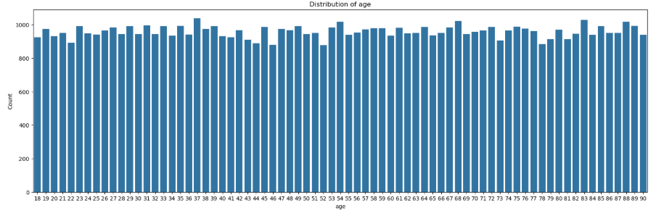

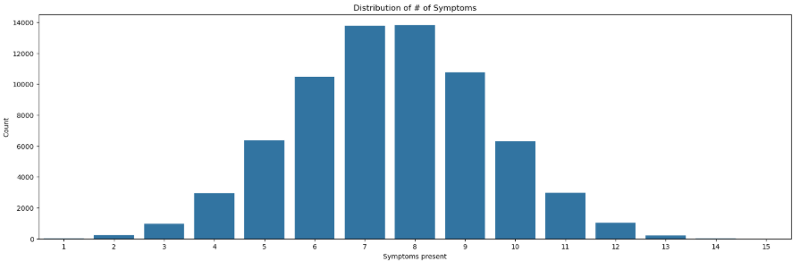
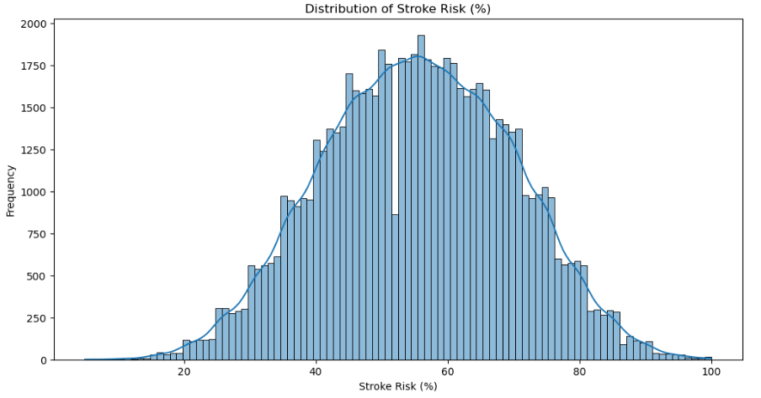
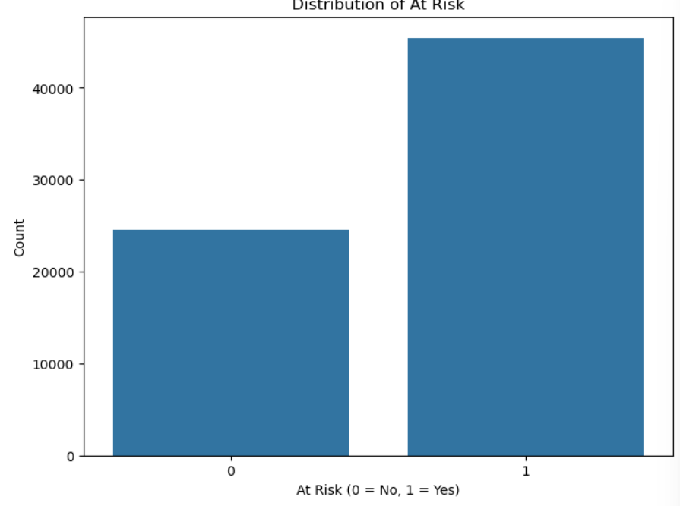

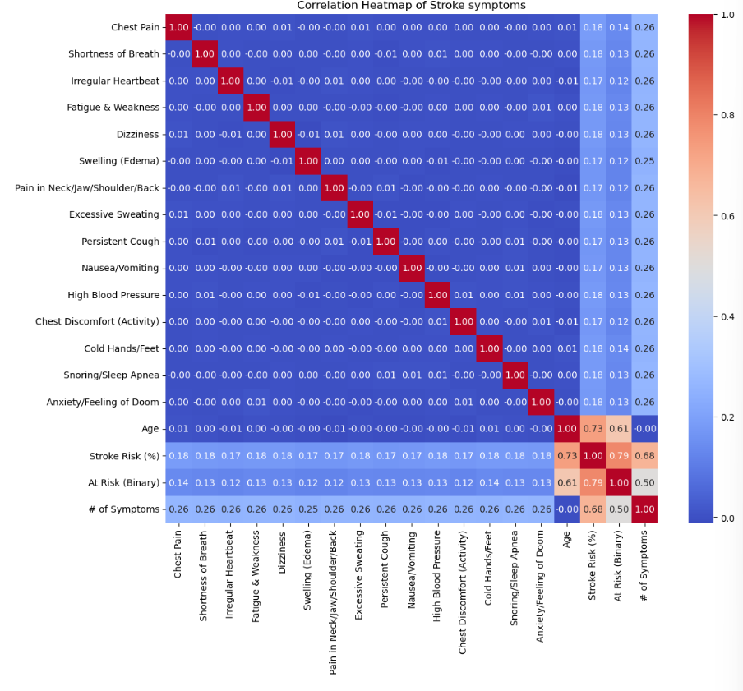
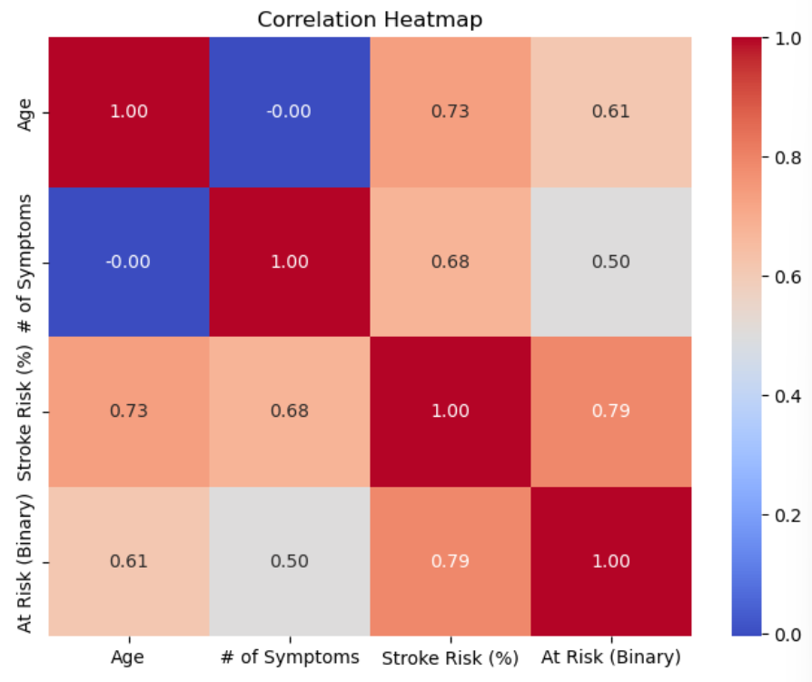

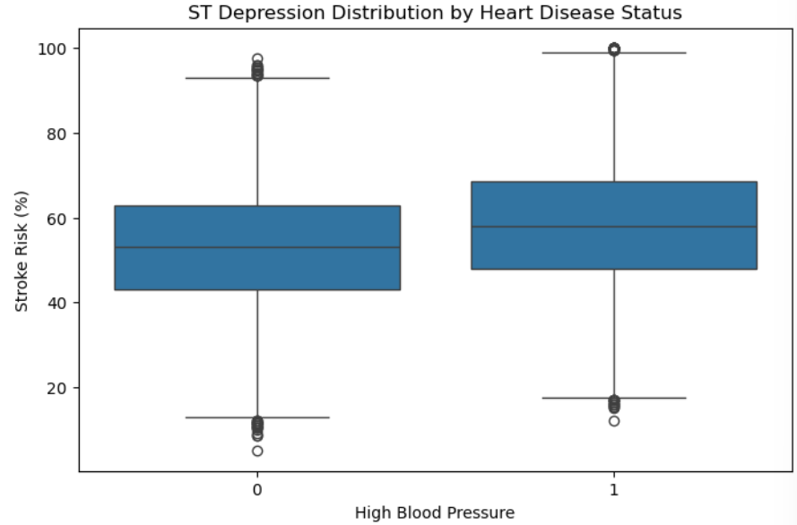
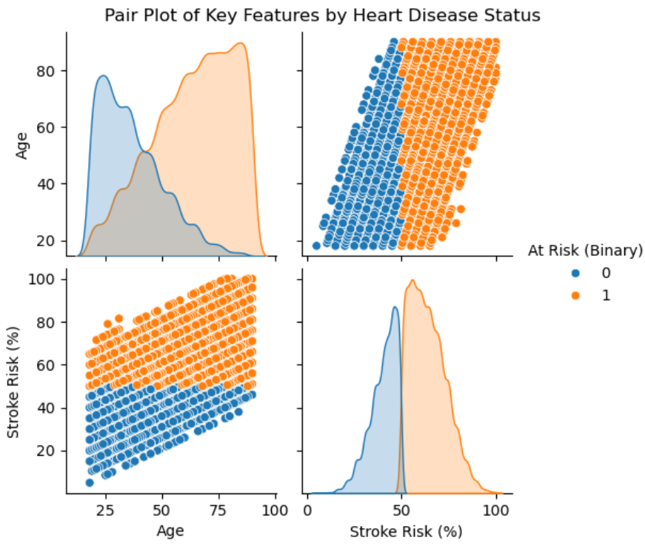

- METHODS

  - Data Preparation
Before building any models, the dataset was reviewed for missing values and cleaned. No missing or null entries were found. All features were already in a numeric format, with binary symptom indicators represented as 0s and 1s. A new feature, # of Symptoms, was created by summing the binary symptom columns for each individual. This new feature aimed to capture overall symptom burden and improve predictive performance. For regression analysis, y was Stroke Risk (%) and X was all other values.

  - Experimental Design
You will run your model several times with different parameters to see what different results you get. In a table, describe your experimental parameters. Three or four experiments are sufficient. This is where you will describe how you divided your data into train, validate and test data sets. For example:

Table X: Experiment Parameters
Experiment Number | Parameters | Model description
1 | All four (4) raw features with 80/20 split for train, and test | All data, 80/20 split
2 | All four (4) raw features with 70/30 split for train, and test | All data, 70/30 split
3 | Selected features with 80/20 split for train, and test | Only age & cardiovascular/neurological symptoms, 80/20 split
4 | Selected features with 70/30 split for train, and test | Only age & cardiovascular/neurological symptoms, 70/30 split

  - Tools Used
The following tools were used for this analysis: Python & the following libraries: Pandas, Numpy, Matplotlib, Seaborn, and SKLearn.
Pandas – load the data & data manipulation
Numpy – numerical operations (mse, rmse, r2)
Matplotlib & Seaborn – data visualization (histograms, heatmaps, box plots, pair plots)
SKLearn – splitting data into train and test sets & building regression model

- RESULTS
  - Classification Measures/ Accuracy measure
Model 1:
Mean squared error 7.212163808644858e-05
Root mean squared error 0.008492445942509648
R square 0.9999996485993495

Model 2:
Mean squared error 4.8791215880574506e-05
Root mean squared error 0.006985070928814861
R square 0.9999997616331122

Model 3:
Mean squared error 48.810700807936094
Root mean squared error 6.9864655447469355
R square 0.7621780027634335

Model 4:
Mean squared error 49.599389343884184
Root mean squared error 7.04268339085921
R square 0.7576848238163447

  - Discussion of Results
Among the four regression models tested, Model 2, which used all features all data with a 70/30 train-test split, performed the best overall. It achieved the lowest RMSE and the highest R² score, indicating that the model’s predictions were extremely close to the actual stroke risk percentages.
Model 4 performed the worst. It used only selected features ['Age', 'Chest Pain', 'Irregular Heartbeat', 'Fatigue & Weakness', 'Dizziness', 'High Blood Pressure', 'Chest Discomfort (Activity)', 'Anxiety/Feeling of Doom'], which were all the cardiovascular/neurological symptoms. Although these were expected to be the most relevant symptoms in regards to stroke risk, the RMSE and R2 scores reflect otherwise.
Overall, these results emphasize that using a full set of original features produced the most accurate predictions for stroke risk.

  - Limitations of Implementation
Linear regression assumes a linear relationship between the input features and the target variable, which may oversimplify the complex nature of how multiple symptoms interact to influence stroke risk. Human health data is often nonlinear, and interactions between symptoms might not be fully captured by this model.

  - Improvements/Future Work
To better train a model in the future, I would try to find data on people who have already had strokes and what their combination of symptoms were. This could help build a more realistic and useful prediction model. Another valuable addition would be a column indicating whether or not a person has already had a stroke, since having a stroke in the past increases the risk of having another one. Including that kind of medical history could improve accuracy.

- CONCLUSION
This project explored the use of linear regression models to predict stroke risk based on symptom presence and age. By using a dataset composed of binary symptom indicators, age, and stroke risk percentage, I was able to evaluate how different combinations of features and train-test splits affected model performance. The goal was to both estimate a person’s likelihood of experiencing a stroke and understand which symptoms were most predictive.
Out of four models tested, the best-performing model used all available features and a 70/30 train-test split, achieving an extremely low RMSE and a near-perfect R² score. Overall, while the model performed well, it would benefit from more diverse real-world data and the use of other machine learning techniques in future work.

