Ariel Rollins
1. Explain regression
2. Help me SQL
3. Create a dataset

a. ChatGPT, explain what a regression model does in simple terms. Explain how it finds the ‘line of best fit’ to predict future outcomes.
b. 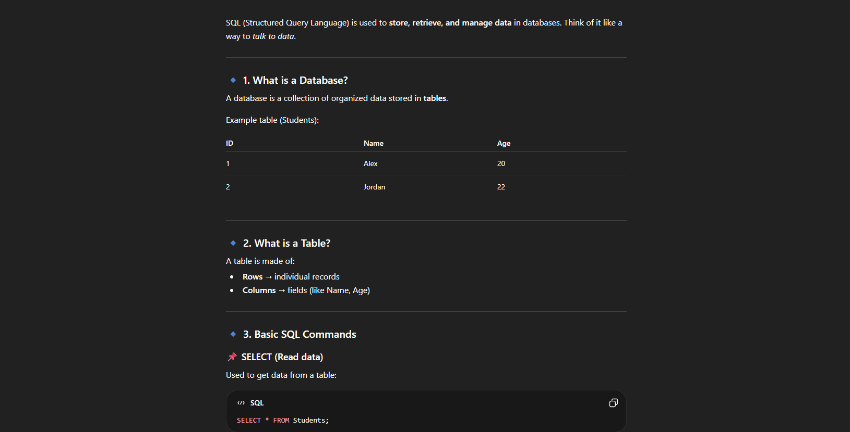
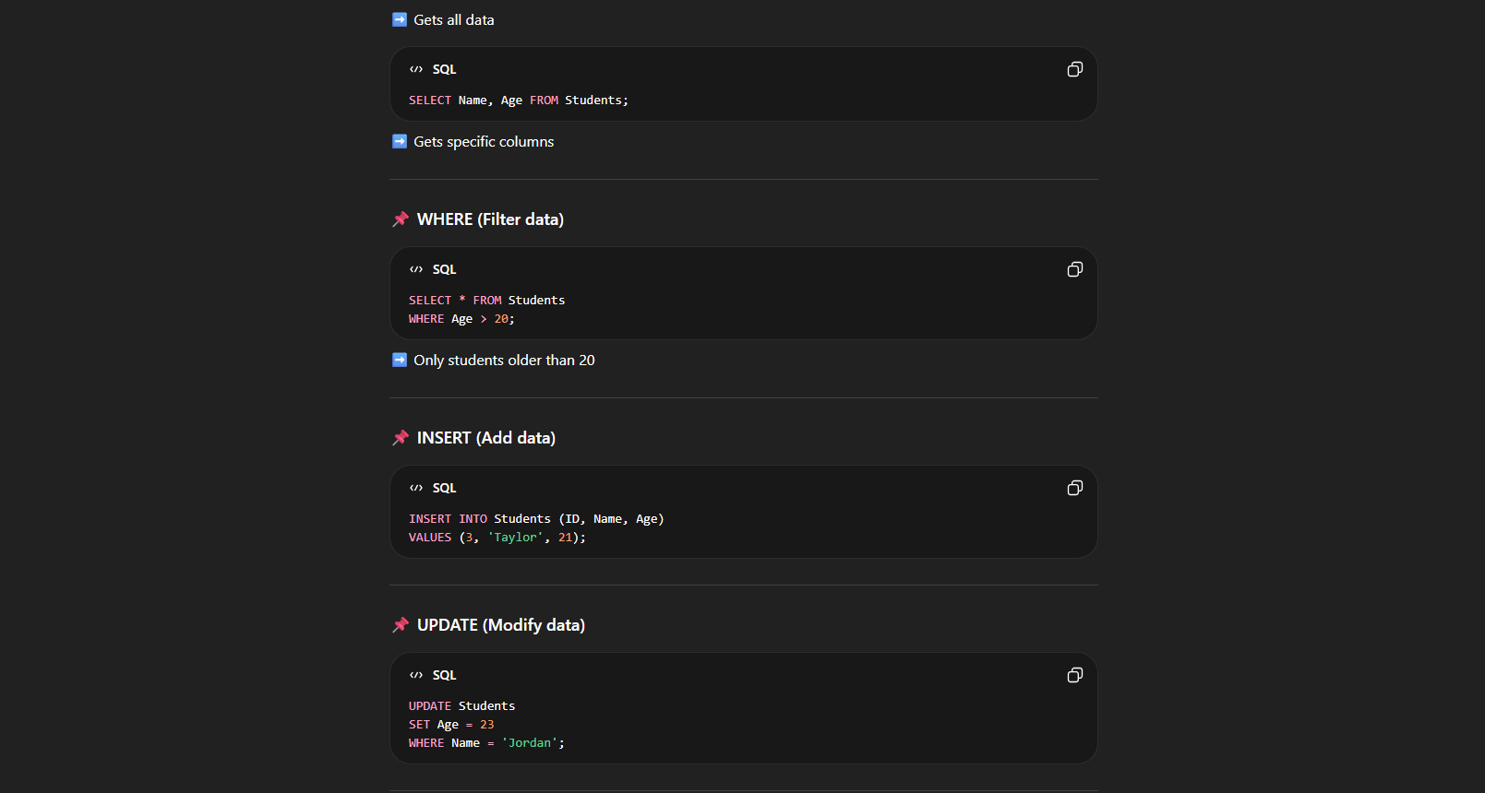
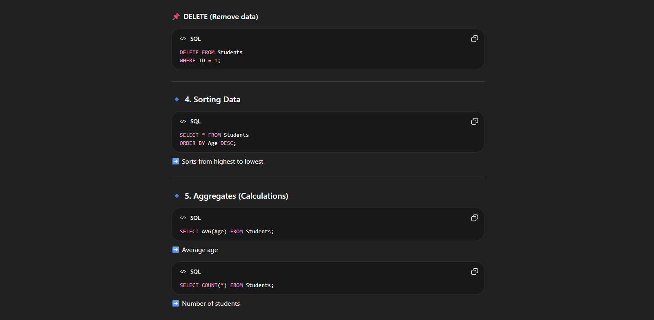

c. This structured prompt with specifc tasks gives the AI better ability to give you exactly what you need. Specifications are vital with AI.

