Writing a Program:

1. Name a file
2. Type “public class name”
3. Type the code “public static void main(String[]args)
4. Use curly brackets with the code “System.out.println(“”).
5. And type whatever you want within the paratheses.

Compiling a Program:

Type in a code into execute and create “JAVACOMPILE” and ‘JAVAEXECUTE”. JAVACOMPILE will compile the code and JAVAEXECUTE will execute the program you wrote.

 -escape sequence: series of characters that represent a character by beginning with a \ to indicate.

-for example:

\t means insert tab in text

\n means insert newline in text

\” means double quote

\\ means back slash

-ASCII art is a technique creating art on the computer by using characters from the ASCII standard.

-It was created because printers back in the day were not as advanced so they had to use characters instead of other graphics

-people often use ASCII art without realizing it for example, a smiley face is ASCII art ☺

-one of the first examples of ASCII art in history was in 1966, created by Kenneth Knowlton

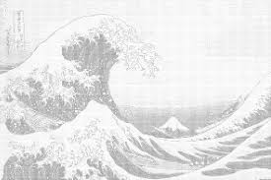 an example of a beautiful extreme ASCII artwork

People also use ASCII artwork in YouTube comments.