Freelance Content

**Homepage**

Welcome to E. Lang’s Tech World, the most popular company of web design! Here you can navigate between different functions of technology. It’s an outstanding place for web design!

**About Our Company**

*Technology is powerful.*

Our company has all different kinds of tools to apply to technology. We write our own language using code when it comes to technology. And we also work for the web worldwide. Our computer language is even applicable to people of all different kinds. Plus, we have different kinds of software as well for content.

My Resume

I am very good at subjects such as math and science, and that’s what would make me a professional web designer.



**Our Services**

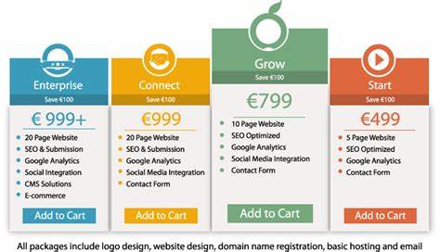

**Our Portfolio**

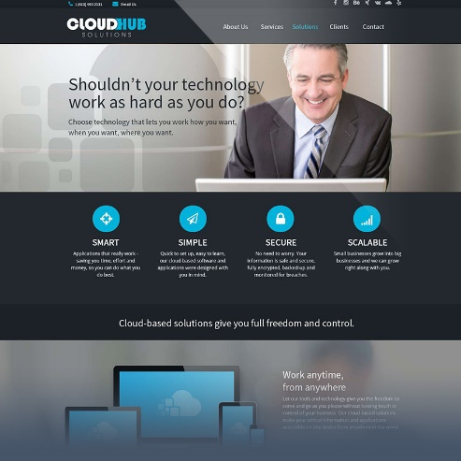

CloudHub Solutions is the most efficient start-up technology site.

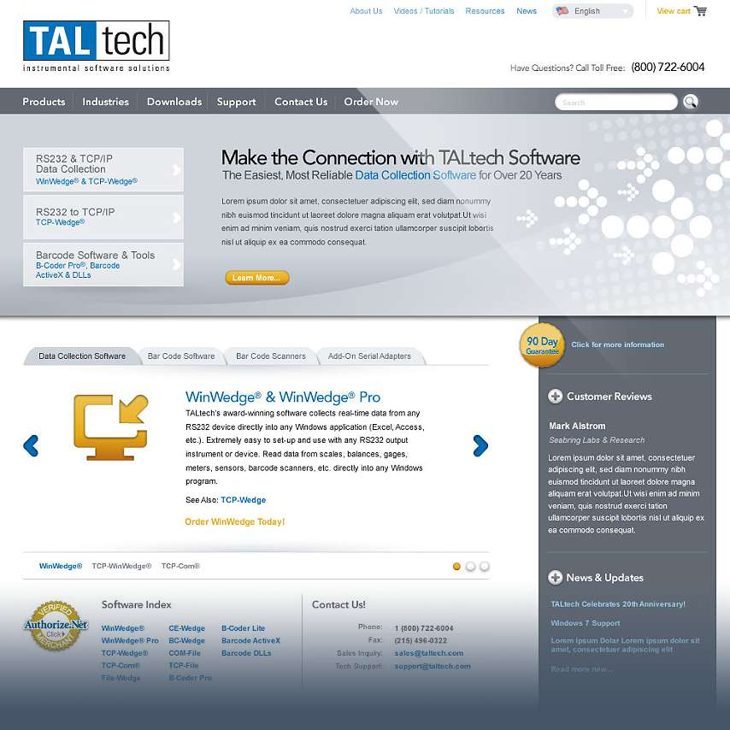

TALtech has showcased their software solutions and products.

**Contact Us**

Eric Lang

1234 Sycamore Valley, PA 18072

267-333-8614