Course Code: CSA1305 Name: Elango M (192411026)
Faculty: Dr Balamanigandan R
EXPERIMENT NO: 28
According to your TOC Lab Manual, Experiment 28 is “Design PDA using simulator to accept the input string”, with the test strings aabb and aaabbb.
Aim
To design a Push Down Automaton (PDA) using the simulator to accept the language .
Software Used
- AutoSim / Automaton Simulator
- Windows Operating System
Procedure
- Open the Automaton Simulator.
- Select PDA (Push Down Automaton).
- Create the required states.
- Set the initial state.
- Mark the final/accepting state.
- Initialize the stack with a bottom-of-stack symbol, such as Z.
- For every input a, push a symbol A onto the stack.
- When b symbols begin, pop one A for every b.
- Continue until the complete input is processed.
- If all pushed A symbols are popped and the input is completely consumed, accept the string.
- Otherwise, reject the string.
Algorithm
- Start in the initial state with stack symbol Z.
- Read each a.
- For every a, push A onto the stack.
- When the first b is encountered, change to the state that processes b's.
- For every b, pop one A.
- Continue until all input symbols are processed.
- If the stack returns to Z after processing all input, move to the final state.
- Otherwise, reject the input.
- Stop.
PDA Transition Idea
Input | Stack Top | Operation
a | Z | Push A
a | A | Push A
b | A | Pop A
End | Z | Accept
The important condition is:
Number of a's = Number of b's, with all a's occurring before the b's.
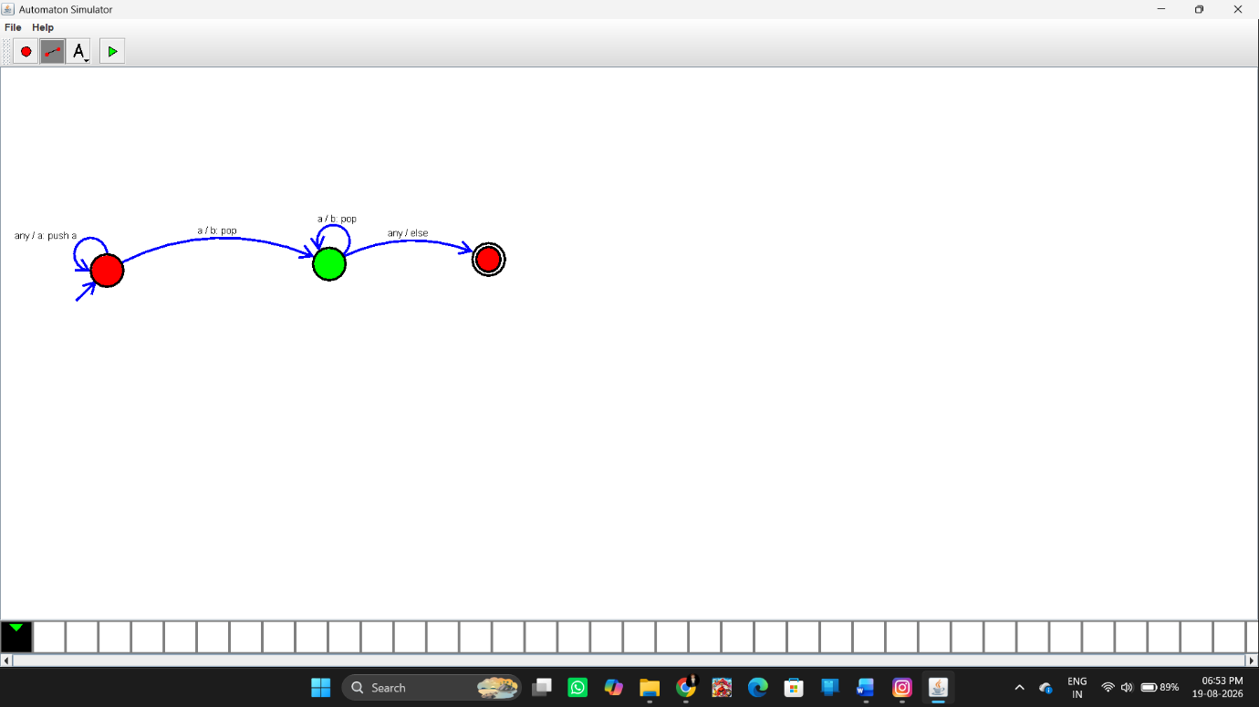Input and Output
Test Case 1
Input:
aabb
Here:
aa = 2 a's
bb = 2 b's
Therefore:
2 = 2
Output:
String Accepted
Test Case 2
Input:
aaabbb
Here:
aaa = 3 a's
bbb = 3 b's
Therefore:
3 = 3
Output:
String Accepted
These are the two strings specified in your manual.
Additional Rejected Example
Input:
aab
Number of a's = 2
Number of b's = 1
Output:
String Not Accepted
Another Rejected Example
Input:
aabb b
or simply:
aabbb
Number of a's = 2
Number of b's = 3
Output:
String Not Accepted
Result
Thus, the Push Down Automaton was successfully designed using the simulator to accept the language . The input strings aabb and aaabbb are accepted because they contain an equal number of a's and b's.

