Course Code: CSA1305 Name: Elango M (192411026)
Faculty: Dr Balamanigandan R
EXPERIMENT NO: 26
Title
DESIGN DFA USING SIMULATOR TO ACCEPT TH+E INPUT STRINGS bc, c, AND bcaaa
Aim
To design a Deterministic Finite Automaton (DFA) using the simulator to accept the input strings bc, c, and bcaaa.
Software Used
- AutoSim / Automaton Simulator
- Windows Operating System
Procedure
- Open the Automaton Simulator.
- Select DFA.
- Create the required states.
- Set the initial state.
- Mark the required final state(s).
- Add transitions for the input symbols.
- Configure the transitions so that the DFA accepts bc, c, and bcaaa.
- Enter each test string in the simulator.
- Run the DFA.
- Check whether the machine reaches a final state.
- Record the output.
Algorithm
- Start from the initial state.
- Read the input string from left to right.
- Follow the corresponding transition for each input symbol.
- After the complete string is read, check the current state.
- If the current state is a final state, print String Accepted.
- Otherwise, print String Not Accepted.
- Repeat for all given input strings.
- Stop.
DFA Design
A simple DFA for accepting exactly the three specified strings can use separate paths:
b c
q0 ─────→ q1 ─────→ qF

q0 ─────→ q2 ─────→ qF
c

q0 ──b──→ q1 ──c──→ q3 ──a──→ q4 ──a──→ q5 ──a──→ qF
Here:
- q0 = Initial state
- qF = Final state
The exact transition arrangement in AutoSim may vary depending on how you construct the DFA.
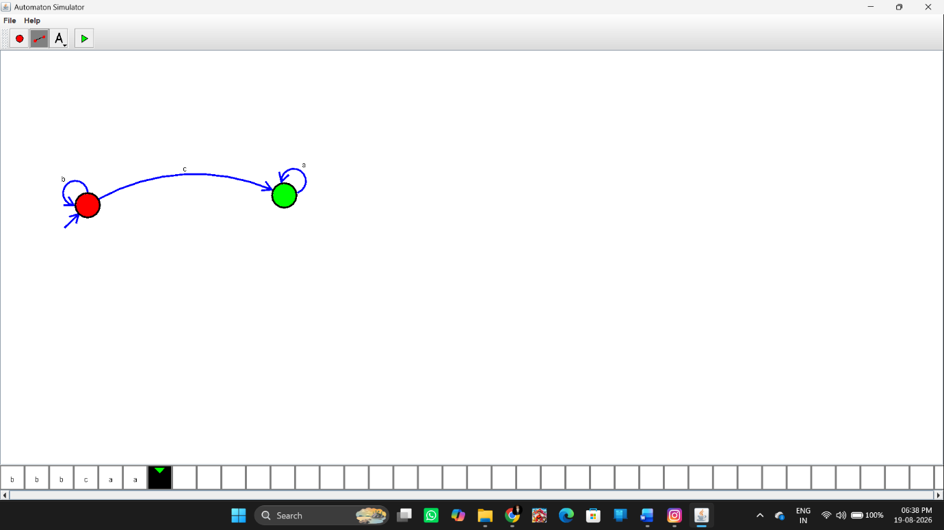Input and Output
Test Case 1
Input:
bc
Output:
String Accepted
Test Case 2
Input:
c
Output:
String Accepted
Test Case 3
Input:
bcaaa
Output:
String Accepted
These are the three input strings specified for Experiment 26 in your lab manual.
Additional Rejected Examples
Input:
bca
Output:
String Not Accepted
Input:
b
Output:
String Not Accepted
Result
Thus, the DFA was successfully designed using the simulator to accept the specified input strings bc, c, and bcaaa.

