Course Code: CSA1305 Name: Elango M (192411026)
Faculty: Dr Balamanigandan R
EXPERIMENT NO: 21
Title
DESIGN DFA USING SIMULATOR TO ACCEPT THE STRING HAVING ab AS SUBSTRING OVER THE SET {a,b}
Aim
To design a Deterministic Finite Automaton (DFA) using the simulator to accept strings having ab as a substring over the alphabet {a,b}.
Software Used
- AutoSim / Automaton Simulator
- Windows Operating System
Procedure
- Open the Automaton Simulator.
- Select DFA.
- Create the required states.
- Set the initial state.
- Mark the final state.
- Add transitions for a and b.
- Design the DFA to detect the substring ab.
- Enter the test string babaaaaa.
- Run the simulator.
- Check whether the machine reaches the final state.
- Record the result.
Algorithm
- Start at the initial state q0.
- Read the input string from left to right.
- If a is read, move to a state indicating that a has been seen.
- If b is read immediately after a, move to the accepting state.
- Once ab has occurred, remain in the accepting state for all subsequent inputs.
- If the complete string is processed in the accepting state, accept the string.
- Otherwise, reject the string.
DFA Transition Table
Current State | Input a | Input b
→ q0 | q1 | q0
q1 | q1 | q2
★ q2 | q2 | q2
- q0 → Initial state
- q1 → a has been detected
- q2 → ab has been detected (Final state)
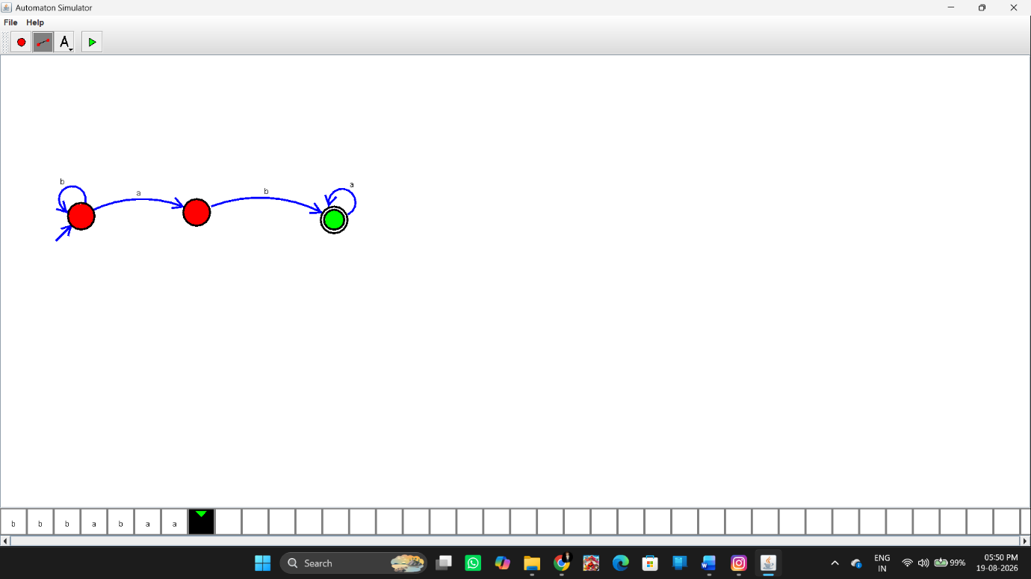Input
babaaaaa
The string contains:
ba[b]aaaaa
More simply, it contains the substring ab at positions 2–3:
b a b a a a a a
↑ ↑
a b
Therefore, it should be Accepted.
Output
Input: babaaaaa

String Accepted
Result
Thus, the DFA was successfully designed using the simulator to accept strings having ab as a substring over the alphabet {a,b}. The given string babaaaaa was successfully accepted.

