Course Code: CSA1305 Name: Elango M (192411026)
Faculty: Dr Balamanigandan R
EXPERIMENT NO: 14
Title
DESIGN A TURING MACHINE (TM) USING SIMULATOR TO ACCEPT THE PALINDROME STRING "ababa"
Aim
To design a Turing Machine (TM) using the AutoSim simulator to accept the palindrome input string "ababa".
Software Used
- AutoSim (Turing Machine Simulator)
- Windows Operating System
Procedure
- Open the AutoSim software.
- Select Turing Machine (TM).
- Create the required states.
- Set the initial state.
- Mark the accepting (final) state.
- Define the tape alphabet and blank symbol.
- Design the TM transitions to recognize the palindrome string "ababa".
- Save the Turing Machine.
- Run the simulation.
- Enter the input string.
- Observe whether the string is accepted or rejected.
Algorithm
- Start.
- Read the input string from the tape.
- Compare the leftmost and rightmost unmarked symbols.
- If they are equal, mark them and move toward the center.
- Repeat the comparison for the remaining symbols.
- If all corresponding symbols match, move to the Accept state.
- If any pair of symbols does not match, move to the Reject state.
- Stop.

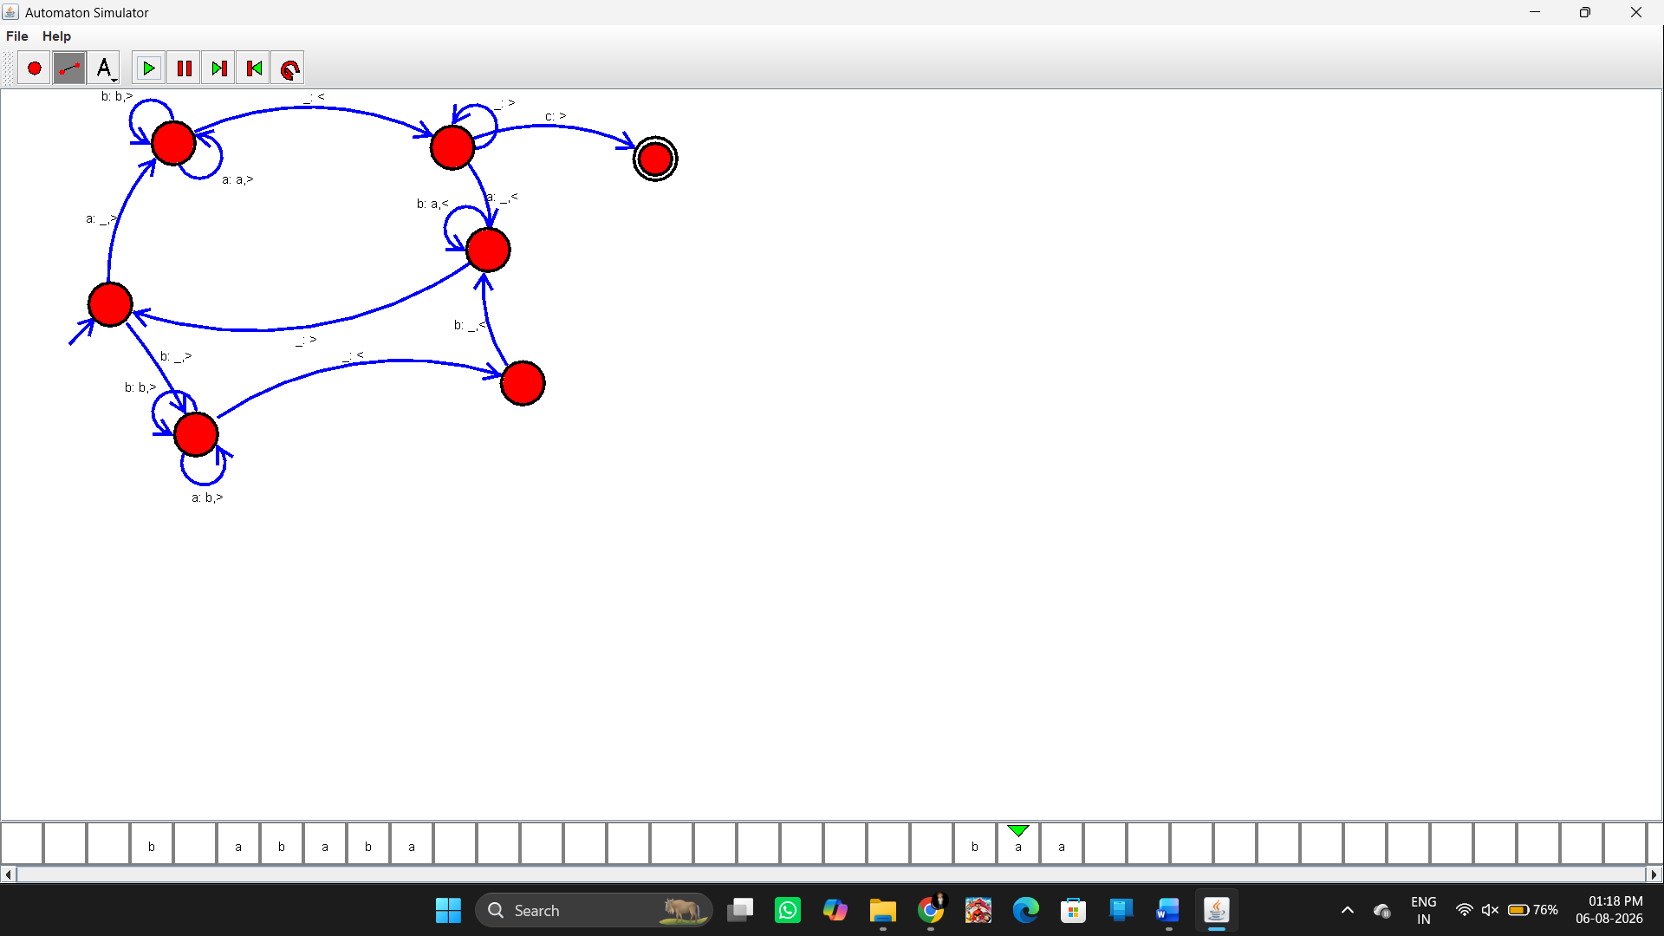Sample Input and Output
Test Case 1
Input
ababa
Output
Accepted

Result
Thus, the Turing Machine (TM) was successfully designed using the AutoSim simulator to recognize palindrome strings, and the given input strings were correctly accepted or rejected based on whether they were palindromes.

