Course Code: CSA1305 Name: Elango M (192411026)
Faculty: Dr Balamanigandan R
EXPERIMENT NO: 23
Title
DESIGN TURING MACHINE USING SIMULATOR TO ACCEPT THE INPUT STRING PALINDROME bbabb
Aim
To design a Turing Machine (TM) using the simulator to accept the palindrome input string bbabb.
Software Used
- AutoSim / Automaton Simulator
- Windows Operating System
Procedure
- Open the Automaton Simulator.
- Select Turing Machine (TM).
- Create the required states.
- Set the initial state.
- Mark the final/accepting state.
- Define the required tape symbols and transitions.
- Enter the input string bbabb on the tape.
- Place the tape head at the first symbol.
- Run the Turing Machine.
- The machine compares the symbols from both ends.
- If all corresponding symbols match, it reaches the accepting state.
- Record the result.
Algorithm
- Start the TM.
- Read the leftmost unmarked symbol.
- Remember whether it is a or b.
- Move to the right end of the input.
- Find the corresponding rightmost unmarked symbol.
- Compare it with the remembered symbol.
- If they are different, go to the Reject state.
- If they are the same, mark the symbols and return toward the left.
- Repeat the process for the remaining symbols.
- When all symbols have been matched, go to the Accept state.
- Stop.
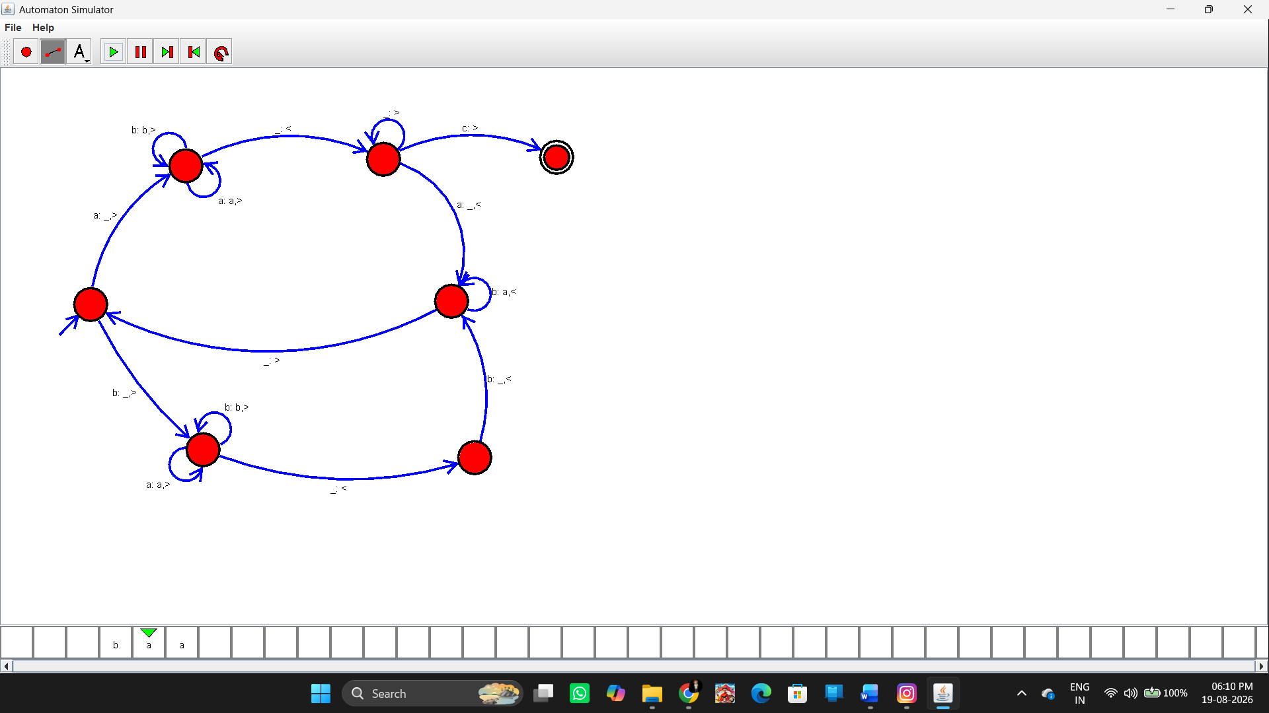Input
The exact input given in the manual is:
bbabb
Why it is accepted
The string is:
b b a b b
Reading from both ends:
b = b
b = b
a = a
Therefore, it is a palindrome.
Output
Input: bbabb

String Accepted
Additional rejected example
Input: bbaba

String Not Accepted
because the first and last symbols are different (b and a).
Result
Thus, the Turing Machine was successfully designed using the simulator to recognize the palindrome bbabb, and the given input string was successfully accepted.

