Course Code: CSA1305 Name: Elango M (192411026)
Faculty : Dr Balamanigandan R
EXPERIMENT NO: 9
Aim
To design a Deterministic Finite Automata (DFA) using the AutoSim simulator to accept the input strings "a", "ac", and "bac".
Software Used
- AutoSim (Automata Simulator)
- Windows Operating System
Procedure
- Open the AutoSim software.
- Select DFA from the simulator.
- Create the required states.
- Set the initial state.
- Mark the accepting (final) states.
- Draw the transitions and assign the input symbols (a, b, c).
- Save the DFA.
- Run the simulation.
- Enter the test strings.
- Verify whether the strings are accepted or rejected.
Algorithm
- Start.
- Create the DFA with the required states.
- Mark one state as the initial state.
- Mark the accepting state(s).
- Define transitions for the input symbols a, b, and c.
- Enter the input string.
- Process each input symbol according to the transition function.
- If the automaton ends in a final state, display Accepted.
- Otherwise, display Rejected.
- Stop.
Simulation
Design the DFA in AutoSim to accept only the strings:
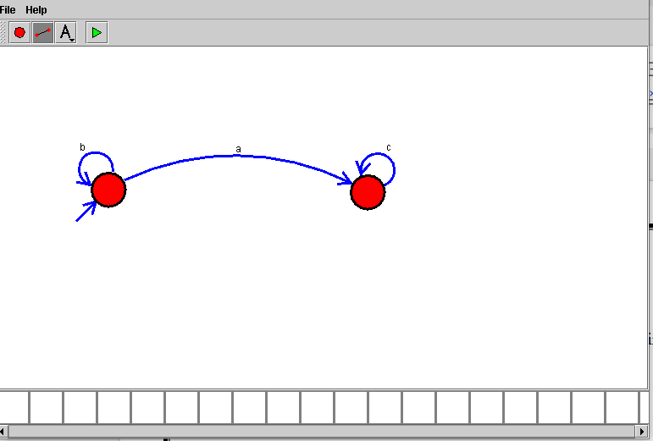
Sample Input and Output
Test Case 1
Input
a
Output
Accepted
Test Case 2
Input
ac
Output
Accepted
Test Case 4
Input
abc
Output
Rejected

Result
Thus, the Deterministic Finite Automata (DFA) was successfully designed using the AutoSim simulator to accept the strings "a", "ac", and "bac", while rejecting all other input strings.
Note: Experiment 9 is a simulator-based experiment, so no C program/code is required. The lab manual specifies designing the DFA using the simulator only.

