Course Code: CSA1305 Name: Elango M (192411026)
Faculty: Dr Balamanigandan R
EXPERIMENT NO: 22
Title
DESIGN DFA USING SIMULATOR TO ACCEPT THE STRING START WITH a OR b OVER THE SET {a,b}
Aim
To design a Deterministic Finite Automaton (DFA) using the simulator to accept strings that start with a or b over the alphabet {a,b}.
Software Used
- AutoSim / Automaton Simulator
- Windows Operating System
Procedure
- Open the Automaton Simulator.
- Select DFA.
- Create the required states.
- Set the initial state.
- Mark the accepting state(s).
- Add transitions for input symbols a and b.
- Design the DFA so that after reading the first symbol, the machine enters an accepting state.
- Enter the test string.
- Run the simulator.
- Check whether the machine reaches the accepting state.
- Record the output.
Algorithm
- Start at the initial state q0.
- Read the first input symbol.
- If the first symbol is a, move to an accepting state.
- If the first symbol is b, move to an accepting state.
- Continue reading the remaining a and b symbols.
- Since the first symbol is either a or b, the string is accepted.
- If an invalid symbol occurs, reject the string.
DFA Transition Table
Current State | a | b
→ q0 | q1 | q1
★ q1 | q1 | q1
- q0 = Initial state
- q1 = Final/accepting state
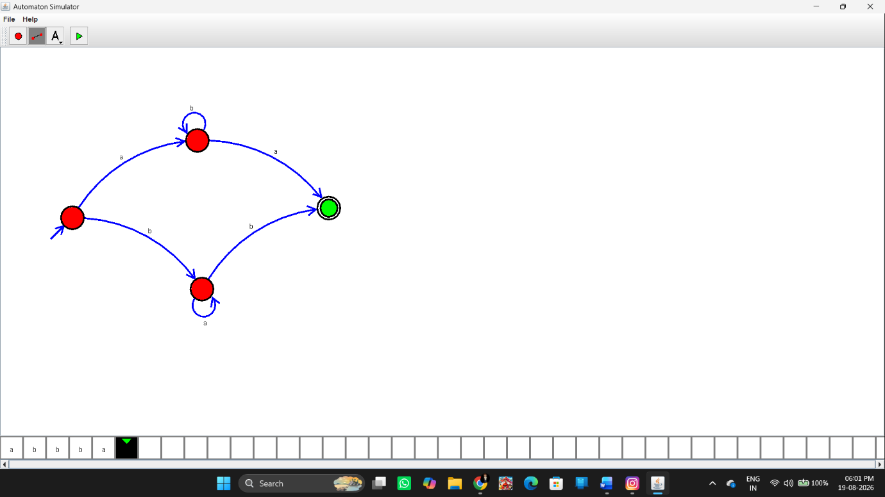Input
abbbba
and
baaaaab
Test Case 1
Input:
abbbba
The first symbol is a, so it is accepted.
Output:
String Accepted
Test Case 2
Input:
baaaaab
The first symbol is b, so it is accepted.
Output:
String Accepted
Result
Thus, the DFA was successfully designed using the simulator to accept strings starting with a or b over the alphabet {a,b}. The given strings abbbba and baaaaab were successfully accepted.

