Course Code: CSA1305 Name: Elango M (192411026)
Faculty: Dr Balamanigandan R

EXPERIMENT NO: 18
Title
DESIGN DFA USING SIMULATOR TO ACCEPT EVEN NUMBER OF a's
Aim
To design a Deterministic Finite Automaton (DFA) using the simulator to accept strings containing an even number of a's.
Software Used
- AutoSim / Automaton Simulator
- Windows Operating System
Procedure
- Open the Automaton Simulator.
- Select the DFA option.
- Create two states:
  - q0 – even number of a's
  - q1 – odd number of a's
- Set q0 as the initial state.
- Mark q0 as the final/accepting state.
- Create transitions for input a.
- From q0, on a, go to q1.
- From q1, on a, go back to q0.
- Enter the input string.
- Run the DFA and observe the final state.
- If the machine ends in q0, the string is accepted.
Algorithm
- Start in state q0.
- Read the input string from left to right.
- For every a:
  - If the current state is q0, move to q1.
  - If the current state is q1, move to q0.
- After all input symbols are processed:
  - If the current state is q0, Accept.
  - If the current state is q1, Reject.
- Stop.
DFA Transition Table
Current State | Input a | State Meaning
→ q0 | q1 | Even → Odd
q1 | q0 | Odd → Even
q0 is the final state.

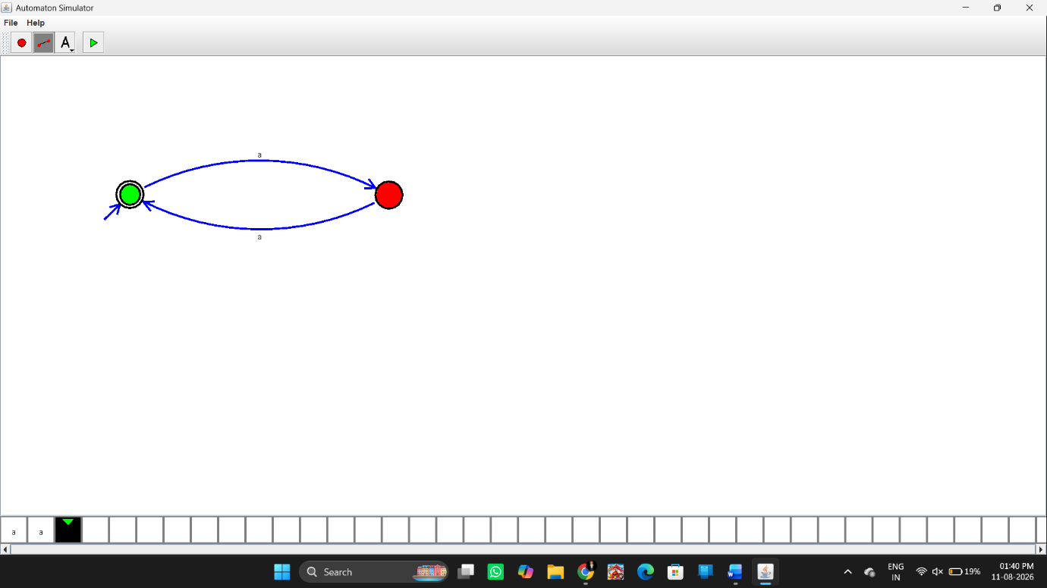
Input and Output
The manual specifies these test strings:
Test Case 1
Input:
aa
Number of a's = 2 → Even
Output:
Accepted
Test Case 2
Input:
aaaa
Number of a's = 4 → Even
Output:
Accepted
Test Case 3
Input:
aaaaaa
Number of a's = 6 → Even
Output:
Accepted
Result
Thus, the DFA was successfully designed using the simulator to accept strings containing an even number of a's. The strings aa, aaaa, and aaaaaa are accepted as specified in the lab manual.

