Course Code: CSA1305 Name: Elango M (192411026)
Faculty: Dr Balamanigandan R

EXPERIMENT NO: 19
Title
DESIGN DFA USING SIMULATOR TO ACCEPT ODD NUMBER OF a's
Aim
To design a Deterministic Finite Automaton (DFA) using the simulator to accept strings containing an odd number of a's.
Software Used
- AutoSim / Automaton Simulator
- Windows Operating System
Procedure
- Open the Automaton Simulator.
- Select the DFA option.
- Create two states:
  - q0 – even number of a's
  - q1 – odd number of a's
- Set q0 as the initial state.
- Mark q1 as the final/accepting state.
- Create a transition from q0 to q1 for input a.
- Create a transition from q1 to q0 for input a.
- Enter the required input string.
- Run the DFA.
- If the machine ends in q1, the string is accepted.
Algorithm
- Start from state q0.
- Read the input string from left to right.
- For every a:
  - If the current state is q0, move to q1.
  - If the current state is q1, move to q0.
- After reading the complete input:
  - If the current state is q1, Accept.
  - If the current state is q0, Reject.
- Stop.
Transition Table
Current State | Input a | Meaning
→ q0 | q1 | Even → Odd
* q1 | q0 | Odd → Even
- q0 = Initial state
- q1 = Final state

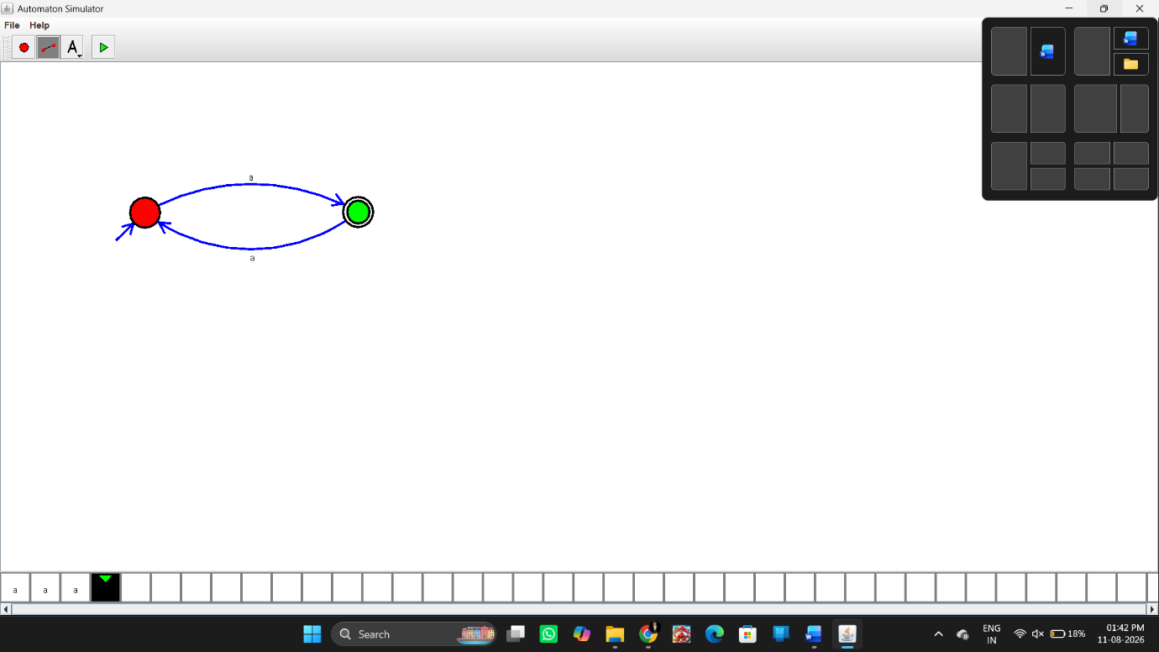

Input and Output
Test Case 1
Input:
a
Number of a's = 1 → Odd
Output:
Accepted
Test Case 2
Input:
aaa
Number of a's = 3 → Odd
Output:
Accepted
Test Case 3
Input:
aaaaa
Number of a's = 5 → Odd
Output:
Accepted
Result
Thus, the DFA was successfully designed using the simulator to accept strings containing an odd number of a's. The strings a, aaa, and aaaaa are accepted as specified in the lab manual.

