Course Code: CSA1305 Name: Elango M (192411026)
Faculty: Dr Balamanigandan R
EXPERIMENT NO: 20
Title
DESIGN DFA USING SIMULATOR TO ACCEPT THE STRING THAT ENDS WITH ab OVER THE SET {a,b}
Aim
To design a Deterministic Finite Automaton (DFA) using the simulator to accept strings ending with ab over the alphabet {a, b}. The given test string is aaabab.
Software Used
- AutoSim / Automaton Simulator
- Windows Operating System
Procedure
- Open the Automaton Simulator.
- Select DFA.
- Create the required states.
- Set the initial state.
- Mark the final state.
- Add transitions for input symbols a and b.
- Design the DFA so that it remembers whether the last two symbols are ab.
- Enter the test string aaabab.
- Run the DFA.
- Observe whether the machine reaches the final state.
- Record the output.
Algorithm
- Start from the initial state q0.
- Read the input string from left to right.
- If a is read, move to the state representing that the latest symbol is a.
- If b is read after an a, move to the accepting state.
- Continue processing the remaining symbols.
- If the last two symbols are ab, accept the string.
- Otherwise, reject the string.
DFA Transition Table
Current State | a | b
→ q0 | q1 | q0
q1 | q1 | q2
★ q2 | q1 | q0
- q0 = Initial state
- q2 = Final/accepting state
The machine accepts only when the input finishes in q2, meaning the string ends in ab.
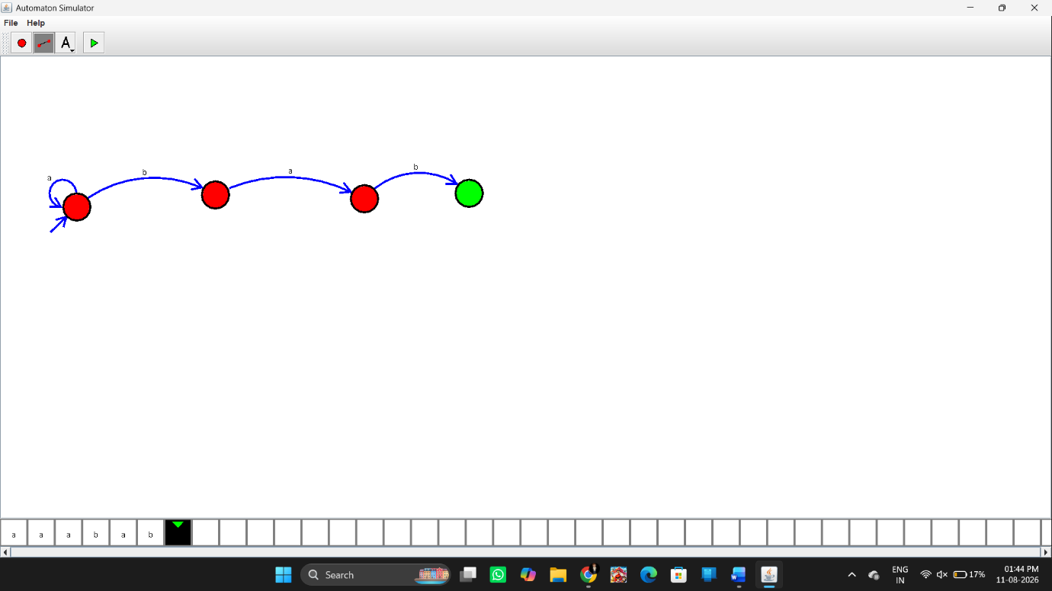

Input
aaabab
State Movement
For:
aaabab
the transitions are:
q0 --a--> q1
q1 --a--> q1
q1 --a--> q1
q1 --b--> q2
q2 --a--> q1
q1 --b--> q2
Final state:
q2
Therefore, the string is Accepted.
Output
Input: aaabab

Result
Thus, the DFA was successfully designed using the simulator to accept strings ending with ab over the alphabet {a,b}. The given string aaabab was successfully accepted.

