Course Code: CSA1305 Name: Elango M (192411026)
Faculty: Dr Balamanigandan R
EXPERIMENT NO: 24
Title
DESIGN TURING MACHINE USING SIMULATOR TO ACCEPT THE INPUT STRING wcw
Your lab manual specifies the strings:
W = { aacaa, bbcbb, abcab }
The manual writes these in compressed form as aa aa, bb bb, and ab ab.
Aim
To design a Turing Machine (TM) using the simulator to accept strings of the form wcw, where the same string w occurs on both sides of c.
Software Used
- AutoSim / Automaton Simulator
- Windows Operating System
Procedure
- Open the Automaton Simulator.
- Select Turing Machine (TM).
- Create the required states.
- Set the initial state.
- Mark the accepting/final state.
- Define the tape symbols and blank symbol.
- Design transitions to compare the portion before c with the portion after c.
- Enter the input string on the tape.
- Place the tape head at the first symbol.
- Run the Turing Machine.
- The machine compares both portions of the string.
- If both portions are identical, the machine reaches the final state.
- Record the result.
Algorithm
- Start the TM.
- Read the string from the left side.
- Find the separator symbol c.
- Compare the first symbol of w with the corresponding symbol after c.
- Mark the compared symbols.
- Return to the next unmarked symbol on the left side.
- Repeat the comparison for all symbols.
- If every symbol before c matches the corresponding symbol after c, go to the Accept state.
- If any symbol does not match, go to the Reject state.
- Stop.
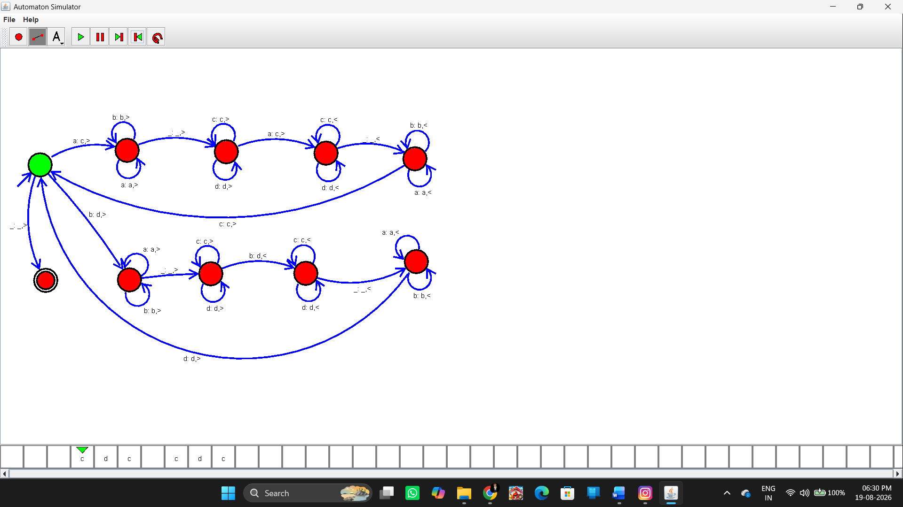Input and Output
Test Case 1
Input:
aacaa
Here:
w = aa
So:
w c w = aa c aa
Output:
String Accepted
Test Case 2
Input:
bbcbb
Here:
w = bb
Therefore:
bb c bb
Output:
String Accepted
Test Case 3
Input:
abcab
Here:
w = ab
Therefore:
ab c ab
Output:
String Accepted
These are the three examples specified by the manual.
Rejected Example
Input:
aacba
This gives:
aa c ba
Since:
aa ≠ ba
Output:
String Not Accepted
Result
Thus, the Turing Machine was successfully designed using the simulator to accept strings of the form wcw, where the string w occurring before c is identical to the string w occurring after c. The inputs aacaa, bbcbb, and abcab are accepted.

