Course Code: CSA1305 Name: Elango M (192411026)
Faculty: Dr Balamanigandan R
EXPERIMENT NO: 12
Title
DESIGN A TURING MACHINE (TM) USING SIMULATOR TO ACCEPT THE INPUT STRING $a^{n}b^{n}$
Aim
To design a Turing Machine (TM) using the AutoSim simulator to accept the input string $a^{n}b^{n}$.
Software Used
- AutoSim (Turing Machine Simulator)
- Windows Operating System
Procedure
- Open the AutoSim software.
- Select Turing Machine (TM).
- Create the required states.
- Set the initial state.
- Mark the accepting (final) state.
- Define the tape alphabet and blank symbol.
- Design the TM transitions to recognize the language $a^{n}b^{n}$.
- Save the Turing Machine.
- Run the simulator.
- Enter the input string.
- Observe whether the string is accepted or rejected.
Algorithm
- Start.
- Read the input string from the tape.
- Replace the leftmost unmarked a with X.
- Move right and find the first unmarked b; replace it with Y.
- Move back to the left end of the tape.
- Repeat Steps 3–5 until all as are marked.
- Check whether any unmarked b remains.
- If all symbols are matched correctly, move to the Accept state.
- Otherwise, move to the Reject state.
- Stop.
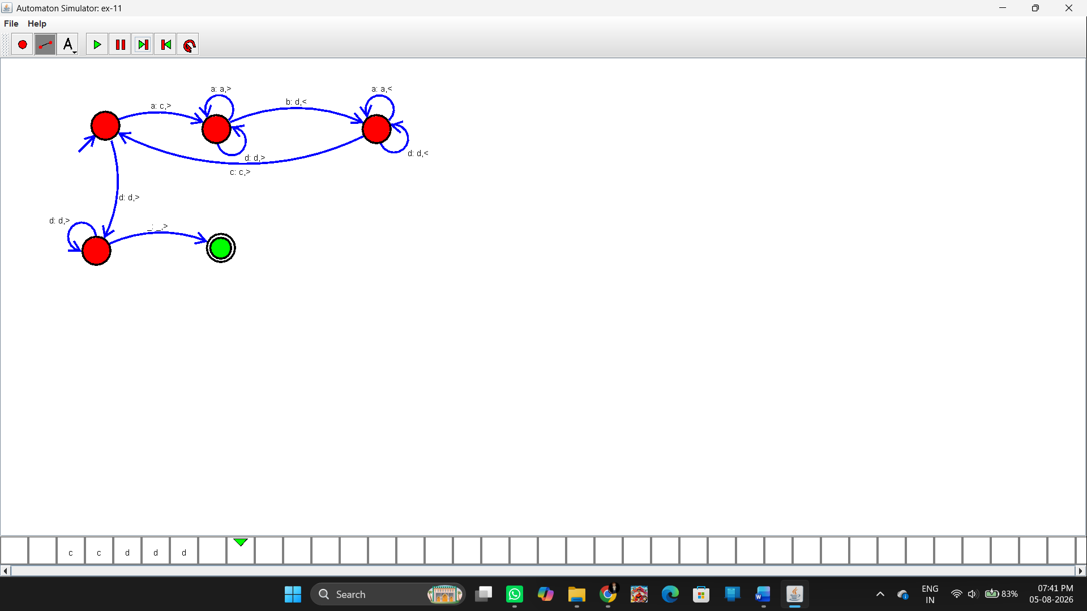Sample Input and Output
Test Case 1
Input
ab
Output
Accepted
Result
Thus, the Turing Machine (TM) was successfully designed using the AutoSim simulator to accept the language $a^{n}b^{n}$, and the given input strings were correctly accepted or rejected according to the language specification.

