Course Code: CSA1305 Name: Elango M (192411026)
Faculty: Dr Balamanigandan R
EXPERIMENT NO: 30
Title
Design DFA using simulator to accept the string having abc as substring over the set {a,b,c}
The lab manual specifies the test strings:
aaaabcccc
abccccc
Aim
To design a Deterministic Finite Automaton (DFA) using the simulator to accept strings having abc as a substring over the alphabet {a,b,c}.
Software Used
- AutoSim / Automaton Simulator
- Windows Operating System
Procedure
- Open AutoSim / Automaton Simulator.
- Select DFA.
- Create the required states.
- Set q0 as the initial state.
- Mark the state representing that abc has been found as the final state.
- Add transitions for a, b, and c.
- Enter the input string.
- Run the DFA.
- Check whether the machine reaches the final state.
- Record the output.
Algorithm
- Start from q0.
- Read the input from left to right.
- When a is found, move to the state indicating that a has been detected.
- From that state, when b is read, move to the state indicating that ab has been detected.
- When c is read after ab, move to the final state.
- Once abc has been found, remain in the final state for subsequent symbols.
- If the complete input ends in the final state, accept.
- Otherwise, reject.
DFA Transition Table
Current State | a | b | c
→ q0 | q1 | q0 | q0
q1 | q1 | q2 | q0
q2 | q1 | q0 | q3
★ q3 | q3 | q3 | q3
- q0 = Initial state
- q1 = a detected
- q2 = ab detected
- q3 = abc detected (Final state)
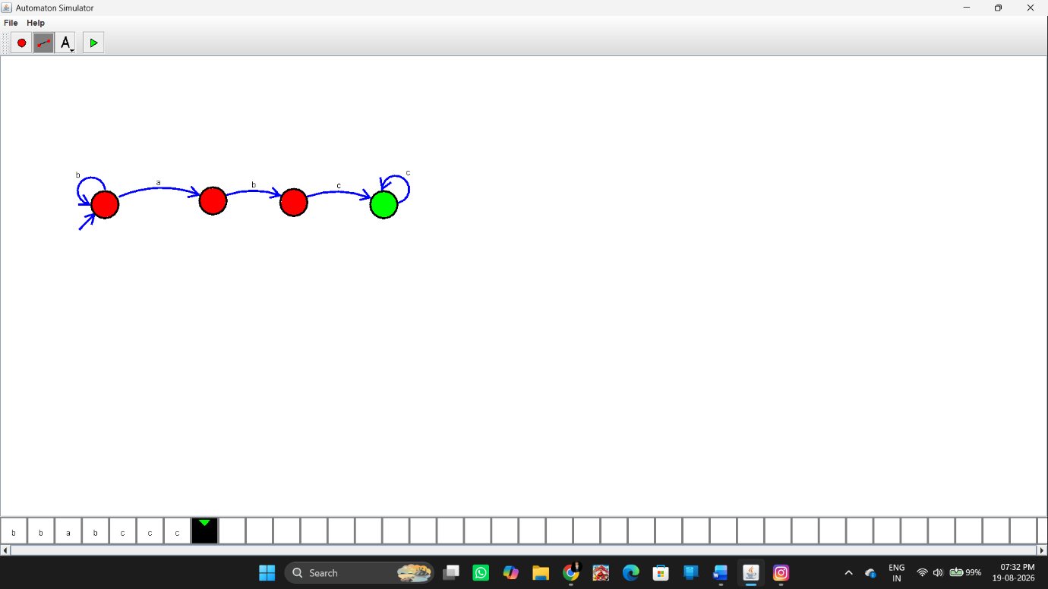Input
Test Case 1
aaaabcccc
This contains:
abc
at the beginning/middle:
aaa[abc]ccc
Test Case 2
abccccc
This contains:
abc
at the beginning:
[abc]cccc
These are the inputs specified in the manual.
Output
Test Case 1
Input: aaaabcccc
Output: String Accepted
Test Case 2
Input: abccccc
Output: String Accepted
Additional rejected example
Input: aacccc
Output: String Not Accepted
because the substring abc does not occur.
Result
Thus, the DFA was successfully designed using the simulator to accept strings having abc as a substring over the alphabet {a,b,c}. The specified inputs aaaabcccc and abccccc are accepted.

