Course Code: CSA1305 Name: Elango M (192411026)
Faculty: Dr Balamanigandan R
EXPERIMENT NO: 15
Title
DESIGN TURING MACHINE USING SIMULATOR TO ACCEPT THE INPUT STRING ww
Aim
To design a Turing Machine (TM) using the simulator to accept the input string ww.
Software Used
- AutoSim / Automaton Simulator
- Windows Operating System
Procedure
- Open the Automaton Simulator.
- Select the Turing Machine (TM) option.
- Create the required states for the TM.
- Select the initial state.
- Create the required transitions.
- Define the tape symbols and blank symbol.
- Design the machine to compare the first part of the input with the second part.
- Enter the input string in the tape.
- Place the tape head at the starting position.
- Run the Turing Machine using the Run button.
- Observe whether the machine reaches the final/accepting state.
- Record the result as Accepted or Rejected.
Algorithm
- Start the Turing Machine.
- Read the input string.
- Divide the input conceptually into two equal parts, w and w.
- Mark a symbol from the first part.
- Move along the tape to the corresponding position in the second part.
- Compare the symbols of both parts.
- If the corresponding symbols are equal, continue with the next symbol.
- If any corresponding symbols are different, move to the reject state.
- Continue until all symbols of both parts have been compared.
- If both parts are identical, move to the accept state.
- Stop.
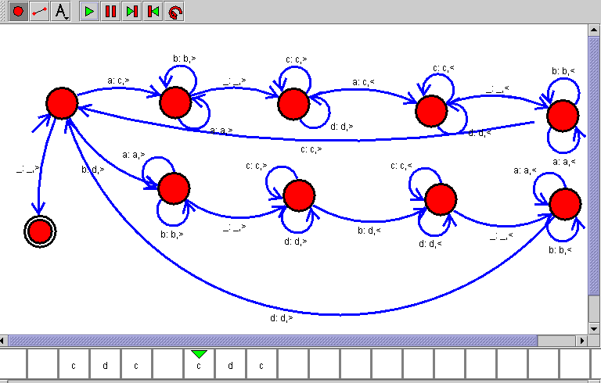Sample Input
Input / Output Table
Input | Division | Output
abab | ab + ab | Accepted
aaaa | aa + aa | Accepted
abcabc | abc + abc | Accepted
abba | ab + ba | Rejected
aabb | aa + bb | Rejected
Result
Thus, the Turing Machine was designed successfully using the simulator to accept strings of the form ww, where the second half of the string is identical to the first half.

