Course Code: CSA1305 Name: Elango M (192411026)
Faculty: Dr Balamanigandan R
EXPERIMENT NO: 16
Title
DESIGN TURING MACHINE USING SIMULATOR TO PERFORM ADDITION OF aa AND aaa
Aim
To design a Turing Machine (TM) using the simulator to perform addition of unary strings aa and aaa.
Software Used
- AutoSim / Automaton Simulator
- Windows Operating System
Procedure
- Open the Automaton Simulator.
- Select the Turing Machine option.
- Create the required states.
- Set the initial state.
- Create the required transitions.
- Enter the unary input strings.
- Use a separator between the two operands if required by the designed TM.
- Run the Turing Machine.
- The machine combines the two groups of as.
- Observe the final tape contents.
- Record the result.
Algorithm
- Start the Turing Machine.
- Read the first group of as.
- Move toward the separator between the two operands.
- Remove/replace the separator as required.
- Combine the first and second groups of as.
- Continue moving until all symbols have been processed.
- The final tape contains the total number of as.
- Move to the final state.
- Stop.
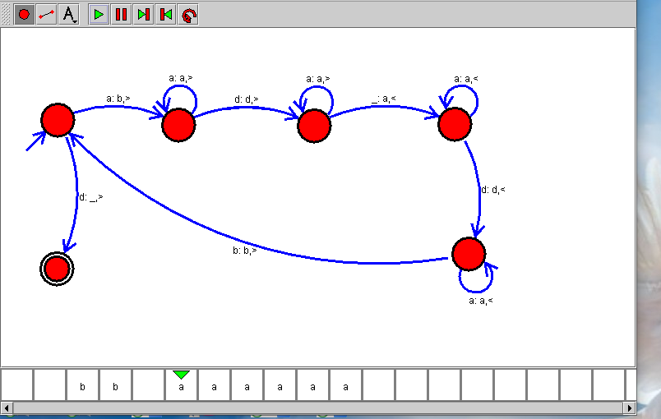Sample Input
aa + aaa
Sample Output
After Addition of a's = aaaaa
Input:
aa + aaaa
Output:
After Addition of a's = aaaaaa
Result
Thus, the Turing Machine was successfully designed using the simulator to perform unary addition, and the two input strings were combined to produce the correct number of as.

