Course Code: CSA1305 Name: Elango M (192411026)
Faculty: Dr Balamanigandan R
EXPERIMENT NO: 25
Title
DESIGN DFA USING SIMULATOR TO ACCEPT THE STRING WITH EVEN NUMBER OF a's AND ODD NUMBER OF b's
Your lab manual specifies the test strings:
W = { aab, bbaab }
Aim
To design a Deterministic Finite Automaton (DFA) using the simulator to accept strings having an even number of a's and an odd number of b's.
Software Used
- AutoSim / Automaton Simulator
- Windows Operating System
Procedure
- Open the Automaton Simulator.
- Select DFA.
- Create four states representing the parity of the number of a's and b's.
- Set the state representing even a and even b as the initial state.
- Mark the state representing even a and odd b as the final state.
- Add transitions for input symbols a and b.
- For every a, change the parity of the number of a's.
- For every b, change the parity of the number of b's.
- Enter the test string.
- Run the DFA.
- If the machine finishes in the final state, the string is accepted.
Algorithm
- Start in the state representing even a and even b.
- Read the input string from left to right.
- Whenever a is read, toggle the parity of a.
- Whenever b is read, toggle the parity of b.
- After all symbols are processed:
  - If the number of a's is even and the number of b's is odd, accept.
  - Otherwise, reject.
- Stop.
DFA States
State | Meaning
q0 | Even a, Even b
q1 | Odd a, Even b
q2 | Even a, Odd b (Final)
q3 | Odd a, Odd b
Transition Table
Current State | Input a | Input b
→ q0 | q1 | q2
q1 | q0 | q3
★ q2 | q3 | q0
q3 | q2 | q1
Here, q0 is the initial state and q2 is the final state.
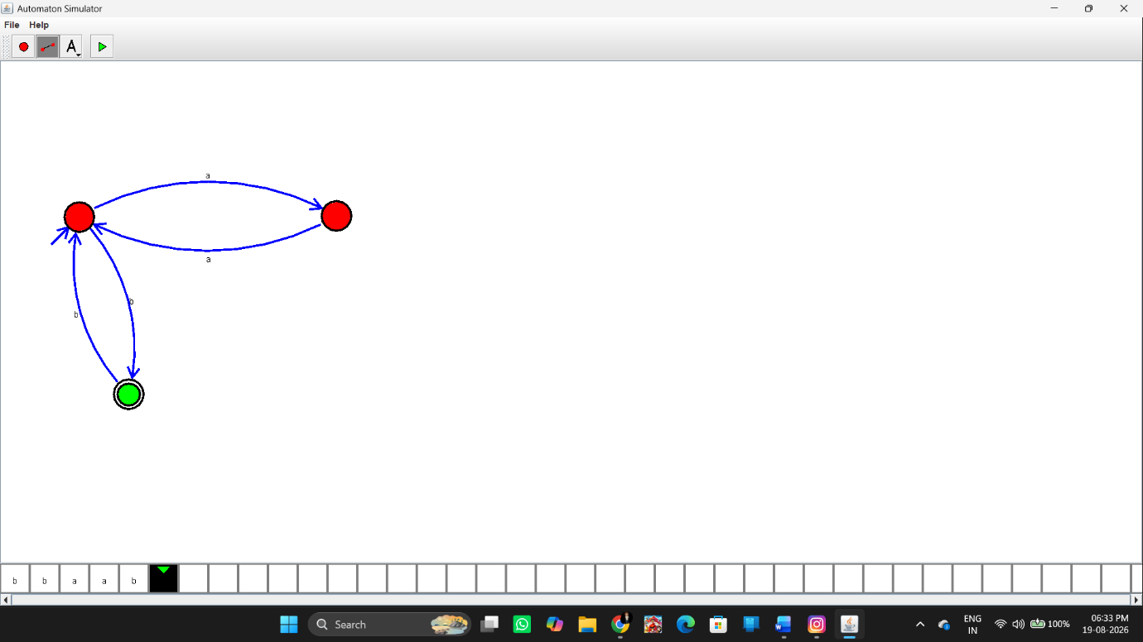Input and Output
Test Case 1
Input:
aab
Count:
- a = 2 → Even
- b = 1 → Odd
Output:
String Accepted
Test Case 2
Input:
bbaab
Count:
- a = 2 → Even
- b = 3 → Odd
Output:
String Accepted
These are the two test strings specified in the manual.
Additional Rejected Example
Input:
aabb
Count:
- a = 2 → Even
- b = 2 → Even
Output:
String Not Accepted
Result
Thus, the DFA was successfully designed using the simulator to accept strings having an even number of a's and an odd number of b's. The given strings aab and bbaab are accepted.

