Course Code: CSA1305 Name: Elango M (192411026)
Faculty: Dr Balamanigandan R
EXPERIMENT NO: 29
According to your TOC Lab Manual, Experiment 29 is:
“Design TM using simulator to perform string comparison where w = {aba aba}.”
Aim
To design a Turing Machine (TM) using the simulator to perform string comparison and determine whether the two given strings are equal.
For this experiment:
w = aba
and the comparison is:
aba = aba
Software Used
- AutoSim / Automaton Simulator
- Windows Operating System
Procedure
- Open the Automaton Simulator.
- Select Turing Machine (TM).
- Create the required states.
- Set the initial state.
- Mark the final/accepting state.
- Enter the two strings to be compared on the tape.
- Place a separator between the two strings if required.
- Start the Turing Machine.
- Compare the first symbol of the first string with the corresponding symbol of the second string.
- Repeat the comparison for all symbols.
- If all corresponding symbols are equal, move to the Accept state.
- If any symbols are different, move to the Reject state.
Algorithm
- Start.
- Read the first symbol of the first string.
- Move to the corresponding symbol in the second string.
- Compare both symbols.
- If they are equal, mark them and continue.
- Repeat for every symbol.
- If all symbols match and both strings have the same length, accept.
- Otherwise, reject.
- Stop.
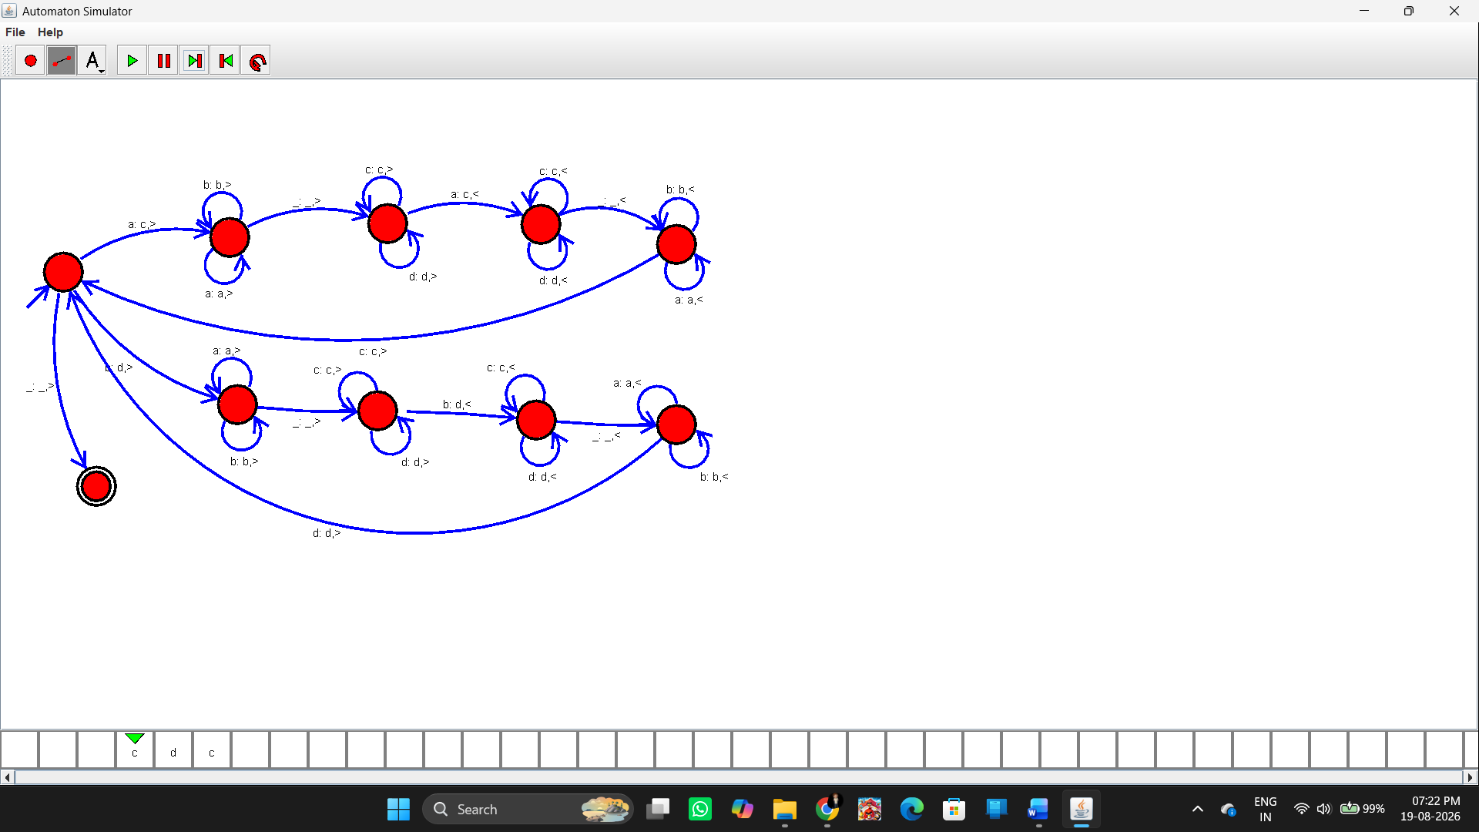Input
The manual specifies:
aba aba
So the two strings are:
First string = aba
Second string = aba
Output
Since:
aba = aba
the expected result is:
String Accepted
Additional Test
You can test:
aba abb
Since:
aba ≠ abb
the expected output is:
String Not Accepted
Input / Output Table
Input | Comparison | Output
aba aba | aba = aba | Accepted
abb abb | abb = abb | Accepted
aba abb | aba ≠ abb | Rejected
abc aba | abc ≠ aba | Rejected
Result
Thus, the Turing Machine was successfully designed using the simulator to perform string comparison, and the strings aba and aba were found to be equal, so the input was accepted.

