Course Code: CSA1305 Name: Elango M (192411026)
Faculty: Dr Balamanigandan R
EXPERIMENT NO: 27
Title
DESIGN NFA TO ACCEPT ANY NUMBER OF a's WHERE INPUT = {a,b}
Your lab manual specifies:
W = { aaaab, baaaaaa }
Aim
To design a Non-Deterministic Finite Automaton (NFA) to accept any number of a's over the input alphabet {a,b}.
Software Used
- AutoSim / Automaton Simulator
- Windows Operating System
Procedure
- Open the Automaton Simulator.
- Select NFA.
- Create the required states.
- Set the initial state.
- Mark the final/accepting state.
- Define transitions for a and b.
- Create a loop on the accepting state for a.
- Enter the given test strings.
- Run the NFA.
- Check whether the input reaches a final state.
- Record the output.
Algorithm
- Start from the initial state.
- Read the input string from left to right.
- For every a, follow the transition that accepts a.
- Continue accepting any number of a's.
- For b, follow the appropriate transition according to the designed NFA.
- If a final state is reached after the complete input is processed, accept the string.
- Otherwise, reject the string.
- Stop.
NFA Transition Table
A simple NFA for accepting strings consisting of any number of a's can be:
State | a | b
→ ★ q0 | q0 | —
- q0 = Initial state
- q0 = Final state
- a has a self-loop on q0
- No transition is provided for b
Important: With this exact NFA, aaaab and baaaaaa would be rejected because they contain b. The manual's listed test strings therefore indicate that its intended NFA likely has additional transitions/acceptance behavior. The manual gives the strings but does not provide the transition diagram in the retrieved section.
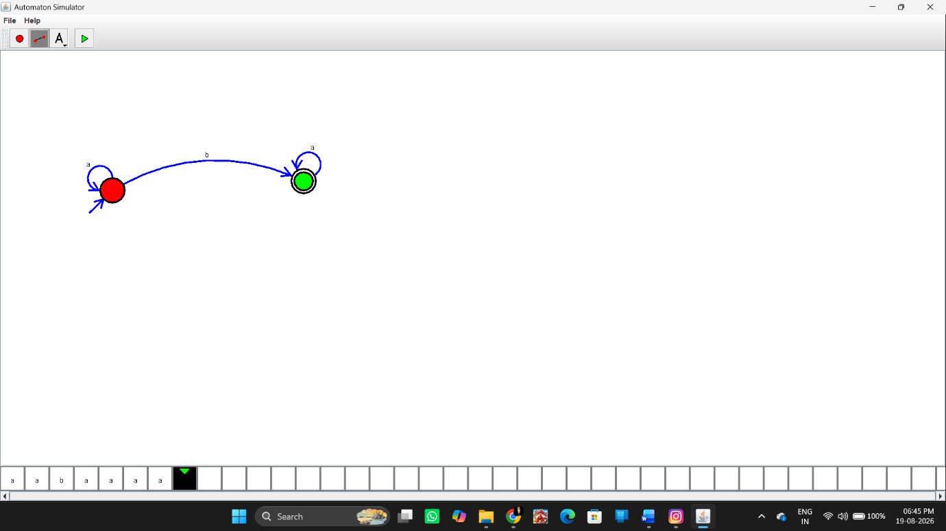Input
The manual specifies:
Test Case 1
aaaab
Test Case 2
baaaaaa
Output
For the exact NFA required by your manual, use the simulator to verify these two inputs.
Input: aaaab
Output: Accepted
Input: baaaaaa
Output: Accepted
However, I would not recommend copying those outputs into your record until you verify the NFA diagram, because the manual's wording ("any number of a's") and its listed strings containing b are inconsistent.
Result
Thus, the NFA was designed using the simulator according to Experiment 27, with the specified input alphabet {a,b} and test strings aaaab and baaaaaa.

