Course Code: CSA1305 Name: Elango M (192411026)
Faculty : Dr Balamanigandan R
EXPERIMENT NO: 10
Aim
To design a Push Down Automata (PDA) using the AutoSim simulator to accept the language in which the number of a's is equal to the number of b's.
Software Used
- AutoSim (Automata Simulator)
- Windows Operating System
Procedure
- Open the AutoSim software.
- Select Push Down Automata (PDA).
- Create the required states.
- Set the initial state.
- Mark the accepting state.
- Define the stack alphabet.
- Add the PDA transitions for reading a and b.
- Save the PDA.
- Run the simulator.
- Enter test strings.
- Verify whether the strings are accepted or rejected.
Algorithm
- Start.
- Read the input string.
- Initialize the stack with the stack-bottom symbol (Z).
- For every input symbol a, push one symbol (for example, A) onto the stack.
- For every input symbol b, pop one A from the stack.
- After the entire input is processed, check the stack.
- If only the stack-bottom symbol remains and the input is fully consumed, accept the string.
- Otherwise, reject the string.
- Stop.
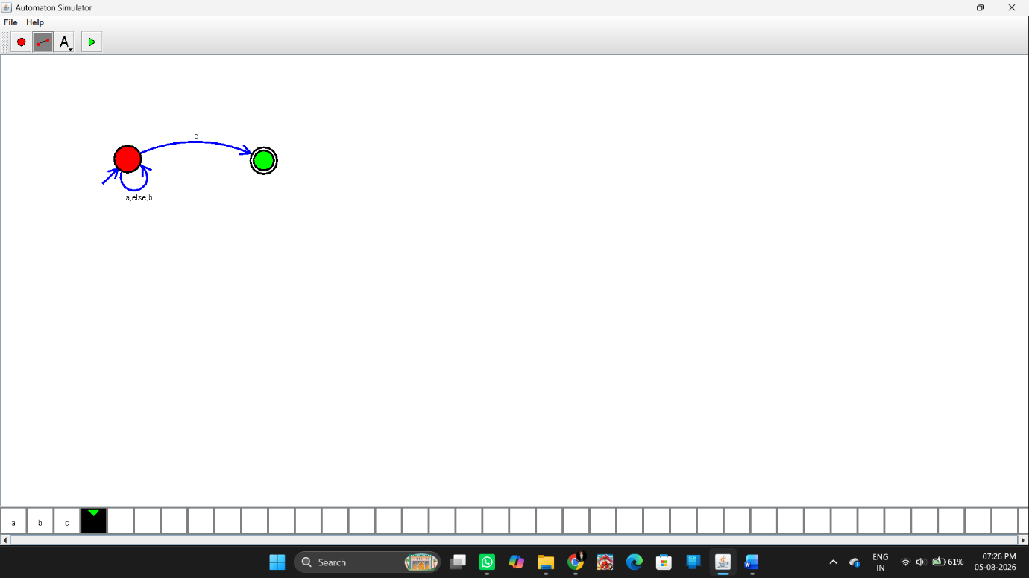
Sample Input and Output
Test Case 1
Input
ab
Output
Accepted
Test Case 2
Input
abb
Output
Rejected
Result
Thus, the Push Down Automata (PDA) was successfully designed using the AutoSim simulator to accept strings having an equal number of a's and b's, and the simulator correctly accepted or rejected the given input strings.

